**Project Name:** Work Efficiency Tracker

Project Members: 1) Divya Sai Teja Pamarthi

2) Swathi Chirukuri

3) Ashish Mulupuri

4) Nishanth Kolli

**Business:** The client owns large refinery and processing plants in multiple locations

**Problem Statement:**

Oil and Gas refinery or processing plant must go for maintenance activities once in 5 to 10 years. During this maintenance activities thousands of temporary workers will be hired to perform the jobs. These workers perform jobs like welding, scaffolding, electric etc., The maintenance activity generally last for 2 – 4 months duration. The problem here is that maintenance activity is being completed within planned duration which resulted in huge loss in terms of man hours and plant shutdown. The owner of the Oil & Gas refinery company would like to track temporary workers and see few productivity driven analytics supported a robust database. The client is expecting to save at least 5% of the total budget by the end turnaround and achieve planned deadlines.

**Solution:**

Each worker in the plant is assigned with an IoT device. We need to create a database that collects and store the raw data received from IoT devices and generate analytics(reports). The entire industrial area is divided into work areas. Each person is assigned an IOT device with a unique id, role and company. We use a transactional table that stores the entering and leaving timestamps of contractors in each work area. Each person will be mapped to a workorder. Each workorder is assigned to one or many areas which are considered as work areas for that person(productive) and the remaining areas for that person will be non-working areas(non-productive).

**Benefits:**

Productive Time: Total time spent by a worker that is assigned by the work order.

Assuming total workers for the turnaround activity is 3000 members with 2000 members in plant at any point of time.

Average pay per hour estimated at 30$.

Total number for days = 120

Total maintenance cost = 2000 * 120 * 30 = 7200000 $

By monitoring the total productive hours and having regular meeting with respective shift supervisors on the drawbacks, we are assuming it increases the productivity and saves at least 5 % of total budget. 5 % of total budget here equals to 12 days of work. Most of the time the maintenance projects are extended. So, even if it helps for the completion of project within time it is a success.

Total budget saved = 7200000 * 0.05 = 360000 $

We can also consider other allowances like food, transport, and other employee benefits as savings.

**Entities:** Area, Person, Role, Shift, Company, Equipment, WorkOrder, AreaChanges, AreaPersonMapping, and AreaManagement

**Entity Descriptions:**

**Area:** It is a master/dimension table that has all the areas in the plant

**Person:** It has all the details related to person like unique_id, Name, Address, role, and company information

**Role:** It is a master/dimension table that contains role information of temporary workers. For example, if we take Oil & Gas industry. The roles would be like production engineer, welder, boilermaker, etc.,

**Company:** Company table is a master/dimension table consists of company name and details of the companies that are hired to do the maintenance activity. Under each company we will have lot of worker with different roles. This table does not contain owning company information. It contains details of companies which are registered to work in maintenance activity.

**Shift:** This is a master table that consists of a shift information like day shift /night shift.

**Equipment:** Each person is assigned with an IOT equipment. We maintain which equipment is tagged to which person.

**WorkOrder:** In Industries, generally every person should be assigned with a proper work order with all his work description to perform the jobs. This entity consists of work order id, start and end time and planned hours for that work order.

**AreaPersonMapping:** It is a mapping table that gives us information on which person is mapped to which area(s) on which workorder. At a point in time, a person can only be active in one workorder.

**AreaChanges:** It is the main transaction table. It records all the movements that each person made in the areas. Attributes would be like Personid, AreaID, start time, end time

**AreaManagement:** It is a derived table from the above tables. This table will contain all the columns that are existing in Person Area Changes and in addition to that we will have a column whether that transaction is from the working zone or not. It will also contain a derived column representing a difference of start and end time in seconds. We take date part from “startdatetime” column and place it in “Date” column for better aggregation and analytics.

**Entity Relationship Diagram:**

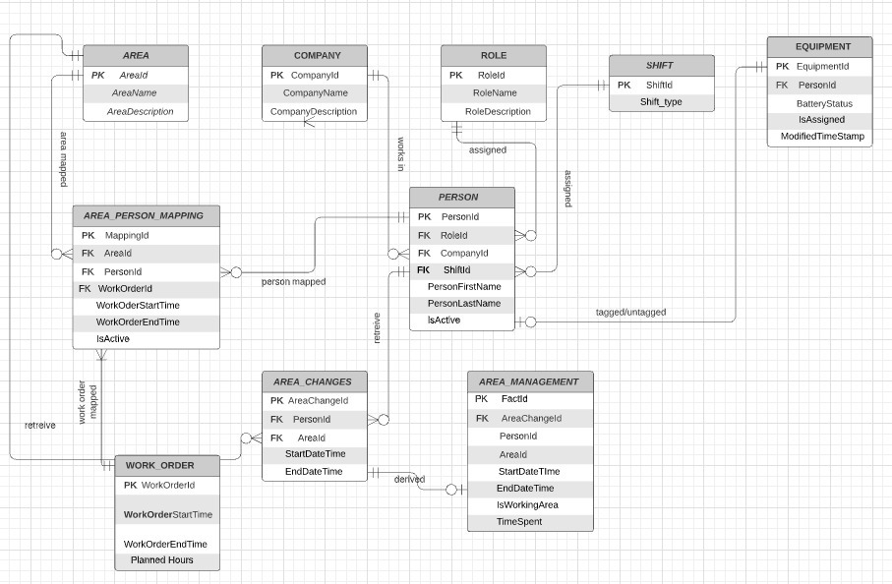

**Business Rules:**

* **Area_Person_mapping**: Many people can be assigned to same area. Each person can be assigned to multiple areas. Even though the areas are existing it is not mandatory that a person should be tagged. “AreaPersonMapping” acts as an associative entity for this relation.
* **Company to Person**: Each company can be tagged to multiple people. Sometimes there is chance that no person is active under that company even though it is listed as a company for maintenance project.
* **Role to Person**: Each Role can be tagged to multiple people. Sometimes there is a chance that no person is active under that role even though it is listed as a Role for maintenance project.
* **Shift to Person:** Each shift type can be tagged to multiple people. Sometimes there is chance that no person is active under that shift even though it is listed like all the people might be in “day” shift only.
* **Equipment to Person:** Each equipment should be mapped to only one person. We maintain stock of equipment’s. So, it is not mandatory to assign an equipment to a person.
* **Work_Order to Area_Person_Mapping:** Each work order should be assigned to at least one area.
* **Person to Area_person_mapping:** A person can be registered for work and exist in person table without any workorder, or area assigned to him.
* **Person to Area_changes:** It is not mandatory for a person to have the records in Area Changes table even though he is assigned to a work order and areas. Because there might be several reasons that person did not show up for work.
* **Area Management:** table is exact replication of AreaChanges with few derived columns. We take some processing time to replicate records from AreaChanges table to AreaManagement table. So, it is not mandatory to have all the records in AreaManagement table that are existing in AreaChanges table.

**Excluded Complex Requirements:**

1. We do not maintain history of roles, companies and equipment assigned to individuals.
2. We are not tracking in department level. We are tracking employees only on role level and their company level.
3. We are not saving base location of the workers.
4. This solution is not connected to HR system and does not track employee leave plans.

**Reports:**

1. Individual Performance
2. Area Wise Hours and Proportion
3. Company Wise Headcount and Total Hours
4. Role Wise Head Count and Total Hours
5. Overall turnaround Performance