Image Captioning on Flickr8k: A Comparative Study of Encoder-Decoder Architectures
Piotr Salustowicz and Olgert Magilaj — Team Neural Narrators MSE FTP — Deep Learning — Mandatory Practical Work 03 Both authors contributed equally to this work.

1. Description of Approach

This project focuses on generating natural-language descriptions for unseen images. We implemented and compared two encoder-decoder architectures on the Flickr8k dataset: the "Show and Tell" baseline and the attention-based "Show, Attend and Tell" model. Both models utilize a shared fine-tuned ResNet-18 encoder and were trained under identical pipeline conditions. The vocabulary was constructed exclusively from the training split (minimum word frequency of 5), yielding 2,649 unique tokens, and captions were padded to 40 tokens using structural tokens (<pad>, <bos>, <eos>, <unk>). Strong data augmentation (random resized crops, horizontal flips, color jitter, and grayscale conversions) was applied during training to mitigate overfitting.

2. Architectural and Implementation Choices
A fine-tuned ResNet-18 backbone serves as the feature extractor. For the baseline model, features were extracted from the final adaptive average pooling layer and projected to produce a 512-dimensional context vector. For the attention models, the network was truncated prior to pooling to preserve a 512x7x7 spatial feature map.
The decoders utilize an LSTM cell. The baseline initializes states directly with the global image vector, processing 256-dimensional word embeddings sequentially. The attention decoder incorporates Bahdanau additive attention over the 49 spatial regions to compute a dynamic context vector at each time step.
Table 1: Training and Model Hyperparameters
Hyperparameter | Baseline Configuration | Attention Configuration
Dimensions (Enc. / Embed. / Hidden) | 512 / 256 / 512 | 512 / 256 / 512
Attention Dimensionality | None | 256
Dropout / Weight Decay | 0.2 / 1e-3 | 0.2 / 1e-3
Learning Rate (Decoder / Encoder) | 5e-4 / 1e-5 | 5e-4 / 1e-5
Batch Size / Max Caption Length | 64 / 40 | 64 / 40
We also evaluated scaled dot-product attention, a Transformer decoder, beam-search decoding, and pretrained GloVe embeddings.

3. Experimental Setup
Models were optimized using AdamW with a linear warmup and cosine decay schedule. For the LSTM-based models, the learning rate warmed up linearly over 3 epochs; the Transformer decoder used a 5-epoch warmup to accommodate its more sensitive optimization landscape. Gradients were clipped to a maximum norm of 5.0 at every step. Regularization included a dropout rate of 0.2 (0.1 for the Transformer decoder), weight decay of 1e-3, and early stopping with a patience of 15 epochs. The objective function was a masked cross-entropy loss. Training was executed using automatic mixed precision on an NVIDIA H200 GPU. The best-performing checkpoints were reloaded for final evaluation.

4. Quantitative Results
Evaluation using greedy decoding revealed highly competitive results across the recurrent baselines, with the Transformer architecture demonstrating the highest absolute performance.
Table 2: Test Set Evaluation Metrics (Greedy Decoding)
Model Architecture | Best Epoch | Perplexity | BLEU-1 | BLEU-2 | BLEU-3 | BLEU-4
Show and Tell (Baseline) | 11 | 14.61 | 0.5871 | 0.4068 | 0.2708 | 0.1782
Show, Attend and Tell (Bahdanau) | 11 | 14.68 | 0.5883 | 0.4096 | 0.2774 | 0.1862
Dot-Product Attention LSTM | 11 | 14.27 | 0.5915 | 0.4148 | 0.2796 | 0.1866
Transformer Decoder | 9 | 14.21 | 0.6151 | 0.4340 | 0.2983 | 0.2047
While training loss decreased consistently, validation loss reached its optimum early (around epochs 9 to 12) before diverging, indicating overfitting due to the constrained sample size of the dataset.
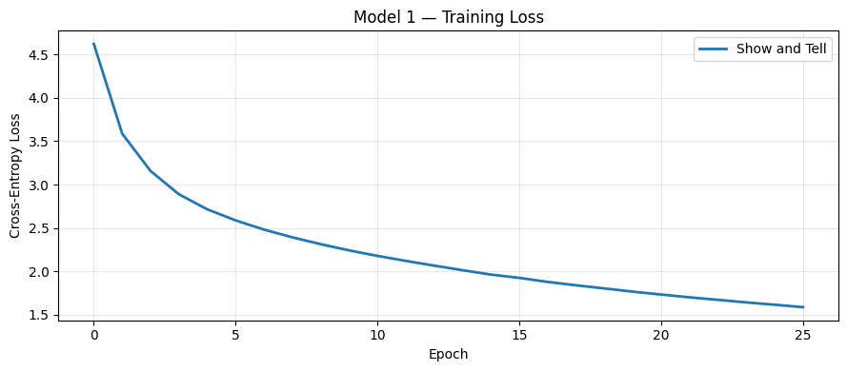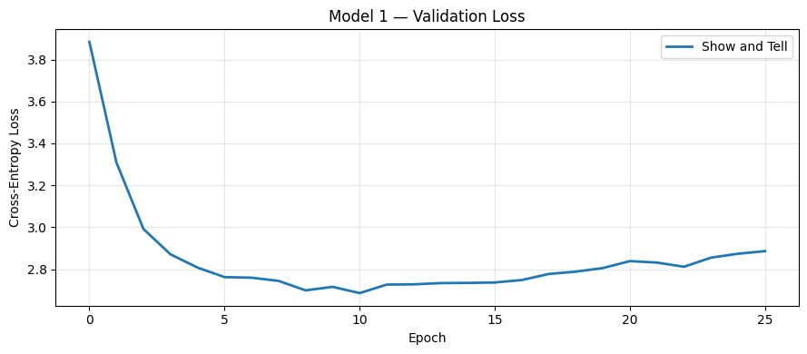
Figure 1: Training and validation loss curves for the baseline architecture, demonstrating early overfitting.
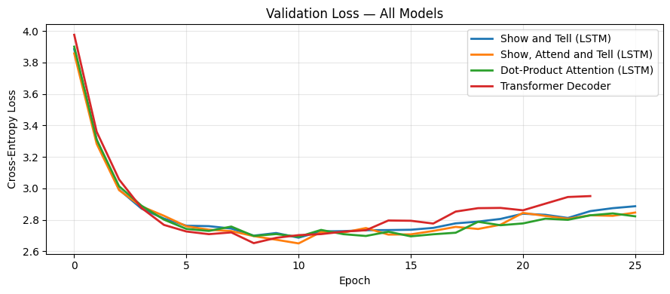
Figure 2: Validation loss comparison across all evaluated architectures.
Beam search (k = 5) consistently out-performed greedy decoding across all metrics, particularly improving higher-order BLEU scores.
Table 3: Inference Strategy Comparison (500-Image Subset)
Strategy | BLEU-1 | BLEU-2 | BLEU-3 | BLEU-4
Greedy Decoding | 0.6005 | 0.4233 | 0.2874 | 0.1912
Beam Search (k = 5) | 0.6081 | 0.4387 | 0.3113 | 0.2172
Integrating pretrained GloVe embeddings yielded no significant advantage, as the training corpus adequately covered 99.5% of the everyday vocabulary.

5. Qualitative Analysis
Qualitative review indicates that while models succeed in identifying primary subjects, they exhibit a drop-off in higher-order sentence fluency.
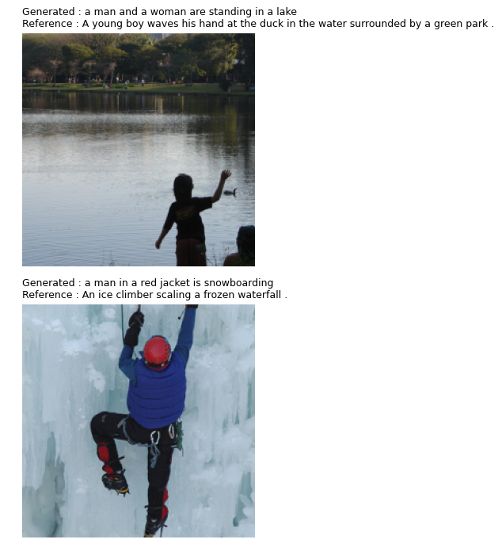
Figure 3: Generated caption examples. Successful instances display accurate object localization (e.g., “grassy hill”). Errors involve hallucinated details (e.g., “snowboarding” instead of “ice climber”) and grammatical errors (e.g., “with a of people”).
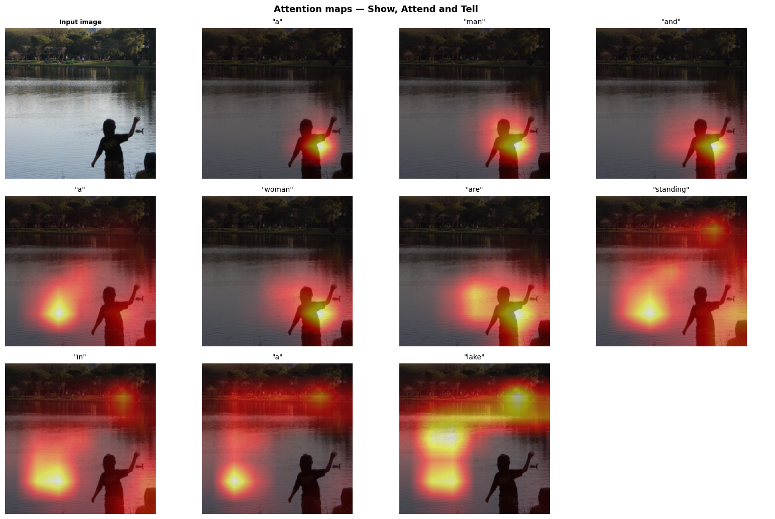
Figure 4: Sequential attention maps. The network correctly focuses on relevant regions (e.g., attending to the water when predicting “lake”), though it misidentifies the child as “man” and “woman”.

6. Discussion and Future Work
The experiments emphasize that dataset scale represents the primary bottleneck. All models overfitted within 12 epochs. Consequently, spatial attention mechanisms yielded marginal performance increases over the global baseline. The Transformer decoder offered the most significant structural advantage, and beam search effectively improved fluency. Future work should investigate larger pre-training corpora, alternative alignment metrics, and scheduled sampling.

