The PRISMA 2020 Statement

- Background and Purpose
The Preferred Reporting Items for Systematic Reviews and Meta-Analyses (PRISMA) was first introduced in 2009 to improve transparency and completeness in reporting systematic reviews.
Due to major advances in review methodology, technology, and publication practices, the guideline was updated in 2020 to reflect modern standards for identifying, selecting, appraising, and synthesizing studies
- The volume of published evidence increased dramatically.
- Researchers began using automation and AI-based tools for screening.
- Review methodologies diversified (e.g., scoping, rapid, umbrella, and living reviews).
Goal: To improve reporting quality, not to evaluate the methodological quality of the review itself.

- The Structure of PRISMA 2020
  - Main Components
- 27-Item Checklist – covers all sections of a review: Title, Abstract, Introduction, Methods, Results, Discussion, and Other Information.
- PRISMA 2020 Flow Diagram – visualizes how many records were identified, screened, excluded, and included in the review.
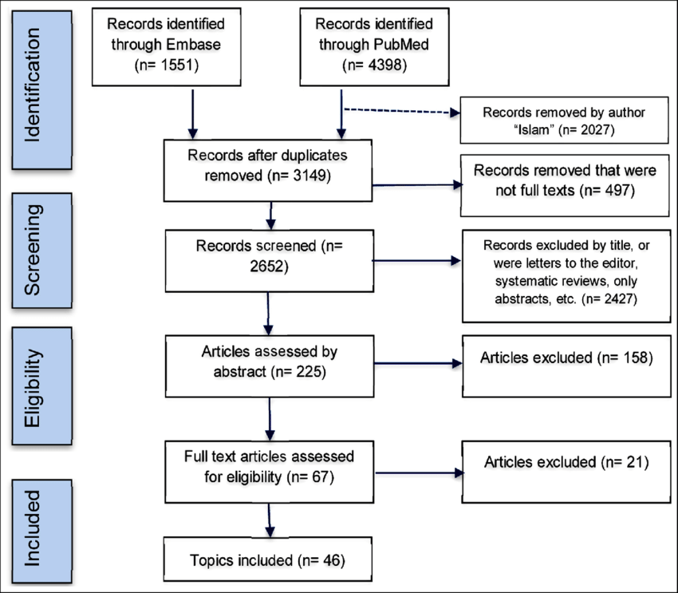
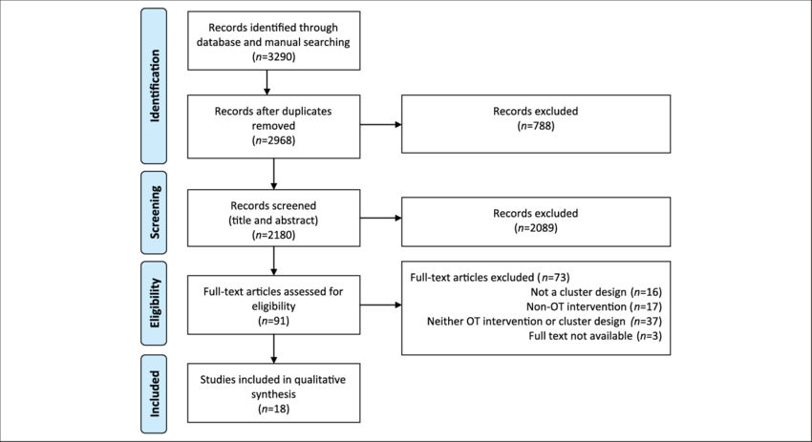
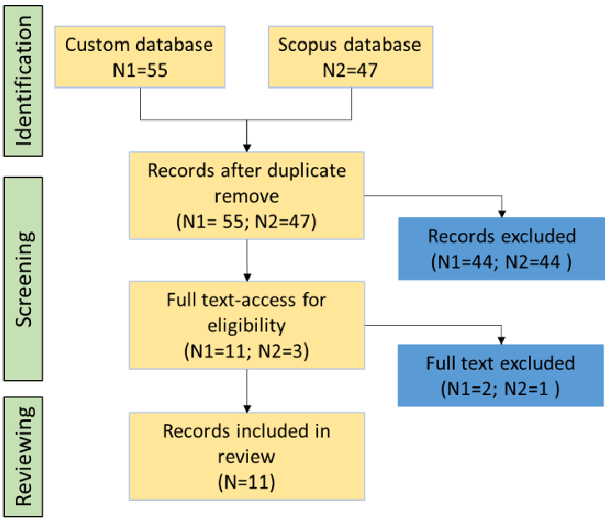
Each checklist item corresponds to what authors should include to make the review transparent, reproducible, and auditable.

Section | Focus | Example of What to Include
Title & Abstract | Clearly identify the work as a systematic review or meta-analysis. | Title: “A Systematic Review of AI in Education”
Introduction | Define rationale, objectives, and research questions. | Explain why this review was needed.
Methods | Describe eligibility criteria, databases, search strategy, screening, risk of bias, and synthesis approach. | Specify which databases (e.g., Scopus, PubMed, IEEE Xplore) were used, with dates and filters.
Results | Report numbers screened, included, and excluded with reasons (via flow diagram). | E.g., “512 records identified; 45 included.”
Discussion | Interpret results, compare with other evidence, discuss limitations. | Highlight strengths and implications.
Other Information | Declare funding, competing interests, and data availability. | e.g., “This study was funded by …”

Major Changes from PRISMA 2009 to 2020
Category | 2009 Version | 2020 Updates
Scope | Focused mainly on health-intervention reviews. | Broadened to include reviews in all disciplines (social sciences, computing, business).
Checklist Items | 27 items. | Still 27, but expanded and reworded for clarity; some items split or updated.
Flow Diagram | One basic template. | Two new versions — one for new and one for updated systematic reviews.
Search Strategy | Limited database coverage. | Must specify all information sources: databases, registers, websites, preprints, and gray literature.
Automation Tools | Not included. | Explicitly asks authors to describe use of software, AI, or screening tools.
Risk of Bias & Certainty | Optional. | Now required to report how bias and evidence certainty were assessed.
Transparency | Minimal mention of data availability. | Must report data, code, and materials availability (encourages open science).

- The PRISMA 2020 Flow Diagram
The flow diagram helps readers visualize the study selection process — from the initial database search to the final number of included studies.
Typical Stages:
- Identification:
  - Databases searched and total records found.
- Screening:
  - Duplicates removed, titles and abstracts screened.
- Eligibility:
  - Full-text articles assessed for inclusion.
- Included:
  - Final number of studies in qualitative and quantitative synthesis.
🧩 Example numbers:
“A total of 1,230 records were identified; after removing 350 duplicates and excluding 800 based on titles/abstracts, 80 full texts were assessed, and 45 were included.”
This visualization ensures readers understand how comprehensive and selective the review process was.

- Development Process of PRISMA 2020
- Initiated by PRISMA Executive Team (Moher, Page, McKenzie, Bossuyt, Boutron, Hoffmann, Mulrow, and others).
- Conducted systematic reviews of existing reporting guidelines.
- Collected survey responses from over 220 experts (methodologists, journal editors, statisticians).
- Organized a face-to-face consensus meeting in Edinburgh (2018).
- Drafted, revised, and pilot-tested multiple times (2019–2020).
The result was a community-validated, evidence-based reporting tool.
- Using PRISMA 2020 in Research
To use PRISMA effectively:
- Plan your review protocol (using PROSPERO or OSF).
- Use the PRISMA checklist during writing — tick each item as it’s covered.
- Attach the completed checklist when submitting to journals (many require it).
- Include the flow diagram in your paper’s methodology section.
- Share search strategies and data for transparency.
Resources available at www.prisma-statement.org.

- Benefits of Following PRISMA 2020
- Ensures completeness and clarity in reporting.
- Makes systematic reviews reproducible and auditable.
- Builds credibility and trust in research findings.
- Encourages open science and data transparency.
- Facilitates peer review and publication acceptance.
💬 Example for students:
“If two groups conduct reviews on AI-based irrigation systems, but only one follows PRISMA 2020, that group’s review will be far easier to verify and publish.”

- Common Misunderstandings
Misconception | Clarification
“PRISMA ensures the quality of my study.” | ❌ No — it improves reporting quality, not the methodology.
“I only need to use PRISMA if I do a meta-analysis.” | ❌ No — PRISMA applies to any systematic review.
“It’s only for medical research.” | ❌ No — PRISMA 2020 is discipline-neutral and fits computing, engineering, education, and management.

- Practical Example
Suppose you are conducting a systematic review on “………………………………..”
You would:
- Search databases like IEEE Xplore, PubMed, and Scopus.
- Record your search strategy (keywords, filters, date).
- Use the PRISMA flow diagram to show how many studies you included/excluded.
- Report all items in the 27-point checklist to ensure transparency.

- conclusion
The PRISMA 2020 Statement is now the global standard for reporting systematic reviews.
It ensures research integrity, transparency, and reproducibility and is adopted across disciplines by leading journals and conferences.
“Transparent reporting is the foundation of trustworthy evidence.” — Page et al., 2021

- Reference for Citing in IEEE Format
[1] M. J. Page, J. E. McKenzie, P. M. Bossuyt, I. Boutron, T. C. Hoffmann, C. D. Mulrow, L. Tetzlaff, E. Akl, J. Brennan, R. Chou, and D. Moher, “The PRISMA 2020 statement: an updated guideline for reporting systematic reviews,” Systematic Reviews, vol. 10, no. 1, p. 89, 2021. [Online]. Available: https://doi.org/10.1186/s13643-021-01626-4. (Accessed: Oct. 12, 2025).

