You are required to develop a Django web application focused on Football that includes the following features:

1. Football Database:
- Create a Django project named ‘footballstats’ with a small database to manage information about football players.
- The database should include the following fields for each player:
  - Player Name (CharField)
  - Country (CharField)
  - Current Club (CharField)
  - Position (CharField)
  - Age (IntegerField)
  - Goals Scored (IntegerField)
  - Assists Provided (IntegerField)
Player Name | Country | Current Club | Position | Age | Goals Scored | Assists Provided
Cristiano Ronaldo | Portugal | Al Nassr | Forward | 39 | 702 | 199
Lionel Messi | Argentina | Inter Miami | Forward | 37 | 672 | 296
Robert Lewandowski | Poland | Barcelona | Forward | 36 | 530 | 110
Neymar Jr. | Brazil | Al Hilal | Left Winger | 32 | 221 | 127
Mohammed Salah | Egypt | Liverpool | Right Winger | 32 | 270 | 123
- Utilize the Django admin panel to set up and manage this database. Your Django admin should enable you to add, edit, and delete player entries.
- The username should clearly be your enrolment no with password as ljiet123, e.g. your Enrolment no is 22002170110001, the username should be 22002170110001 and password should be ljiet123.

2. Web Pages:
- Design a web application with multiple pages. Your application should include at least four primary pages:
  - Homepage: This page should display a list of football players from the database. Each player's entry should display their name.

Sample Home Page:
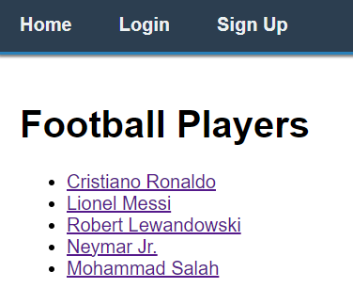
  - Player Detail Page: When a user clicks on a player's name on the homepage, they should be directed to a detailed page that showcases all information about the selected player, including their name, country, current club, position, age, goals scored, and assists provided.
This page should display details only when the user is logged in.

Sample Player Detail Page:
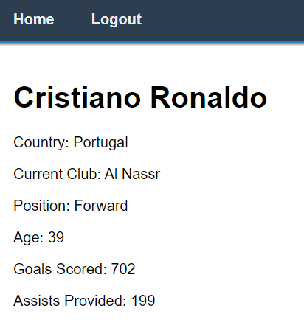
If user is not logged in, it should show this blank page.
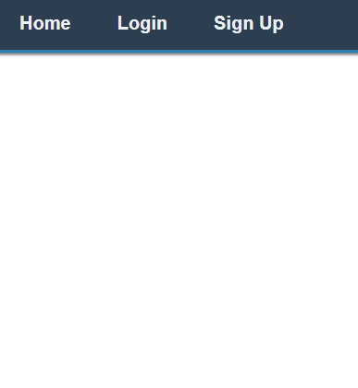
  - Login Page: Create a form page that allows users to login to the website.

Sample Login Page:
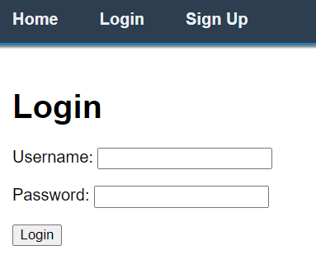
  - Signup Page: Create a form page that allows users to signup to the website.

Sample Signup Page:
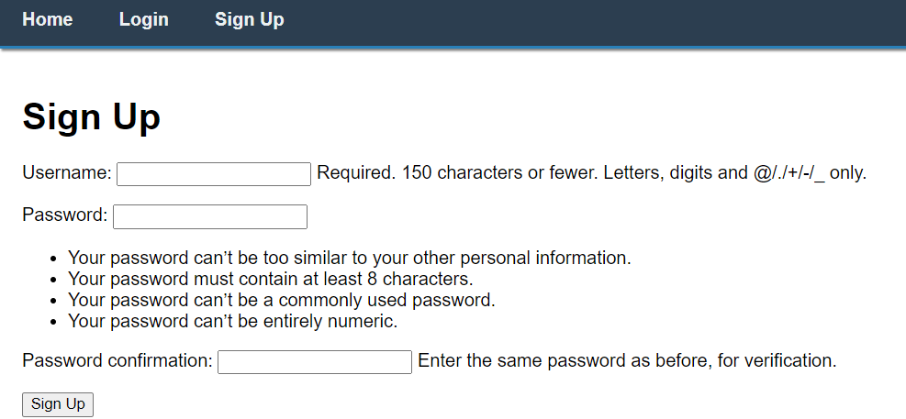

BASE FILE for Nav bar: (base.html)
<!DOCTYPE html>
<html lang="en">
<head>
<meta charset="UTF-8">
<title>Football App</title>
<style>
body {
margin: 0;
font-family: Arial, sans-serif;
}

.navbar {
background-color: #2c3e50;
overflow: hidden;
border-bottom: 3px solid #2980b9;
box-shadow: 0 4px 2px -2px gray;
}

.navbar a {
float: left;
display: block;
color: #ecf0f1;
text-align: center;
padding: 14px 20px;
text-decoration: none;
transition: background-color 0.3s ease, color 0.3s ease;
font-weight: bold;
}

.navbar a:hover {
background-color: #2980b9;
color: #ffffff;
border-radius: 5px;
}

.content {
padding: 20px;
}
</style>
</head>
<body>
<div class="navbar">

“Here provide all necessary anchor tags with url links using Django Template Language”

</div>

<div class="content">
{% block content %}
{% endblock %}
</div>
</body>
</html>

Instructions:
Organize your Django project following best practices and adhering to the MVT (Model-View-Template) architectural pattern.

