You are required to create a Django project named eventmanagement that includes two apps: events (for handling the events and their display) and categories (for listing the event categories). The project should meet the following specifications:
1.Home Page:
- The home page of the website should have 2 links named Upcoming Events and Event Categories

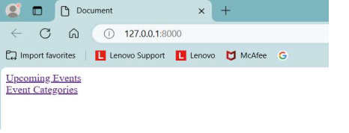

2.Upcoming Events Page (events app):
-When you click on the Upcoming Events link, it should redirect you to a page where a table of upcoming events is displayed.
-The table should include the following columns: Event Name, Event Date, Location, and Category (e.g., Conference, Workshop, etc.).
- The data for this table should be extracted from the database stored in the Django admin interface with name Events and should be ordered by date in ascending order. (Enter the data in the database as shown in sample output)
- There should be a search bar that allows the user to search for events by event name.
- will also be a link at the bottom of the page labelled Event Categories that will redirect the user to the Event Categories page of categories app.
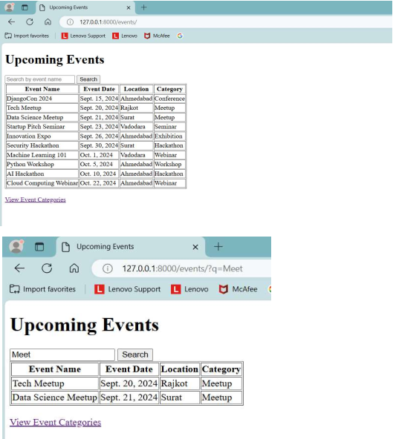

HTML Snippet For above webpage (Add appropriate DTL in it):
<html>
<head> <title>Upcoming Events</title> </head>
<body>
<h1>Upcoming Events</h1>
<form method="GET">
<input type="text" name="q" placeholder="Search by event name">
<button type="submit">Search</button>
</form>
<table border="1">
<thead>
<tr>
<th>Event Name</th> <th>Event Date</th> <th>Location</th> <th>Category</th>
</tr>
</thead>
<tbody>
<tr>
<td></td> <td></td> <td></td> <td></td>
</tr>
</tbody>
</table> <br>
<a href="#">View Event Categories</a> </body>
</html>

3.Event Categories Page (categories app):
- When you click on the Event Categories link, it should redirect you to a page where a list of event categories is displayed.
- The categories should be extracted from the database stored in the Django admin interface with name Categories and displayed in order.
- There will also be a link at the bottom of the page labelled Upcoming Events that will redirect the user to the Upcoming Events page of events app.
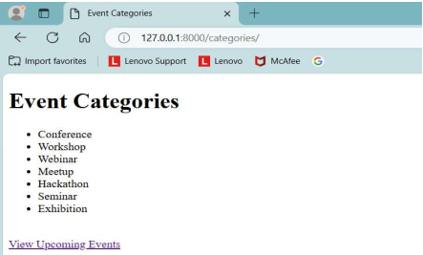

HTML Snippet For above webpage (Add appropriate DTL in it):
<html>
<head>
<title>Event Categories</title>
</head>
<body>
<h1>Event Categories</h1>
<ul>
<li></li>
</ul>
<br/>
<a href="#">View Upcoming Events</a>
</body>
</html>

4.Admin Functionality:
•Create a superuser with your roll number as the username and your enrollment number as the password.
This superuser should be able to add and manage events and categories within the Django admin interface.
•Ensure that all data for both pages is extracted dynamically from the database and not hardcoded in HTML.

