

Instructions for using the SigmaStar tool



© 2019 SigmaStar Technology Corp. All rights reserved.

SigmaStar Technology makes no representations or warranties including, for example but not limited to, warranties of merchantability, fitness for a particular purpose, non-infringement of any intellectual property right or the accuracy or completeness of this document, and reserves the right to make changes without further notice to any products herein to improve reliability, function or design. No responsibility is assumed by SigmaStar Technology arising out of the application or use of any product or circuit described herein; neither does it convey any license under its patent rights, nor the rights of others.

SigmaStar is a trademark of SigmaStar Technology Corp. Other trademarks or names herein are only for identification purposes only and owned by their respective owners.

# REVISION HISTORY

|  |  |  |  |
| --- | --- | --- | --- |
| **Review where No.** |  | **Description** | **Date** |
| V1.0 • | | Initial release | 08/11/2019 |

# TABLE OF CONTENTS

**REVISION HISTORY .............................................................................................................. i**

**TABLE OF CONTENTS ............................................................................................................ ii**

**LIST OF TABLES ................................................................................................................... iii LIST OF FIGURES ................................................................................................................. iii**

1. **Sstar System Tool .......................................................................................................... 1**
   1. Sstar System tool description ........................ ..... 1
2. **S**star flash tool **............................................................................................................ 7**
   1. Sstar Flash Tool Usage Instructions .................. ............ 7
      1. Burn hardware environment preparation .............. 7
         1. Debug tool Hardware Serial Port Tool ........................ 7
         2. Hardware connection block diagram .................................... 7
         3. SPI-NOR Flash empty burn ........................... ........................................................... 8
         4. SPI-NAND FLASH empty film burning .................. 11
         5. Image Burn Method ......................... 17
         6. How to erase Flash ..................... 19
   2. Sstar Flash Tool burn error ............. .............................................................................................. 20
      * 1. Hardware connection error ................................ 20
        2. The serial port tool was selected incorrectly ................... ............................................................... 20
        3. Flash type selection error .............. 20
        4. Flash tool file is missing ................................................. .................................. 21
        5. Serial terminal not closed.............. 22

**LIST OF TABLES**

Table 1: {Table Title} ........................................................................................................ Error**!** No bookmark is defined.

**LIST OF FIGURES**

Figure 1: {Figure Name} ............................................................................................. ....... Error**!** No bookmark is defined.

# 1. SSTAR SYSTEM TOOL

## 1.1. Sstar System tool说明

Software developers accessing the SigmaStar chip registers must use the Debug Tool hardware tool and the Sstar System Tool software tool. The Debug Tool hardware tool, as shown in Figure 1

The purchase link is as follows: [https://item.taobao.com/item.htm?id=15437784110https://item.taobao.com/item.htm?id=15437784110](https://item.taobao.com/item.htm?id=15437784110)

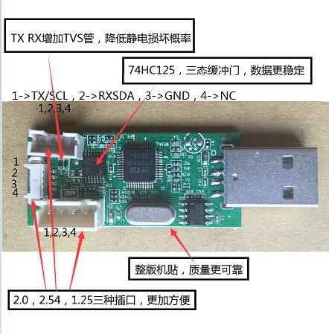 Figure 1

Use a USB extension cable to connect to a PC and install the debug tool driver for win7.

Open the Securt CRT tool . At present, there are two ways to stop the serial port:

1. Enter uboot, click the command debug , and enter to close the serial terminal (very important), as shown in Figure 2 below:

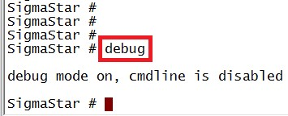 Figure 2

1. Enter the system, enter 11111 (5 1s), stop the serial port, and close the serial terminal (important), as shown in Figure 3 below:

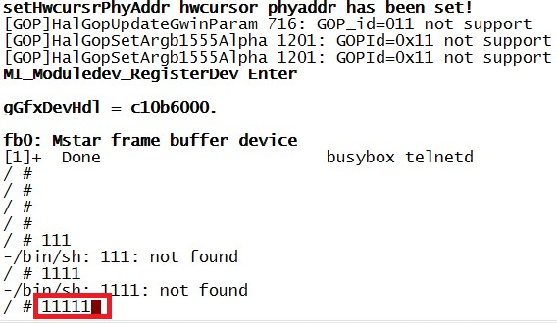 Figure 3

In the following Figure 4 interface, confirm the chip/interface/Slave addr in the interface, select the following figure 4, and then click the button to appear in Figure 5

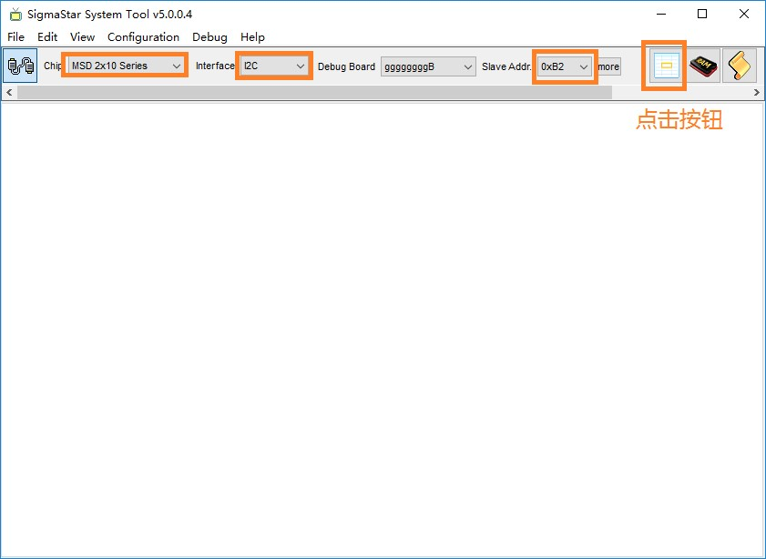 Figure 4

In the following Figure 5 interface, select bank, the range is in the 1002-1016 range, select MIU, and then click Read Bank, if you can read the data normally, it means the Sstar tool The connection with the chip is normal.

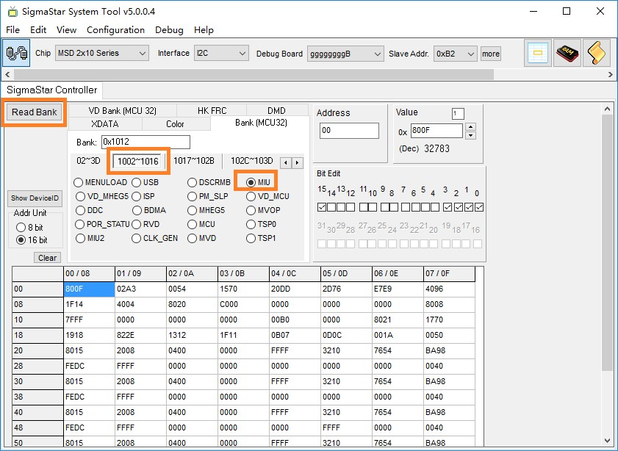 Figure 5

As Figure 6 shows: Bank1012 offset address 1B 16bit is 0x1F11

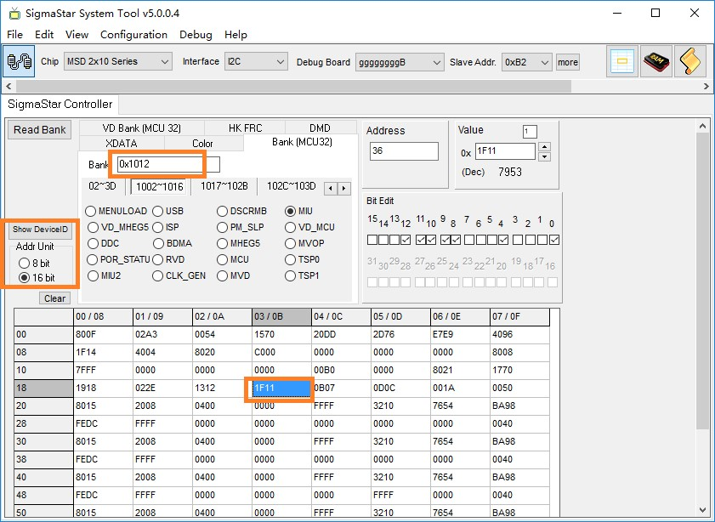

Figure 6

As Figure 7 shows: For example, the value of Bank1012 offset address 36 8bit is 0x1F the value of offset address 35 8bit is 0x11

Converting 8bit to 16bit is 36/2=1B (hexadecimal).

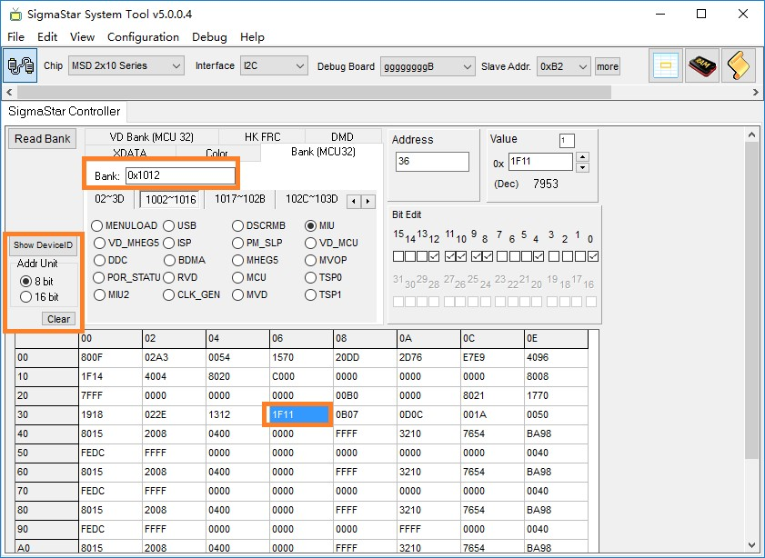

Figure 7

## **2. S**STAR FLASH TOOL

2.1. Instructions for using the Sstar Flash Tool

### 2.1.1 Preparation of the flashing hardware environment

2.1.1.1. Debug tool Hardware serial port tool

This tool is designed for uboot burning of SigmaStar chips and access to the chip's Sstar tool registers.



Figure 8

2.1.1.2. Hardware Connection Block Diagram

Hardware single board Debug Tool

PIN1 NC PIN1 NC

PIN2 GND PIN2 GND

PIN3 RX PIN3 RX

PIN4 TX PIN4 TX

The SigmaStar chip connection single board order is NC GND RX TX

2.1.1.3. SPI-NOR Flash Empty Chip Burning

Suitable for empty machine burning, or uboot has been damaged to make it impossible to upgrade through uboot.

SPI Norflash burned the offer as follows:

Different chips may burn different addresses and require consulting with a software engineer.

|  |  |  |
| --- | --- | --- |
| **name** | **offset** | **path** |
| IPL.bin | 0x0000 | project\image\output\i-mages\IPL.bin |
| IPL_CUST.bin | 0x10000 | project\image\output\images\IPL_CUST.bin |
| MXP_SF.bin | 0x20000 | project\image\output\images\MXP_SF.bin |
| u-boot.xz.img.bin | 0x30000 | project\image\output\images\u-boot.xz.img.bin |

Table 2-1

Step 1: Use the debug tool to connect the board, close the serial terminal, execute the Flash Tool tool, and power on the board. Step 2: Select the "SPI" tab, click "More" and select the type "SPINOR";

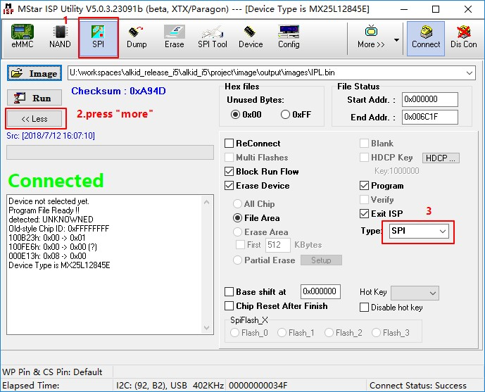

Figure 9

Step 3: Load the burned file and click "Connect"

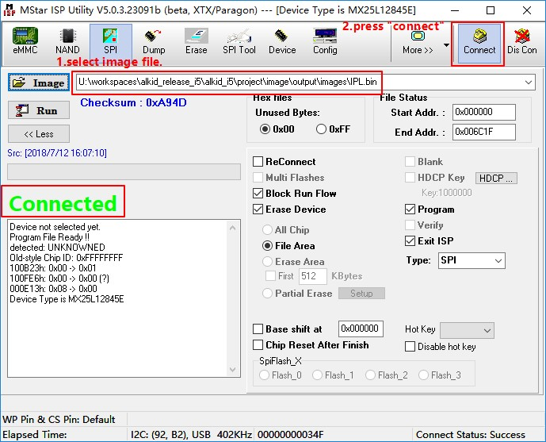

Figure 10

Step 4: Load image "IPL.bin", click "Run";

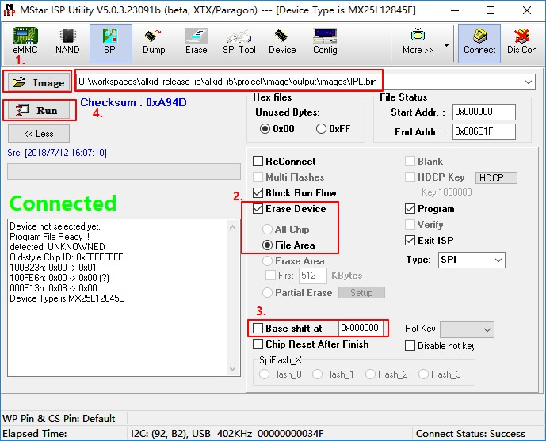 Figure 11

5: Load image "IPL_CUST.bin", set "Base shift" at 0x10000. Note: Subject to change depending on version, the address of Base shift is based on Table 2-1 data.

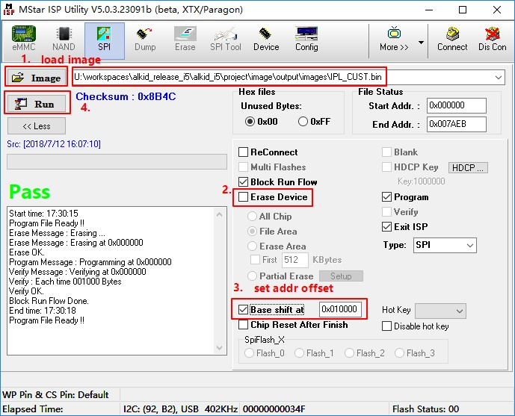

Figure 12

Step 6: Load image "MXP_SF.bin", set "Base shift" at 0x20000.

Step 7: 加载image “u-boot.xz.img.bin” , 设置“Base shift”at 0x30000。

Step 9: Restart the board

2.1.1.4. SPI-NAND FLASH empty chip burning

Suitable for empty machine burning, or uboot has been damaged to make it impossible to upgrade through uboot.

The method of burning SPINAND is the same as SPINOR, but the address and file are slightly different, and the address of different chips may be different, and it is necessary to consult a software engineer.

|  |  |  |  |
| --- | --- | --- | --- |
| **Name** | **Erase Device** | **offset** | **Path** |
| GCIS.bin | All Chip | 0x00000 | project/I2m/image |
| IPL.bin | File Area | 0x140000 | project/I2m/image |
| IPL_CUST.bin | File Area | 0x200000 | project/I2m/image |
| u-boot_spinand.xz.img.bin | File Area | 0x2C0000 | project/I2m/image |

Table 2-2

Step 1: Use the debug tool to connect the board, close the serial terminal, and power on the board.

Step 2: Open the Flash Tool tool, as shown in Figure 13 below;

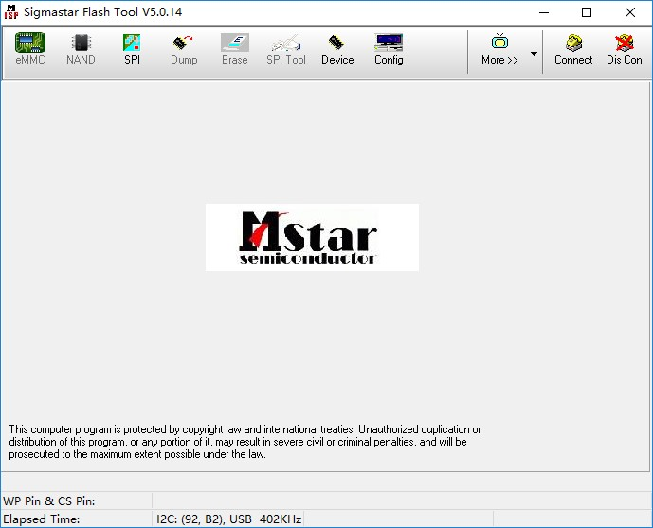 Figure 13

3: Select the SPI button, the interface of Figure 14 appears as below

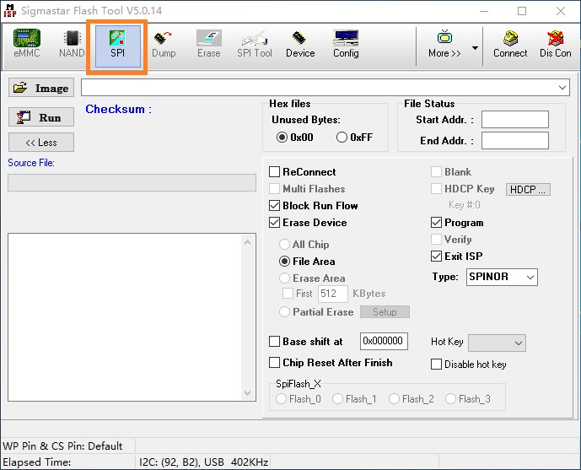

Figure 14

Step 4: In the Type button, select SPINAND, connect the Connect button, the interface as shown in Figure 15 as below appears, and click OK. 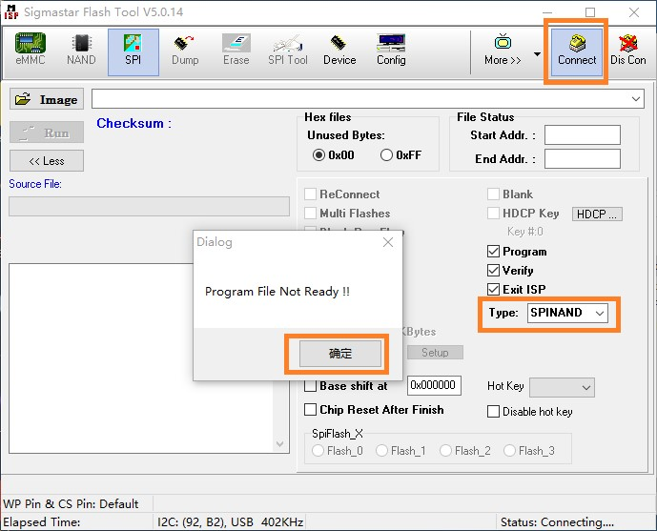 Figure 15

Step 5: When the connection is successful, the interface in Figure 16 as shown below shows the corresponding Flash model, indicating that the connection is successful.

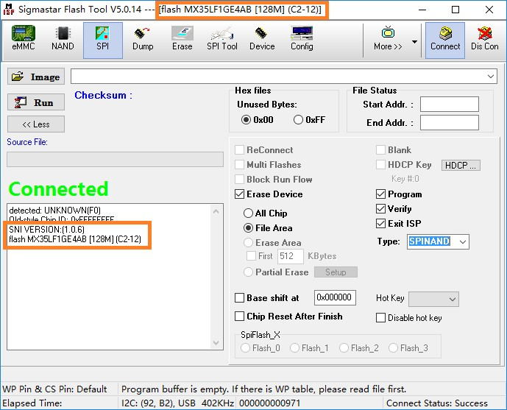 Figure 16

6: Load image " GCIS.bin ", click "Run";

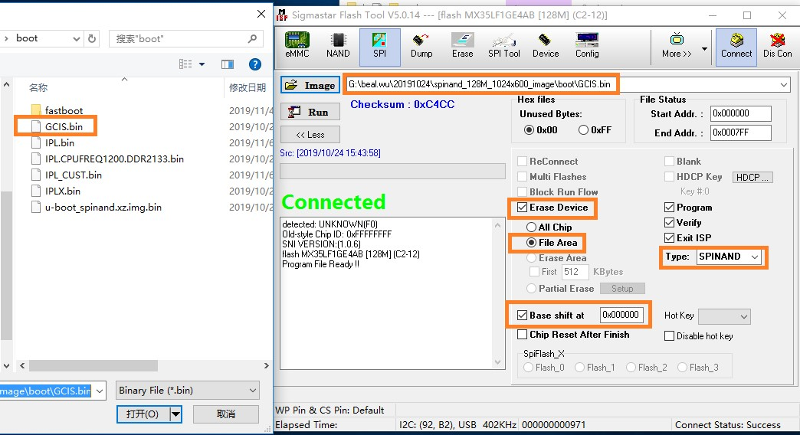 Figure 17

Step 7: Load image "IPL.bin", set "Base shift" at 0x140000. Note: Subject to change depending on version, the address of Base shift is based on Table 2-2 data.

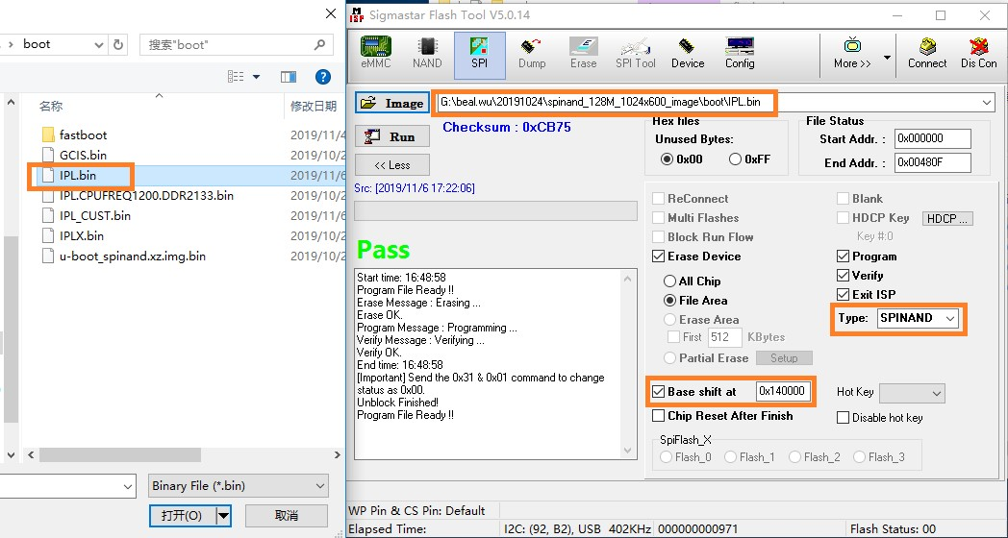

Figure 18

Step 6: Load image "IPL_CUST.bin", set "Base shift" at 0x200000.

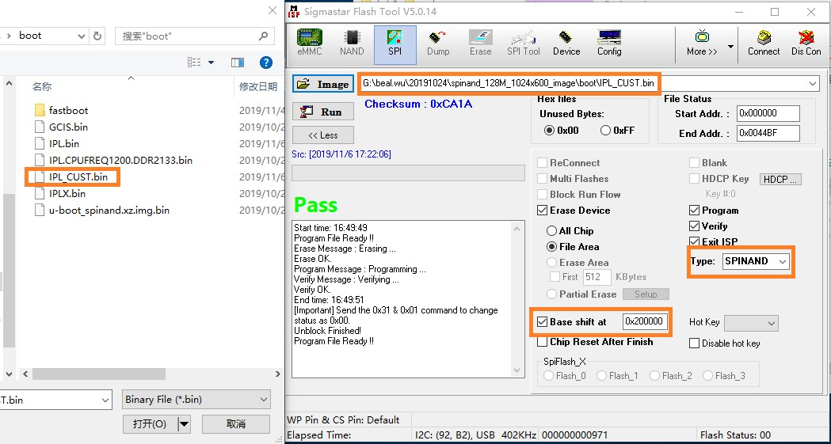 Figure 19

7: 加载image “u-boot_spinand.xz.img.bin” , 设置“Base shift”at 0x2c0000。

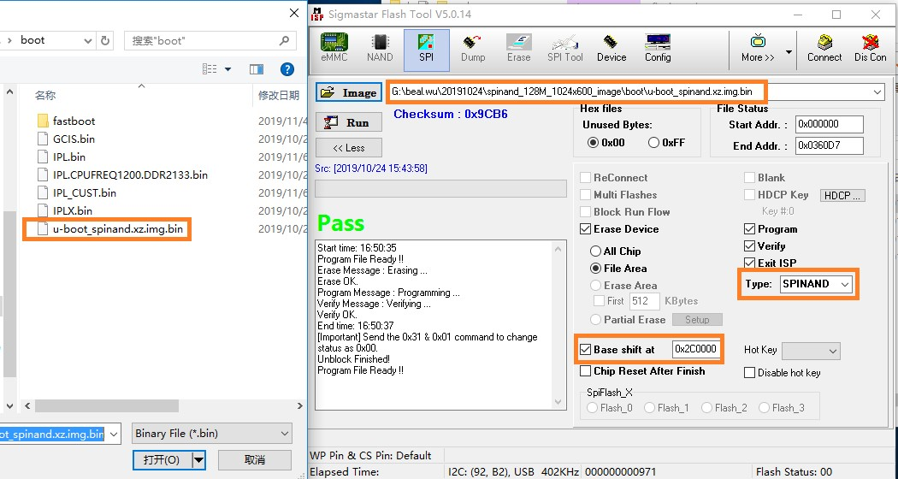 Figure 20

Step 9: Restart the board

2.1.1.5. Image Burning Method

After using the Flash tool to burn uboot, there are three ways to burn the image file, which can be burned through USB, SD card, and network. Different chips support different programming methods, and the focus here is on network programming, which is also the most common programming method for software development. For detailed methods of USB and SD card burning, consult SigmaStar software engineers.

To use network flashing, you need to prepare A PC, switch, development board, and the network topology is as follows:



PC



switchboard



Development board

Cable

Cable

clause

One

step

：

ensure

Internet

connect

normal

，

Set up

exploitation

board

IP

address

and

server

IP

address

，

And then

protect

exist

environment

variable

。

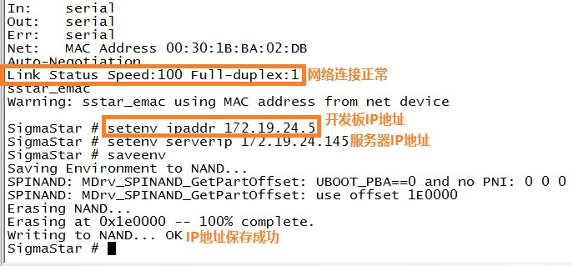

Figure 21

Step 2: Use the TFTP software to specify the burning path of Image and ensure that the server IP address is configured correctly, as shown in Figure 22 below, on the board

Serverip is 172.19.24.149

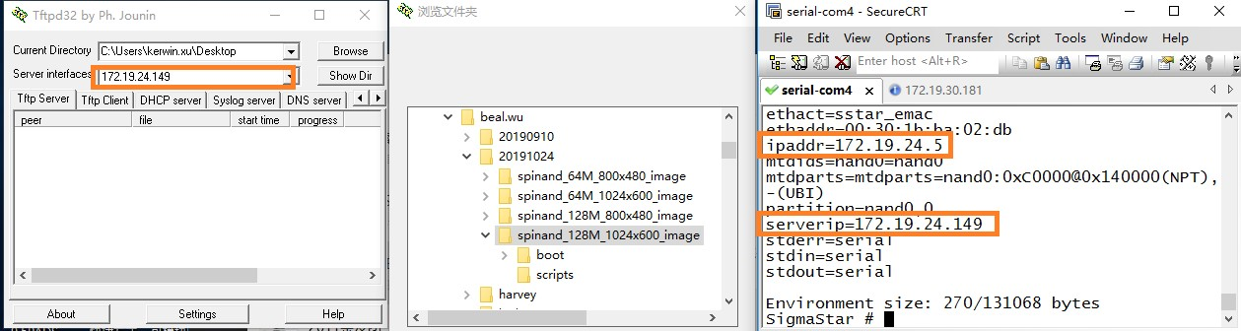 Figure 22

Step 3: Enter the "estar" command to burn normally.

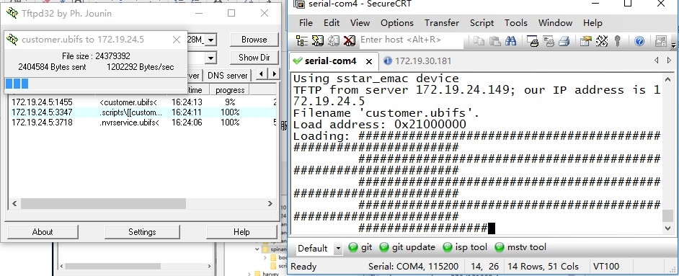 Figure 23

2.1.1.6. How to Erase Flash

Sometimes there are programs in flash that need to be erased using the Flash tool software tool. As below screenshot shown, select the correct Flash type, then select "All Chip" and specify a GCIS.bin file, click "Run" button to erase Flash.

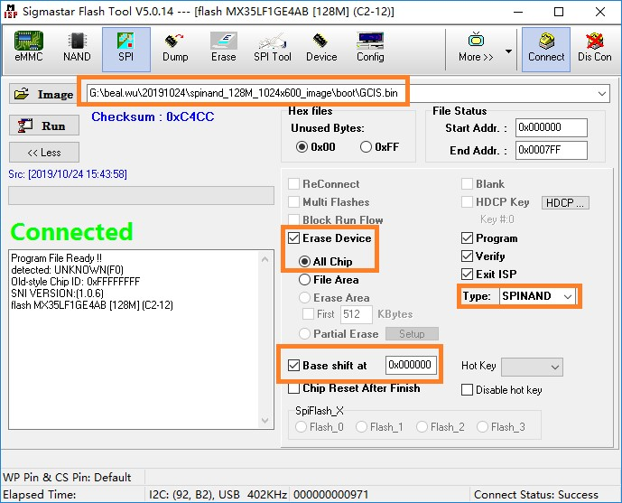

Figure 24

2.2. Sstar Flash Tool burn error

2.2.1.1. Hardware connection error Using the hardware tool Debug tool and chip connection, you need to pay attention to the wiring order of the serial port, SigmaStar chip debugging serial pin is

PM_UART_RX/PM_UART_TX, the interface order is NC GND RX TX, note the Debug Tool PCBA silk screen naming, the connection method is RX to RX, TX to connect TX, GND is connected to GND.

2.2.1.2. Serial Port Tool Selects Wrong Empty Chip Burning Without Using the Debug Tool Hardware Tool, but Using ordinary Serial Port Tools, as shown in Figure 25. SigmaStar chip debugging serial port has an I2C function inside, when programming access registers, it is to use the I2C function, ordinary serial print tools do not have this function, so you need to use the hardware tools mentioned in Figure 1 above.

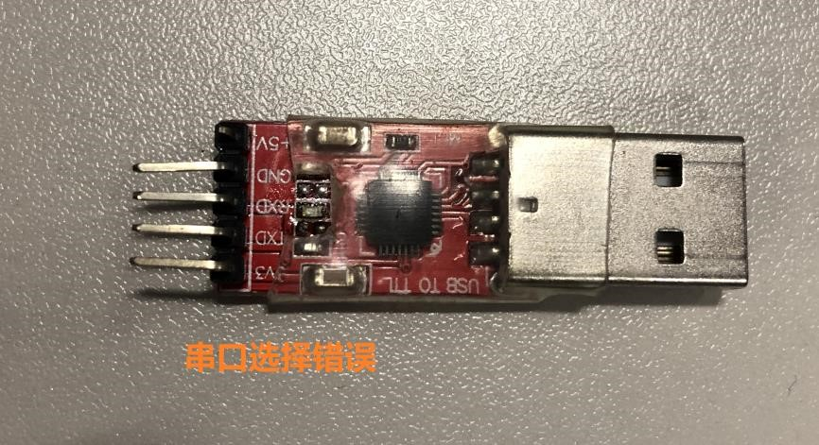 Figure 25

2.2.1.3. Flash Type Selection Error During spinand burning, the corresponding Flash type was not selected, such as flashing SPINAND, and SPINOR was selected. As shown in the following figure, selecting the wrong Flash type, the chip shows connected, but the connection is not successful.

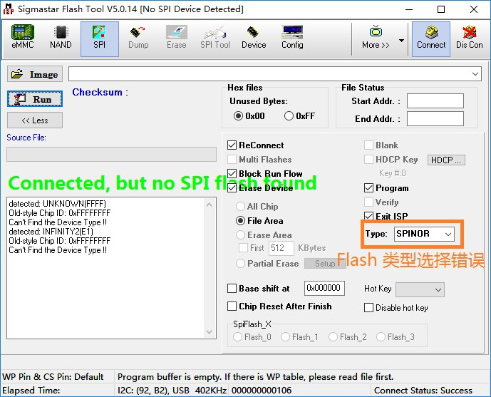 Figure 26

2.2.1.4. The Flash tool file is missing

The Flash type was selected correctly, as shown in the following figure, but the SPINAND model is still not found, it may be missing files

SPINANDINFO.sni, which contains spinand manufacturers, IDs and other information

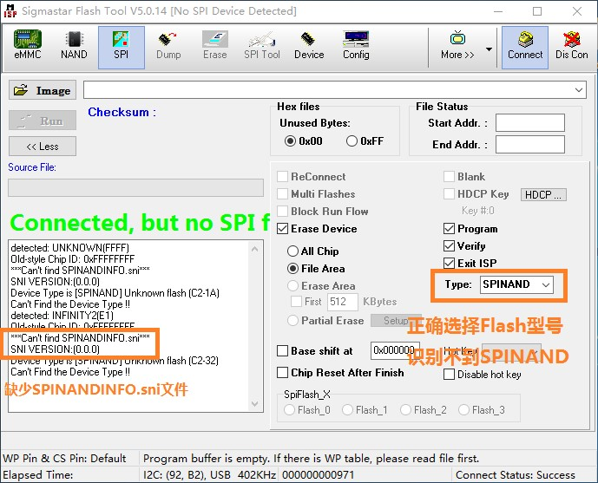 Figure 27

2.2.1.5. Serial terminal is not closed When the Flash tool software is opened, the computer's serial terminal software is not closed, resulting in the Flash tool not recognizing Flash.

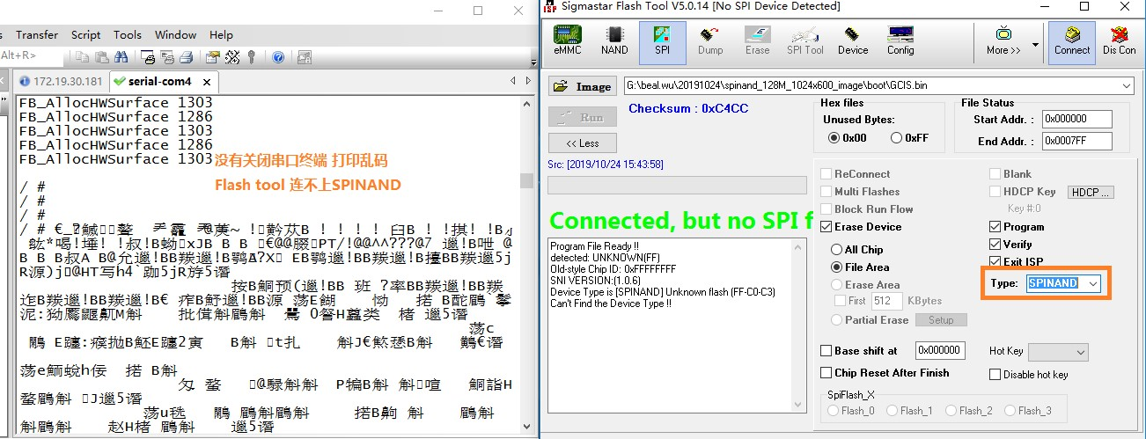

Figure 28