MS team/Skype integration with RB

Table of Contents

Document Update History 2

Introduction 2

Current integration status 2

Objective 2

Future goals 2

User stories 2

Data flow 3

Bot API design 3

post /notify/{conversationId} 3

Path parameters 3

Payload 4

Responses 4

Plans 4

Assumptions 4

Phase 1: Feature exploration 4

Phase 2: Technical exploration 4

Phase 3: Design and implementation 4

Expectations 4

Project update 1 - 27 November 2016 5

Old planning update 5

Phase 1: Feature exploration 5

Phase 2: Technical exploration 5

Phase 3: Design and implementation 5

New planning 5

Phase 1: Feature exploration and feature design 5

Phase 2: Implementation 5

Project update 2 - 4 December 2016 6

Old planning update 6

Phase 1: Feature exploration and feature design 6

Phase 2: Implementation 6

New background information 7

New planning 7

Phase 2: Publish independent integration 7

Phase 3: Add FB integration 7

# Document Update History

|  |  |  |
| --- | --- | --- |
| Date | Author | Changes |
| 11/08/2016 | g2minhle | Document started. |
| 11/27/2016 | g2minhle | + Update original end date due calculation mistake  + Update progress  + Add new plan |
| 11/28/2016 | g2minhle | + Add user stories  + Update document layout (add new and old plan into update 1)  + Add dataflow  + Add API design |
| 12/05/2016 | g2minhle | + Update document layout (add new and old plan into update 2, move design stuff after intro)  + Add update 2 |

# Introduction

ReviewBoard (RB) is a 10 years old open source code review tools. It is an industrial grade tool that is being used by large organization like VMWare, Mozilla, Amazon etc. Skype is a well-known video, chat communication tool. Microsoft Team (MST) is the new collaboration tool (released in October 2016) created as a competitor to Slack (a chat based collaboration tool).MST is a newly release software so it lacks a lot of 3rd-party features, including RB integration with RB. Developer access is also quite limited with MST, so instead direct integration with MST we make a bot for Skype which can also be used for MST.

## Current integration status

Currently, RB only has Slack integration and RB team is building HipChat integration.

Integration code can be found at <https://github.com/reviewboard/rbintegrations/tree/master/rbintegrations/slack>

## Objective

Our goal is to reach parity (similar feature) with Slack integration for MST/Skype integration

## Future goals

In RB 3.0 there will be extra support from RB core team to integrate with other services. Given that, we are only few doing integration, it is likely that we can work on more integrations.

# User stories

* User instantiate conversation with Bot, then bot will give out a unique link for the conversation
* User add a new integration on RB, input name, filters, and the unique link to the Bot
* User makes changes on RB, RB send payload to Bot, Bot notify user
* User remove integration on RB and leave conversation
* User get removed by Skype admin if no longer belong to team

# Data flow

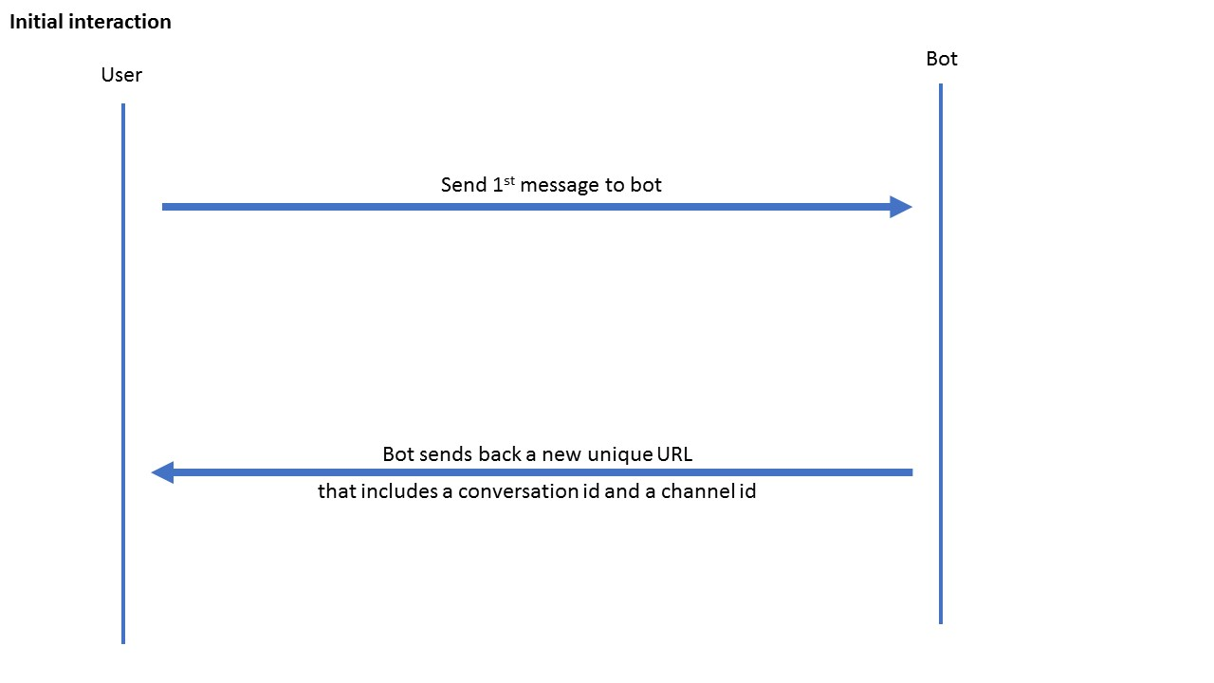

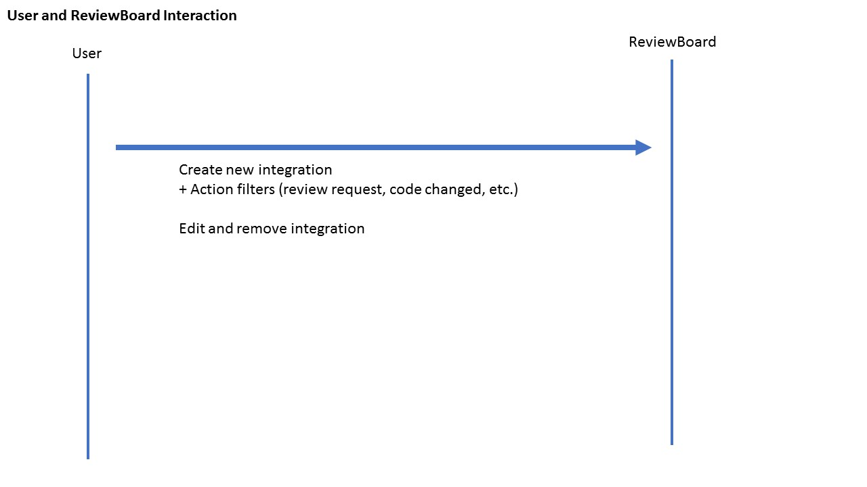

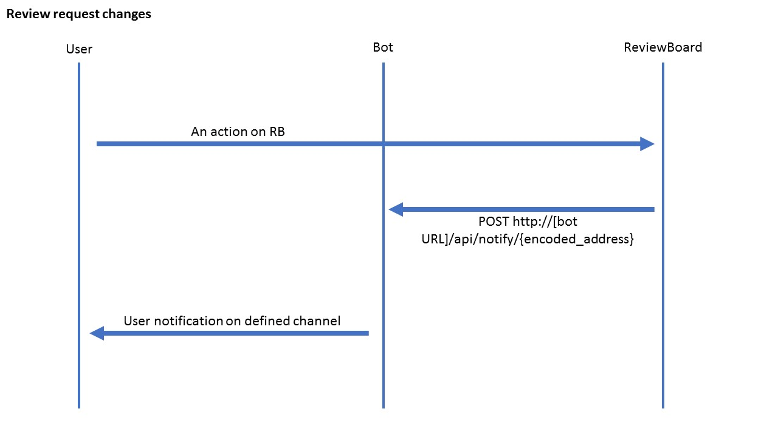

# Bot API design

## post /notify/{encoded_address}

Notify Bot to send out notification

### Path parameters

Encoded_address (required)

### Payload

TBD

### Responses

200

Message received

404

If there is no conversation with given encoded_address

500

Server Internal Error.

# Plans

## Assumptions

We are expecting **8 hours/day**, **5-day work week**. However, extra hours are always welcome.

**Work week:** 5 week – 25 days

**Buffering:** 1 week – 5 days

**Total time:** 6 week – 30 days

**Expected start date:** November 14, 2016

**Expected end date:** December ~~16~~23, 2016

## Phase 1: Feature exploration

|  |  |
| --- | --- |
| Setup environment | 1 day |
| Install RB with slack integration to see features | 1.5 days |
| Feature listing | 0.5 day |
| Total | 3 days |

## Phase 2: Technical exploration

|  |  |
| --- | --- |
| Setup bot development environment | 1 day |
| Create a sample bot to interact with | 3 days |
| Go through and understand the Slack code  Try to copy a diff extension and play around with it | 5 days |
| Total | 9 days |

## Phase 3: Design and implementation

|  |  |
| --- | --- |
| Design | 1 day |
| Implement | 12 days |
| Total | 13 days |

## Expectations

Daily stand up at 1:30pm EST (10:30 pm PDT) for 5 mins to update on work

# Project update 1 - 27 November 2016

## Old planning update

### Phase 1: Feature exploration

|  |  |
| --- | --- |
| ~~Setup environment~~ | ~~1 day~~ 5 days |
| ~~Install RB with slack integration to see features~~ | ~~1.5 days~~ 0.5 day |
| Feature listing | 0.5 day unknow status |
| Total | ~~3 days~~ 0.5 |

### Phase 2: Technical exploration

|  |  |
| --- | --- |
| ~~Setup bot development environment~~ | ~~1 day~~ 1 day |
| ~~Create a sample bot to interact with~~ | ~~3 days~~ 3 days |
| Go through and understand the Slack code  Try to copy a diff extension and play around with it | 5 days |
| Total | ~~9 days~~ 5 days |

### Phase 3: Design and implementation

|  |  |
| --- | --- |
| Design | 1 day 0.5 in progress |
| Implement | 12 days |
| Total | 13 days |

**Old estimated time**: 18.5 = 19 days – 4 weeks

**Expected end date:** December 23, 2016

## New planning

### Phase 1: Feature exploration and feature design

|  |  |
| --- | --- |
| Feature listing  - Create a list of all user stories (sample: User fill in Name, Webhooks, and add proper filtering and save the form etc, word document is fine) | 0.2 day |
| Design  - Draw out all the component and how data will flow with user in the pictures (example, dataflow in <https://g2minhlesdejournal.wordpress.com/2016/11/22/bing-data-cleaner-my-zero-cost-stack-a-way-for-beginners-to-bootstrap-their-portfolio/>, powerpoint)  - Indicate the contract, what api, what endpoint (similar to this <https://g2minhle.github.io/BingDataCleanerAPIDesign.html>, word document is fine) | 0.2 |
| Create new account on <https://reviews.reviewboard.org/account/login/>  Please be professional | 0.2 |
| Total | < 1 day – expected to be done by 10a PDT |

### Phase 2: Implementation

|  |  |
| --- | --- |
| Deploy a do-nothing bot to Azure with the name ReviewBoardBot  - Push to github  - Make private repo  - Add g2minhe  - For bot we will use pull request model | 2 days |
| Create a bot that follow the designed API | 2 days |
| Create a new integration in RB integration that do nothing with a form for user input  - We will user RB code review model | 2 days |
| Start to implement the rest on ReviewBoard **with proper tests** | 5 days ☺ |
| Total | **11 Days** |

**New estimated time**: 12 days – 3 weeks + 1 week buffer

**Expected end date:** December 23, 2016

# Project update 2 - 4 December 2016

## Old planning update

### Phase 1: Feature exploration and feature design

|  |  |
| --- | --- |
| ~~Feature listing~~  ~~- Create a list of all user stories (sample: User fill in Name, Webhooks, and add proper filtering and save the form etc, word document is fine)~~ | ~~0.2 day~~ |
| ~~Design~~  ~~- Draw out all the component and how data will flow with user in the pictures (example, dataflow in~~ [~~https://g2minhlesdejournal.wordpress.com/2016/11/22/bing-data-cleaner-my-zero-cost-stack-a-way-for-beginners-to-bootstrap-their-portfolio/~~](https://g2minhlesdejournal.wordpress.com/2016/11/22/bing-data-cleaner-my-zero-cost-stack-a-way-for-beginners-to-bootstrap-their-portfolio/)~~, powerpoint)~~  ~~- Indicate the contract, what api, what endpoint (similar to this~~ [~~https://g2minhle.github.io/BingDataCleanerAPIDesign.html~~](https://g2minhle.github.io/BingDataCleanerAPIDesign.html)~~, word document is fine)~~ | ~~0.2~~ |
| ~~Create new account on~~ [~~https://reviews.reviewboard.org/account/login/~~](https://reviews.reviewboard.org/account/login/)  ~~Please be professional~~ | ~~0.2~~ |
| ~~Total~~ | ~~< 1 day – expected to be done by 10a PDT~~ <1 day |

### Phase 2: Implementation

|  |  |
| --- | --- |
| ~~Deploy a do-nothing bot to Azure with the name ReviewBoardBot~~  ~~- Push to github~~  ~~- Make private repo~~  ~~- Add g2minhe~~  ~~- For bot we will use pull request model~~ | ~~2 days~~ 1 day |
| ~~Create a bot that follow the designed API~~ | ~~2 days~~ 1 day |
| ~~Create a new integration in RB integration that do nothing with a form for user input~~  ~~- We will user RB code review model~~ | ~~2 days~~ 1 day |
| Start to implement the rest on ReviewBoard **with proper tests** | 5 days ☺ in progress |

**Old estimated time**: 12 days – 3 weeks + 1 week buffer

**Old end date:** December 23, 2016

## New background information

ReviewBoard team does not very happy with the fact that there is a dependency on external service (the bot service). The consequence is we cannot merge this current architecture into the RB code base. Hence, there is a new direction for the project so that we can still have the flexibility from MS Bot framework and being a ReviewBoard contributor. In short, we will divide the work into 2 part: publish and maintain our own integration, build at least 1 integration to RB using Webhook – for now, FB messenger is the target

## New planning

### Phase 2: Publish independent integration

|  |  |
| --- | --- |
| Update comment on the current code base | 0.5 days |
| Create a new integration project on github and copy over work from current integration | 0.5 days |
| Figure out how to run tests and  fix test accordingly on new integration | 2 days |
| Add note to ReviewBoard bot that this is an independent project and this is a free and limited version, add link to github and how ppl can deploy their own server + integration | 1 day |
| Resume updating | 0.2 day |
| Summarize lesson learned | 0.2 day |
| **Total** | < 5 days |

### Phase 3: Add FB integration

|  |  |
| --- | --- |
| Find out the Webhook model on Facebook | 1 days |
| Implement on RB side | 4 days |
| **Total** | 5 days |

**New estimated time**: 10 days – 2 weeks + 1 week buffer

**Expected end date:** December 23, 2016