**UNIVERSITY OF WATERLOO**

Faculty of Mathematics

**The importance of Continuous Integration (CI) and practical guide to overcome challenges when implementing CI**

Flynn Inc.,

Mississauga, Ontario

Phat Tran

20619470

2A Mathematics

August 2017

**MEMORANDUM**

To: Alan Zych

From: Phat Tran

Date: December 16, 2016

Re: Work Report: The importance of Continuous Integration (CI) and practical guide to overcome challenges when implementing CI

Dear Alan,

I have prepared the enclosed report “The importance of Continuous Integration (CI) and practical guide to overcome challenges when implementing CI” for my 2A work report and for the Development Team. This report is part of the four required reports that I need to complete as part of my Bachelor of Computer Science Co-op degree requirements. It has not received an academic credit.

During my co-op term, my job is to develop custom web/mobile applications for the Development Team at Flynn. I also manage and improve test suites for web/mobile applications developed for Flynn.

The Faculty of Mathematics requests that you evaluate this report for command of topic and technical content/analysis. Following your assessment, the report, together with your evaluation, will be submitted to the Math Undergrad Office for evaluation on campus by qualified work report markers. The combined marks determine whether the report will receive credit and whether it will be considered for an award.

Thank you for your assistance in making this report.

*Phat Tran*

*(signature)*

Table of Contents

List of Figures 3

Executive summary 4

Introduction 5

Analysis 6

What is Continuous Integration (CI)? 6

Pros and cons of CI 8

Overcome common challenges 10

Conclusion 11

References 13

# **List of Figures**

Figure 1 - The Typical Open Office 6

Figure 2 - The World's Largest Open Office 7

Figure 3 - Mark Zuckerberg at his Workstation 7

Figure 4 - Camis Headquarter 7

# **Executive summary**

This report attempts to analyze the overall effect of practicing continuous integration by considering its advantages and its disadvantages. In the last section of the analysis, it shows the possible strategies to overcome the common obstacles to maximize the benefits of this infrastructure.

# **Introduction**

With recent advancement in technology, people’s lives have been improved drastically. People spends more time than ever on various social media platforms like Facebook, Instagram and consumes many technology-required services like Amazon and Uber. Billions of customers across the world that are served daily; thus, maintaining high service’s uptime is one of the most important concern of these tech giants. On another note, due to the advancement of technology, the entry barrier is extremely low so the market is highly competitive. Therefore, a strategy needs to be formed to improve product faster without compromising the availability to gain the advantage over other competitors.

In this report, we will analyze the pros and cons of CI and ways to overcome common roadblocks when setting up such infrastructure. Therefore, it is assumed that readers have a basic understanding of typical tech product development and deployment process though general definition of such process will be given, and comparison will be made against the given example.

# **Analysis**

## What is Continuous Integration (CI)?

### Introduction to CI

This concept was carried out in the 1950s by a team in Hamburg, Germany (Faustman, 2013). According to Matt, (2013) the main rationality behind an open concept office is to “facilitate communication and the flow of ideas”. In the recent years, many technology companies have been taking advantage of this concept. Facebook and Square are two of many examples that apply this idea to their headquarters (Newport, 2016). Lesser known software companies such as Camis Inc. located in Guelph, Ontario also have an open-office headquarter, but in a slightly different variation.

### Implementation of CI

When one mention “open-office plan”, it is typical for one to imagine such application to resemble this:

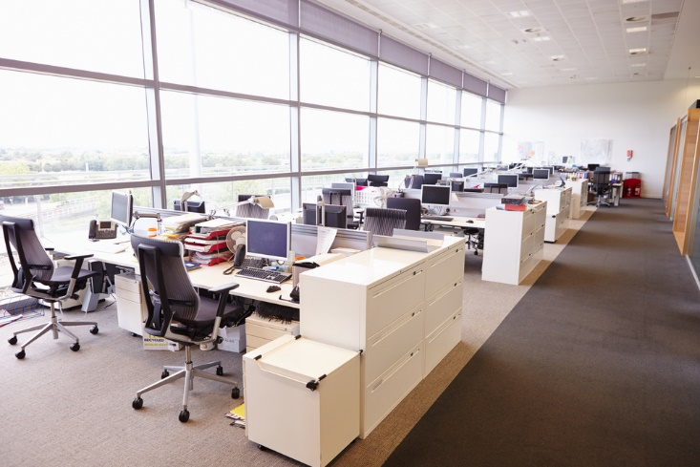

Figure - The Typical Open Office

There are many other variations. Some are more open:

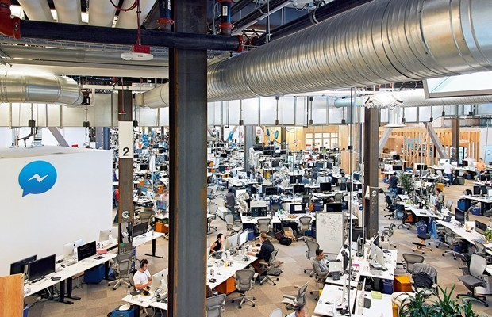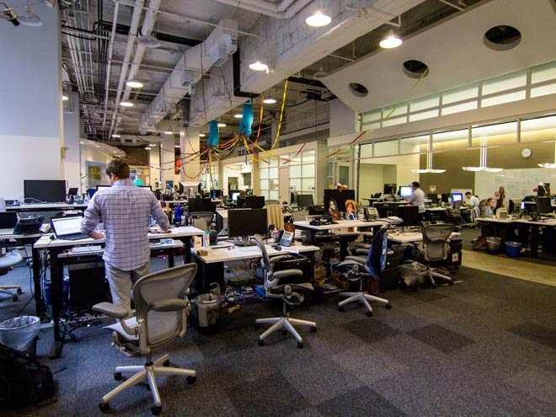

Figure - The World's Largest Open Office

Figure - Mark Zuckerberg at his Workstation

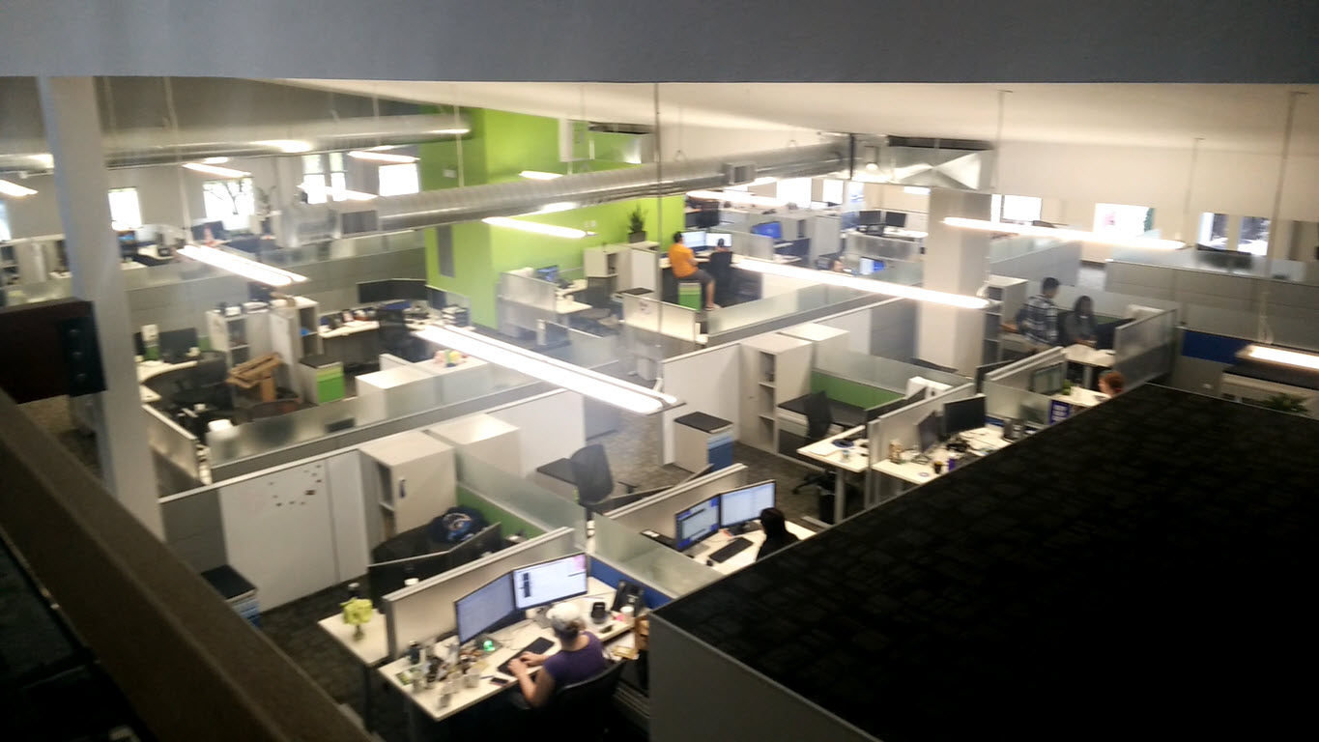While others are more traditional and have some more privacy between workspaces:

## 

Figure - Camis Headquarter

## Pros and cons of CI

### advantages

The main and most important reason why company consider implementing an open-office plan is to encourage serendipitous interaction among workers. Not only would it greatly expedite communication process between employees, the fact that it is so easy to talk to your teammates also improves team chemistry. Hence, it would improve teams’ productivities and even potentially foster new innovative ideas.

The second important benefit of open design is that it provides an invisible accountability in the work environment, since everyone can walk by and see one’s work without a moment notice. This would inadvertently keep employees from working on personal matter using the company’s resource. Therefore, the office layout saves company’s resource in the long run.

Finally, speaking of saving resource, having no walls in between offices can greatly reduce the cost of building an office. Even though this might not be a significant benefit to enormous corporations, it’s impact is quite profound on smaller businesses. This extra savings in resource could be reallocated and used elsewhere to further grow the company.

### disadvantages

Due to the nature of open office, the noise level can vary and become incontrollable for everyone. Because of that, open-office floorplan can be extremely distracting for one to focus. According to Maria (2014), it is “damaging to the workers’ attention spans”, thus, lowering workers’ concentrating ability and motivation.

Besides damaging the focus ability of office workers, the transparency of the office also creates a subtle pressure of being watched constantly. As mentioned above, it forces employees to focus on work-related tasks. The pressure, however, also raises one’s epinephrine level which causes their anxiety level to increase as well (Ramsay, 2015). Needless to say, no one can achieve their maximum potential if too much stress is introduced into their workflow. This is especially true as these external factors cannot be controlled within an open office.

Lastly, open office kills privacy, and “privacy allows for more creativity, where someone is more likely to achieve a state of flow” (Ramsay, 2015). In fact, Adam Grant, an elite professor at Wharton who produces at an incredible level, chooses to isolate himself from social interaction to focus on his research. During these periods, he goes as far as putting “an out-of-office auto-responder on his email so correspondents will know not to expect a response.” (Newport, 2016) It is certain that he wouldn’t be able to achieve what he did achieve if he worked in an open office research center.

### overall effect

Even though on paper, it sounds quite logical to implement an open floor office, reality shows otherwise. With thousands of researches and studies on the effect of having a no-walls office on satisfaction, attention span, productivity, and many other important metrics of workers, it is clear that having no boundaries between cubicles can be quite detrimental to the business in the long run despite its advertised short term advantages. However, if a company still decides to carry on with its current open office plan due to financial or time constraint, one can configure his/her work habits using a couple strategies. The purpose of these techniques is to overcome the negative effect of an open office without losing much of its upside such as spontaneity in communication.

## Overcome common challenges

### implement a daily undistracted work hours

In the discussion, the worst side effect of no-walls cubicles is the uncontrollable noise level. Another type of distraction can come from instant messaging and emails from coworkers. Generally, these two issues can be simply resolved by one wearing an earphones or other similar devices having an auto-responder email that states your current undistracted working hours. This ensure that your colleagues acknowledge your work schedule and lower their expectation. Your undistracted block, for example, can be a three-hour block in the morning from eight to eleven or it could be the first 45 minutes of every hour. The time template is different for every role. Management roles tend to have more in meetings while others do not have any at all such as contractors. Unless your job isn’t involved producing valuable, energy-intensive tasks, anyone can benefit from this work regime.

This could be quite difficult to pull off in the beginning especially if you don’t have a proven productive track record. Not everyone buys into the ideas and values of undisrupted work. It takes time for the majority to understand the importance of deep work in order to execute this strategy. However, if one manages to incorporate this tactic into his/her workflow, his productivity can surpass the majority of knowledge workers nowadays.

### pack all communication in one block of time

This method is the complement of the strategy above. When one has put in his daily amount of undisrupted work hours, he can now handle all communication tasks without building up excessive attention residue from jumping back and forth between work and peer interaction (Basu, 2016). If one’s job consists of an enormous amount of communications, it is also possible to insert them in between deep work sessions. For instance, taking the example above, say if the undisrupted work is the first 45 minutes of every hour, the last 15 minutes can be for responding to relatively urgent requests.

The important thing here is not the amount of time spent focusing on deep work, but rather the habitual cycle of working intensely on cognitively challenged tasks followed by low-intensity, low-effort activities. This is the ideal condition and the general goal is to convert all your working time into these small hard work-easy work cycles. It’s an ambitious goal, and the nature of working in an open office makes this goal seems impossible. With that being said, there is a last technique to deal with these unexpected stimuli.

### give way to distraction

This last method is to deal with unexpected interruption from boss and colleagues. Before jumping into the task with them, one should be able to identify the urgency of the tasks they assign. If it’s not as urgent, ignore it until the next easy-work block. If it is super important and has to be dealt with in a timely manner, one should stop whatever he/she is working on and immediately start this newly-assigned task immediately. However, pretend that this is a low-cognitive task and treat one’s current time block as an easy-half of the cycle. The key thing here is to ensure there is a distinction between energy consuming and low-level activities.

# **Conclusion**

In conclusion, despite many advertised benefits of open-concept office, it carries many productivity downsides. However, there are many tactics that one can deploy to fully take advantage of open office concept but still maintain one’s productivity. Thus, as an employee, it is important for one to equip the proper knowledge and work habits to excel in the workplace regardless of the work environment.

# **References**

Faustman, M. (2013). How Open Office Designs Went Too Far and Killed Business Productivity [Blog post]. Retrieved from https://www.upcounsel.com/blog/how-open-office-designs-went-too-far-and-killed-business-productivity

Beaudoin, L. (2016, September 26). To boost productivity and cognition in the Knowledge Age, prioritize Deep work, avoid the Shallows, and Self-Quantify [Blog post]. Retrieved from http://sharpbrains.com/blog/2016/09/26/to-boost-productivity-and-cognition-in-the-knowledge-age-prioritize-deep-work-avoid-the-shallows-and-self-quantify/

Konnikova, M. (2014, January 7). The Open-Office Trap [Blog post]. Retrieved from http://www.newyorker.com/business/currency/the-open-office-trap

Ramsay, D. (2015, June 4). Open Office Plans: The Advantages, Disadvantages, and Research [Blog post]. Retrieved from http://www.adventureassoc.com/open-office-plans-the-advantages-disadvantages-and-research/

Newport, C. (2016). Deep Work: Rules for Focused Success in a Distracted World. New York, NY: Grand Central Publishing

Basu, T. (2016, January 21). Something Called ‘Attention Residue’ Is Ruining Your Concentration [Blog post]. Retrieved from http://nymag.com/scienceofus/2016/01/attention-residue-is-ruining-your-concentration.html