Class 6

Paige Dubelko

January 24, 2019

### Section 1: Reading files

We are using the **read.table()** funtion and friends to read some example flat files.

read.csv("test1.txt")

## Col1 Col2 Col3  
## 1 1 2 3  
## 2 4 5 6  
## 3 7 8 9  
## 4 a b c

For the test1 file, we are able to use read.table(), but because we notice it is separated by “,” and appears to have a header, the **read.csv** is a simpler option.

We will now look at our **second** text file… We see that this file is separated by ‘$’ and has a header.

read.table("test2.txt", header = TRUE, sep = "$")

## Col1 Col2 Col3  
## 1 1 2 3  
## 2 4 5 6  
## 3 7 8 9  
## 4 a b c

Because we do not have a friend function that separates by “$” it is easy to edit table to specify it for this file.

Now onto the **third** file. We notice that the data is separated by what looks like spaces and does not have a header. So we just use the **read.table()** function.

read.table("test3.txt")

## V1 V2 V3  
## 1 1 6 a  
## 2 2 7 b  
## 3 3 8 c  
## 4 4 9 d  
## 5 5 10 e

### Section 2: R Functions

Lets write a simple function, add()…

add <- function(x,y=1){  
 #Sum the input x and y  
 x + y  
}

Now lets try add()!

x <- 7  
y <- 3  
add(7,3)

## [1] 10

We are also able to use our add function with vectors :) Remember: the y variable is optional.

add(c(1,2,3))

## [1] 2 3 4

If you find yourself doing the same thing three or more times, it might be time to think about writing a function.

**2nd Function: Rescale**

rescale <- function(x){  
 rng <- range(x)  
 (x - rng[1]) / (rng[2] - rng[1])  
}

Lets test on a small example, where we know what the answer should be

rescale(1:10)

## [1] 0.0000000 0.1111111 0.2222222 0.3333333 0.4444444 0.5555556 0.6666667  
## [8] 0.7777778 0.8888889 1.0000000

With how it is currently written, our rescale function will not take NA values, so we must change it.

rescale2 <- function(x){  
 rng <- range(x, na.rm = TRUE)  
 (x - rng[1]) / (rng[2] - rng[1])  
}

This will now work for vectors containing NA values because we set **na.rm** equal to TRUE

x <- c(1,2,NA,3,10)  
rescale2(x)

## [1] 0.0000000 0.1111111 NA 0.2222222 1.0000000

Lets edit this function one more time.

rescale3 <- function(x, na.rm = TRUE, plot = FALSE){  
 rng <- range(x, na.rm = na.rm)  
 print("Hello")  
   
 answer <- (x - rng[1]) / (rng[2] - rng[1])  
   
 print("is it me you are looking for?")  
   
 if(plot){  
 plot(answer, typ = "b", lwd = 4)  
 }  
 print("I can see it in ...")  
 return(answer)  
}

Lets try it!

rescale3(c(1:6), plot = TRUE)

## [1] "Hello"  
## [1] "is it me you are looking for?"

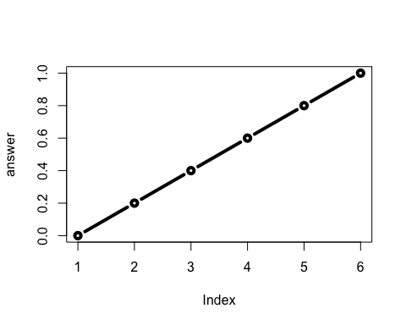

## [1] "I can see it in ..."

## [1] 0.0 0.2 0.4 0.6 0.8 1.0