Hands on Assessment: Graphs

Paige Dubelko

January 22, 2019

#Whisker plot  
x <- rnorm(1000,0)  
boxplot(x)

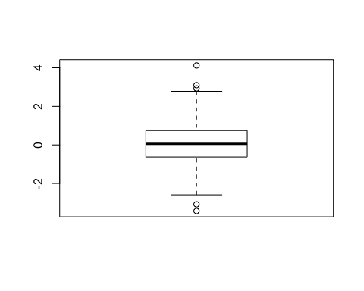

# Age vs Weight - offset graph  
weight <- read.table("bimm143_05_rstats/weight_chart.txt", header = TRUE)  
plot(weight, type = "o", pch = 15, cex = 1.5, lwd = 2, ylim = c(2,10),  
 xlab = "Age (months)", ylab = "Weight (kg)",  
 main = "Baby Weight with Age")

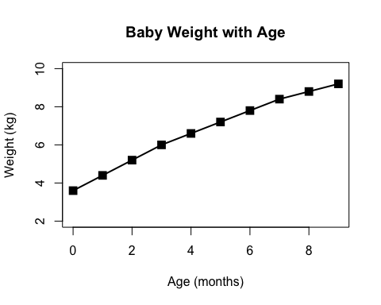

#Bar Graph  
mouse <- read.table("bimm143_05_rstats/feature_counts.txt", header = TRUE,  
 sep = "\t")  
par(mar = c(2.5,11,2,2))  
barplot(mouse$Count, main = "Mouse Genes", horiz = TRUE,  
 xlab = "Count", names.arg = mouse$Feature, las = 1,  
 col = rainbow(nrow(mouse)))

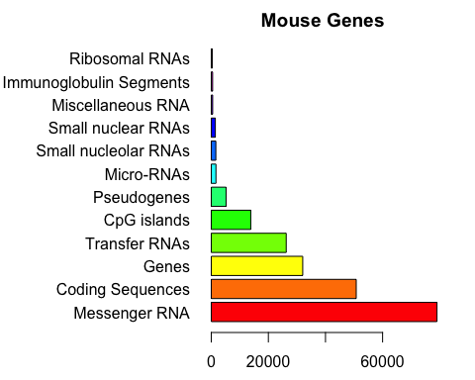

#Histrogram  
x <- c(rnorm(10000), rnorm(10000) + 4)  
hist(x, breaks = 10)

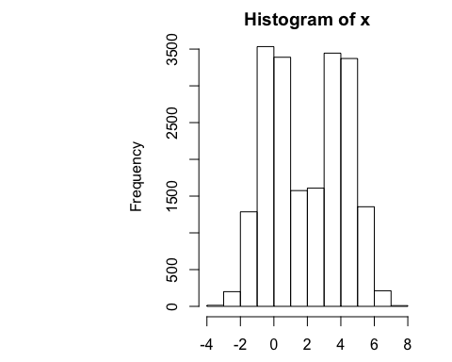

#male_female_counts.txt  
gender <- read.table("bimm143_05_rstats/male_female_counts.txt", header = TRUE,  
 sep = "\t")  
par(mar = c(5.1,5,5,2.1))  
barplot(gender$Count, col = c("blue", "pink"), main = "Gender Count",  
 names.arg = gender$Sample, ylim = c(0,20), las = 2)

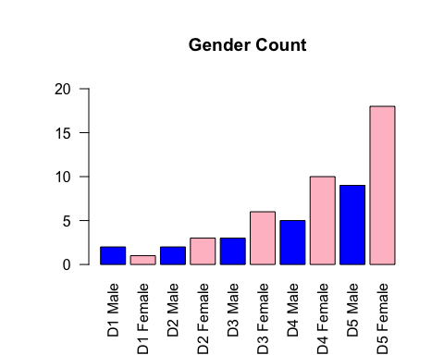

#up_down_expression.txt  
genes <- read.delim("bimm143_05_rstats/up_down_expression.txt")  
palette(c("blue", "grey", "magenta"))  
par(mar = c(5.1,5,5,2.1))  
plot(genes$Condition1, genes$Condition2, col = genes$State, xlab = "Expression Condition 1",  
 ylab = "Expression Condition 2", main = "Expression Levels")

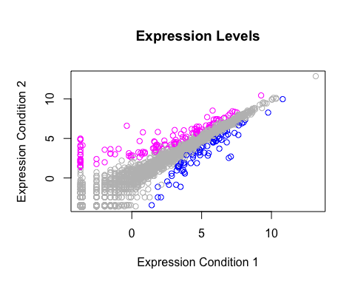

#meth  
meth <- read.delim("bimm143_05_rstats/expression_methylation.txt")  
index <- meth$expression > 0  
color <- densCols(meth$gene.meth[index], meth$expression[index],  
 colramp = colorRampPalette(c("blue", "green", "red", "yellow")))  
plot(meth$gene.meth[index], meth$expression[index], xlab = "Gene", ylab = "Expression",  
 col = color, pch = 20, main = "Gene Expression")

