Case Study 3 : Social Recommendation
Ratings, Trust & Performance Evaluation

Author : Paula Dwan
Email : paula.dwan@gmail.com
Student ID : 13208660
Course : MSc Advanced Software Engineering
Module : COMP-47270 Computational Network Analysis and Modelling
Lecturer : Dr. Neil Hurley
Email : neil.hurley@ucd.ie
Due Date : 11 May 2015


Table of Contents
1 Case Study Requirements 3
1.1 Case Study Requirements 3
1.2 Understanding of Requirements from Class Discussions 3
2 Introduction 3
2.1 Social Recommendation 3
2.2 Datasets Used 3
2.3 How Recommendations Work? 3
2.3.1 Ratings : Collaborative Filtering 4
2.3.2 Ratings : Collaborative Filtering 4
2.3.3 Trust : Page-Rank (Google) 5
2.3.4 Trust : Simple Mapping – User [i] Trusts User [j]? 5
3 Social Recommendation Applied 5
3.1 Ratings – collaborative Filtering – Simple 5
3.1.1 Components – Simple 5
3.1.2 How Calculated – Simple? 6
3.2 Ratings : Collaborative Filtering – Top-N 6
3.2.1 Components – Top-N 6
3.2.2 How Calculated – Top-N? 6
3.2.3 Issues with code 6
3.3 Trust – Simple Association 6
3.3.1 Components – Trust 6
3.3.2 How Calculated – Trust? 7
4 Overall Results Comparison 7
5 Conclusions 7
6 References / Acknowledgements 8
6.1 References – Networks Datasets 8
6.1.1 Acknowledgements – Datasets 8
6.1.2 Statistics – Datasets 8
6.2 Citations / Acknowledgements 9

Case Study Requirements

Case Study Requirements
Devise and evaluate an algorithm that combines ratings data and trust data to make a recommendation.
Epinions data is provided (... other data can be downloaded from the web).
- Compare your algorithm with and without the trust data?
- Does the trust data data improve the recommendation?

Understanding of Requirements from Class Discussions
- Use the Collaborative Filtering algorithm as covered in class with any updates made as Rating recommendation algorithm.
- Device another for Trust Ratings.
- Evaluate the results.
- Provide suggestions / conclusions.

Introduction

Social Recommendation
To start, what is Social Recommendation?
In real-life, the equivalent is personal recommendations from friends, colleagues and family on such items as whether or not to try a new restaurant, what hotel to use if visiting an area visited previously by someone known to the individual, what school to send a child to, what book to read next, if the latest block-buster film is worth seeing in cinema or should one wait on the DVD.
In social networks, social recommendation is using personal information on the user (publicly available or harvested by the social network) to provide a unique and personalized recommendation to the user. There is a wealth of information available on anyone with a social media / web presence (email, purchasing history, browser history, facebook, twitter, instagram, blogs, newspaper comments on articles, queries / answers on professional sites). This data may be mined and learned from to provide strong, detailed recommendation to the user.

Datasets Used
Each of the directed graphs chosen deal with Social media and vary in the number of nodes present. For more information on each, please see the section : References – Datasets

How Recommendations Work?
Recommendations are usually created by :
Collaborative Filtering | Collects and analyse a large amount of user information covering common user behaviours and on-line activities.  Predicts what users will then prefer using similarity to other users.
Content Based Filtering | Uses the item description and users known preferences to suggest other items the user would like.  So if a user liked item x previously and item is similar to item y then the user will also probably like item y.
Recommendations are usually improved by adding Trust. Existing user rate other users on a pre-agreed scale indicating level of trust he/she has in other users. If user 1 trusts user 2 and user 3 also trusts user 2, then user 1 may also trust the recommendations of user 2.
There are many ways of doing this including :
Local Trust | Use the personal views of the users to predict different trust values in all other users. Examples include : MoleTrust (Paolo Massa et al, 2007) and TidalTrust (Jennifer Ann Golbeck, 2005).
Global Trust | Global reputation value for each user is used. Basically, an average rating for each user based on how the entire community views that user. Examples include : PageRank (Google) and Eigentrust ().
Performance results are evaluated using :
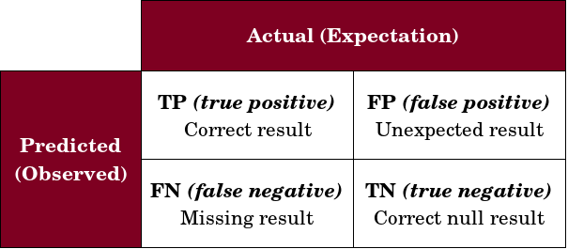 | Recall  Fraction of the recommended set that includes relevant items.  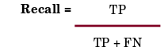
Precision
Fraction of the recommended set that includes relevant items.
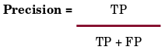
For precision and recall, as N increases recall increases towards 1 but precision decreases towards 0. Performance is also calculated using :
Mean Absolute Error (MAE) | How close is the predictions to the eventual outcomes.  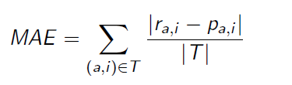
Root Mean Squared Error (RMSE) | Differences between predicted values by a model and the actual values.  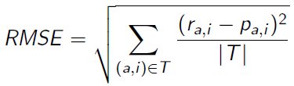

Ratings : Collaborative Filtering
Overview | Use a simple Collaborative Filtering algorithm.
Calculation | Simple Collaborative Filtering as completed in Jan 2015.

Ratings : Collaborative Filtering
Overview | Use a Top N Collaborative Filtering algorithm for both training sets test sets.
Calculation | Collaborative Filtering with Pearson's Coefficient included.  Calculate Pearson's for all test data sets against training data set.  Use the test data set with the best Pearson's coefficient result.  Calculate Top N for the test data set.  Compare the results to those for the training data set and calculate overall MAE.
Pearson's Coefficient | If r =  + .70 or higher Very strong positive relationship  + .40 to +.69 Strong positive relationship  + .30 to +.39 Moderate positive relationship  + .20 to +.29 weak positive relationship  + .01 to +.19 No or negligible relationship  - .01 to -.19 No or negligible relationship  - .20 to -.29 weak negative relationship  - .30 to -.39 Moderate negative relationship  - .40 to -.69 Strong negative relationship  - .70 or higher Very strong negative relationship

Trust : Page-Rank (Google)
Overview | Page rank of a web page is a number which assigns weight or importance of the page bsed on in-bound and out-bound connections. According to the Page Rank algorithm a webpage is more important if many other pages point to it.  Say we have : six web pages [P1, P2, , P3, P4, P5, P6]  each of which connects to itself and to all others, thus the L and A matrices are :  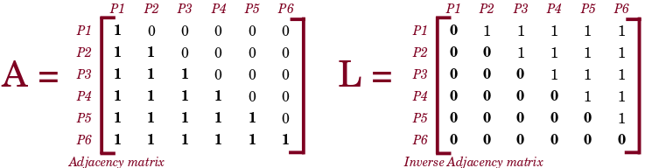
Page rank formula is :
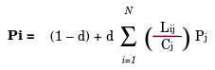
where :
Lij : Link exists from i → j? if true = 1, else = 0
N : Total number of pages
Cj : Number of outbound links
d : Positive constant = 0.85

Trust : Simple Mapping – User [i] Trusts User [j]?
Overview | Page rank applies on a global level, in this instance a more localised approach would be better. Thus I went for the simplest possible implementation :  Does user [i] trust user [j]?  If [yes] then use the rating, if [no] don't and rating is set to 0.

Social Recommendation Applied

Ratings – collaborative Filtering – Simple

Components – Simple
Component | Explanation
Testing set | Compute similarity between active(current) user and all users in training set.  Take k neighbours who are most similar to active user

How Calculated – Simple?
See CS3/cf_simple.m for code used.

Ratings : Collaborative Filtering – Top-N

Components – Top-N
Component | Explanation
Top N → Train | This is evaluated using the training set.. Sets the standard that Test has to achieve or out-pace.
Top N → Test | This is evaluated using the training set. This uses Pearson's Coefficient to obtain the Top N.

How Calculated – Top-N?
Component | Implementation & Explanation
Top N | This uses top N (top 5) ratings in training and in test.  - The epinions dataset was divided into five segments, each acted in turn as the training set (total x 1/5). For training set code, see : calculateTopNForTrainSet in cf_top_n.m.  - The remaining is used as 4 x 1/5 test sets. For Test sets code, see : calculateTopNForTestSetPearsons in cf_top_n.m.  - Calculate Pearson's coefficient for each test set -v- training set.  - Use the best match to calculate Top N.  - Compare to training [ Ý | ß | = ]

Issues with code
I had a few issues with the matlab code when passing matrices to the two functions.
Thus I estimated the values expected for MAE. I would expect it to reduce until k becomes impractical, here I suggest about k = 500, but k could have a negative impact at a later or earlier stage.

Trust – Simple Association

Components – Trust
Component | Explanation
Update trust relationship | Read in files : epinions_ratings and epinions_trust  Check if user [i] trusts user [j], then ratings are retained as they are.  If no trust exists then reset trust for that relationship to 0.  If trust exists then leave the values alone.
Calculate recommendation for dataset | Evaluate ratings for all trusted users and accept the Top N or the average for all ratings which are > midpoint.
This could also be amended to increase rating if trust is mutual. Just because user [i] trusts user [j] doe not mean that user [j] trusts user [I].

How Calculated – Trust?
Covered by pseudo code:
Component | Implementation & Explanation
If userRating(j:1)==userTrust(j:2) && activeUser==userTrust(i:1) then
trust exists
rating is unchanged
else
trust does not exist
amend rating to 0
For the activeUser, get top N ratings
For the activeUser, get average of all ratings > midpoint
Amendments : | if userRating[r:1]==userTrust[j:2] && activeUser==userRating[r:1] then  if trust listing == null then  activeUser==userRating[r:1] x 50% % (partial)

Overall Results Comparison
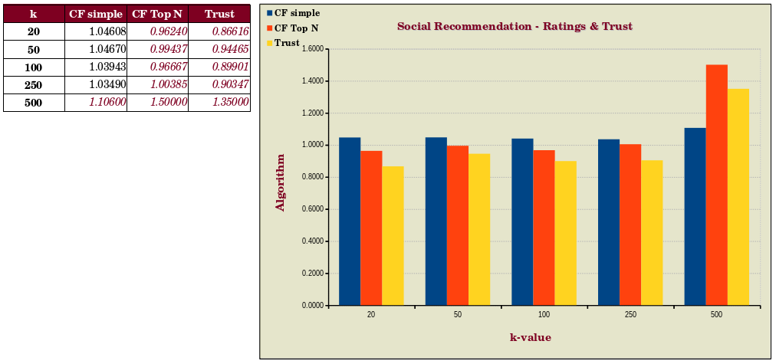
Figure 1 - Expected trend (red, italics) and actual result (black)

Conclusions
Rating : Collaborative Filtering | There are some weaknesses with Collaborative Filtering.  - Data sparsity – if no data exists already then there is none to use as a basis to recommend with  - New users – no data exists on them so no suggestions may be made on expected  - Stalker user – can potentially copy actions of target to fool the system that the stalker is actually to the target.
Trust :  Page Rank | These are overcome through use of trust ratings. However, it is worth noting that the more distant is the suggester from the user (greater number of connections between them) then the impact is less if the suggester changes his/her mind. However an immediate neighbour will have greater impact.
Overall | Depending on the value of k use, precision / recall improves (or should) with the addition of Top-N and also Trust.
Overall, it is best to combine different methods depending on (i) target users prior use history, (ii) target users interests (iii) items being sold / used and also (iv) market conditions. For example, if the item being sold is very expensive then the best target user would have disposable income to purchase the item and would be interested in doing so. Supplier needs to choose an algorithm to best evaluate how to improve sales or the customer use experience.

References / Acknowledgements

References – Networks Datasets

Acknowledgements – Datasets
Name | Details | Link
epinions | supplied

Statistics – Datasets
Dataset | Details
epinions - ratings | There are six columns and they are  | userid | productid | categoryid | rating | helpfulness | time stamps |  1 2 3 4 5 6  It means that user 1 gives a rating of 4 to the product 2 from the category 3.  The helpfulness of this rating is 5 in the time stamp 6.  I recalibrated the dataset file to contain only : | userid | productid | rating |
Epinions - trust | This includes the trust relations between users including time stamps when the relations were established.  There are three columns:  | userid | userid | timestamp |  1 2 3  Meaning that user 1 trusts user 2 at timestamp 3.  I decided to ignore column 3, the result dataset file contains : | userid | userid |

Citations / Acknowledgements
Reference | Acknowledgement
epinions
Recommendation Systems Overview | http://en.wikipedia.org/wiki/Recommender_system  Class notes  http://2015.recsyschallenge.com/
Collaborative Filtering | http://en.wikipedia.org/wiki/Collaborative_filtering  Class notes
Pearson's Coefficient | http://uk.mathworks.com/help/stats/corr.html  http://strategic.mit.edu/docs/matlab_networks/pearson.m  http://strategic.mit.edu/docs/matlab_networks/laplacian_matrix.m  http://onlinestatbook.com/2/describing_bivariate_data/calculation.html
PageRank | http://people.revoledu.com/kardi/tutorial/PageRank/index.htm  http://en.wikipedia.org/wiki/PageRank
Performance –  Mean Absolute Error  (MAE) | Class Notes
Performance –  Root Mean Square Error (RMSE) | Class Notes

