Case Study 2 : Community Finding

Algorithims (Louvain, Hierarchical Clustering, Laplacian & Girvan-Newman)

Author : Paula Dwan
Email : paula.dwan@gmail.com
Student ID : 13208660
Course : MSc Advanced Software Engineering
Module : COMP-47270 Computational Network Analysis and Modelling
Lecturer : Dr. Neil Hurley
Email : neil.hurley@ucd.ie
Due Date : 20 April 2015


Table of Contents
1 Case Study Requirements 3
1.1 Case Study Requirements 3
1.2 Understanding of Requirements from Class Discussions 3
2 Introduction 3
2.1 Community Finding 3
2.2 Datasets Used 3
2.3 Evaluations Used 3
2.3.1 Modularity Function 4
2.3.2 Best Partition 4
2.3.3 Calculate Run-time 4
2.3.4 Impact of Dataset Size 4
3 Louvain Algorithm (Community Detection in Large Networks) 4
3.1 Overview 4
3.1.1 What is the Louvain Algorithm? 4
3.1.2 Components 5
3.1.3 How Calculated Using Python? 5
3.2 Results obtained 6
3.2.1 Facebook : Small Dataset → ≤ 10k Nodes (Louvain) 6
3.2.2 cit-HepTh : Medium Dataset → 10k to 100k Nodes (Louvain) 6
3.2.3 Twitter : Medium Dataset → 10k to 100k Nodes (Louvain) 7
3.2.4 Google + : Large Dataset → > 100k Nodes (Louvain) 7
4 Hierarchical Clustering Algorithm 7
4.1 Overview 7
4.1.1 What is Hierarchical Clustering Algorithm? 7
4.1.2 Components 8
4.1.3 How Calculated Using Python? 8
4.2 Results obtained 10
4.2.1 Facebook : Small Dataset → ≤ 10k Nodes (Hierarchical Clustering) 10
4.2.2 p2p-Gnutella06 : Small Dataset → 10k to 100k Nodes (Hierarchical Clustering) 11
4.2.3 Medium & Large Datasets (Hierarchical Clustering) 11
5 Laplacian Algorithm 12
5.1.1 Components 12
5.1.2 How Calculated Using Python? 13
5.2 Results obtained 13
5.2.1 Facebook : Small Dataset → ≤ 10k Nodes (Laplacian Algorithm) 13
5.2.2 p2p-Gnutella06 : Small Dataset → 10k to 100k Nodes (Laplacian Algorithm) 15
5.2.3 Medium & Large Datasets (Laplacian Algorithm) 15
6 Girvan & Newman Algorithm 16
7 Conclusions 16
8 References / Acknowledgements 17
8.1 References – Networks Datasets 17
8.1.1 Acknowledgements – Datasets 17
8.1.2 Statistics – Datasets 17
8.2 Citations / Acknowledgements 18

Case Study Requirements

Case Study Requirements
Evaluate some community-finding methods on SNAP data and on simulated networks with embedded communities:
- Implement your own community-finding algorithm.
- Compare with at least two other algorithms.
- Compute their relative performance in terms of quality (NMI, modularity) and run-time.

Understanding of Requirements from Class Discussions
- Write a new community finding algorithm or use Laplacian as covered in class.
- Compare to at least two others.
- Evaluate one against the other two by performance / scalability:
NMI score (0 totally different → 1 = very similar)
Newman's Modularity / Modularity
Time taken to calculate calculations
Size of dataset used

Introduction

Community Finding
To start, what is a community?
A community of a graph G is a sub-graph C of G, such that the number of edges joining two vertices in C is greater than the number of edges joining vertices in C to vertices in G\C.
So basically, a community is a sub-set of a graph where groups of nodes are very similar to each other, all of which are close neighbours of each other. Quite a few means of creating and evaluating communities exist.

Datasets Used
Each of the directed graphs chosen deal with Social media and vary in the number of nodes present. For more information on each, please see the section : References – Datasets

Evaluations Used
Once each community /partition is created using the community-finding algorithms, it is evaluated using :
- Modularity
- Best partition
- Time taken to complete evaluation
- Impact of dataset size

Modularity Function
Overview | Uses Louvain to best calculate the partition of the graph nodes which maximises modularity. This enables us to evaluate the dense connectivity between nodes within the same module / clusters. Smaller communities are unfortunately not evaluated very well by this function. Higher the value, the more closely connected are the clusters.
How calculated? | G = graph()  partition = community.best_partition(G)  modularity = community.modularity(partition, G)

Best Partition
Overview | Compute the modularity of a partition of a graph
How calculated? | G = graph()  partition = community.best_partition(G)

Calculate Run-time
Overview | Basically, how long does it take algorithm to produce the clustered graphs for the communities?
How calculated? | I used an existing python module called timeit. This calculates the start and end time and subtraction produces the difference. Time taken may then be compared across all algorithms and all datasets.  import timeit # import inbuilt python method  def getStartTime(): # return the start time  return timeit.default_timer()  def showTimeTaken(start): # end time & calculate total time taken  logging.info(cs_ref, 'calculate Time Taken to run partitioning')  time_end = timeit.default_timer()  print 'Time taken to run = {0} - {1} = {2}'.format(end, start, end-start)

Impact of Dataset Size
Overview | Does a larger dataset produce better communities? Does a larger dataset significantly increase the time taken? Is the a ratio between the dataset size and the time taken?In short, does the size of the dataset rather than algorithm used impact the time taken?
How calculated? | It is not but is based on the results obtained for each algorithm.

Louvain Algorithm (Community Detection in Large Networks)

Overview

What is the Louvain Algorithm?
The Louvain Algorithm was developed by Vincent D Blondel, Jean-Loup Guillaume, Renaud Lambiotte, Etienne Lefebvre, when all were based in Louvain. It computes the best partitions of large scale networks and works as follows :
- First, it looks for "small" communities by optimizing modularity in a local way.
- Second, it aggregates nodes of the same community and builds a new network whose nodes are the communities.
- Repeat until a maximum of modularity is attained.
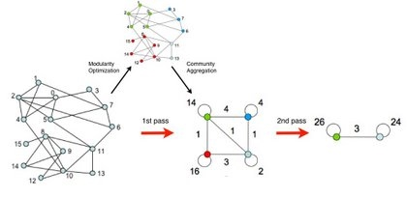
Figure 1 : Louvain Process (src : )
Initially, many communities are created, each of which is small in size. After each iteration, the communities become larger and larger until no more partitions can be created. This is also call a greedy optimization method.

Components
Component | Explanation
Modularity  Best partition | Used community functions, as explained previously (see : Evaluations Used).
timing | Used timeit functions,, as explained previously (see : Evaluations Used).
All communities | Detail all communities present in the graph, if time permits also plot them using matlab.
Best community | Detail the community which forms the best partition of the graph.

How Calculated Using Python?
Component | Implementation & Explanation
Louvain –  all communities | for i in set(partition.values()):  members = [nodes for nodes in partition.keys()  if partition[nodes] == i]  members_info = 'Community[' + str(i) + '] : ', members  with open(dest_file, "a") as dat_file:  dat_file.write("\n\t" + str(members_info))  print "\t" + str(members_info)  for com_ref, members in com_dict:  com_values["community_{0}".format(i)].append(members)
Louvain –  best community | Knowing the best partition of the graph, retrieve all nodes present in that cluster.  count = 0.  for com in set(bp.values()):  count += 1.  list_nodes = [nodes for nodes in partition.keys()  if partition[nodes] == com]  nodes_info = "\tNodes in best partitioned Community[" + str(com) + "]  = " + str(list_nodes)

Results obtained

Facebook : Small Dataset → ≤ 10k Nodes (Louvain)
Best partitions | 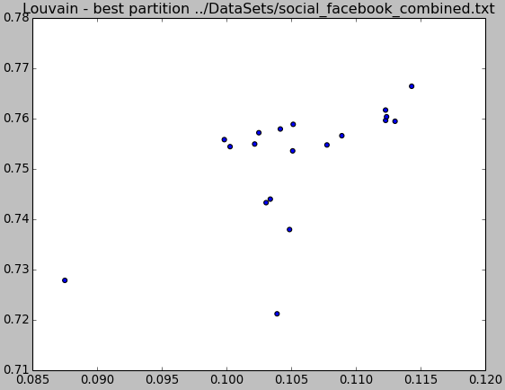  Figure 2 : best partition as plotted  Community[15] =  [2670, 2699, 2703, 2767, 2834, 2879, 2889, 2959, 2972, 2982, 3008, 3283, 3309, 3311, 3314, 3318, 3325, 3382, 3423]
Modularity | Modularity : : 0.83497475803
All Communities | Community[0] to Community[15] of various sizes
Time taken | w/ Plot : End – Start = 509365079.165 usec  w/o Plot : End – Start = 1560554.02756 usec

cit-HepTh : Medium Dataset → 10k to 100k Nodes (Louvain)
Best partitions | 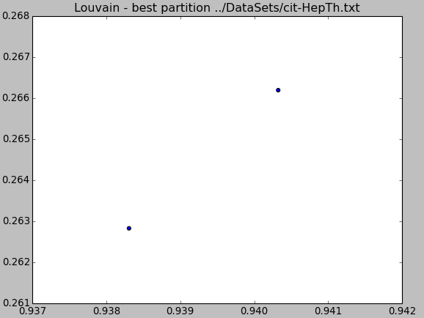  Figure 3 : best partition for community  Community[172] =  [9302016, 9303169]
Modularity | Modularity : : 0.649750739315
All Communities | Community[0] to Community[172] of various sizes
Time taken | w/ Plot : End – Start = 2265986901.04 usec  w/o Plot : End – Start = 13264205.9326 usec

Twitter : Medium Dataset → 10k to 100k Nodes (Louvain)
Best partitions | 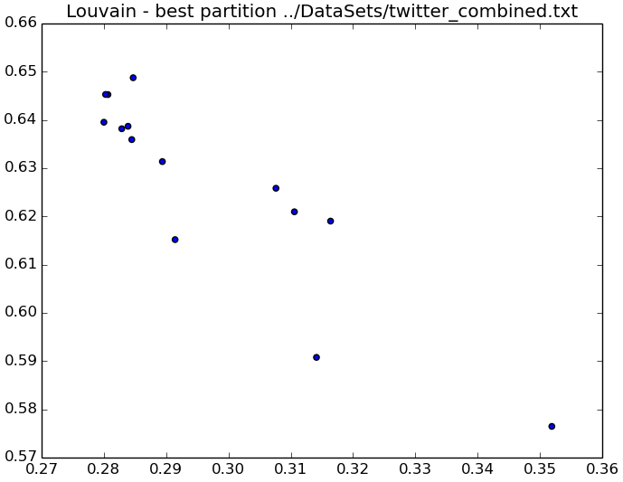Figure 4 : best partition for community  Community[74] =  [16018368, 16806252, 227197639, 20765038, 228911535, 521746689, 203768124, 322524776, 23167567, 203268821, 107456903, 48132194, 167432593, 164087020]
Modularity | Modularity : : 0.805019461044
All Communities | Community[0] to Community[74] of various sizes
Time taken | w/ Plot : End – Start = n/a  w/o Plot : End – Start = 51262211.7996 usec

Google + : Large Dataset → > 100k Nodes (Louvain)
Not processed due to memory error :
File "build/bdist.linux-x86_64/egg/community/__init__.py", line 186, in best_partition
File "build/bdist.linux-x86_64/egg/community/__init__.py", line 248, in generate_dendrogram

… … … …

File "/usr/lib/python2.7/copy.py", line 192, in deepcopy
memo[d] = y
MemoryError

Hierarchical Clustering Algorithm

Overview

What is Hierarchical Clustering Algorithm?
Let N be a set of items which need to be combined where similar (clustered), where there also exists a matrix of size NxN. This matrix details the similarities / differences between each item.
- Initially, create N clusters containing one item per cluster. Apply the same distance between each cluster as exists between the items each contains.
- Merge the two most similar pair of clusters (If more than one exists that are practically indistinguishable, then choose one at random. One less cluster now exists.
- Recalculate all distances to include the new cluster.
- Repeat steps 2 and 3 until all items are clustered into a single cluster of size N.
There are different ways to calculate the distances. Also, it is possible to complete this computation in reverse, with all nodes assigned to a single cluster and dividing at each iteration. As implemented, this is an Agglomerative Clustering algorithm which joins from the bottom up rather than divides from the top down. As I did not apply connectivity constraints where each cluster may only join an adjacent one, computation is somewhat significant for larger datasets (actually, out of memory errors arose).
There are also different means of calculating the optimal number of clusters, including :
- calculate elbow criterion → number of clusters -v- sum of squared distance,
- visually inspect the dendrogram → where does similarities = dissimilarities for existing clusters.
Basically, the dendrogram is cut where there is space to cut them, where there is an obvious large jump in levels of consecutive nodes.
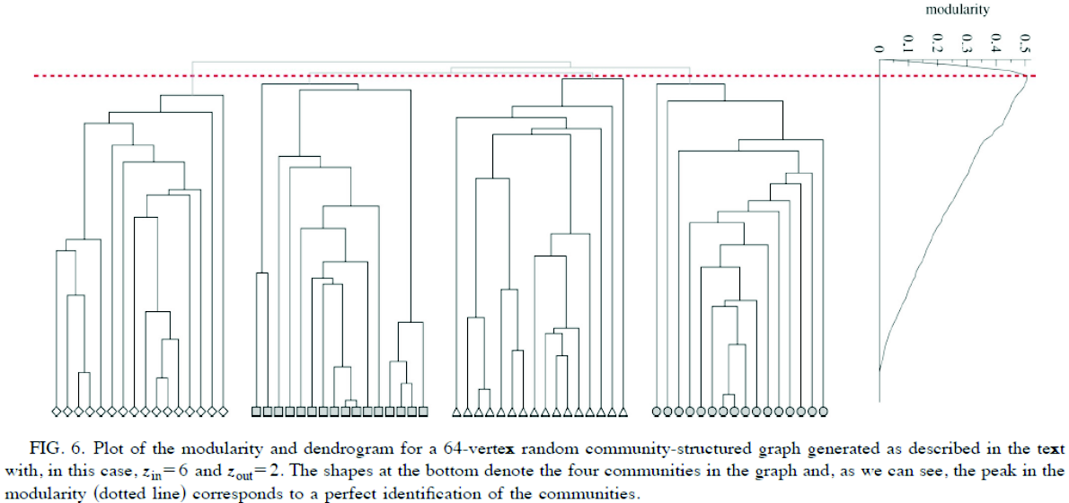
Figure 5 : Sample Dendrogram from lecture slides

Components
Component | Explanation
get dendrogram | Parse the graph and retrieve the dendrogram tree structure, using scipy.cluster > hierarchy and scipy.spatial > distance to generate the dendrogram.
Plot results | Used hierarchy functionality to plot the tree / dendrogram
Modularity  Best partition | Used community functions, as explained previously (see : Evaluations Used).
timing | Used timeit functions,, as explained previously (see : Evaluations Used).

How Calculated Using Python?
Component | Implementation & Explanation
Get dendrogram | # calculate the shortest distance between each node in the graph  path_length = nx.all_pairs_shortest_path_length(g)  n = len(g.nodes())  distances = np.zeros((n, n))  # merge the two nodes closest together into the same cluster &  # recalculate distances  for u, p in path_length.iteritems():  for v, d in p.iteritems():  distances[int(u) - 1][int(v) - 1] = d  sd = distance.squareform(distances)  hier = hierarchy.average(sd)  return hier
Plot results | I used scipy hierarchy.dendrogram to plot the results:  hierarchy.dendrogram(hier, show_leaf_counts=True, truncate_mode='level',  p=7, show_contracted=True)  plt.title("Hierarchical Clustering - dendrogram " + src_file)  plt.ylabel("Dissimilarity (Distance)")  plt.xlabel("Node reference")  plt.savefig("plots/hierarchical_clustering.png")  plt.show()
The x-axes contains the node references and this is more clearly seen in the following sample. For larger dendrograms, the x-axis is illegible.
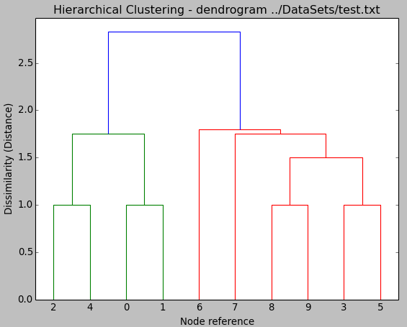
Figure 6 : Sample dendrogram – 10 nodes & 13 edges.
As a result, I restricted the number of levels to produce a cleaner output :
show_leaf_counts=True, truncate_mode='level', p=7, show_contracted=True

Results obtained

Facebook : Small Dataset → ≤ 10k Nodes (Hierarchical Clustering)
dendrogram | 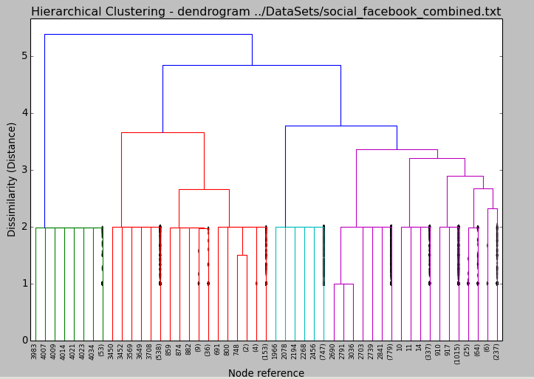  Figure 7 : resulting dendrogram – with set number of levels (p=7) for clarity.  Visually cut dendrogram at 3.0 to optimize clusters
dendrogram – full hierarchy | 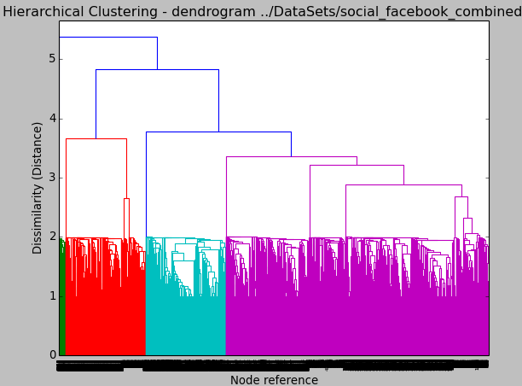  Figure 8 : resulting dendrogram – with all levels included.
Best partitions | Community[15] =  [2670, 2699, 2703, 2767, 2834, 2879, 2889, 2959, 2972, 2982, 3008, 3283, 3309, 3311, 3314, 3318, 3325, 3382, 3423]
Modularity | 0.83497475803
Time taken | w/ Plot : End – Start = 1.43147966635e+15 – 1.43147958886e+15 = 77489745.1401 usec  w/oPlot : End – Start = 1.43145102074e+15 – 1.4314507998e+15 = 220930594.206 usec

p2p-Gnutella06 : Small Dataset → 10k to 100k Nodes (Hierarchical Clustering)
dendrogram | 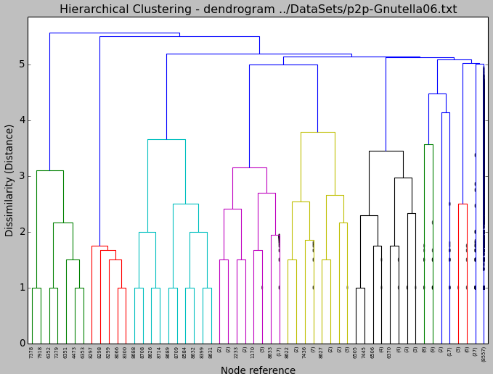  Figure 9 : resulting dendrogram – with set number of levels (p=7) for clarity  Visually cut dendrogram at 4.0 to optimize clusters
Best partitions | Community[21] =  [348, 553, 597, 598, 602, 603, 604, 605, 748, 1036, 1037, 1041, 1042, 1043, 1044, 1045, 1112, 1114, 1115, 1116, 1128, 1169, 1208, 1330, 1332, 1333, 1334, 1335, 1336, 1342, 1471, 1473, 1474, 1475, 1476, 1477, 1479, 1625, 2149, 2150, 2152, 2153, 2155, 2212, 2249, 2250, 2251, 2252, 2255, 2373, 2519, 2530, 2590, 2592, 2594, 2595, 2597, 2757, 2828, 2976, 3019, 3054, 3069, 3188, 3199, 3275, 3294, 3299, 3314, 3364, 3420, 3494, 3511, 3533, 3607, 3629, 3673, 3708, 3740, 3742, 3743, 3745, 3770, 3778, 3787, 3798, 3824, 3895, 3986, 3996, 4073, 4074, 4075, 4076, 4083, 4253, 4254, 4256, 4257, 4258, 4259, 4263, 4390, 4402, 4404, 4443, 4456, 4522, 4532, 4581, 4648, 4741, 4933, 4951, 4968, 5067, 5144, 5145, 5205, 5206, 5208, 5209, 5236, 5352, 5394, 5395, 5428, 5479, 5554, 5555, 5599, 5674, 5675, 5676, 5693, 5704, 5726, 5757, 5760, 5780, 5803, 5804, 5805, 5856, 5868, 5939, 5945, 5946, 5947, 5948, 5949, 5968, 5969, 5970, 5971, 5972, 6051, 6062, 6097, 6106, 6226, 6334, 6415, 6417, 6440, 6494, 6579, 6640, 6641, 6642, 6643, 6688, 6711, 6804, 6805, 6896, 7004, 7011, 7017, 7034, 7035, 7036, 7037, 7063, 7064, 7067, 7080, 7081, 7123, 7312, 7313, 7314, 7315, 7324, 7325, 7326, 7374, 7486, 7490, 7493, 7495, 7497, 7499, 7552, 7570, 7572, 7573, 7610, 7642, 7704, 7708, 7733, 8094, 8143, 8198, 8259, 8286, 8327, 8332, 8334, 8368, 8411, 8412, 8413, 8422, 8423, 8426, 8495, 8520]
Modularity | 0.393810635543
Time taken | w/ Plot : End – Start = 1.43146545306e+15 – 1.43146492412e+15 = 528944584.846 usec  w/O Plot : End – Start = 1.4314641486e+15 – 1.43146372118e+15 = 427414832.115 usec

Medium & Large Datasets (Hierarchical Clustering)
Again, a memory time-out occurred so I decided to use two small datasets for comparison, Facebook and Gnutella peer-to-peer network, August 6 2002 (http://snap.stanford.edu/data/p2p-Gnutella06.html) :
Details | ≤ 10k : Facebook | ≤ 10k : p2p-Gnutella06
Node | 4,039 | 8,717
Edges | 88,234 | 31,525
Nodes in largest WCC | 4,039 (1.000) | 8,717 (1.000)
Edges in largest WCC | 88,234 (1.000) | 31,525 (1.000)
Nodes in largest SCC | 4,039 (1.000) | 3,226 (0.370)
Edges in largest SCC | 88,234 (1.000) | 13,589 (0.431)
Average clustering coefficient (ACE) | 0.6055 | 0.0067
Number of triangles | 1,612,010 | 1,142
Fraction of closed triangles | 0.2647 | 0.002717
Diameter (longest shortest path) | 8 | 10
90-percentile effective diameter | 4.7 | 5.3
Again, please see relevant SNAP web-page for more information on each dataset.

Laplacian Algorithm
Spectral clustering algorithm which uses the eigenvectors of the graph Laplacian matrices to cluster the social network. Kmeans to associate nodes based on shortest distance to the centre of each cluster.
Laplacian | Having a graph G = (V, E), where G is undirected, un-weighted with no graph loops  (i.e.: vi → vi). There are different types of Laplacian :  laplacian_matrix(G[, nodelist, weight]) Return Laplacian matrix G  normalized_laplacian_matrix(G[, nodelist, …]) Return normalized Laplacian matrix G  directed_laplacian_matrix(G[, nodelist, …]) Return directed Laplacian matrix G
K-Means | K-Means is calculated as follows :  - Decide K for each cluster at random.  - Assign all objects to the nearest K (centre of respective cluster).  - Move each K (centre) to the average of all members of that cluster.  - After moving each K (centre), re-assign all other objects to the nearest K.  - Repeat steps 2 to 4 until each K (centre) no longer needs to move.

Components
Component | Explanation
Calculate laplacian | Use networkx inbuilt function
Calculate k-means | Use k-means functions vq, kmeans, whiten from scipy.cluster.vq import
Plot results | Use networkx inbuilt function
Modularity  Best partition | Used community functions, as explained previously (see : Evaluations Used).
timing | Used timeit functions,, as explained previously (see : Evaluations Used).

How Calculated Using Python?
Component | Implementation & Explanation
laplacian | Used NetworkX to return eigen values for the Laplacian matrix created from source graph.  g2 = cv.convert_to_directed(g)  laplacian = nx.directed_laplacian_matrix(g2)  eigen_values= lg.eigvals(laplacian.A)  eigen_info = "\tLaplacian : \n\tLargest eigen-value :" + str(max(eigen_values)) + "\n\tSmallest eigen-value : " \  + str(min(eigen_values))  with open(dest_file, "a") as dat_file:  dat_file.write("\n" + eigen_info)  print(eigen_info)  return eigen_values
K-Means | Used scipy to calculate :  g_matrix= nx.to_numpy_matrix(g)  g_array = np.asarray(g_matrix).reshape(-1)  whitened = whiten(g_array)  clusters = 3  centroids,_ = kmeans(whitened, clusters)  idx,_ = vq(g_array, centroids)
Plot results | Plot a scatter graph containing all clusters  plt.scatter(X_reduced[:, 0], X_reduced[:, 1], c=y_pred);

Results obtained

Facebook : Small Dataset → ≤ 10k Nodes (Laplacian Algorithm)
Laplacian | 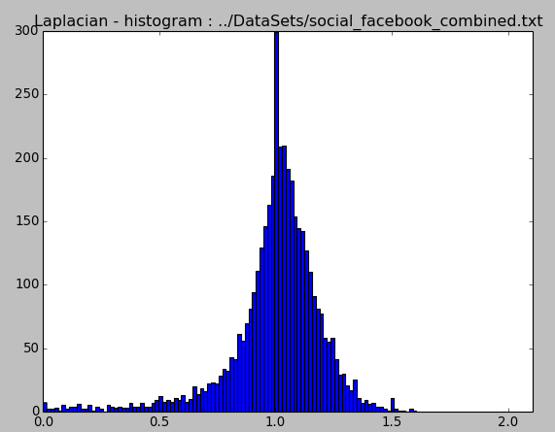  Figure 10 : Histogram of directed_laplacian_matrix applied to dataset.  where: Largest eigen-value : 1.60618522009  Smallest eigen-value : -3.89662260791e-16
KMeans | Applying kmeans and eigen-vectors in cs2_laplacian_amended.py results in :  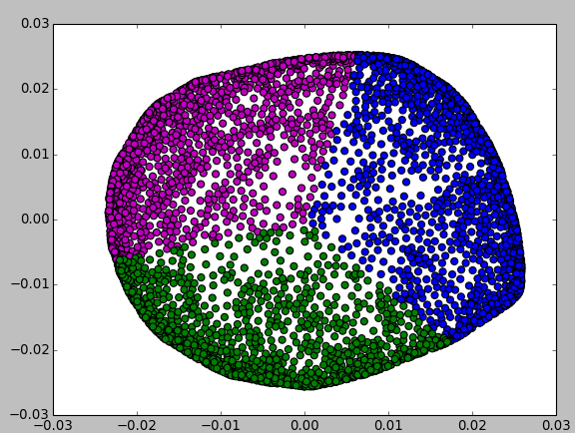  and K-Means and Delauney results in :  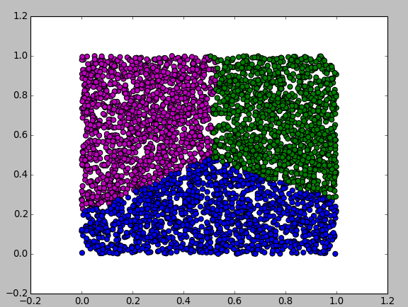
Best partitions | Community[15] =  [2670, 2699, 2703, 2767, 2834, 2879, 2889, 2959, 2972, 2982, 3008, 3283, 3309, 3311, 3314, 3318, 3325, 3382, 3423]
Modularity | 0.83497475803
Time Taken | w/ Plot : End – Start = 1.43149743004e+15 – 1.43149731495e+15 = 115089203.119 usec  w/o Plot : End – Start = 1.43149777696e+15 - 1.43149767847e+15 = 98486344.8143 usec

p2p-Gnutella06 : Small Dataset → 10k to 100k Nodes (Laplacian Algorithm)
Laplacian | where: Largest eigen-value : 1.63497817956  Smallest eigen-value : -9.2699337316e-14  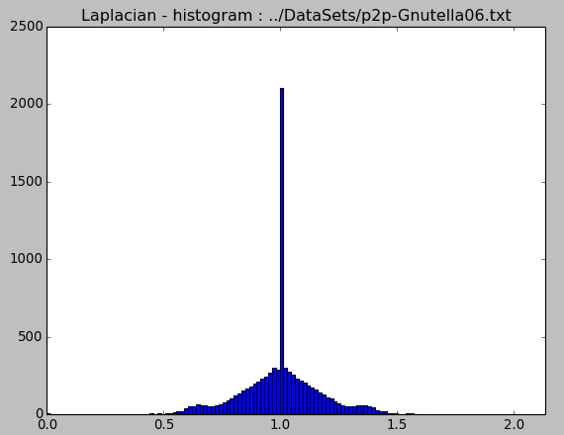  Figure 11 : Histogram of directed_laplacian_matrix applied to dataset.
KMeans
Best partitions | Community[21] =  [348, 553, 597, 598, 602, 603, 604, 605, 748, 1036, 1037, 1041, 1042, 1043, 1044, 1045, 1112, 1114, 1115, 1116, 1128, 1169, 1208, 1330, 1332, 1333, 1334, 1335, 1336, 1342, 1471, 1473, 1474, 1475, 1476, 1477, 1479, 1625, 2149, 2150, 2152, 2153, 2155, 2212, 2249, 2250, 2251, 2252, 2255, 2373, 2519, 2530, 2590, 2592, 2594, 2595, 2597, 2757, 2828, 2976, 3019, 3054, 3069, 3188, 3199, 3275, 3294, 3299, 3314, 3364, 3420, 3494, 3511, 3533, 3607, 3629, 3673, 3708, 3740, 3742, 3743, 3745, 3770, 3778, 3787, 3798, 3824, 3895, 3986, 3996, 4073, 4074, 4075, 4076, 4083, 4253, 4254, 4256, 4257, 4258, 4259, 4263, 4390, 4402, 4404, 4443, 4456, 4522, 4532, 4581, 4648, 4741, 4933, 4951, 4968, 5067, 5144, 5145, 5205, 5206, 5208, 5209, 5236, 5352, 5394, 5395, 5428, 5479, 5554, 5555, 5599, 5674, 5675, 5676, 5693, 5704, 5726, 5757, 5760, 5780, 5803, 5804, 5805, 5856, 5868, 5939, 5945, 5946, 5947, 5948, 5949, 5968, 5969, 5970, 5971, 5972, 6051, 6062, 6097, 6106, 6226, 6334, 6415, 6417, 6440, 6494, 6579, 6640, 6641, 6642, 6643, 6688, 6711, 6804, 6805, 6896, 7004, 7011, 7017, 7034, 7035, 7036, 7037, 7063, 7064, 7067, 7080, 7081, 7123, 7312, 7313, 7314, 7315, 7324, 7325, 7326, 7374, 7486, 7490, 7493, 7495, 7497, 7499, 7552, 7570, 7572, 7573, 7610, 7642, 7704, 7708, 7733, 8094, 8143, 8198, 8259, 8286, 8327, 8332, 8334, 8368, 8411, 8412, 8413, 8422, 8423, 8426, 8495, 8520]
Modularity | 0.393810635543
Time Taken | w/ Plot : End – Start = 100066301.076 usec  w/o Plot : End – Start = ---

Medium & Large Datasets (Laplacian Algorithm)
Again due to memory issues, it was not possible to calculate for medium and large datasets.

Girvan & Newman Algorithm
I was going to use the SNAP implementation of the Girwan and Newman algorithm, however I decided that I had used enough and any more might not add any more to the resulting data nor to the end conclusions. Girwan & Newman is summarised as follows :
- First, calculate the betweenness of all existing edges in the network.
- Remove the edge with the highest betweenness
- Recalculate the betweenness of any edge impacted by step 2.
- Repeat until no edges remain in the network.

Conclusions
Overall, this was a very interesting exercise as it showed the differences between hierarchical clustering, Laplacian Eigen-Values, K-Means, Louvain. As a python learning experience, I decided where practical to use third party functions.
The purpose of the algorithms chosen was to see if the type of algorithm would improve on the resulting clusters. Did the type of dataset rather than the size of the dataset affect the results. (Larger datasets did affect the results as in some instances there were none due to memory issues)
Louvain | This algorithm uses modularity of the graph to calculate the appropriate clusters (communities). As a network with a high modularity will have good (strong) connections between the nodes within the same cluster Connections to other clusters will be sparse in number.  If we take two social networks Facebook (4k nodes) and Twitter (81k nodes), both have modularity of about 80% (actually 81% and 83% respectively). While a citation dataset has a modularity of 65%. The resulting number of clusters is significantly higher for the citation network cit-HepTh, than the social networks.
Hierarchical Clustering | In the algorithm as used, all nodes were assigned to individual clusters and then merged based on a similarity measure, usually proximity. This is from the bottom up implementation (top-down implementation also exists)  Again, the social network appears to work better with Hierarchical Clustering than does the citation network, cutting dendrogram at 3 rather than 4. Also it is worth noting that that the citation network has many small clusters of similar sizes.  Due to the time taken to calculate only small networks were used – all medium and large networks failed due to memory errors.
Laplacian | A directed Laplacian Matrix was created using NetworkX using as source the dataset. From this, the eigenvalues were calculated and the minimum and maximum noted.  Again, there were memory issues for medium and large datasets.  To finalise this algorithm, it necessary to apply K-Means.  From the results to date, again social networks appear to fair better in the creation of strong communities.
KMeans | While the results are calculated, they are not yet graphed. It will be interesting if the results seen so far also apply to K-Means.
No one algorithm is better than the other, it depends on the requirements when creating the clusters. Do we know how many clusters we need, then perhaps k-means would be an appropriate option to define them. If we don't then perhaps hierarchical clustering would be a better choice, allowing the user to decide what number of clusters apply once all are known. If a network has a high modularity then Louvain would be more appropriate, however if the resulting clusters will be small in size then Louvain could sometimes assign the wrong entity to the wrong cluster.

References / Acknowledgements

References – Networks Datasets
Datasets : http://snap.stanford.edu/data/index.html
The information in this section is taken directly from http://snap.stanford.edu/ and is included for informational purposes only.

Acknowledgements – Datasets
Name | Size | Link
Social circles: Facebook | Small → ≤ 10k nodes | http://snap.stanford.edu/data/egonets-Facebook.html
Social circles: Twitter | Medium → 10k to 100k nodes | http://snap.stanford.edu/data/egonets-Twitter.html
High-energy physics citation network | Medium → 10k to 100k nodes | http://snap.stanford.edu/data/cit-HepPh.html
High-energy physics theory citation network | Medium → 10k to 100k nodes | http://snap.stanford.edu/data/cit-HepTh.html
Social circles: Google+ | Large → > 100k nodes | http://snap.stanford.edu/data/egonets-Gplus.html

Statistics – Datasets
Details | ≤ 10k :  Facebook | 10k → 100k :  cit-HepTh | 10k → 100k  cit-HepPh | 10k → 100k :  Twitter | > 100k :  Google +
Nodes | 4,039 | 27,770 | 34,546 | 81,306 | 107,614
Edges | 88,234 | 352,807 | 421,578 | 1,768,149 | 13,673,453
Nodes in largest WCC | 4,039  (1.000) | 27,400  (0.987) | 34,401  (0.996) | 81,306  (1.000) | 107,614 (1.000)
Edges in largest WCC | 88,234  (1.000) | 352,542  (0.999) | 421,485 (1.000) | 1,768,149 (1.000) | 13,673,453 (1.000)
Nodes in largest SCC | 4,039  (1.000) | 7,464  (0.269) | 12,711  (0.368) | 68,413  (0.841) | 69,501  (0.646)
Edges in largest SCC | 88,234  (1.000) | 116268  (0.330) | 139,981 (0.332) | 1,685,163 (0.953) | 9,168,660 (0.671)
Average clustering coefficient (ACE) | 0.6055 | 0.3120 | 0.2848 | 0.5653 | 0.4901
Number of triangles | 1,612,010 | 1,478,735 | 1,276,868 | 13,082,506 | 1,073,677,742
Fraction of closed triangles | 0.2647 | 0.04331 | 0.05377 | 0.06415 | 0.6552
Diameter  (longest shortest path) | 8 | 13 | 12 | 7 | 6
90-percentile effective diameter | 4.7 | 5.3 | 5 | 4.5 | 3

Citations / Acknowledgements
Reference | Acknowledgement
SNAP → datasets | Sourced from : http://snap.stanford.edu/data  Please see each dataset page link provided for specific link.
Best partition using Louvain | https://bitbucket.org/taynaud/python-louvain  http://perso.crans.org/aynaud/communities/  https://sites.google.com/site/findcommunities/
Python timeit module | http://pymotw.com/2/timeit/  https://docs.python.org/2/library/timeit.html
Graph Clustering and Community Finding | Comp-47270 lectures → Section 4  Dr. Neil Hurley
Hierarchical Clustering | http://en.wikipedia.org/wiki/Hierarchical_clustering  Web Science Summer School 2011  http://docs.scipy.org/doc/scipy-0.14.0/reference/generated/scipy.cluster.hierarchy.dendrogram.html
Girvan & Newman's Algorithm
General overview | http://scikit-learn.org/
Laplacian - amended | Used Lab 2 file as amended on the day
Laplacian | http://www.networkx.org
Laplacian - kmeans | http://scikit-learn.org/  http://docs.scipy.org/doc/scipy/reference/generated/scipy.cluster.vq.kmeans.htm
Different algorithms and queries | http://wiki.cns.iu.edu/

