Graph Structure & Modelling

Case Study 1 : Broder et al, Power-Law & Price's Model

Author : Paula Dwan
Email : paula.dwan@gmail.com
Student ID : 13208660
Course : MSc Advanced Software Engineering
Module : COMP-47270 Computational Network Analysis and Modelling
Lecturer : Dr. Neil Hurley
Email : neil.hurley@ucd.ie
Due Date : 20 April 2015


Table of Contents
1 Case Study Requirements 3
1.1 Understanding of Requirements from Class Discussions 3
2 Introduction 3
2.1 What is a Directed Network? 3
2.2 Directed graphcs used & Why? 4
3 Broder et al 4
3.1 Overview of Broder et al 4
3.1.1 Components : Bow-Tie Model 4
3.1.2 How Calculated Using Python 5
3.2 Results of Broder et al 5
3.2.1 Small graph → ≤ 10k nodes 5
3.2.2 Medium graph→ 10k to 100k nodes 5
3.2.3 Large graph → > 100k nodes 5
4 Plot the Degree Distribution 5
4.1 Overview 5
4.1.1 Components : Log-Log Plot 6
4.1.2 How Calculated Using Python 6
4.1.3 Functions Used 6
4.2 Calculate Parameter β for Power-Law Degree Distribution Model 6
5 Price Model 7
5.1 Overview 7
5.1.1 Components : Price Model 7
5.1.2 How Calculated Using Python 7
5.2 Networks best represented by Price's Model 7
6 Conclusions 7
7 References - Datasets 8
7.1 Networks Datasets 8
7.1.1 Network Dataset Statistics 8
7.2 Social Circles : Wikipedia vote network 8
7.2.1 Dataset information 8
7.2.2 Source (citation) 9
7.2.3 Files 9
7.3 Social circles: Twitter (Social / Directed) 9
7.3.1 Dataset information 9
7.3.2 Source (citation) 10
7.3.3 Files 10
7.4 Social circles: Google+ (Social / Directed) 10
7.4.1 Dataset information 10
7.4.2 Source (citation) 10
7.4.3 Files 10
7.5 Citing SNAP 10

Case Study Requirements
Determine the qualitative nature of the networks you are studying and write up a report.
Do some of the following:
- For the directed networks, sketch the Broder et al picture of the network.
Number of nodes in (SCC) strongest connected components, IN, OUT, and other sections of the network.
- Fit a line to a log-log plot of the degree distribution.
Compute the slope of this line to determine the parameter β of the power-law degree distribution model.
- Simulate the Price model to generate a network of n nodes for a particular power-law parameter α where α = β – 1.
Compute all of the above parameters for the Price model.
Which (real-life) network/s does the Price Model best represent?

Understanding of Requirements from Class Discussions
- Choose three directed networks from http://snap.stanford.edu/data/.
- Generate Broder et al : not directly possible using NetworkX and python, thus need to calculate number of nodes exist as SCC, IN, OUT, Tendrils, Tubes and Disconnected.
- Plot the results for each [ x – y ] → [ log(rank) – log (deg)].
Compute the slope of the line plotted to get parameter β of the power-law degree distribution model.
- Why does the parameter β differ for each network?
- Simulate the Price Model to generate a network of n nodes for power-law parameter α where α = β – 1.
- Calculate three parameters for Price Model : degree-coefficient, assortativity co-efficient and clustering co-efficient.
- Which real-life networks best matches the Price Model?

Introduction

What is a Directed Network?
Source : http://en.wikipedia.org/wiki/Directed_graph)
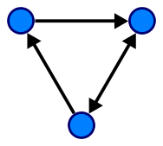 | In mathematics, and more specifically in graph theory, a directed graph (or digraph) is a graph, or set of nodes connected by edges, where the edges have a direction associated with them. In formal terms, a digraph is a pair G=(V,A) (sometimes G=(V,E)) of:[1]  - a set V, whose elements are called vertices or nodes,  - a set A of ordered pairs of vertices, called arcs, directed edges, or arrows (and sometimes simply edges with the corresponding set named E instead of A).  It differs from an ordinary or undirected graph, in that the latter is defined in terms of unordered pairs of vertices, which are usually called edges.  A digraph is called "simple" if it has no loops, and no multiple arcs (arcs with same starting and ending nodes). A directed multigraph, in which the arcs constitute a multiset, rather than a set, of ordered pairs of vertices may have loops (that is, "self-loops" with same starting and ending node) and multiple arcs. Some, but not all, texts allow a digraph, without the qualification simple, to have self loops, multiple arcs, or both.

Directed graphcs used & Why?
Each of the directed graphs chosen deal with Social media and vary in the number of nodes present. For more information on each, please see the section : References – Datasets
        - Small → ≤ 10k nodes http://snap.stanford.edu/data/wiki-Elec.html
        - Medium → 10k to 100k nodes http://snap.stanford.edu/data/egonets-Twitter.html
        - Large → > 100k nodes http://snap.stanford.edu/data/egonets-Gplus.html

Broder et al

Overview of Broder et al
In 2000, Broder and various colleagues conducted a large-scale analyis of the web. They concluded that as a directed graph there was a recongnisable structure in place that of a bow-tie (see following figure.) In short, if a page x is connected to page y via a directed edge then a hyperlink connects page x to page y.
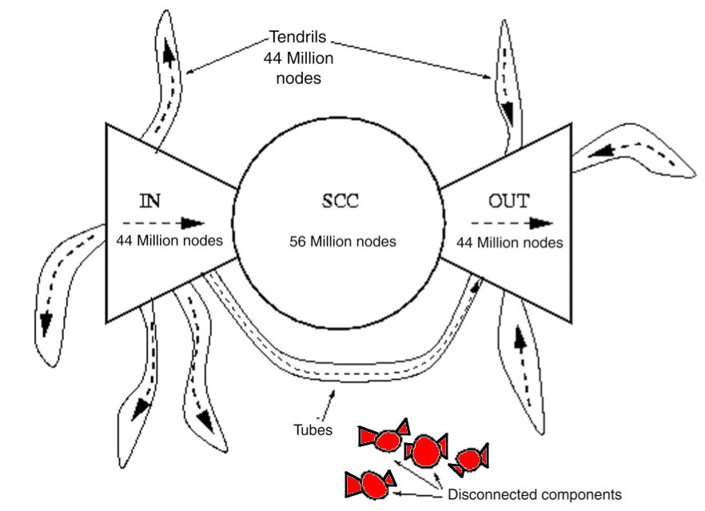
Figure 1 : Bow-tie model of the web graph (Broder et al, 2000).

Components : Bow-Tie Model
Component | Explanation
IN (→) | Nodes that are up-stream of the SCC (i.e.: these nodes have in→edges from other IN only and out←edges to other nodes in IN, SCC, Tendrils or Tubes).
SCC | Nodes which are part of the 'strongly connected component' (SCC). Each nodes has in→edges from IN, SCC and out←edges to OUT or SCC. Each node in SCC has one or more paths to every other node in SCC.
OUT | Nodes that are down-stream of the SCC (i.e.: these nodes have out←edges to other OUT only and in→edges from other nodes in OUT, SCC, Tendrils or Tubes).
Tubes | Nodes that have in→edges from IN or other pages in Tubes and out←edges to nodes in Tubes or OUT.
Disconnected | Nodes that are basically outside of the bow-tie structure. Nodes have no in→edges from and no out←edges to any components. These pages may be linked to each other.
Tendrils | Nodes that are can accessible from IN only or only have out←edges to OUT. The nodes do not pass through SCC.

How Calculated Using Python
There is no one function in NetworkX or in python to evaluate a directed graph and confirm what node is part of what component, therefore node must be examined to see what connections exist and in what direction.
Component | Explanation
IN
SCC | Use NetworkX function : strongly_connected_components(G) which generates the nodes in strongly connected component of the graph provided as a list of nodes for each strongly connected component of G..  - See : https://networkx.github.io/documentation/latest/reference/generated/networkx.algorithms.components.strongly_connected.strongly_connected_components.html  - Note : need to check if graph G is undirected before implementation otherwise an exception is thrown.  If needed, can also use the function : number_strongly_connected_components(G) which returns the number of strongly connected components in graph (integer).
OUT
Tubes
Disconnected
IN-Tendril
OUT-Tendril

Results of Broder et al

Small graph → ≤ 10k nodes
Component | % of nodes | Number of nodes
IN
SCC
OUT
Tubes
Disconnected
Tendril-IN
Tendril-OUT
Total

Medium graph→ 10k to 100k nodes
Component | % of nodes | Number of nodes
IN
SCC
OUT
Tubes
Disconnected
Tendril-IN
Tendril-OUT
Total

Large graph → > 100k nodes
Component | % of nodes | Number of nodes
IN
SCC
OUT
Tubes
Disconnected
Tendril-IN
Tendril-OUT
Total

Plot the Degree Distribution

Overview
A power-law is a direct relationshipt beween the rank and degree or the number of edges and the number of nodes in the directed graphs chosen.
Here, we evaluate the degree-distribution for each graph.
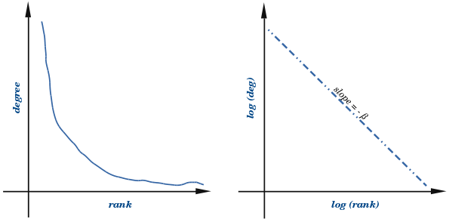
Figure 2: Power-Law Distribution

Components : Log-Log Plot
Component | Explanation

How Calculated Using Python
Component | Explanation

Functions Used

Function : degree_histogram (G)
Information | Return a list of the frequency of each degree value.
Parameters | G : NetworkX graph  A graph.
Returns | hist : list  A list of frequencies of degrees. The degree values are the index in the list.
Notes | The bins are width one, hence len(list) can be large (Order(number_of_edges))
Source | https://networkx.github.io/documentation/latest/reference/generated/networkx.classes.function.degree_histogram.html

Calculate Parameter β for Power-Law Degree Distribution Model
Graph size | Value of β
Small
Medium
Large

Price Model

Overview
While the Broder et al Model evaluates the physical properties of the three directed graphs chosen, Price's Model (1976) evaluates how social networks grow. Derek de Solla Price used published academic papers as his nodes. He proposed that the increase in citations by other authors should be proportional to the number of citations the paper already has. He did add a constant factor for a newly published paper which initially will have zero citations. This is basically preferential advantage → 'the rich get richer'. This is also the first known example ofa scale-free network, where we expect that regardless of the number of nodes in the graph the power-law remains constant.

Components : Price Model
Component | Explanation
citations | How many times a paper was cited (refered to) by authors of other papers.
Age of paper | A new paper has 0 citations and this

How Calculated Using Python
Component | Explanation
citations | indegrees → how many times this node(paper) was cited  outdegrees → how many times this node (paper) cited other notes (papers)
Age of paper | Not really calculated but emulate as eac node was added.

Networks best represented by Price's Model
Internet and social networks (three of which were examined in this case study, even those direct social interaction were not present).

Conclusions

References - Datasets

Networks Datasets
Datasets : http://snap.stanford.edu/data/index.html
The information in this section is taken directly from http://snap.stanford.edu/ directly and is included for informational purposes only.

Network Dataset Statistics
Dataset statistics
Nodes | Number of nodes in the network
Edges | Number of edges in the network
Nodes in largest WCC | Number of nodes in the largest weakly connected component
Edges in largest WCC | Number of edges in the largest weakly connected component
Nodes in largest SCC | Number of nodes in the largest strongly connected component
Edges in largest SCC | Number of edges in the largest strongly connected component
Average clustering coefficient | In graph theory, a clustering coefficient is a measure of the degree to which nodes in a graph tend to cluster together. Evidence suggests that in most real-world networks, and in particular social networks, nodes tend to create tightly knit groups characterised by a relatively high density of ties; this likelihood tends to be greater than the average probability of a tie randomly established between two nodes (Holland and Leinhardt, 1971;[1] Watts and Strogatz, 1998[2]).  Two versions of this measure exist: the global and the local. The global version was designed to give an overall indication of the clustering in the network, whereas the local gives an indication of the embeddedness of single nodes.
Number of triangles | Number of triples of connected nodes (considering the network as undirected)
Fraction of closed triangles | Number of connected triples of nodes / number of (undirected) length 2 paths
Diameter (longest shortest path) | Maximum undirected shortest path length (sampled over 1,000 random nodes)
90-percentile effective diameter | 90th percentile of undirected shortest path length distribution  (sampled over 1,000 random nodes)

Social Circles : Wikipedia vote network

Dataset information
http://snap.stanford.edu/data/wiki-Vote.html
Wikipedia is a free encyclopedia written collaboratively by volunteers around the world. A small part of Wikipedia contributors are administrators, who are users with access to additional technical features that aid in maintenance. In order for a user to become an administrator a Request for adminship (RfA) is issued and the Wikipedia community via a public discussion or a vote decides who to promote to adminship. Using the latest complete dump of Wikipedia page edit history (from January 3 2008) we extracted all administrator elections and vote history data. This gave us 2,794 elections with 103,663 total votes and 7,066 users participating in the elections (either casting a vote or being voted on). Out of these 1,235 elections resulted in a successful promotion, while 1,559 elections did not result in the promotion. About half of the votes in the dataset are by existing admins, while the other half comes from ordinary Wikipedia users.
The network contains all the Wikipedia voting data from the inception of Wikipedia till January 2008. Nodes in the network represent wikipedia users and a directed edge from node i to node j represents that user i voted on user j.

Dataset statistics
Nodes | 7115
Edges | 103689
Nodes in largest WCC | 7066 (0.993)
Edges in largest WCC | 103663 (1.000)
Nodes in largest SCC | 1300 (0.183)
Edges in largest SCC | 39456 (0.381)
Average clustering coefficient | 0.1409
Number of triangles | 608389
Fraction of closed triangles | 0.04564
Diameter (longest shortest path) | 7
90-percentile effective diameter | 3.8
Raw Wikipedia adminship election data that was used to create the Wiki-vote network can be accessed at http://snap.stanford.edu/data/wiki-Elec.html.

Source (citation)
        - J. Leskovec, D. Huttenlocher, J. Kleinberg. Signed Networks in Social Media. CHI 2010.
        - J. Leskovec, D. Huttenlocher, J. Kleinberg. Predicting Positive and Negative Links in Online Social Networks. WWW 2010.

Files
File | Description
Wiki-Vote.txt.gz | Wikipedia adminship vote network till January 2008

Social circles: Twitter (Social / Directed)

Dataset information
http://snap.stanford.edu/data/egonets-Twitter.html
This dataset consists of 'circles' (or 'lists') from Twitter. Twitter data was crawled from public sources. The dataset includes node features (profiles), circles, and ego networks. Data is also available from Facebook and Google+.
Dataset statistics
Nodes | 81306
Edges | 1768149
Nodes in largest WCC | 81306 (1.000)
Edges in largest WCC | 1768149 (1.000)
Nodes in largest SCC | 68413 (0.841)
Edges in largest SCC | 1685163 (0.953)
Average clustering coefficient | 0.5653
Number of triangles | 13082506
Fraction of closed triangles | 0.06415
Diameter (longest shortest path) | 7
90-percentile effective diameter | 4.5

Source (citation)
J. McAuley and J. Leskovec. Learning to Discover Social Circles in Ego Networks. NIPS, 2012.

Files
File | Description
twitter.tar.gz | Twitter data (973 networks)
twitter_combined.txt.gz | Edges from all egonets combined
readme-Ego.txt | Description of files

Social circles: Google+ (Social / Directed)

Dataset information
http://snap.stanford.edu/data/egonets-Gplus.html
This dataset consists of 'circles' from Google+. Google+ data was collected from users who had manually shared their circles using the 'share circle' feature. The dataset includes node features (profiles), circles, and ego networks. Data is also available from Facebook and Twitter.
Dataset statistics
Nodes | 107614
Edges | 13673453
Nodes in largest WCC | 107614 (1.000)
Edges in largest WCC | 13673453 (1.000)
Nodes in largest SCC | 69501 (0.646)
Edges in largest SCC | 9168660 (0.671)
Average clustering coefficient | 0.4901
Number of triangles | 1073677742
Fraction of closed triangles | 0.6552
Diameter (longest shortest path) | 6
90-percentile effective diameter | 3

Source (citation)
J. McAuley and J. Leskovec. Learning to Discover Social Circles in Ego Networks. NIPS, 2012.

Files
File | Description
gplus.tar.gz | Google+ (132 networks)
gplus_combined.txt.gz | Edges from all egonets combined
readme-Ego.txt | Description of files

Citing SNAP
We encourage you to cite our datasets if you have used them in your work.
You can use the following BibTeX citation:
@misc{snapnets,
author = {Jure Leskovec and Andrej Krevl},
title = {{SNAP Datasets}: {Stanford} Large Network Dataset Collection},
howpublished = {\url{http://snap.stanford.edu/data}},
month = jun,
year = 2014
}

