A Critical Analysis of the Project Development
APP : Combine Voucher System Among Multiple Irish Stores

Author : Paula Dwan ( paula.dwan@gmail.com )
FAO : Dominic Carr ( dominic.carr@ucdconnect.ie )
Tadhg O'Sullivan ( t.osullivan@ucd.ie )
Barnard Kroon ( barnard.kroon@ucdconnect.ie )
Course : MSc Advanced Software Engineering
Module : COMP–47330 : Practical Android Programming
Student ID : 13208660
Due Date : 01-May-2015



Table of Contents
1 Overview of Application 4
1.1 High-level Functionality 4
1.2 App Flow – New User (Start to End) 4
1.2.1 Mock-up : Start-to-End Flow 4
1.2.2 Actual : Start-to-End Flow 4
1.3 App Flow – Existing User (Start to End) 5
1.3.1 Mock-up : Start-to-End Flow 5
1.3.2 Actual : Start-to-End Flow 5
1.4 App File Structure – Android Studio 5
1.5 App Flow – Changes to Common Implementation 6
1.5.1 Reasons Why? 6
1.5.2 Advantages of Changes Made 6
1.5.3 Disadvantages of Changes Made 6
1.6 App Usage – Devices & Orientations / Layouts 7
2 Project Run-through 8
2.1 Activity – Welcome 8
2.1.1 What this activity does? 8
2.1.2 View : Mock-up -V- Actual 8
2.1.3 Code : LoginHomeActivity.java 8
2.1.4 Layout : activity_login_home.xml 9
2.2 Activity – Terms & Conditions (New User) 9
2.2.1 What this activity does? 9
2.2.2 View : Mock-up -V- Actual 9
2.2.3 Code : RegisterTermsAndConditionsActivity.java 10
2.2.4 Layout : activity_register_terms_and_conditions.xml 10
2.3 Activity – Register Customer Contact Details (New User) 11
2.3.1 What this activity does? 11
2.3.2 View : Mock-up -V- Actual 11
2.3.3 Code : RegisterContactDetailsActivity.java 12
2.3.4 Layout : activity_register_contact_details.xml 12
2.4 Activity – Register SignIn Details (New User) 13
2.4.1 What this activity does? 13
2.4.2 View : Mock-up -V- Actual 13
2.4.3 Code : RegisterSignInDetailsActivity.java 13
2.4.4 Layout : activity_register_sign_in_details.xml 14
2.5 Activity – Sign In (Existing User) 14
2.5.1 What this activity does? 14
2.5.2 View : Mock-up -V- Actual 14
2.5.3 Code : SignInActivity.java 14
2.5.4 Layout : activity_sign_in.xml 15
2.6 Activity – Cancel Registration (Existing User) 15
2.6.1 View : Mock-up -V- Actual 15
2.7 Activity – Store Listing : Add / Use (New & Existing Users) 15
2.7.1 What this activity does? 15
2.7.2 View : Mock-up -V- Actual 16
2.7.3 Code : DisplayStoreListing.java 16
2.7.4 Layout : activity_display_store_listing.xml 16
2.8 Activity – Store Status [store_name] (New & Existing User) 17
2.8.1 What this activity does? 17
2.8.2 View : Mock-up -V- Actual 17
2.8.3 Code : DisplayStoreSpecificInfo.java 17
2.8.4 Layout : activity_display_store_specific_info.xml 17
2.9 Activity – Bar-code (New & Existing User) 18
2.9.1 What this activity does? 18
2.9.2 View : Mock-up -V- Actual 18
2.9.3 Code : GenerateZXingCodeActivity.java 18
2.9.4 Layout : activity_generate_zxing_code.xml 18
2.10 Common Files used 19
2.10.1 XML files 19
2.10.2 SQLite Files 20
2.10.3 Store ListView Files 21
3 Technologies 22
3.1 Technologies Planned 22
3.1.1 SQLite database software library Overview 22
3.1.2 ZXing Overview 22
3.1.3 Encryption of User Data 23
3.1.4 Ensuring Secure Login – Users 23
3.2 Technologies Actually Used 24
3.2.1 SQLite database 24
3.2.2 ZXing QR-Code & Bar-code Generation 26
3.2.3 Encryption of User Data 26
3.2.4 Ensuring Secure Login – Users 26
3.3 What I would have used instead! 26
4 Challenging / Interesting Features 28
4.1 What I thought would be challenging / interesting? 28
4.2 In the end – what was ? 28
4.3 If I had my time over – Would I do this project? 28
5 Conclusions / Final Comments 29
6 References 30
Index of Tables
Table 1:1 – Directory Structure (high-level overview of project structure as implemented) 6
Table 2:1 – Lunar Store intial screen → Welcome screen 8
Table 2:2 – Register New Customer → Agree to T&Cs 9
Table 2:3 – Register Customer New Customer → Contact details with blank details 11
Table 2:4 – Register New Customer → Contact details with fields and check boxes completed 11
Table 2:5 – Register New Customer → Add login details 13
Table 2:6 – Existing User SignIn 14
Table 2:7 – Cancel Registration Activity - replaced with ActionBar OverFlow menu option. 15
Table 2:8 – Store Listing → those in use and additional ones available. 16
Table 2:9 – Store Status - available points and offers. 17
Table 2:10 – Generate QR-Code & Bar-Code for selected item. 18
Table 2:11 – Common XML files in the app. 19
Table 2:12 – Common table titles and button formatting XML files in the app. 20
Table 2:13 – 3-Level SQLite files as applied. 20
Table 2:14 – ListView files as used by the Store activities. 21
Table 3:1 – android.permissions options available. 23
Table 3:2 – encryption options evaluated 23

Overview of Application

High-level Functionality
App based rewards / points / vouchers scheme for customers of national and/or local stores.
- Customer registers using Android (or web-page login);
- Customers details are saved in central database;
- Customer enters a new store and scans QR code to sign-up (or web-page);
- Customer receives all vouchers via app – mailings, points, money-off, mailings, event vouchers, etc.;
- Customer can login with Facebook;
- Customer perhaps also receives proximity vouchers

App Flow – New User (Start to End)
This flow covers a new user. The detailed start-to-end flow covers the user experience from when he/she starts the app to leave/closing it. A new user has some of the same views as an existing user :
- Home / Welcome
Once registered, the following are available :
- Store Listing : Add / Use | Store Status [store_name] | Bar-code / QR-code | Cancel Regisration
However, he/she also has views restricted to new users only :
- Terms & Conditions | Register : Contact Details | Register : Login Details

Mock-up : Start-to-End Flow
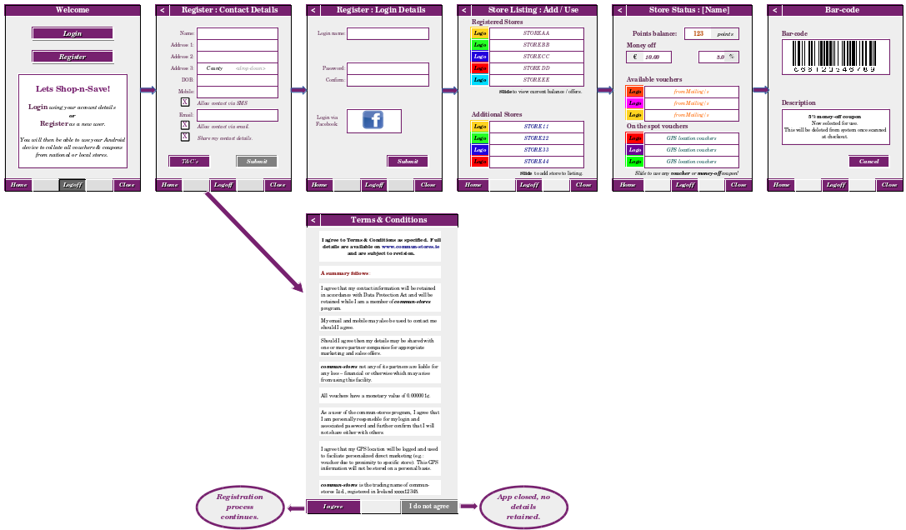

Actual : Start-to-End Flow
<what was finally delivered – multiple if needed>

App Flow – Existing User (Start to End)
This flow covers an existing user. The detailed start-to-end flow covers the user eperience from when he/she starts the app to leave/closing it. An existing user has some of the same views as a new user :
- Home / Welcome
Once signed in the following are available :
- Store Listing : Add / Use | Store Status [store_name] | Bar-code / QR-code | Cancel Regisration
However, he/she also has views restricted to existing users only :
- Login

Mock-up : Start-to-End Flow
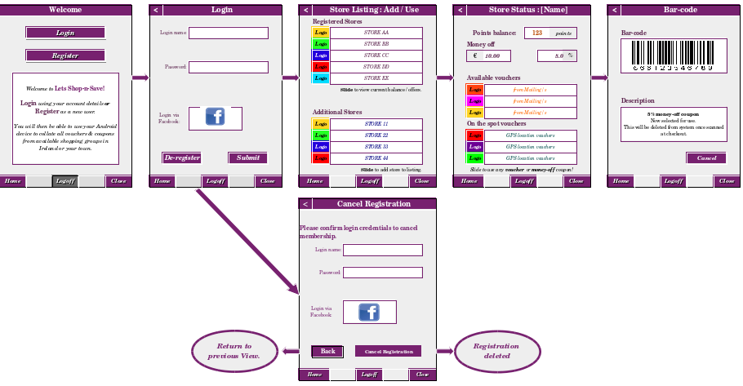

Actual : Start-to-End Flow
<what was finally delivered – multiple if needed>

App File Structure – Android Studio
 | Manifest file → specifics activity flow : parent → child.
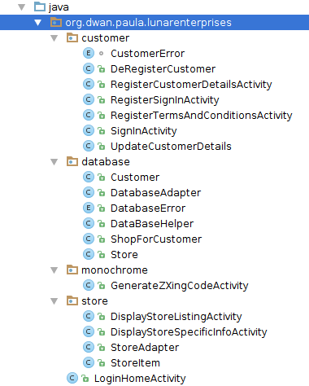 | File and directory structure as implemented in An#####droid Studio.  - org.dwan.paula.lunarenterprises → main project is which contains the Home Activity.  - org.dwan.paula.lunarenterprises.customer → all customer specific activities.  - org.dwan.paula.lunarenterprises.database → all database specific activities as well as helper and adapter.  - org.dwan.paula.lunarenterprises.monochrome → QR-Code / Bar-code generation activities.  - org.dwan.paula.lunarenterprises.store → all store specific activities.
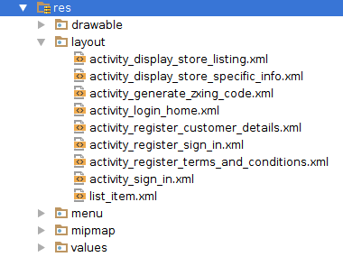 | - /drawable → graphic files, e.g.: app and store logos.  - /layout → Specific layout for each activity.  - /menu → any menu specific files, e.g.: activaty bar layout.  - /values → resource files for the app, e.g.: strings.xml.
Table 1:1 – Directory Structure (high-level overview of project structure as implemented)

App Flow – Changes to Common Implementation
This section details any common changes with the app flow or functionality.

Reasons Why?
Remove :  Bottom bar | I removed the bottom bar for [Home], [Logoff] and [Close]. I instead added an Overflow Icon in the Action Bar, thus I then had the same functionality on each page and just checked that the customer was signed in (otherwise could not [Logoff]). I also changed the action name from [Logoff] to [Sign Out] to better match the initial option of [Sign In].
Remove :  Cancel Registration | This activity was removed and replaced with an option in the Acttion Bar.  This functionality was added to the Overflow menu present in every activity once the customer signs in or registers. Thus this functionality was easily accessible all the time and not just at one point in the process. The user is asked to confirm his/her password as additional confirmation.
Remove :  Facebook Login | I did not have time to implement this. If this app is developed further (if some shops are interested) then it would be a good feature to have as the customer would not need to remember another login name and password. It would require updates to the database to validate live against Facebook as it would not be ideal to save the password and user name locally or in SQLite (the customer could update directly in Facebook or delete his/her facebook account).
Add :  Color Schemes | [ New User ] → [ Existing User ] → [ Shops ]  This ensured that each customer interaction was easily recognised. Different colour implies different functionality and requirements on the customer and app.

Advantages of Changes Made
Remove :  Bottom bar | Better use of screen space and the bottom of each screen was now available for the main layout. This also resulted in a cleaner display which is more in keeping with today's apps.
Remove :  Cancel Registration | Removal of one activity – reduce app size and also simplify usage for the customer, just click the drop-down option to 'Yes! I want to cancel my registration.'
Remove :  Facebook Login | None really as it is reduced functionality. However it does simplify the app for the first iteration.
Add :  Color Schemes | Improved appearance and customer should find it easier to recognise where he/she is when using the app.

Disadvantages of Changes Made
Remove :  Bottom bar | It is always possible to split the Action Bar where the screen size ensures thant doing so improves legibilty
Remove :  Cancel Registration | None really.
Remove :  Facebook Login | Reduced functionality.
Add :  Color Schemes | Meant that rounded cell shapes had to be duplicated for each colour scheme – taking more time to complete and also that I had to ensure the corrent one was used in the appropriate activity / situation.

App Usage – Devices & Orientations / Layouts
Phone – typical | I restricted orientation to portrait as landscape does not really make sense when completing a form. The QR-Code was also generated in portrait layout while the Bar-code was generated as landscape only. The orientation reverted to portrait once the user returned to the previous activity or to home via the Activity Bar.
Tablet | The only difference between a phone and Tablet implementation is the QR-Code / Bar-code is created to the right-hand side of the store listing.  I retained registration of customer details activity and that to register signin details (name and password) as separate activities. Thus more customer information may be requested at a later stage without impacting current design and also perhaps training videos on usage or an introductory offer from the store the customer is located in could be added to the right-hand side of the Register SignIn Activity later on.
Phone – small | Not covered as after checking on ZXing and displays on the small phones, the screen is too small for the bar-code or the QR-code to be legible for the scanners.  Depending on the number of older devices in user and by whom (core customer group?), it may be required to send the bar-code using digits only by SMS or email. However, this would need to be looked at as the shop assisstant would need to type in the code and this could slow down check-outs.

Project Run-through

Activity – Welcome

What this activity does?
Home activity – this is first layout of the app where an existing user signs back in or a new user begins the registration process.

View : Mock-up -V- Actual
Mock-up | Actual
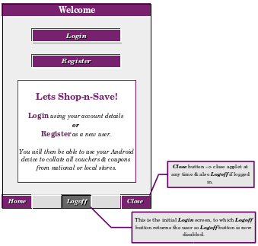
Table 2:1 – Lunar Store intial screen → Welcome screen
Difference/s | Common updates (see : App Flow – Common Discrepancies) and the following :  - The buttons were relocated to underneath the introductory text.  - The name of the app was changed.
Reason/s | - The user will read from top to bottom so it makes more sense to have buttons underneath the introduction.  - No real reason just want a moon for an app logo.

Code : LoginHomeActivity.java
LoginHomeActivity.java contains methods called for onClick listener for each button :
[ Register ] | Opens RegisterTermsAndConditionsActivity  Opens the T&C activity → once the new user agrees to the T&Cs as proposed, he/she can then register personal details and options in a new activity, followed by user name (unique) and password in a subsequent activity.  This listener, if implemented, calls the method :  public void registerNewUser(View view) {  Log.d(CLASS_NAME, "\t: register as new user, call new layout ...");  Intent intentRegister = new Intent(getApplicationContext(),  RegisterTermsAndConditionsActivity.class);  startActivity(intentRegister);  }
[ Sign In ] | Opens SignInActivity  An existing user opens the sign-in activity and logs in using an existing user name and corresponding password.  This listener, if implemented, calls the method signInExistingUser, which calls the class SignInActivity.java with the intent intentSignin.

Layout : activity_login_home.xml
A <LinearLayout> was used for the overall display and all informational text strings were displayed using <TextViews>. In addition, there are two <Button>'s and each has an OnClick listener :
[ Register ] was formatted using drawable/cell_round_navy.xml, and had an OnCLick listener to call the RegisterContactDetails activity
[ Sign In ] was formatted using drawable/cell_round_purple.xml, and had an OnClick listener to call the SignIn activity

Activity – Terms & Conditions (New User)

What this activity does?
Displays a summary of the Terms & Conditions to the potential customer. The user is asked to confirm that he/she has read and also understood the T&C's before the [ I Do Agree ] button is enabled. When clicked this button causes the RegisterContactDetails activity to open. The [ I Don't Agree ] button is always enabled and closes the app. As the user has not entered any details, there is no need to clear any information.

View : Mock-up -V- Actual
Mock-up | Actual
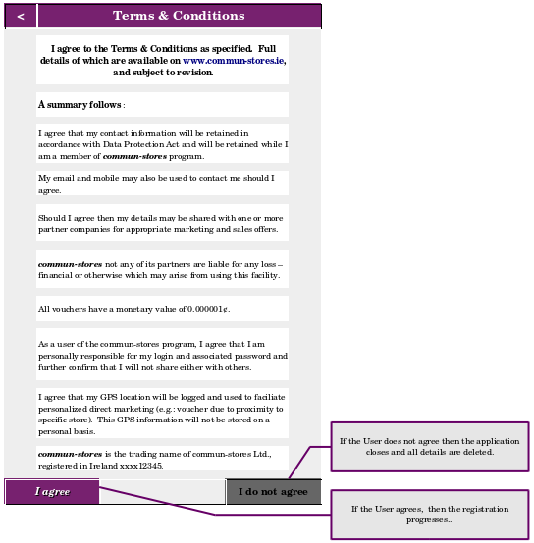
Table 2:2 – Register New Customer → Agree to T&Cs
Difference/s | Common updates (see : App Flow – Common Discrepancies) also the flow was changed.  From : 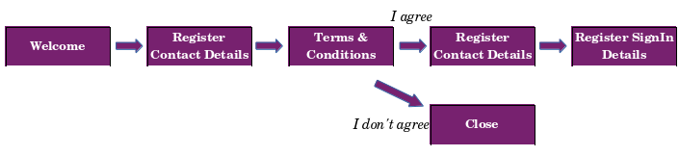  To : 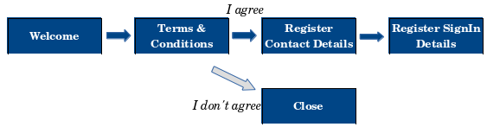
Reason/s | The user goes immediately to T&Cs and can decide if Lunar Stores is a viable app to use. Also, no details need to be stored and thus deleted if the user chooses [ I Don't Agree ] button. Until the user clicks on 'I confirm that I have read and understood the T&Cs', the [ I Do Agree ] button is disabled. Once clicked, RegisterCustomerDetails activity opens.

Code : RegisterTermsAndConditionsActivity.java
LoginHomeActivity.java contains an onClickListener for each button :
[ I Do Agree ] | Opens RegisterContactDetailsActivity  This listener, if implemented, calls the method AgreeToTermsAndConditions which basically opens the activity to register new customer activity.  public void AgreeToTermsAndConditions(View view) {  Log.d(CLASS_NAME, "\t: Agree to T&C's, call new layout ...");  Intent intentRegisterDetails = new Intent(getApplicationContext(),  RegisterCustomerDetailsActivity.class);  startActivity(intentRegisterDetails);  }
[ I Don't Agree ] | Closes the app → basically calls finish() and closes database if open.  public void DoNotgreeToTermsAndConditions(View view) {  Log.d(CLASS_NAME, "\t: Do Not Agree to T&C's, finish ...");  finish();  }

Layout : activity_register_terms_and_conditions.xml
A <TableLayout> was used for the overall display. This was embedded in a <ScrollView> ensuring that any items off screen initially could be scrolled to by the user.
In order to fake the bullets in the left cell using drawable/cell_round_nay_bullet.xml. All T&C text strings were displayed using <TextViews>, and Multiple Line display was enabled in case needed – depending on device.
<TableRow … … … … >
<TextView
android:id="@+id/textViewTandCBullet01"
android:background="@drawable/cell_round_navy_bullet"
android:textColor="@color/grey_pale"
android:textStyle="bold"
android:text="@string/tvTandCsBullet"
android:gravity="center_horizontal" > </TextView>
<TextView
android:id="@+id/textViewTandC01"
android:padding="5dp"
android:text="@string/tvTermConditions01"
android:textAppearance="@android:style/TextAppearance.Small"
android:maxLines="10"
android:singleLine="false"
android:textStyle="italic"
android:ems="5"
android:layout_weight="1" > </TextView>
</TableRow>
Where no bullets applied then the string spanned two cells, with a null spacer in the first cell.
<TableRow … … … ... >
<TextView
android:id="@+id/nullStr01"></TextView>
<TextView
android:id="@+id/textViewTandCsString01"
android:textColor="@color/blue_dark"
android:background="@color/grey_pale"
android:textStyle="bold"
android:maxLines="5"
android:singleLine="false"
android:text="@string/tvTermConditionsIntro01"
android:padding="5dp"
android:layout_span="2"
android:layout_weight="1" > </TextView>
</TableRow>
There are two <Button>'s and each has an OnClick listener :
[ I Do Agree ] was formatted using drawable/cell_round_navy.xml,
[ I Don't Agree ] was formatted using drawable/cell_round_grey.xml.

Activity – Register Customer Contact Details (New User)

What this activity does?
The user must first agree to the T&Cs, only then is he/she allowed to enter any contact details to the SQLite database. Once the user has entered contact information and checked (or not) SMS, Email or 3rd party contact then he/she may click on Submit, the data is retained and the new customer is then in this activity, is asked to provide a user name and password.
Rather than detailed help functionality – separate ReadMe or help activity – I used hints for each <EditText> field.

View : Mock-up -V- Actual
Mock-up | Actual
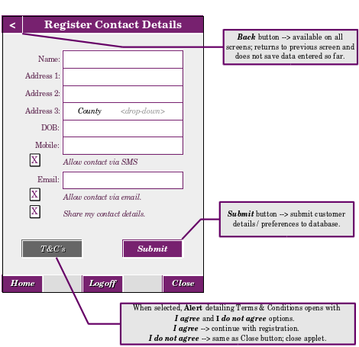
Table 2:3 – Register Customer New Customer → Contact details with blank details
Table 2:4 – Register New Customer → Contact details with fields and check boxes completed
Difference/s | Common updates (see : App Flow – Common Discrepancies) also the flow was changed.  It was initially thought to have all <TextEdit> and <CheckBox> disabled until the T&C's had been agreed to. This was changed to a flow revision, which is explained in section View : Mock-up -v- Actual of Activity – Terms & Conditions (New User)
Reason/s | Improve flow by moving T&C's and also improved functionality / user experience by implementing common updates.

Code : RegisterContactDetailsActivity.java
[ Submitt ] | The customer details as entered are validated and if okay are added to an intent which is sent to a new activity where he/she provides user name (unique) and password.  public void SubmitCustomerDetails(View view) {  Log.d(CLASS_NAME, "\t: accept and save customer details, call new layout...");  Intent intentRegisterDetails = new Intent(getApplicationContext(),  RegisterSignInActivity.class);  intentRegisterDetails.putExtra(CUST_NAME1, etName1.toString());  intentRegisterDetails.putExtra(CUST_NAME2, etName2.toString());  intentRegisterDetails.putExtra(CUST_ADDRESS1, etAddress1.toString());  intentRegisterDetails.putExtra(CUST_ADDRESS2, etAddress2.toString());  intentRegisterDetails.putExtra(CUST_ADDRESS3, etAddress3.toString());  intentRegisterDetails.putExtra(CUST_ADDRESS4, etAddress4.toString());  intentRegisterDetails.putExtra(CUST_EMAIL, etEmail.toString());  intentRegisterDetails.putExtra(CUST_MOBILE, etMobile.toString());  intentRegisterDetails.putExtra(CUST_EMAIL_OKAY, emailOkay);  intentRegisterDetails.putExtra(CUST_MOBILE_OKAY, smsOkay);  intentRegisterDetails.putExtra(CUST_3PARTY_OKAY, thirdPartyOkay);  validateActivityFields();  startActivity(intentRegisterDetails);  }
[ Clear All ] | All <EditText> strings as entered, are cleared, for example :  etName1.getText().clear();  All <CheckBox> as clicked, are cleared, for example :  chkAllowSMS.setChecked(false);  Values of <CheckBox> for SQLite database are also reset to 0 → false, for example :  smsOkay = 0;
There are also private validation methods; e.g.: REGeX of strings entered, Email is valid form using android.util.Patterns, if allow contact by email is clicked that an email is provided; which are used by validateActivityFields(). Validation is only completed once the user clicks the [ Submitt ] button.
The values for the <EditText> fields and the equivalent int values for SMS, Email and 3rd Party contact allowed (true = 1 | false = 0) are saved for later addition to the database.
As previously, the Action Bar was created and as the user has not yet registered, the <De-Register> option is not available.

Layout : activity_register_contact_details.xml
Again, I used a <TableLayout> embedded in a <ScrollView>with column 1 used for titles like, <Name>, <Address>, <Mobile>, and <Email>. These were all <TextField> formatted using drawable/cell_round_navy.xml. Column 2 contained the <EditText> fields which were used to retrieve the customers contact details. Column 2 was also used for the <CheckBox> options permitting contact via SMS, Email or from 3rd parties. Two buttons applied :
[ Submitt ] was formatted using drawable/cell_round_navy.xml, and had an onClick listener assigned.
[ Clear All ] was formatted using drawable/cell_round_grey.xml, and had an onClick listener assigned.

Activity – Register SignIn Details (New User)

What this activity does?
The new customer provides a user name and password, which is confirmed to ensure the user knows what he/she typed. The original password and the confirmation password are checked if equal, if not the user is asked to re-input them. The customer name is checked that it is lower case. Finally, both user name and login are checked for uniqueness. Once all validations are completed, the user contact details as well as user name and password are added to the SQLite database.

View : Mock-up -V- Actual
Mock-up | Actual
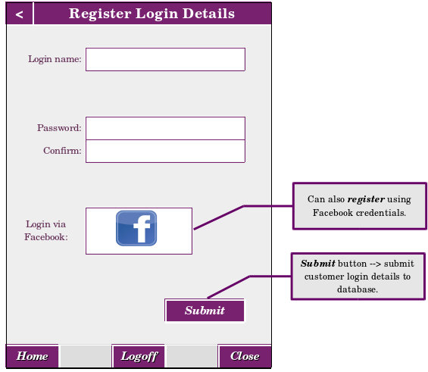
Table 2:5 – Register New Customer → Add login details
Difference/s | Common updates (see : App Flow – Common Discrepancies).
Reason/s | N/A

Code : RegisterSignInDetailsActivity.java
In the previous activity the user provided his contact details which were validated for not Null, length and adhering to REGeX formatting (email, phone, etc.). No details were validated against the database. A customer may want the option of opening a second account, thus duplication of contact details is not relevant. However, sign-in details must be unique, so the user name and password must not exist in the database already. If either is duplicated then the customer is advised that eitheruser name and password is duplicated and to retry.
Again validation is completed once the Submitt button is clicked.
[ Submitt ] | The customer user name and password as entered are validated and if okay are added the SQLite datebase for that customer, all previously entered details are also added to the customer.tb table. The store listing activity now opens and the customer may start using the app.
[ Clear All ] | User name and password (Enter and confirm) are reset to the defaults.  etNewUser.getText().clear();

Layout : activity_register_sign_in_details.xml
Again, I used a <TableLayout> with column 1 used for titles <User Name> and <Password>. These were all <TextField> formatted using drawable/cell_round_navy.xml. The <TableLayout> was enclosed in a <ScrollView> in case needed. Column 2 contained the <EditText> fields which were used to retrieve the customers user name, initial password and confirmation password for confirmation. As previously, there were two buttons :
[ Submitt ] was formatted using drawable/cell_round_navy.xml, and had an onClick listener assigned.
[ Clear All ] was formatted using drawable/cell_round_grey.xml, and had an onClick listener assigned.

Activity – Sign In (Existing User)

What this activity does?
The existing user signs in using an existing user name and password. The Store Listing activity then opens with existing information and points saved to date listed.

View : Mock-up -V- Actual
Mock-up | Actual
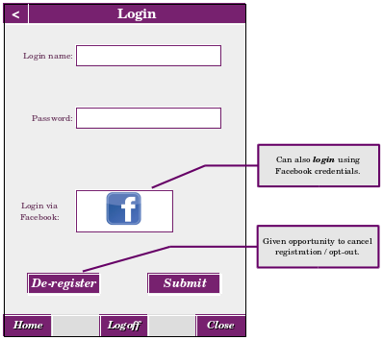
Table 2:6 – Existing User SignIn
Difference/s | Common updates (see : App Flow – Common Discrepancies) and De-register was moved to the common Action Bar. Also as in Register Customer Login Details, a Clear All button was added to reset Login Name and Password to default values.
Reason/s | Improved functionality and ease of customer use.

Code : SignInActivity.java
The user provides his/her sign-in name and associated password which are validated for not Null, and against the database. Again validation is completed once the Submitt button is clicked.
[ Submitt ] | The customer user name and password as entered are validated against the SQLite datebase for that customer. If valid then the store listing activity now opens and the customer may start using the app.
[ Clear All ] | User name and password are reset to the defaults, for example :  etNewUser.getText().clear();

Layout : activity_sign_in.xml
Again, I used a <TableLayout> with column 1 used for titles <User Name> and <Password>. These were all <TextField> formatted using drawable/cell_round_purple.xml. The <TableLayout> was enclosed in a <ScrollView> in case needed. Column 2 contained the <EditText> fields which were used to retrieve the customers name and password. As previously, the two buttons :
[ Submitt ] was formatted using drawable/cell_round_purple.xml, and had an onClick listener assigned.
[ Clear All ] was formatted using drawable/cell_round_grey.xml, and had an onClick listener assigned.

Activity – Cancel Registration (Existing User)

View : Mock-up -V- Actual
Mock-up | Actual
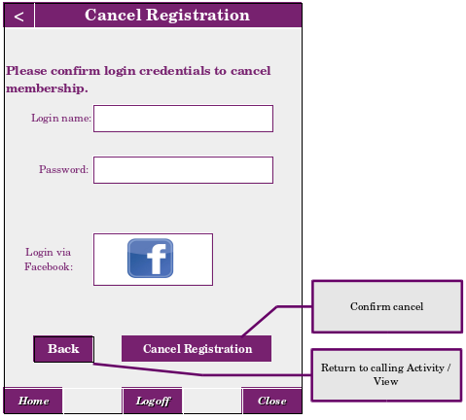
Table 2:7 – Cancel Registration Activity - replaced with ActionBar OverFlow menu option.
Difference/s | Deleted activity altogether, used an Alert instead.
Reason/s | The user has already logged in, so it makes more sense to just use an option in the Activity Bar drop down and request the use to confirm his/her request to cancel registration.

Activity – Store Listing : Add / Use (New & Existing Users)

What this activity does?
Provides a listing (i) stores the customer collects points from currently and listing (ii) additional stores available. Customer then selects a store from listing (i) to see current balance and use points if applicable and if wished and from listing (ii) to add that store to the list of stores he/she collects points from.

View : Mock-up -V- Actual
Mock-up | Actual
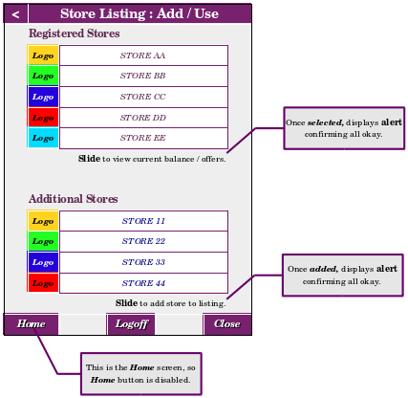
Table 2:8 – Store Listing → those in use and additional ones available.
Difference/s | - Common updates (see : App Flow – Common Discrepancies).  - Slide was not enabled, click on the list item was instead.
Reason/s | - N/A → see earlier  - Easier for user to note what item he/she selected and thus less liklihood of error on smaller screens.

Code : DisplayStoreListing.java

Layout : activity_display_store_listing.xml

Activity – Store Status [store_name] (New & Existing User)

What this activity does?
This displays current poinsts available and also any money-off or %-off vouchers which may be redeemed for the selected store. If any available vouchers is selected by the customer then a QR-code or Bar-code (depending) on user selected is generated in the next activaty.

View : Mock-up -V- Actual
Mock-up | Actual
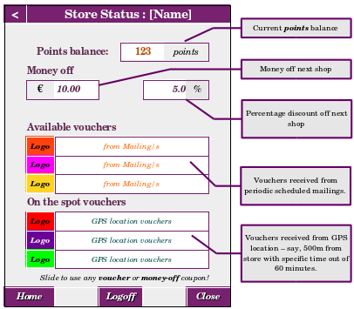
Table 2:9 – Store Status - available points and offers.
Difference/s | Common updates (see : App Flow – Common Discrepancies).
Reason/s | N/A → see earlier

Code : DisplayStoreSpecificInfo.java

Layout : activity_display_store_specific_info.xml

Activity – Bar-code (New & Existing User)

What this activity does?
This displays the QR-code or the Bar-code for the selected voucher.

View : Mock-up -V- Actual
Mock-up | Actual
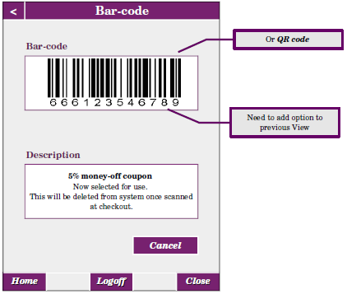
Table 2:10 – Generate QR-Code & Bar-Code for selected item.
Difference/s
Reason/s

Code : GenerateZXingCodeActivity.java

Layout : activity_generate_zxing_code.xml

Common Files used

XML files
values/  strings.xml | This is a listing of all strings used in the project : Button, CheckBox, EditText, TextView, Hint.  Some strings were formatted for HTML display <b> … </b>, other strings used formatting via the layout .xml file (TextSize, TextAppearance, etc). This meant that theoretically in a real app – any updates to the contents of or display of any string could be completed by a UX engineer.  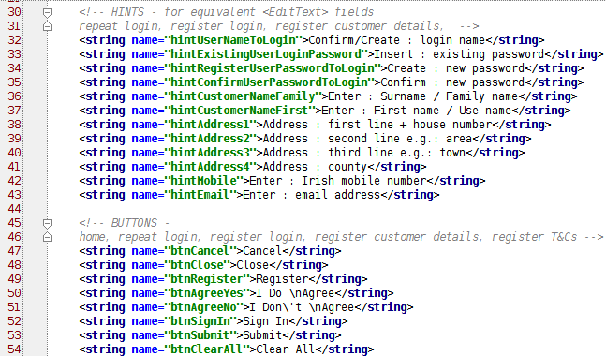
values/  colors.xml# | This file contains all colors used in the project. Having a common file for use throughout ensured that any variants in shading were applied to all usages.  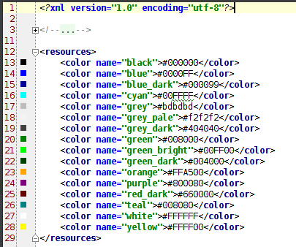
Table 2:11 – Common XML files in the app.
Rounded buttons were used throughout to ensure contenuity throughout the app and to provide a common look-n-feel. The easiest way to do so was to define a drawable shape, with specific colour depnding on where is app flow customer is.
drawable/  cell_round_green.xml | Green was used for stores  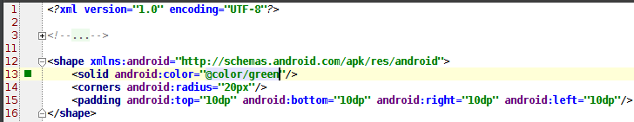
drawable/  cell_round_purple.xml | Purple was used for existing customers.  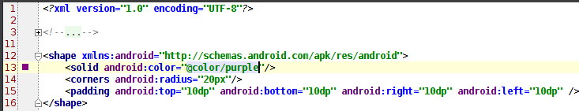
drawable/  cell_round_navy.xml | Navy was used for new customers.  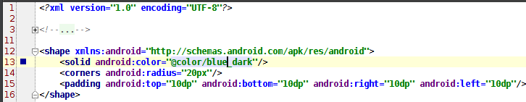
drawable/  cell_round_black.xml | Black was used for Lunar Stores references.
drawable/  cell_round_grey.xml | Grey was used for Cancel, No, etc.
drawable/  cell_round_navy_bullet.xml | This was used to fake the bullets for the Terms & Conditions activty – only difference between this and drawable/cell_round_navy.xml is the size of the padding "10dp" → "2dp".
Table 2:12 – Common table titles and button formatting XML files in the app.

SQLite Files
DataBaseHelper.java | This works on the database itself for onCreate object (is it a new or existing database?) and onUpgrade (structure changes, version incremented, version decremented).  public void onCreate(SQLiteDatabase db) {  Log.d(CLASS_NAME, ":\t onCreate - create three tables in SQLite  database...");  db.execSQL(CREATE_TABLE_STORE);  db.execSQL(CREATE_TABLE_CUSTOMER);  db.execSQL(CREATE_TABLE_SHOP_FOR_CUSTOMER);  }  and  public void onUpgrade(SQLiteDatabase db, int oldVersion,  int newVersion) {  Log.d(CLASS_NAME, ":\t onUpgrade inc. recreate three tables for  SQLite ...");  db.execSQL("DROP TABLE IF EXISTS " + TABLE_STORE);  db.execSQL("DROP TABLE IF EXISTS " + TABLE_CUSTOMER);  db.execSQL("DROP TABLE IF EXISTS " + TABLE_SHOP_FOR_CUSTOMER);  onCreate(db);  }  Basically, the SQLite Schema!
DatabaseAdapter.java | This is responsible for managing the SQLite database data. It is used by the app to insert, update, delete and query data from the SQLite database tables : customer.tb, store.tb and shop4customer.tb. Basically, CRUD functionality as well as close the database once done.  For example : delete data from a table using the PK (id) for the table :  public void deleteStore(long store_id) {  Log.d(CLASS_NAME, ":\t delete store for specified store id ...");  SQLiteDatabase db = dbHelper.getWritableDatabase();  db.delete(TABLE_STORE, KEY_ID + " = ?", new String[]  { String.valueOf(store_id) });  }
Table 2:13 – 3-Level SQLite files as applied.

Store ListView Files
StoreAdapter.java | Adapter for the store items for the listing :  public View getView(int position, View view, ViewGroup parent) {  StoreHolder storeHolder = null;  LayoutInflater layoutInflater = (LayoutInflater)  context.getSystemService(Activity.LAYOUT_INFLATER_SERVICE);  if (view == null) {  view = layoutInflater.inflate(R.layout.list_item, null);  storeHolder = new StoreHolder();  storeHolder.image_icon = (ImageView)  view.findViewById(R.id.image_icon );  storeHolder.text_store = (TextView)  view.findViewById(R.id.text_store );  view.setTag(storeHolder);  } else {  storeHolder = (StoreHolder) view.getTag();  }  StoreItem storeItem = getItem(position);  storeHolder.image_icon.setImageResource(storeItem.icon);  storeHolder.text_store.setText(storeItem.store );  return view;  }
StoreItem.java | Constructor for each store as listed in the activity DisplayStoreListingActivity.
activity_display_store_listing.xml | This uses a <ListView> which is populated using the image and name from list_item.xml :  <ListView  android:id="@+id/storeList"  android:layout_width="match_parent"  android:layout_height="wrap_content"  android:gravity="center_vertical"  android:padding="10dp" ></ListView>
list_item.xml | This contains a placeholder for each row of the store listing for image on left-hand side and store name on right-hand side of each row:  <ImageView  android:id="@+id/image_icon"  android:layout_width="80dp"  android:layout_height="80dp"  android:layout_alignParentBottom="true"  android:layout_alignParentTop="true"  android:layout_marginBottom="5dp"  android:layout_marginLeft="10dp"  android:layout_marginRight="10dp"  android:layout_marginTop="5dp"  android:contentDescription="@string/icon" > </ImageView>  <TextView  android:id="@+id/text_store"  android:layout_width="fill_parent"  android:layout_height="fill_parent"  android:layout_alignParentBottom="true"  android:layout_alignParentTop="true"  android:gravity="center_vertical|center_horizontal"  android:padding="5dp"  android:textSize="30sp"  android:textStyle="bold"></TextView>
Table 2:14 – ListView files as used by the Store activities.

Technologies

Technologies Planned

SQLite database software library Overview
 | SQLite is a software library that implements a self-contained, server-less, zero-configuration, transactional SQL database engine. SQLite is the most widely deployed SQL database engine in the world. The source code for SQLite is in the public domain. [1]  Each Android App has its own SQLite database and is available only to that app and no others on the device thus enabling a more secure implementation.
SQLite as other SQL based database system that also adheres to the SQL principles of :
Atomicity | All or nothing – if one part of the transaction fails then all fails (e.g.: if customer surname is invalid or not present then no data for that new customer is written to customer.tb.
Consistency | For each transaction, the database is in a valid state for before and after the transaction is implemented.
Isolation | Running transactions simultaneously is the same as running one after the other – each is implementation independently of the other.
Durability | Once a transaction is completed, it is present in the database regardless of device system failures, etc.

ZXing Overview
 | ZXing ("zebra crossing") is an open-source, multi-format 1D/2D barcode image processing library which is implemented using Java. There is functionality for other languages also. It was initially developed in Japan about 1994 for car manufacturing.  Formats supported incldue 1-D product, 1-D industrial and 2-D. For this project, I used :  - QR-Code → 2-D = QR-Code  - Bar-Code → 1-D industrial = Code-128
Android Components present in the latest release and those needed for this Android project are :
core | The core image decoding library, and test code
javase | JavaSE-specific client code
android | Android client Barcode Scanner Barcode Scanner
androidtest | Android test app, ZXing Test
android-integration | Supports integration with Barcode Scanner via Intent
android-core | Android-related code shared among android, androidtest, glass
glass | Simple Google Glass application
zxingorg | The source behind zxing.org
zxing.appspot.com | The source behind web-based barcode generator at zxing.appspot.com
There are certain permissions which are required when ZXIng is incorporated into an app for bar-code and/or QR-code generation or usage. These are implemented in the AndroidManifest.xml file and are :
android.permission.  CAMERA | read → Use the device’s photo camera for reading the barcode  e.g.: <uses-permission android:name="android.permission.CAMERA"/>
android.permission.  VIBRATE | read / write → Report that the product was successfully read / writtern
android.permission.  FLASHLIGHT | read → Better view of the barcode
android.permission.  WAKE_LOCK | read / write → Maintain the application open, until the scanning operation is successfully done
android.permission.  WRITE_EXTERNAL_STORAGE | read / write → Allow app to write bitmap to device for QR-code or for Bar-code.
Table 3:1 – android.permissions options available.
I implemented ZXing to generate the bar-code and/or the QR-code for the voucher or money-off coupon. ZXing may also be used to read either bar-code or QR-code using the phone's or the tablet's camera.

Encryption of User Data
Boton  | http://botan.randombit.net/  This was ruled out as this is aimed at C++ developers. Even though, it is released under a very open free BSD-2 license (see : http://botan.randombit.net/license.html for more information), it is not applicable to Android development..
SEE  | SQLite Encryption Extension  http://www.hwaci.com/sw/sqlite/see.html  Again, this was ruled out due to licence fees – a perpetual licence costs US$ 2,000.
SQL ciper | https://www.zetetic.net/sqlcipher/  https://www.zetetic.net/sqlcipher/sqlcipher-for-android/ → how to use in Android app  This was the one chosen as it is basically an extension to SQLite. SQLCipher also employs 256-bit AES encryption of database files and it works on Linux and is free of charge (open source licence)..
SQLiteCrypt  | http://sqlite-crypt.com/documentation.htm  This was ruled out as this is licenced.  The licence fee is curently US$128 ("one platform binary").
WxSQLite  | http://sourceforge.net/projects/wxsqlite/  This is suited to MAC and to WOS operating systems as I used Ubuntu, it is not applicable.
Table 3:2 – encryption options evaluated

Ensuring Secure Login – Users
<TO DO>
http://www.androidcentral.com/android-security-and-you

Technologies Actually Used

SQLite database
SQLite is based on SQL which is explained as follows :
 | Structured Query Language (SQL) is a language used to create new, access existing, query existing, and update existing relational databases. A relational database has one or more tables with a unique identifier for each row of all tables.  Data is retrieved from a table or multiple tables using the main SQL commands [5] :  - SELECT extracts data from a database  - UPDATE updates data in a database  - DELETE deletes data from a database  - INSERT INTO inserts new data into a database  - CREATE DATABASE creates a new database  - ALTER DATABASE modifies a database  - CREATE TABLE creates a new table  - ALTER TABLE modifies a table  - DROP TABLE deletes a table
SQLite was used as it is a standalone database system which is compact and suited to use on Android or iOS devices. There are two .java files used to define and use the SQLite database and these are explained in the section : SQLite Files.

SQL Table as implemented – CUSTOMER.TB
customer.tb contains customer information for every customer : name, address, date of birth (as some offers may be specific to over 18yo or to over 21yo), sign-up date, contact information and confirmation that the contact information may or may not be used for additional offers or marketing. This table also stores the customer's login name and login password and also interacts with both tables store.tb and with shop4customer.tb. Each customer has a unique identifier in the table – the primary key = customer_id. This is an automatically incremented integer. Finally, customer.tb contains boolean confirmation if the customer has signed up to shop1, shop2, etc. for vouchers and money-off.
customer.tb was created using SQLite which applied the following SQL to do :
CREATE TABLE customer (
"Customer_ID" INTEGER NOT NULL,
"Customer_Name1" TEXT NOT NULL,
"Customer_Name2" TEXT NOT NULL,
"Customer_Address1" TEXT NOT NULL,
"Customer_Address2" TEXT NOT NULL,
"Customer_Address3" TEXT,
"Customer_Address4" TEXT NOT NULL,
"Customer_DOB" TEXT NOT NULL,
"Customer_EMail" TEXT,
"Customer_EmailOK" INTEGER DEFAULT ('0|1'),
"Customer_Mobile" TEXT,
"Customer_MobileOK" INTEGER DEFAULT ('0|1'),
"Customer_3partyOK" INTEGER DEFAULT ('0|1'),
"Customer_Login" TEXT NOT NULL,
"Customer_Password" TEXT NOT NULL
);
It was pre-populated with five customers :
id=1
id=2
id=3
id=4
id=5

SQL Table as implemented – STORE.TB
store.tb contains information on each shop which has signed up the scheme : name, logo, address, contact number, contact email, name of main contact, name of backup contact, date shop joined the scheme and date shop left scheme. Each shop has a unique identifier in the table – the primary key = store_id. This is an automatically increment integer. If the shop leaves Lunar Stores then no more additional points may be collected after this date and a 3-month cut-off applies to usage of any points via the scheme. Initially, this is assigned the start date -1, so if the end date is < start date then the store is active.
The table store.tb was created using SQLite as follows :
CREATE TABLE store (
"Store_ID" INTEGER NOT NULL,
"Store_Name" TEXT NOT NULL,
"Store_Logo" TEXT NOT NULL DEFAULT ('app_logo.png'),
"Store_Address1" TEXT NOT NULL,
"Store_Address2" TEXT NOT NULL,
"Store_Address3" TEXT,
"Store_Address4" TEXT NOT NULL,
"Store_ContactName1" TEXT NOT NULL
"Store_ContactName2" TEXT NOT NULL,
"Store_ContactEmail" TEXT NOT NULL,
"Store_ContactNumber" TEXT NOT NULL,
"Store_DateStart" TEXT NOT NULL DEFAULT ('CURRENT_DATE "DD-MM-YYYY"'),
"Store_DateEnd" TEXT DEFAULT('CURRENT_DATE "DD-MM-YYYY"')
);
Initially, five shops were created and added to the database :
id=1
id=2
id=3
id=4
id=5

SQL Table as implemented – SHOP4CUSTOMER.TB
shop4customer.tb contains a direct 1-1 link between a shop in store.tb and a customer in customer.tb using the primary keys of customer_id and store_id respectively. shop4customer.tb has a primary key = shop4_id and again, this is an automatically increment integer.
The table shop4customer.tb was created using SQLiteManas follows :
CREATE TABLE "Shop4Customer" (
"Shop4_ID" INTEGER PRIMARY KEY AUTOINCREMENT NOT NULL,
"Customer_ID" INTEGER REFERENCES Customer(Customer_ID),
"Store_ID" INTEGER REFERENCES Store(Store_ID),
"Shop4_Points" INTEGER NOT NULL DEFAULT (0)
);
When a customer uses the app, all rows in the table shop4customer.tb containing that customer_id and a valid store_id indicate that store is available for use by that customer. All other stores are available for current or future selection. If another store is activated by the customer then a new row is added to the table and the customer may start collecting points having an initial value of 0 (nil) points. This balance is increased if the customer shops in that store or decreased if the customer uses available points to purchase a % or money-off voucher.
Again, the table was pre-populated with two shops allocated to three customers :
Cust=1
shop=1
Cust=1
shop=2
Cust=2
shop=1
Cust=2
shop=2
Cust=3
shop=1
Cust=3
shop=2

ZXing QR-Code & Bar-code Generation
Also, ZXing works on Android via Intents or by referencing the ZXing library. Intents are easier to implement but the customer must have ZXing preinstalled on his/her device. This involved the customer agreeing to a 3rd party product and additional download before he/she even gets to use Lunar Stores. Alternatively, and this was the method implemented for this project.
In order to use ZXing libreary, add this line to the dependencies section of the gradle.build file (ZXing is present in the Maven Public Repositories and may be retrieved from there) :
dependencies {
compile fileTree(dir: 'libs', include: ['*.jar'])
compile 'com.android.support:appcompat-v7:21.0.3'
compile 'com.google.zxing:core:3.1.0'
}
and then import the library in the usual fashion in the activity :
import com.google.zxing
There are minor differences between QR code and Bar-code Generation, mainly in image size, writer/reader, depending on where the *-code is a voucher generated for use in a store or is a code being read to increate customer points. Both, however are black and white so minimal RGB is required.

ZXing QR-code Generation
QR-Code uses com.google.zxing.Writer to create a new QRCodeWriter(), The BarCodeFormat is QR_CODE and of course the resulting Bitmap is square 150x150 pixels.
Creation of the Bitmap is the same as that for the Bar-Code pixels are generated for x,y co-ordinates for the full square and each pixel is black or white. The resulting bitmap is then displayed to the user for use.
ARGB_8888 is recommended for the Config of the resulting bitmap but as this is a Black & White image, pixelation will not be lost if RGB_565 is used instead.

ZXing Bar-code Generation
Bar-Code uses com.google.zxing.MultiFormatWriter to create a new MultiFormatWriter(), The BarCodeFormat is CODE_128 and of course the resulting Bitmap is rectangular 180x40 pixels.

Encryption of User Data
<TODO> SQL ciper overview and how implemented.

Ensuring Secure Login – Users
Unique user name and password was required for each user. If a user created a second account with the same contact details, he/she was permitted to do so. For future iterations, it would be best to confirm that this was completed by email or SMS.
Also minimum requirements for user login name length and also password are required. I don't this that applying more stringent sign-in requiremets, for example : alpha-numeric password with no proper words allowed or requiring users to sign-in in provate would be viable. This is a consumer app, one that is designed to be used in a public venue – hopefully frequently. It will not be practical to apply as strong safe-guards as Banks.

What I would have used instead!
There are other database options available but SQLite is one which seems to be preferred for Adnroid delopment due to its low impact on memory during exection and saving. However, I found it somewhat lacking (no Foreign Keys, Triggers had to be manully implemented). This reduced ease of use for non-SQL experienced persons and also increases the overheads on maintenance of a live system.
<TODO> _id applicable?

SQLCipher is designed to work with SQLite and is readily integrated into new or existing code. However, there

Challenging / Interesting Features

What I thought would be challenging / interesting?
SQL / SQLite | I expected SQL / SQLite implementation to be of particular interest. Previously, I would have worked on SQL databases in Linux and it is only through this project that I realized how much knowledge I had lost.
ZXing | I expected this to be somewhat difficult to implement as most of the examples and documentation cover reading of QR-Codes and Bar-Codes and not generation. The actual implementation was reasonably okay, however whether this will work with shop bar-code / QR-code readers is not something I have tested so I don't know if the slight glare on some phone screens would impact use. It may be necessary to dim the screen before hand and reset it after the bar-code / QR-code is read t point of sale.
Encryption
Other

In the end – what was ?
SQL / SQLite | SQLite implementation was as interesting as I had expected it to be.
ZXing
Encryption
Other

If I had my time over – Would I do this project?
Yes but I would have been more specific on what I would accomplish in the time available. I would also have done more initial research into the technologies I thought appropriate. I also think that this has more commercial suitability that I had orginally envisaged and thus would have been better completed by a team, thus ensuring that more than one viewpoint was taken into consideration. I would also have partnered with a retail outlet for testing purposes, just to make sure it workds as planned. Finally, I would survey shoppers in various age-groups to see exactly what each needs. As what I have designed may not be what the market wants.

Conclusions / Final Comments
There are similar app's available on the market. One thing to note is that Android users seem concerned that companies are installing and upgrading apps without users registering for that app. Even if that app is dormant, upgrades are completed. For example; the Sansung app 'Beaming Service for Samsung'. This goes against privacy claims that many company Android app suppliers advocate and users request.
we are not Apple or Google, we will not retain your data without your permission (paraphrased)
This is the main reason that I design a registration activity as part of this app – if the user does not agree to the T&C's or if he/she re-registers then the app is disabled on his/her Android device. For future implementation, perhaps on de-registration the user can be offered an option to delete the app from the device, similarly this option could also be made available in the T&C activity.
This app if offered commercially would require more back-end support and implementation than I have provided. This is due to Data Protection and security concerns.
It may also be possible to enable a user to apply a bespoke background perhaps sponsoring a local organization or team (10% of points raised by the customer would go to that organization). This could be advertised by the customer through a background or color schema in the teams / schools colors.
3-Level SQLite was applied which would make it relatively easy to separate the database helper and adapter into separate package, this would be advisable for a commercial app. In this implementation, I just created separate packages for customer, store, database, etc. This could be amended with the addition Design Pattern Factories for additon of new users →
- multiple simultaneously – how handled?
- who takes priority if a duplicate login name
- complexity of passwrd required – I would expect a lot of people would use say 'Passw0rd', date of birth or the name of a local store for ease of re-call).

References
Ref. | Information | How used? / What for?
[1] | SQLite database software library  https://www.sqlite.org/ | Store customer and store information in separate database (.db) files.
[2] | SQLite tutorials  http://www.tutorialspoint.com/sqlite/  http://www.vogella.com/tutorials/AndroidSQLite/article.html  SQLite – multiple tables  http://www.androidhive.info/2013/09/android-sqlite-database-with-multiple-tables/  SQLite – ListView  http://www.mysamplecode.com/2012/07/android-listview-cursoradapter-sqlite.html | Introduction to applying SQLite (overview, multiple tables and listview)
[3] | SQLite training  https://www.sqlite.org/autoinc.html | Introduction to applying SQLite to project implementation.
[4] | Bar-code / QR-code Generation  https://github.com/zxing/  http://codeisland.org/2013/generating-qr-codes-with-zxing/ | Code for ZXing  Trainign for ZXing (not really well documented for generation on device)
[5] | SQL  http://www.w3schools.com/sql/default.asp | Introduction to SQL commands and usage.
[6] | Logos | Source material for logo's used for shop logos and thus icons
[7] | ListView – icon & text | ListView of stores for which points are collected or add a store to the list and start collecting points for it.
[8] | Tick-box / Check-box  http://examples.javacodegeeks.com/android/core/ui/checkbox-ui/android-checkbox-example/ | Tutorial - allow SMS, email & 3rd party contact customer
[9] | SQLCipher  https://www.zetetic.net/sqlcipher/  https://www.zetetic.net/sqlcipher/sqlcipher-for-android/ | Source material and training for SQLCipher (encryption for SQLite).
[10]

