COMP-40730 HPC

Report for Assignment 3

Author: | Paula Dwan
Due date: | 13-July-2014
Lecturer: | Alexey Lastovetsky
Subject: | COMP-40730 High Performance Computing
College: | University College Dublin

Contents
Contents 2
Exercise 3
Overview of Computations Obtained and How 4
Assignment Execution 5
Running A3-omp-1D : standalone 5
Log Files Obtained 5
GNUplot Execution 7
Summary Results : 9
GNUplot Graphs 9
Conclusions 10
Appendix I – Validate Results 12
Appendix II – Acknowledgements 13

Exercise

Write a parallel OpenMP program computing the norm of the product of two n×n dense matrices on a p-processor SMP so that
• p threads are involved in the parallel computations.
• The 1-dimensional parallel algorithm of matrix multiplication is employed:
– one of matrices is partitioned in one dimension into p equal slices
– there is one-to-one mapping between the partitions and threads
– each thread is responsible for computation of the corresponding slice of the resulting matrix
• Computation of the norm of the resulting matrix employs the mutex synchronization mechanism.

You can use BLAS or ATLAS for local computations.

Experiment with the program and build:
• The dependence of the execution time of the program on the matrix size n.
• The speedup over a serial counterpart of the program.

Explain the results.

Variants of the assignment:

1. Granularity of the program:
(a) Two successive steps:
i. Parallel matrix multiplication
ii. Parallel computation of the norm of the resulting matrix
(b) One-step algorithm. No intermediate resulting matrix.

2. Partitioning scheme:
(a) Left matrix is horizontally partitioned
(b) Right matrix is vertically partitioned

3. Matrix norm to be computed:
(a) The maximum absolute column sum norm (aka one-norm):
(b) The maximum absolute row sum norm (aka infinity-norm):
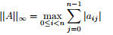

Overview of Computations Obtained and How
Assignment 3 basically involved (for me) writing one program which utilized open MP when calculating manually and BLAS when calculating otherwise. :
A3-omp.-1D.c
Algorithm  using additional variable | for (i=0; i<rows; i++)  {  for (j=0; j<cols; j++)  {  double sum = 0.0;  for (k=0; k<rows; k++)  {  sum+= (A [i][k]) * (B [k][j]);  }  C [i][j] = sum;  }  }
|C| matrix was calculated using the algorithm as covered in the first assignment. The same matrix computation was implemented using cblas. Time taken to calculate |C| and the infinity norm was noted and graphed.
This was completed using A3-omp-1D.c :
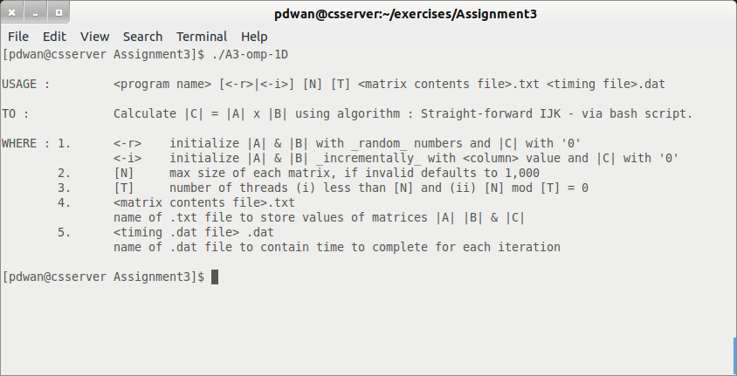
This is compiled using gcc and openmp:
[pdwan@csserver Assignment3]$ gcc -I/home/cs/khasanov/libs/CBLAS/src A3-omp-1D.c -o A3-omp-1D /home/cs/khasanov/libs/cblas_LINUX.a /usr/lib/libblas.a -lgfortran -fopenmp
and executed on a once off using (for example)
[pdwan@csserver Assignment3]$ ./A3-omp-1D -r 10 2 matrix2.txt timings2.dat
Where -r indicates random number generation (for 1 to 10) and -i indicates number of column + 1.

Assignment Execution
Each program was executed multiple times using the script ./runAssignment3.sh. This has multiple options and the syntax and usage follows:
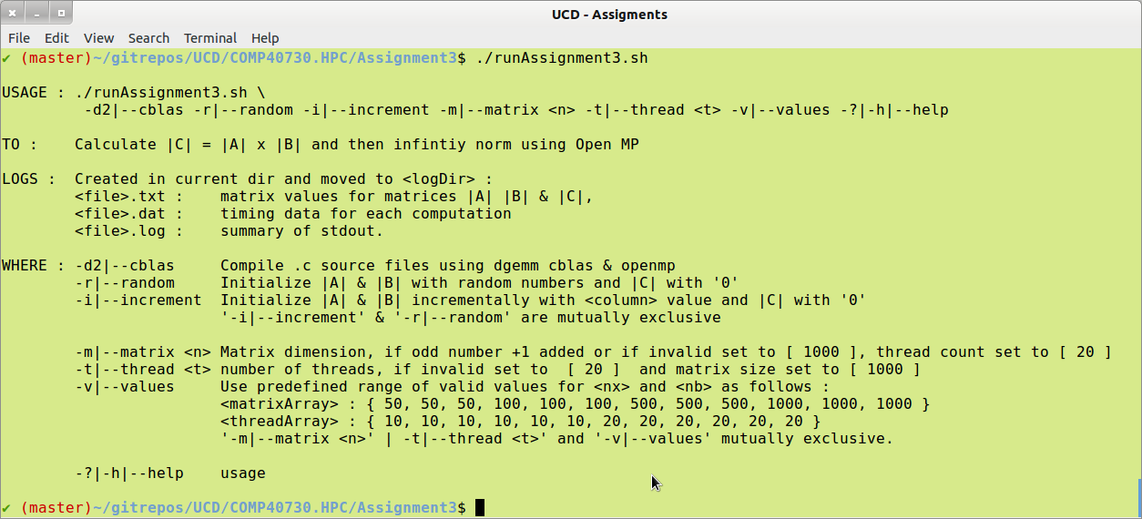
Execute this script in the home directory of Assignment 3.
Note: Please retain the overall directory structure when unzipping.
Note that the script ./runAssignment3.sh allows two types of implementation
- Multiple iteration : use the switch <-v|--values>, when a predefined range applies for [N] : matrix size and [T] : number of threads applicable.
- Single iteration : use the switch <-m|--matrix> [N] where the user specifies the values for [N] : matrix size and [T] : number of threads applicable.

Running A3-omp-1D : standalone
The compiled .c program may also be run standalone. Usage follows:
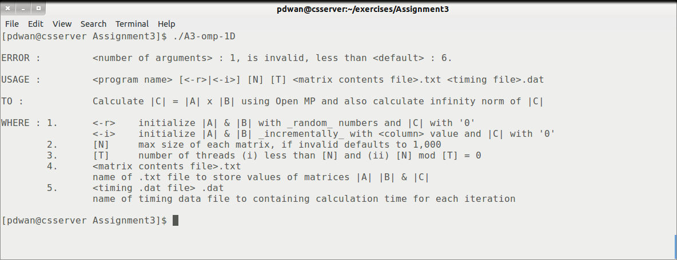

Log Files Obtained
Data text files suitable containing the values of the computation used for matrices |A| and |B| and the results stored in |C| are saved in the appropriate log files. File naming convention via the script is :
<data log file name> | pdwan-<time>—values-<A3-omp-1D->-<iteration>.txt
example: | pdwan-20140708.015835-values-A3-omp-1D-8.txt
Single iteration also applies where the user enters arbitrary, valid values for matrix size and does not use the scripts and the other required parameters.
A summary file containing processing time for each computation (manual and BLAS) for is also saved. This is in a format suitable for us with GNUplot.
<timing log file name> | pdwan-<time>—timing-<A3-omp-1D->-<iteration>.dat
example: | pdwan-20140708.015835-timing-A3-omp-1D-8.dat
Finally a log file containing <stdout> for the script was created.
If ./A3-omp-1D is used without the script then files may be named whatever the user wishes and no .log file applies.
Sample timings file :
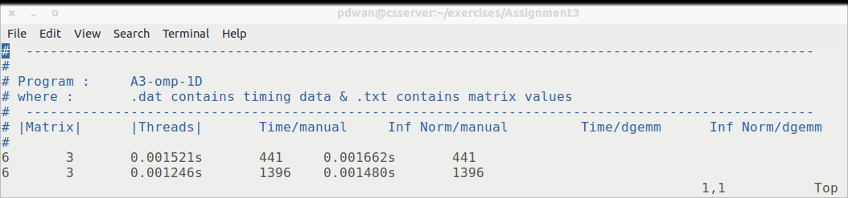
Sample Matrix values file:
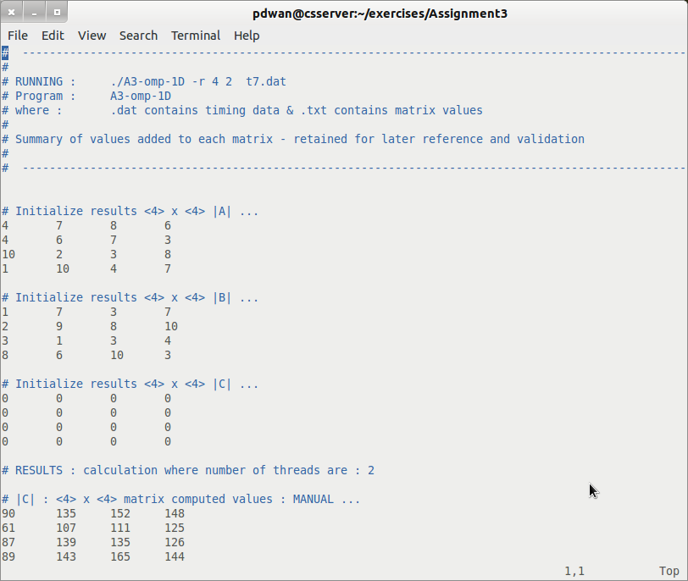
I wished to keep each .c program as clean as possible and so all production setup was completed in the script for each assignment. Thus file creation and validation for each iteration was completed before the .c program was even called. Simple validation of the arguments passed to each .c program is also completed.
I also spot-checked the results as practical. Results obtained are detailed in Appendix I – Validate Results.

GNUplot Execution
I followed the same convention for each .dat file as produced, an example follows :
Sample .dat file
Each was then presented in graphical format using GNUplot, comparing times taken for manual and for BLAS/ATLAS computations. A generic GNUplot program was written to output the data to the screen.
GNUplot program execution | # To execute, launch GNUplot and run :  # gnuplot> load <filename.gp>  # making sure that the data file name used is updated if needed.  # Paula Dwan : Assignment 3 : A3-plotgraph-matrix.gp  reset  set xtic auto  set ytic auto  set size 1,1  set grid  set key outside  #  set title 'Comparison : Matrix Size v time taken'  set ylabel 'Time taken / s'  set xlabel 'Matrix size'  set origin 0,0  plot 'logDir/pdwan-20140714.051601-data-A3-omp-1D.dat' u 1:3 t 'simple' w l lw 0.5 lc rgb 'blue', 'logDir/pdwan-20140714.051601-data-A3-omp-1D.dat' u 1:5 t 'dgemm' w l lw 0.5 lc rgb 'red'  #  pause -1  # Paula Dwan : Assignment 3 : A3-plotgraph-thread.gp  reset  set xtic auto  set ytic auto  set size 1,1  set grid  set key outside  #  set title 'Comparison : No of Threads v Time taken'  set ylabel 'Time taken / s'  set xlabel 'no of Threads'  set origin 0,0  set key outside  plot 'logDir/pdwan-20140714.052102-data-A3-omp-1D.dat' u 2:3 t 'simple' w l lw 0.5 lc rgb 'blue', 'logDir/pdwan-20140714.052102-data-A3-omp-1D.dat' u 2:5 t 'dgemm' w l lw 0.5 lc rgb 'red'  #  pause -1
Plotting the folliowing we get graphs for matrix size v time and also for no of threds v time (using -i so that each iteration uses the same values for A[i] and B[i] where I is the value of the column.
Matrix Size | no of Threads | Time / manual | Infinity Norm / manual | Time /dgemm | Infinity Norm / dgemm
10 | 2 | 0.000245 | 3025 | 0.000549 | 3025
10 | 2 | 0.002002 | 3025 | 0.002351 | 3025
10 | 2 | 0.001001 | 3025 | 0.001316 | 3025
20 | 2 | 0.001562 | 44100 | 0.002868 | 44100
20 | 2 | 0.000634 | 44100 | 0.001808 | 44100
20 | 2 | 0.000673 | 44100 | 0.001917 | 44100
30 | 10 | 0.000718 | 216225 | 0.002673 | 216225
30 | 10 | 0.000804 | 216225 | 0.003045 | 216225
30 | 10 | 0.000774 | 216225 | 0.003035 | 216225
40 | 10 | 0.001076 | 672400 | 0.004412 | 672400
40 | 10 | 0.001097 | 672400 | 0.004799 | 672400
40 | 10 | 0.001169 | 672400 | 0.004890 | 672400
50 | 10 | 0.001539 | 1.62562e+06 | 0.007291 | 1.62562e+06
50 | 10 | 0.001658 | 1.62562e+06 | 0.007325 | 1.62562e+06
50 | 10 | 0.001525 | 1.62562e+06 | 0.007136 | 1.62562e+06
Thankfully for Linux (Ubuntu) – I could install and run GNUplot locally.
Screen shots of each were taken and added to the sections GNUplot graphs.

Summary Results :
Build/plot: | • The dependence of the execution time of the program on the matrix size n.  • The speedup over a serial counterpart of the program.
Variant : | - One-step algorithm. No intermediate resulting matrix.  - Left matrix is horizontally partitioned  - The maximum absolute row sum norm (aka infinity-norm):
Infinity norm | Sum the absolute values along each row and then take the biggest answer.  Example: A = | 1 −7 |  | −2 −3 |  then matrix norm of A = max ( 1 + |-7|, |-2| + |-3| ) = max ( 8, 5 ) = 8

GNUplot Graphs
Graph for logDir/pdwan-20140714.051601-data-A3-omp-1D.dat
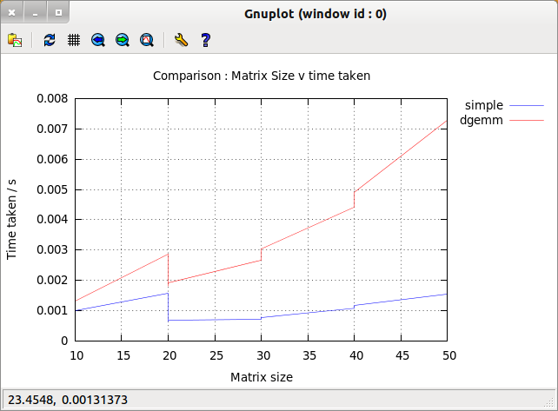
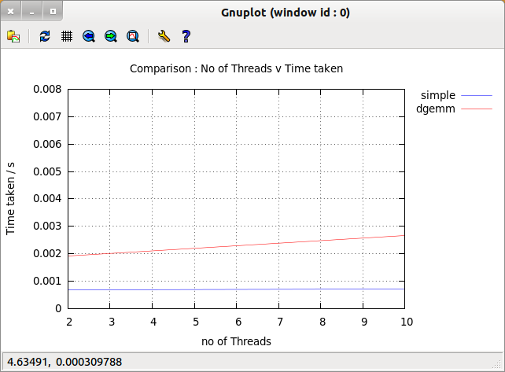
Using different data set, the following is obtained :
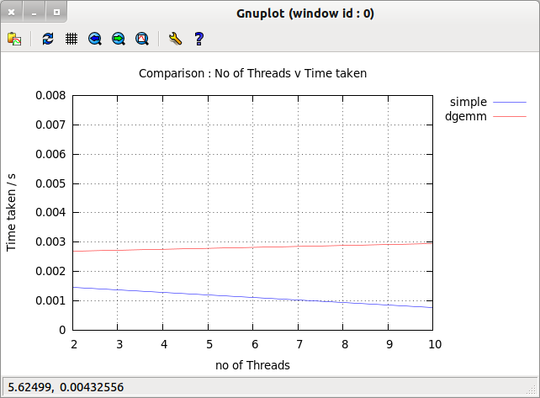
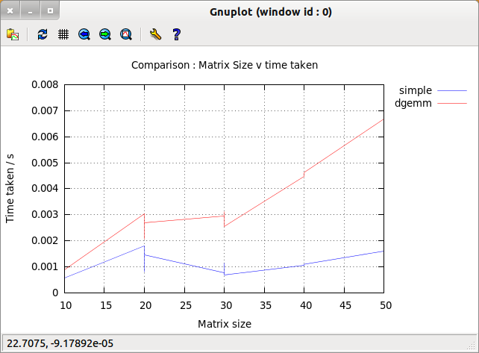

Conclusions
The increase in size of the matrix is after a while no longer negates the increase in time taken. This is evident when the matrix size is increased to 1,000 x 1,000. Also the value was alittle too large to graph. The following is an example of this.
Finally, there is only a finite number of threads available in any one system.
Matrix Size | no of Threads | Time / manual | Infinity Norm / manual | Time /dgemm | Infinity Norm / dgemm
50 | 10 | 0.001546 | 1.62562e+06 | 0.007661 | 1.62562e+06
50 | 10 | 0.001771 | 1.62562e+06 | 0.009032 | 1.62562e+06
50 | 10 | 0.001597 | 1.62562e+06 | 0.007557 | 1.62562e+06
100 | 10 | 0.007191 | 2.55025e+07 | 0.030856 | 2.55025e+07
100 | 10 | 0.010156 | 2.55025e+07 | 0.035289 | 2.55025e+07
100 | 10 | 0.008451 | 2.55025e+07 | 0.039047 | 2.55025e+07
500 | 20 | 1.363494 | 1.56876e+10 | 2.859575 | 1.56876e+10
500 | 20 | 1.370261 | 1.56876e+10 | 2.927285 | 1.56876e+10
500 | 20 | 1.325166 | 1.56876e+10 | 3.256134 | 1.56876e+10
1000 | 20 | 12.946991 | 2.505e+11 | 21.963079 | 2.505e+11
1000 | 20 | 12.964027 | 2.505e+11 | 22.225876 | 2.505e+11
1000 | 20 | 12.597507 | 2.505e+11 | 22.171022 | 2.505e+11

Appendix I – Validate Results
Spot check only using 6x6 matrices, initializing matrices |A| and |B| using successive column values.
Build using :
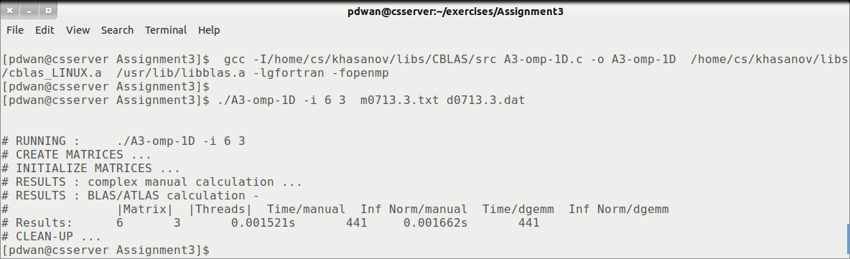
Resulting summary timing data file contains :
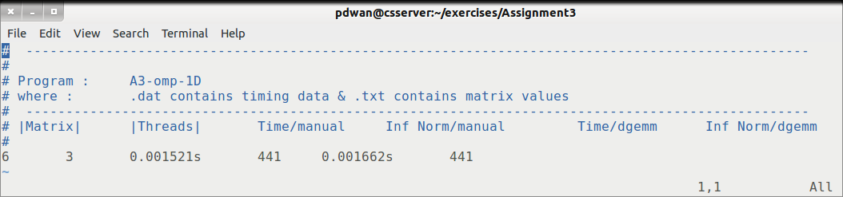
Validating results gives :
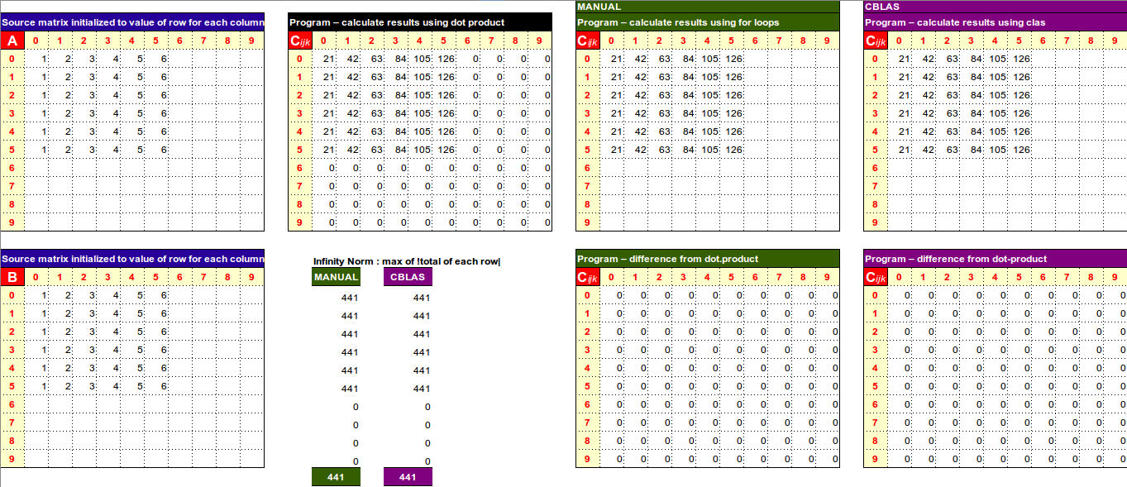
Running again with -r (random number generation from 1 to 10) :
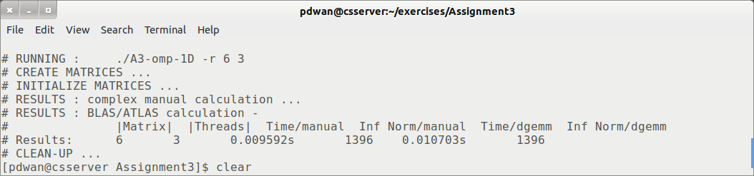
Note that the timing calculations are added to the .dat file (as the same filenames are used):
Again, validation gives :
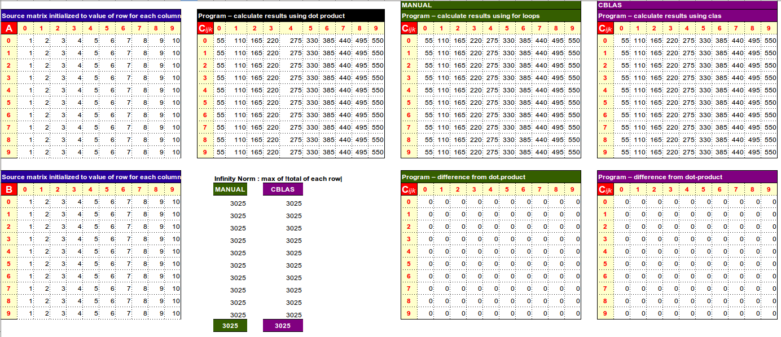

Appendix II – Acknowledgements
- wikipedia.org
- Geln McLachlan – gnuplot tutorials (youtube)
- Stackoverflow.com – examples of Open MP

