COMP-40730 HPC

Report for Assignment 4

Author: | Paula Dwan
Due date: | July-2014
Lecturer: | Alexey Lastovetsky
Subject: | COMP-40730 High Performance Computing
College: | University College Dublin

Contents
Contents 2
Exercise 3
Overview of Computations Obtained and How 4
Assignment Execution 5
Running A4-mpi-1D-<atlas | cblas> : standalone 6
Log Files Obtained 6
GNUplot Execution 7
Overview of MPI functions used 8
Matrix Sizes Evaluated 10
Row-Major as applied 11
Summary Results 12
Comparison MPI, Open MP & pthreads 12
GNUplot Graphs – cblas using matrix sizes 50 → 1000 12
$ ./runAssignment4.sh -i -v 12
GNUplot Graphs – cblas using matrix sizes 50 → 100 13
$ ./runAssignment4.sh -r -v 13
Conclusions 13
Appendices 14
Appendix I – Validate Results 14
Appendix II – Summary of Results Obtained 16
./A4-mpi-1D-cblas -r 50 → 100 16
./A4-mpi-1D-cblas -i 50 → 100 16
./A4-mpi-1D-cblas -r 50 → 1000 17
./A4-mpi-1D-cblas -i 50 → 1000 17
Appendix III – References / Acknowledgements 18

Exercise

Write a parallel MPI program computing the norm of the product of two n×n dense matrices on a p-processor SMP so that :
- p processors are involved in the computations.
- The 1-dimensional parallel algorithm of matrix multiplication is employed:
- the matrices are identically and equally partitioned in one dimension into p horizontal slices
- there is one-to-one mapping between the partitions and the processors
- each processor is responsible for computation of the corresponding slice of the resulting matrix

You can use BLAS or ATLAS for local computations.

Experiment with the program and build:
• The dependence of the execution time of the program on the matrix size n.
• The speedup over a serial counterpart of the program.

Explain the results.

Variants of the assignment:

1. Granularity of the program:
(a) Two successive steps:
i. Parallel matrix multiplication
ii. Parallel computation of the norm of the resulting matrix
(b) One-step algorithm. No intermediate resulting matrix.

2. Partitioning scheme:
(a) Left matrix is horizontally partitioned
(b) Right matrix is vertically partitioned

3. Matrix norm to be computed:
(a) The maximum absolute column sum norm (aka one-norm):
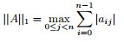
(b) The maximum absolute row sum norm (aka infinity-norm):
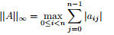

Overview of Computations Obtained and How
Assignment 4 basically involved (for me) writing one program, which contained the code for manual straight-forward IJK computation, calculation of matrix |C| using dgemm and calculation of matrix |C| using MPI. I then compared the time taken to calculate matrix |C| for each method using [N]x[N] matrices |A| and |B| of different sizes. :
- manual straight-forward IJK computation
Implementation of a straight forward matrix nxn multiplication :
Code | for (ni=0 ; ni<rows ; ni++)  {  for (nj=0 ; nj<cols ; nj++)  {  double sum = 0.0 ;  for (nk=0 ; nk<rows ; nk++)  {  sum+= (A[(ni*rows)+nk]) * (B[(nk*rows)+nj]) ;  }  C[(ni*rows)+nj] = sum ;  }  }
- Dgemm for straight-forward IJK computation
I used dgemm compiled for atlas or for cblas.
Code | int ni, nj ;  // m, n, k : local integers indicating the size of the matrices for  // rows x columns :: A : m x k, B : k x n, C: m x n  // Here, m = n = k = rows = columns = <nx> = <ny> as supplied  int lm = rows, ln = rows ;  // la_offset, lb_offset, lc_offset :  // Leading dimension of matrix A, B or C respectively, or the number of elements  // between successive rows for row-major storage or columns for column-major  // storage.  int la_offset = rows, lb_offset = cols, lc_offset = rows ;  int ALPHA=1.0 ;  int BETA=0.0 ;  cblas_dgemm( CblasRowMajor, CblasNoTrans, CblasNoTrans, lm, ln, ln, ALPHA, \  A, la_offset, B, lb_offset, BETA, C, lc_offset) ;
- MPI calculation
This was completed using a data structure, creating a new thread to correspond to the each slice.
Code | MPI_Barrier ()  MPI_Bcast ()  MPI_Comm_rank ()  MPI_Comm_size ()  MPI_Finalize ()  MPI_Gather ()  MPI_Init ()  MPI_Scatter ()  MPI_Wtime()
Note: Please see section for detailed description of code used : Overview of MPI functions used.
For options 2. and 3., the matrix |C| was calculated (cblas by default otherwise the use could decide to re-build and execute using cblas or atlas).
Thus results were obtained for each option 1., 2. and 3. using the same source |A| and |B| to ensure like was compared to like.
Multiple implementation of each .c program was enabled using ./runAssignment4.sh, for example :
$ ./runAssignment4.sh -i -v
This runs the c. program using cblas for incremental column values, using predefined settings for matrix for each implementation.
Single implementation is completed using A4-mpi-1D.c.
$ ./A4-mpi-1D-cblas -i 10 file.txt file.dat
This is compiled using mpicc for atlas and cblas, as follows :
mpicc -I/home/cs/khasanov/libs/CBLAS/src A4-mpi-1D.c -o A4-mpi-1D-cblas \ /home/cs/khasanov/libs/cblas_LINUX.a /usr/lib/libblas.a -lgfortran
mpicc -o A4-mpi-1D-atlas A4-mpi-1D.c -I/home/cs/khasanov/libs/ATLAS/include/ \ -L/home/cs/khasanov/libs/ATLAS/lib/Linux_UNKNOWNSSE2_4/ -lcblas -latlas -lm -O3

Assignment Execution
The compiled .c program ./A4-mpi-1D was executed multiple times standalone or using the script ./runAssignment4.sh to obtain as wide a range of time taken to calculate |C| using each algorithm.
This has multiple options and the syntax and usage follows :
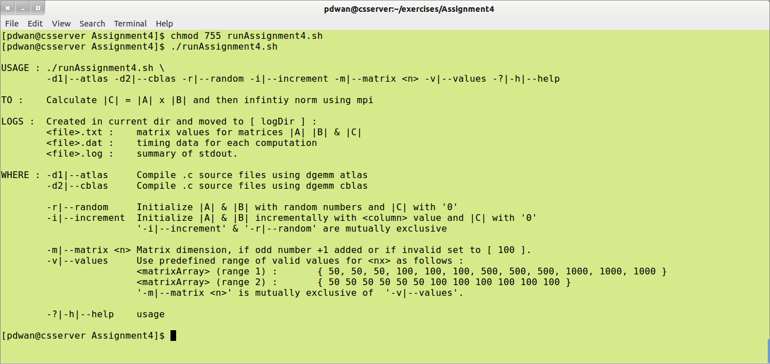
Execute this script in the home directory of Assignment 4.
Sample execution follows for :
$ ./runAssignment4.sh -i -v
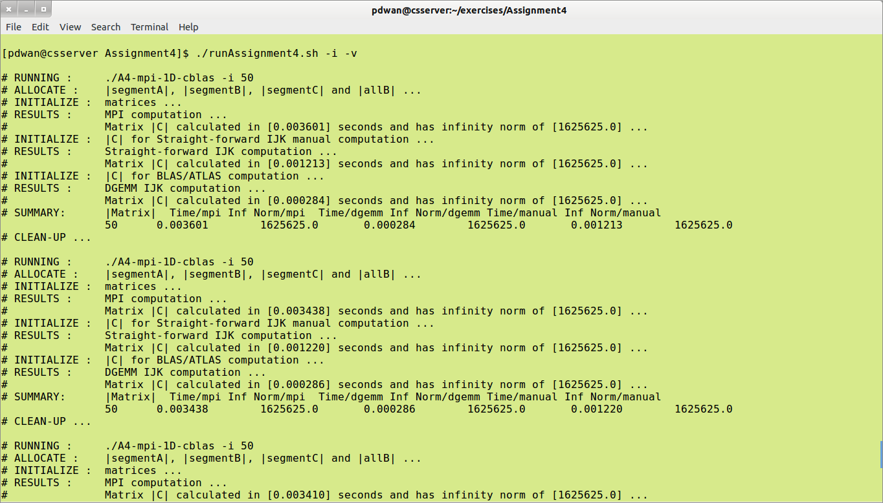
Please retain the overall directory structure when unzipping.
Note that the script ./runAssignment4.sh allows two types of implementation
- Multiple iteration : use the switch <-v|--values>, when a predefined range applies for [N] : matrix size.
- Single iteration : use the switch <-m|--matrix> [N] where the user specifies value for [N] : matrix size.

Running A4-mpi-1D-<atlas | cblas> : standalone
The compiled .c program may also be run standalone. Usage and sample execution follows :
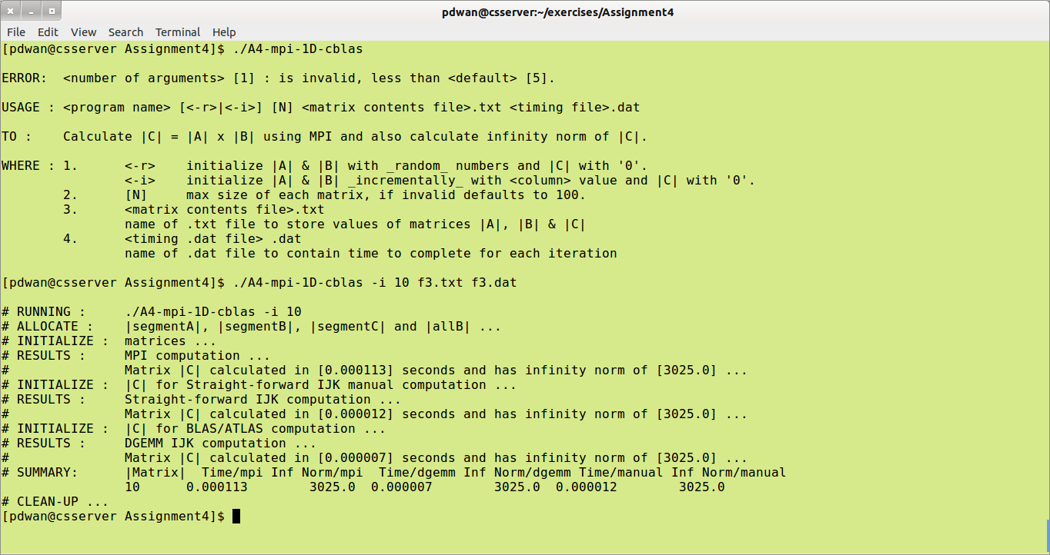

Log Files Obtained
Data text files suitable containing the values of the computation used for matrices |A| and |B| and the results stored in |C| are saved in the appropriate log files. File naming convention via the script is :
<data log file name> | Values-<time>-A4-mpi-1D-<iteration>.txt
example: | Values-20140715.170928-A4-mpi-1D-0.txt  f1.txt
Single iteration also applies where the user enters arbitrary, valid values for matrix size and does not use the scripts and the other required parameters. Each new matrices |A| and |B| and the results in |C| were saved to the data file, thus simple validation using LibreOffice Calc.
A summary file containing processing time for each computation (manual, DGEMM and MPI) is also saved. This is in a format suitable for us with GNUplot.
<timing log file name> | Data-<time>-A4-mpi-1D.dat
example: | Data-20140715.171337-A4-mpi-1D.dat  Data-20140715.172124-A4-mpi-1D.dat  f1.dat
I did not save a separate .dat file for each run of the script for each algorithm. Instead each .dat file contains the time taken for each matrix size for the preset range of values. ./runAssignment4.sh may be updated with more if needed but the following are those in use at the moment.
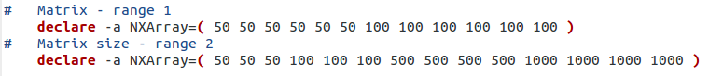
For compilation using the script, a suffix of -atlas indicates compilation for atlas and a suffix of -cblas indicates that the c program was compiled via cblas.
Finally a log file containing a listing of each algorithm used for that iteration.
After each run, all .log, .txt, .dat and .bup files are copied to the directory logDir/.
If ./A4-mpi-1D-<cblas|atlas> is used without the script then .dat and .txt files may be named whatever the user wishes and no .log file applies.
I wished to keep each .c program as clean as possible and so all production setup was completed in the script for each assignment. Thus file creation and validation for each iteration was completed before the .c program was even called. Simple validation of the arguments passed to each .c program is also completed if ran standalone.
I also spot-checked the results as practical. Results spot-check are detailed in Appendix I – Validate Results.

GNUplot Execution
I followed the same structure for each .dat file as produced, an example follows :
Sample .dat file
If wished, the .txt file contains the matrices |A| and |B| used to calculate |C| and the type of computation applicable and the time taken to complete. The .dat file is just a summary of the matrix sizes (when the later is applicable) as well as time taken for each type of computation.
The contents of each .dat was then presented in graphical format using GNUplot, comparing times taken for manual and for BLAS/ATLAS computations.
Sample GNUplot program execution | # To execute, launch GNUplot and run :  # gnuplot> load <filename.gp>  # making sure that the data file name used is updated if needed.  # –-----------------------------------------------------------------------  # Paula Dwan : Assignment 4  reset  set xtic auto  set ytic auto  set size 1,1  set grid  set key outside  #  set title 'mpi : Matrix size -v- Time taken'  set ylabel 'Time taken / seconds'  set xlabel 'Matrix size'  set xrange [0:1100]  set yrange [0:34]  set xtics (100,200,300,400,500,600,700,800,900,1000,1100)  set origin 0,0  set key outside  plot 'logDir/Data-mpi.dat' u 1:3 t 'manual' w l lw 0.8 lc rgb 'blue', 'logDir/Data-mpi.dat' u 1:5 t 'dgemm' w l lw 0.8 lc rgb 'black', 'logDir/Data-mpi.dat' u 1:7 t 'mpi' w l lw 0.8 lc rgb 'red'  #  pause -1
Thankfully for Linux (Ubuntu) – I could install and run GNUplot locally.
Screen shots of each were taken and added to the section Summary Results.

Overview of MPI functions used
Basic Linear Algebra Subprograms (BLAS) are a specified set of low-level subroutines that are used in this exercise for matrix multiplication (Level 3 BLAS). Compilation may be completed using ATLAS (Automatically Tuned Linear Algebra Software) or cBLAS.
So in this exercise, we calculate :
|C| += |A| x |B|
Message Passing Interface (MPI) supports communication between processors, i.e.: parallel programming. MPI is a standardized implementation, in this case written in C, and easily applies dgemm to calculate the portion of the matrix A as send to that processor for computation.
In this .c program implementing MPI, we have a fixed number of process [P] using a [N]x[N] sized matrix for |A|, |B|, and |C|. Each processor can communicate via calls to MPI communication primitives. Each we will use collective communication which involves a group of processors.
The MPI functions used are (not necessarily in order of use):
Ø | MPI_Init (&argc, &argv)  When the program starts only one process is in use (the root process), MPI_Init initializes the run time environment creating the child processes.  Syntax :  int MPI_Init(int *argc, char ***argv)
 | where :
 | &argc | argc C/C++ only: Pointer to the number of arguments.  Number of arguments in program.
 | &argv | argv C/C++ only: Argument vector.  Listing of arguments applicable to program.

Ø | MPI_Comm_rank (MPI_COMM_WORLD, &rank)  Returns the rank of the current process.  Syntax :  int MPI_Comm_rank(MPI_Comm comm, int *rank)
 | where :
 | MPI_COMM_WORLD | comm Communicator (handle).  Default communicator  communicator of all processes making up the MPI program
 | &rank | rank Rank of the calling process in group of comm (integer).  Returns the rank of all the processes in the group.

Ø | MPI_Comm_size (MPI_COMM_WORLD, &size)  Returns the number of processes requested for the the job  Syntax :  int MPI_Comm_size(MPI_Comm comm, int *size)
 | where :
 | MPI_COMM_WORLD | comm Communicator (handle).  Default communicator  communicator of all processes making up the MPI program
 | &size | size Number of processes in the group of comm (integer).  Number of processes in the group

Ø | MPI_Bcast (B, nx*ny, MPI_DOUBLE, 0, MPI_COMM_WORLD)  Broadcasts a message from the root process to all other processes in the group.  Syntax :  int MPI_Bcast(void *buffer, int count, MPI_Datatype datatype, int root, MPI_Comm comm)
 | where :
 | B | buffer Starting address of buffer (choice).  Matrix |B|
 | nx*ny | count Number of entries in buffer (integer).  [N] x [N] matrix size of [row] x [column]
 | MPI_DOUBLE | datatype Data type of buffer (handle).  Data item is an integer : size of matrix [row] x [column]
 | 0 | root Rank of broadcast root (integer).  Root process reference
 | MPI_COMM_WORLD | comm Communicator (handle).  Default communicator  communicator of all processes making up the MPI program

Ø | MPI_Scatter (A, nx*ny/np, MPI_DOUBLE, A + offset, nx*ny/np, MPI_DOUBLE, 0, MPI_COMM_WORLD)  Sends data from one task to all tasks in a group.  Syntax :  int MPI_Scatter(const void *sendbuf, int sendcount, MPI_Datatype sendcount,  void *recvbuf, int recvcount, MPI_Datatype recvtype, int root, MPI_Comm comm)
 | where :
 | A | sendbuf Address of send buffer (choice, significant only at root).  matrix |A| → full
 | nx*ny/np | sendcount Number of elements in send buffer (integer, significant only at root).  Size of buffer – so [row] x [column] / [no. of processors]
 | MPI_DOUBLE | sendtype Datatype of send buffer elements (handle, significant only at root).  → here, double.
 | A + offset | recvbuf Address of receive buffer (choice).  matrix |A| → subset only
 | nx*ny/np | recvcount Number of elements in receive buffer (integer).  size of buffer – so [row] x [column] / [no. of processors]
 | MPI_DOUBLE | recvtype Datatype of receive buffer elements (handle).  → here, double.
 | 0 | root Rank of broadcast root (integer).  Root process reference
 | MPI_COMM_WORLD | comm Communicator (handle).  Default communicator  communicator of all processes making up the MPI program

Ø | MPI_Finalize ()  Closes the run-time environment. No more MPI calls may be made once this function is executed, not even MPI_Init().  Syntax :  int MPI_Finalize(void)

Ø | MPI_Wtime ()  MPI_Wtime returns a floating-point number of seconds, representing elapsed wall-clock time since some time in the past.  Syntax :  double MPI_Wtime()

Ø | MPI_Barrier  Blocks until all processes in the communicator have reached this routine.  Syntax :  int MPI_Barrier(MPI_Comm comm)
 | where :
 | MPI_COMM_WORLD | comm Communicator (handle).  Default communicator  communicator of all processes making up the MPI program

Ø | MPI_Gather (C+offset, nx*ny/np, MPI_DOUBLE, C, nx*ny/np, MPI_DOUBLE, 0, MPI_COMM_WORLD)  Gather / collect the distributed blocks and return them to the root process.  Syntax :  int MPI_Gather(const void *sendbuf, int sendcount, MPI_Datatype sendtype,  void *recvbuf, int recvcount, MPI_Datatype recvtype, int root, MPI_Comm comm)
 | where :
 | C + offset | sendbuf Starting address of send buffer (choice).  matrix |C| → subset only
 | nx*ny/np | sendcount Number of elements in send buffer (integer).  size of buffer – so [row] x [volumn] / [no. of processors]
 | MPI_DOUBLE | sendtype Datatype of send buffer elements (handle).  → here, double.
 | C | recvbuf Address of receive buffer (choice, significant only at root).  matrix |C| → full
 | nx*ny/np | recvcount Number of elements for any single receive  (integer, significant only at root).  As previously,  size of buffer – so [row] x [volumn] / [no. of processors]
 | MPI_DOUBLE | recvtype Datatype of recvbuffer elements (handle, significant only at root). r → here, double.
 | 0 | root Rank of receiving process (integer).
 | MPI_COMM_WORLD | comm Communicator (handle).  Default communicator  communicator of all processes making up the MPI program

Matrix Sizes Evaluated
When applying the three options I used matrices |A| and |B| of varying sizes from [ 10x10 ] to [ 1000x1000 ]. The values in each matrix were dependent on the switch
- -r
random from 1 to 10, so each cell regardless of matrix size had a value of 1 to 10 inclusive. This reduced computation time based on large cell values.
- -i
increment based on column index + 1, so all cells in column 1000 had a value of 1001.
This could increase computation time of larger matrices as the cell would have comparatively larger values also.

Row-Major as applied
For the straight-forward algorithm of |C|[ij] += |A|[ik] * |B|[kj] uses row major as follows (e.g.: [ 4x4 ] matrix:
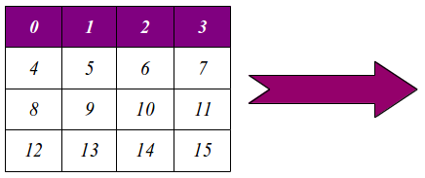
Whereas column-major is as follows :
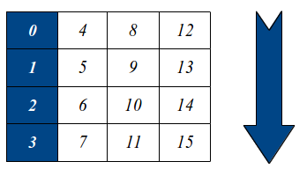
So for this assignment (variant applied) we use :
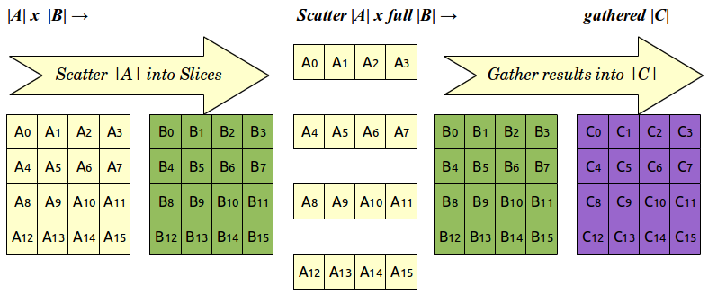

Summary Results
Build/plot: | • The dependence of the execution time of the program on the matrix size n.  • The speedup over a serial counterpart of the program.
Variant : | - One-step algorithm. No intermediate resulting matrix.  - Left matrix is horizontally partitioned  - The maximum absolute row sum norm (aka infinity-norm):
Infinity norm | Sum the absolute values along each row and then take the largest value as the answer.  Example: A = | 1 −7 |  | −2 −3 |  then matrix norm of A = max ( 1 + |-7|, |-2| + |-3| ) = max ( 8, 5 ) = 8

Comparison MPI, Open MP & pthreads
As this is the fourth assignment in a series using pthreads, open MP and MPI, it is probably worth comparing each at this stage, at a very high level.
OpenMP implementation utilises thread spawning and thread-to-processor allocation. This means less memory usage and direct thread to thread communication. However, threads must be synchronized and joined, thus increasing the time taken to execute the program particularly for larger matrix sizes. Open MP optimises program performance which runs on a single machine using muptiple CPU's.
PThreads is esentially OpenMP on a lower level. It uses #pragmas (basically, code comments) to indicate to the compiler that this is where threading applies.
Message Passing Interface (MPI ), basically divides a complex problem into smaller parts which can be solved on indivdual machines. MPI uses direct inter-process communication via bus messages. Each process (program segement) is standalone and no memory is shared.

GNUplot Graphs – cblas using matrix sizes 50 → 1000

$ ./runAssignment4.sh -i -v
manual

dgemm

mpi

GNUplot Graphs – cblas using matrix sizes 50 → 100

$ ./runAssignment4.sh -r -v
manual

dgemm

mpi

Conclusions

Appendices

Appendix I – Validate Results
Spot check only using 10x10 matrices, initializing matrices |A| and |B| using successive column values.
Built using :
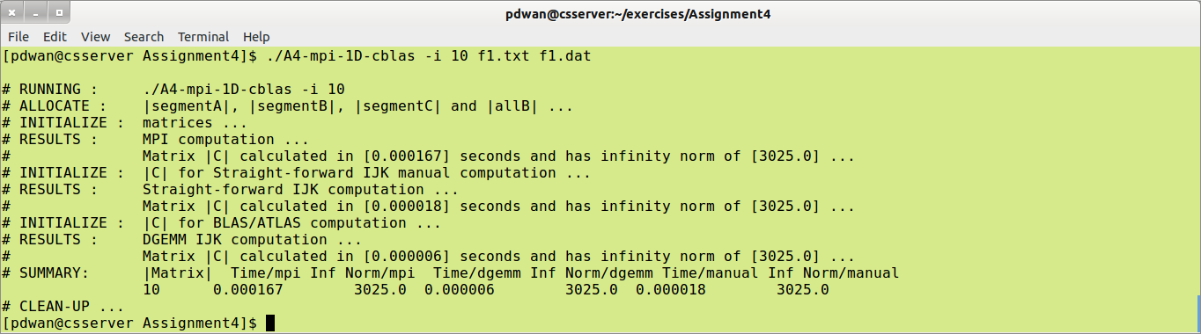
Resulting sample Matrix .txt file contains :
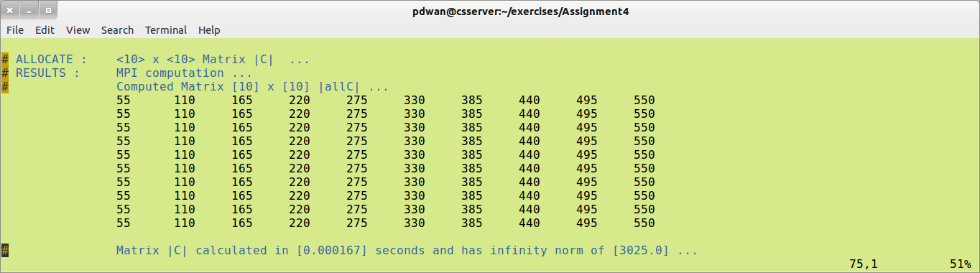
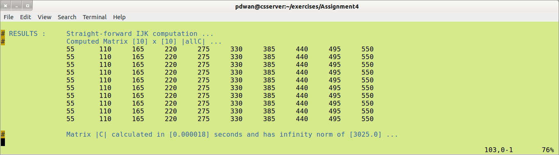
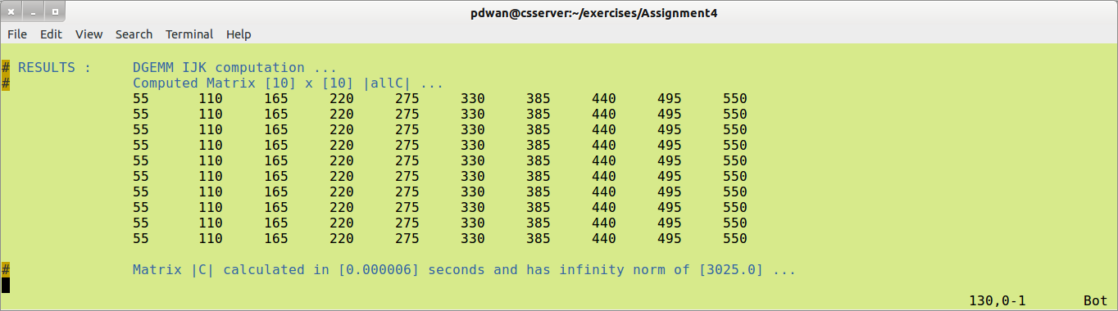
Resulting sample summary timing data file contains :
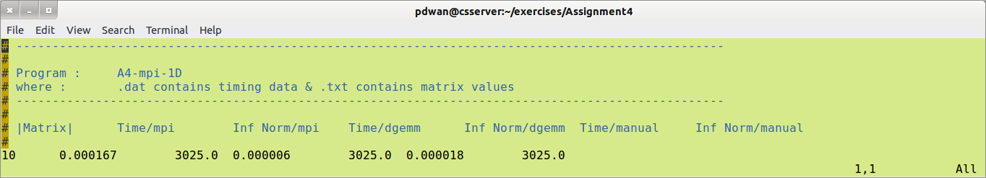
Validating results gives :
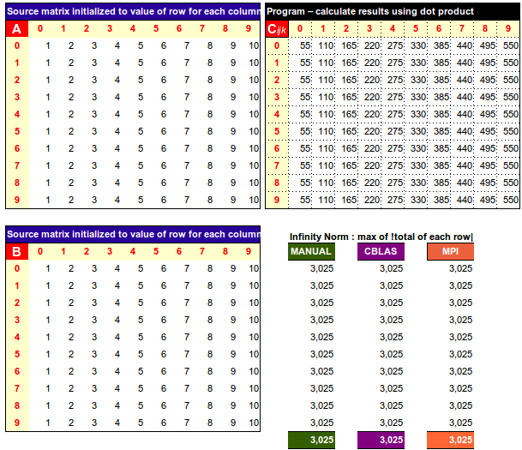
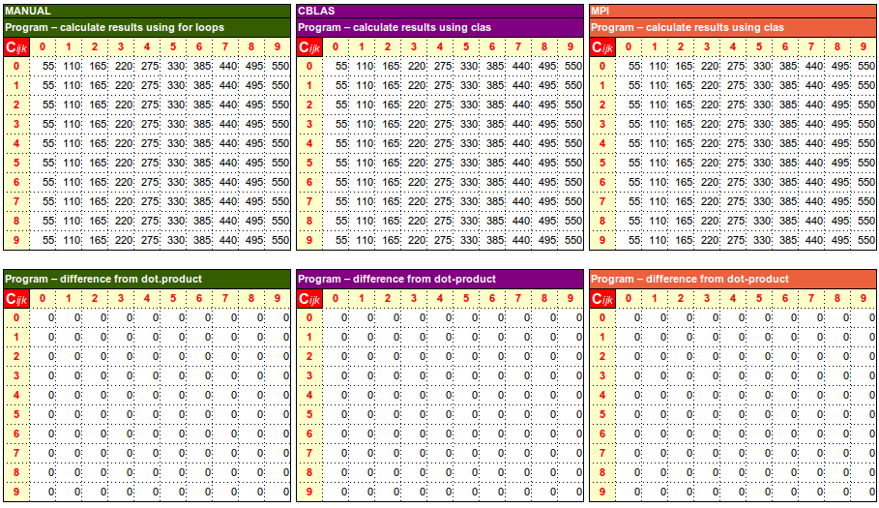

Appendix II – Summary of Results Obtained

./A4-mpi-1D-cblas -r 50 → 100
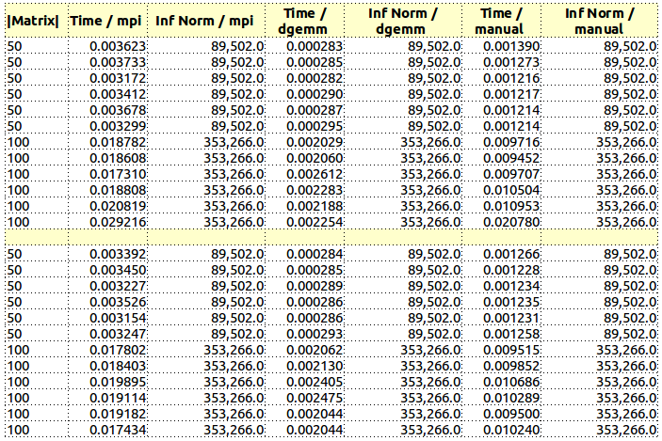

./A4-mpi-1D-cblas -i 50 → 100
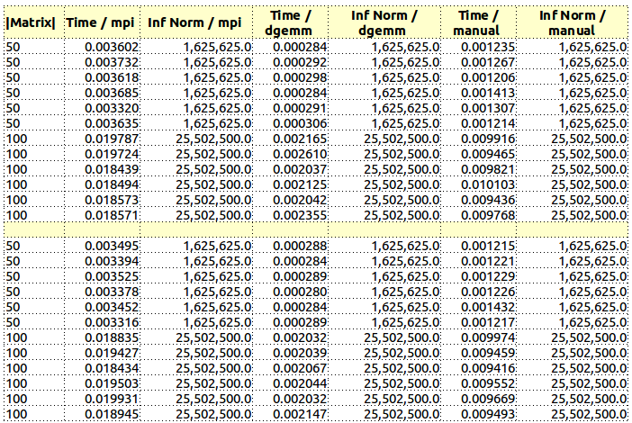

./A4-mpi-1D-cblas -r 50 → 1000
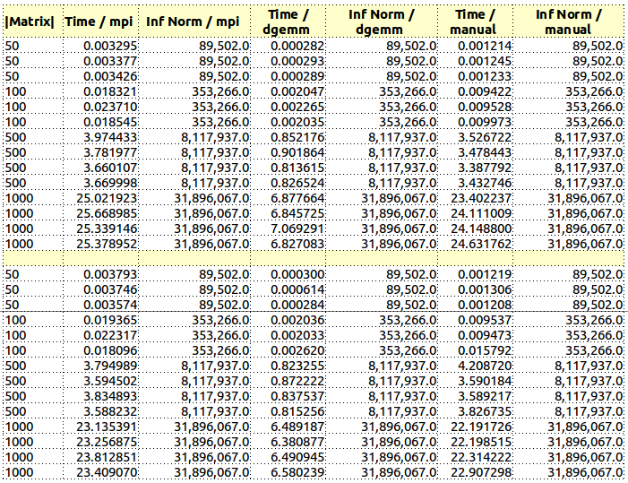

./A4-mpi-1D-cblas -i 50 → 1000
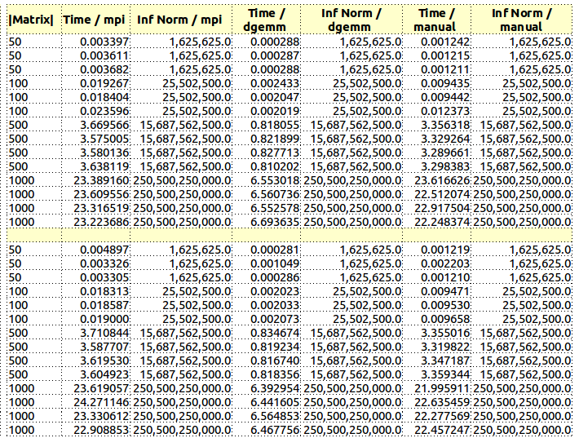

Appendix III – References / Acknowledgements
- www.stackoverflow.com : general queries on MPI function not working and possible workaround
- http://en.wikipedia.org/wiki/Basic_Linear_Algebra_Subprograms
- http://en.wikipedia.org/wiki/Message_Passing_Interface
- www.emsl.pnl.gov : Pacific Northwest National Laboratory / Batelle : “Introduction to MPI”
- www.ucd.ie : COMP40700 High Performance Computing – Notes 2014 “Message Passing Libraries”

