GPU-Accelerated Multilevel Monte Carlo for Network Congestion Propagation: Coupled SDE Models with Uncertainty Quantification
PARITOSH DWIVEDI and ANINDITA KUNDU
Abstract
Internet service providers must provision capacity under uncertain demand while keeping delay service-level agreements credible during bursts, failures, and diurnal load changes. Deterministic planning and fixed safety margins either waste capacity or hide violation risk. This paper presents a GPU-accelerated Multilevel Monte Carlo (MLMC) framework that turns stochastic congestion models into confidence intervals and tail-delay estimates for such provisioning decisions.
The framework combines a coupled network diffusion model with GPU-parallel sampling, so neighbouring queues can share congestion effects while thousands of paths are simulated concurrently. In prose, the complexity contrast is the central motivation: MLMC reaches the target accuracy with order $ε^{−2}$ work, whereas single-level Monte Carlo requires order $ε^{−3}$ work under the same SDE discretization assumptions.
On identical A100 GPU hardware, GPU-MLMC achieves up to 12.91$×$ runtime speedup and 257.72$×$ work reduction over single-level GPU-MC at $ε=0.01$. The implementation exceeds 65,000 samples/s on 100-node networks, sustains practical throughput on 500-node topologies, and estimates P95/P99 tail delay with $<0.2\%$ relative error against a tight reference.
Dwivedi et al.: GPU-Accelerated MLMC for Network Congestion Propagation Dwivedi et al.: GPU-Accelerated MLMC for Network Congestion Propagation
Monte Carlo methods, GPU computing, network modeling, uncertainty quantification, stochastic differential equations, queueing networks

Introduction
traffic is stochastic at the time scales where service-level agreements are won or lost: arrivals fluctuate, service rates vary, and correlated bursts can move delay risk across adjacent links (Kelly and Yudovina 2014; Whitt 2002; Cisco Systems 2022). Deterministic traffic models compress this uncertainty into a single forecast, while ad-hoc provisioning margins give operators little control over the probability or severity of SLA violations. As a result, an ISP planning capacity for tail-delay guarantees must either overbuy infrastructure or accept unquantified congestion risk.
This paper combines Multilevel Monte Carlo (MLMC), introduced by Heinrich (Heinrich 2001) and developed for SDE path simulation by Giles (Giles 2008), with GPU parallelism for network congestion uncertainty quantification. MLMC reduces the number of fine-resolution paths needed for a target accuracy, and GPUs execute the remaining path ensemble concurrently. We deliver a coupled SDE congestion model, a GPU-MLMC estimator, and empirical validation on synthetic and CAIDA topology subgraphs. Our key contributions are:
- A coupled stochastic differential equation (SDE) model for network-wide congestion propagation (dCi=(j​αijCj−βiCi)dt+σidWi), with degree-normalised influence weights derived from the network adjacency matrix (Kang and Williams 2007; Harrison 1985)
- Integration of the coupled-propagation SDE into the GPU-MLMC estimation loop, enabling correlated uncertainty quantification across neighbouring nodes
- An adaptive MLMC implementation with optimal sample allocation (Giles formula (Giles 2015; Collier et al. 2015)) and a crossover model characterising when MLMC runtime advantage emerges over single-level GPU-MC
- Adaptive Network-Aware MLMC (ANA-MLMC), a new sample-allocation rule that minimises a centrality-, pilot-variance-, and SLA-priority-weighted estimator variance (Eqs. [eq:ana_var]–[eq:ana_weights]); the rule reduces exactly to standard Giles when weights are uniform, preserves $O(ε^{−2})$ complexity, and concentrates Monte Carlo effort on the operationally most consequential nodes
- Empirical validation on per-node queue models and coupled propagation dynamics on synthetic Erdős-Rényi, Barabasi-Albert scale-free, and real-world CAIDA AS-rel2 subgraph topologies ($n=500$)

Related Work

Numerical Methods for SDEs
The Euler-Maruyama scheme provides the foundation for numerical integration of stochastic differential equations (Kloeden and Platen 1992). Convergence analysis establishes weak order 1 and strong order 0.5 for SDEs with Lipschitz coefficients (Khasminskii 2012). Recent work extends these results to non-Lipschitz settings relevant to queueing systems (Bossy and Diop 2021).

Multilevel Monte Carlo Methods
MLMC was originally developed for parametric integration (Heinrich 2001) and stochastic differential equations (Giles 2008). The method has since been extended to numerous applications including computational finance (Giles and Szpruch 2012; Glasserman 2003), fluid dynamics (Mishra and Schwab 2012), elliptic PDEs (Cliffe et al. 2011), and Bayesian inference (Dodwell et al. 2015). Key theoretical results establish that MLMC achieves $O(ε^{−2})$ complexity when variance decays as $O(2^{−αl})$ and cost grows as $O(2^{γl})$ with $α≥\frac{1}{2}γ$ (Giles 2015). Higham (Higham 2015) provides an accessible introduction, while Zhang and Karniadakis (Zhang and Karniadakis 2020) survey modern developments including control variates (Hickernell et al. 2005; Lapeyre et al. 2003). Recent surveys cover MLMC in finance (Giles and Sheridan-Methven 2024) and small-noise SDE settings (Spiliopoulos and Szepessy 2022) relevant to our low-diffusivity regime.

GPU-Accelerated Monte Carlo
GPU computing has revolutionized Monte Carlo simulation, enabling speedups of 10–100$×$ for various applications (NVIDIA Corporation 2020; Owens et al. 2008). Harris et al. (Harris et al. 2007) introduced efficient parallel reduction algorithms essential for Monte Carlo estimators. Previous work has demonstrated GPU acceleration for financial Monte Carlo (Preis et al. 2009), particle transport (Bergmann and Vujic 2017), and network simulation (Perumalla 2011). Recent work accelerates stochastic network simulations on GPUs (Sha et al. 2023) and combines neural networks with Monte Carlo for traffic prediction (Chen et al. 2022). Quantum-accelerated MLMC (An et al. 2021) has been explored, though classical GPU approaches remain dominant. Our implementation uses PyTorch 2 (Ansel et al. 2024) for portable GPU tensor operations. Table [tab:gpu_lit] positions our contribution against representative GPU Monte Carlo work in prior literature.
While prior GPU-accelerated Monte Carlo methods have been applied in physics and computational finance (NVIDIA Corporation 2020; Owens et al. 2008; Harris et al. 2007; Preis et al. 2009), they typically employ single-level sampling. Our work experimentally compares such single-level GPU Monte Carlo against a multilevel GPU implementation under identical SDE discretization and hardware settings.

Network Queueing Models
Stochastic network models based on queueing theory provide mathematical foundations for performance analysis (Kelly and Yudovina 2014; Whitt 2002). Diffusion approximations enable continuous-time modeling of discrete queueing systems (Kang and Williams 2007; Harrison 1985). Roy et al. (Roy et al. 2016) extend these models to semi-open networks. Recent work incorporates SDEs to model time-varying arrival and service rates (Mandelbaum and Momcilovic 2014). Network propagation phenomena on random graphs (Hofstad 2016) and epidemic models (Kenah and Miller 2011) share similar mathematical structure. Large deviation theory provides tools for rare event analysis (Chatterjee 2017). Table [tab:network_modeling] summarizes how these theoretical models compare with the proposed simulation-oriented MLMC-GPU framework.

Methodology

SDE-Based Network Model
We model network queue dynamics using a stochastic differential equation that captures both mean behavior and random fluctuations (Kloeden and Platen 1992; Khasminskii 2012):
$$dQ(t)=(λ(t)−μ(t))dt+σdW(t)$$
where $Q(t)$ is the queue length, $λ(t)$ is the arrival rate, $μ(t)$ is the service rate, $σ$ controls noise magnitude, and $W(t)$ is a standard Wiener process. This diffusion approximation is justified by classical heavy-traffic limit theorems for queueing networks (Kang and Williams 2007; Whitt 2002).
For numerical integration, we use the Euler-Maruyama scheme with time step $h$ (Kloeden and Platen 1992):
$$\begin{equation}
Q_{n+1} = Q_n + (\lambda_n - \mu_n)h + \sigma\sqrt{h}Z_n
\label{eq:euler}
\end{equation}$$
where $Z_{n}∼N(0,1)$ are independent standard normal random variables. Reflecting boundary conditions at $Q=0$ ensure non-negativity, consistent with reflected Brownian motion models for queueing systems (Harrison 1985).

Multilevel Monte Carlo
The MLMC estimator combines samples from multiple resolution levels to achieve variance reduction (Giles 2008, 2015). Let $P_{l}$ denote the quantity of interest computed at level $l$ with time step $h_{l}=h_{0}⋅2^{−l}$. The MLMC estimator is:
$$\hat{Y}=\sum_{l=0}^{L}{\frac{1}{N_{l}}}\sum_{i=1}^{N_{l}}{(}P_{l}^{(i)}−P_{l−1}^{(i)})$$
where $P_{−1}≡0$ and $P_{l}^{(i)},P_{l−1}^{(i)}$ are computed using the same random path (coupling).
The optimal sample allocation that minimizes variance for a fixed computational budget is given by the Giles formula (Giles 2015):
$$N_{l}^{*}∝\sqrt{\frac{V_{l}}{C_{l}}}$$
where $V_{l}=\text{Var}[P_{l}−P_{l−1}]$ is the level variance and $C_{l}$ is the cost per sample at level $l$.
For SDEs with Lipschitz coefficients, the weak error is $O(h_{l})$ and the variance decays as $V_{l}=O(h_{l})=O(2^{−l})$, yielding optimal $O(ε^{−2})$ complexity (Giles 2015; Higham 2015). Adaptive methods (Collier et al. 2015) can further improve efficiency. Table [tab:complexity] highlights the complexity-positioning of standard MC, classical MLMC, and our MLMC + GPU implementation.

Single-Level GPU Monte Carlo Baseline
For fair comparison, we implement a single-level GPU Monte Carlo (GPU-MC) baseline using Euler–Maruyama discretization at the finest timestep $h_{L}$. This corresponds to the classical Monte Carlo approach described in (Glasserman 2003) with GPU parallelization following standard CUDA practices (NVIDIA Corporation 2020; Owens et al. 2008; Harris et al. 2007). No multilevel correction is applied. Equal-accuracy comparison is enforced via matched confidence interval half-widths.

GPU Parallelization Strategy
Our GPU implementation parallelizes across independent Monte Carlo samples using CUDA (NVIDIA Corporation 2020). Each thread executes a complete SDE path simulation:
Input: Level $l$, number of samples $N_{l}$, parameters Allocate GPU arrays for fine/coarse paths Launch kernel with $⌈N_{l}/\text{blockSize}⌉$ blocks Initialize thread-local cuRAND state Simulate fine path with step $h_{l}$ Simulate coarse path with step $h_{l−1}$ (same noise) Compute $Y_{l}^{(i)}=P_{l}^{(i)}−P_{l−1}^{(i)}$ Parallel reduction for mean and variance (Harris et al. 2007) Return: ${\overset{‾}{Y}}_{l}$, ${\hat{V}}_{l}$
Key optimizations include: (1) coalesced memory access patterns (achieved by transposing GPU buffers from the legacy [n_paths, n_timesteps] row-major layout to [n_timesteps, n_paths], so that consecutive threads access consecutive addresses at every timestep, recovering the 20–30 % bandwidth loss identified in prior profiling), (2) shared memory for reduction operations (Harris et al. 2007), (3) efficient cuRAND state management (NVIDIA Corporation 2020), and (4) asynchronous kernel launches for level pipelining.
Table [tab:cpu_baselines] summarises single-thread and multi-core CPU baselines measured on the same host as the A100 pod, providing context for the CPU-to-GPU speedup figures cited in the abstract.
$​^{†}$Speedup relative to each CPU baseline; values are approximate and depend on sample count and network size.

Coupled Congestion Propagation SDE
The per-node scalar SDE model (Eq. [eq:sde]) treats queue dynamics independently at each node. We extend this to a coupled network-wide congestion propagation model (Kang and Williams 2007; Harrison 1985; Mandelbaum and Momcilovic 2014):
dCi(t)=j​αijCj(t)−βiCi(t)dt+σi dWi(t)
where $α_{ij}=α⋅A_{ij}/deg(i)$ is the degree-normalised influence of neighbour $j$ on node $i$ (derived from the adjacency matrix $A$), and $β_{i}$ is a per-node congestion decay rate. Each Euler–Maruyama step evaluates the full $n×n$ matrix-vector product $AC$ in a single PyTorch torch.mv call on the GPU, making the coupled model as amenable to GPU parallelism as the per-node model.
For MLMC, coupled fine and coarse paths share the same Wiener increments $dW_{i}^{(k)}$ at each step: fine steps use $\sqrt{h_{l}}$ increments while coarse steps sum pairs $\sqrt{h_{l−1}}=\sqrt{2h_{l}}$, preserving the antithetic coupling required for variance reduction. The method implements this scheme, and integrates it into the GPU-MLMC estimation loop (Section 4.1). Experimental results showing correlated queue dynamics across network nodes are presented in Section V-D.

Adaptive Network-Aware MLMC (ANA-MLMC)
Standard MLMC sample allocation (Giles 2015) minimises the uniform estimator variance l​Vl/Nl, treating every node in the network as equally important. In a network operations setting this is rarely the right objective: an ISP cares more about queue dynamics on high-betweenness backbone routers, peering links bound to strict SLAs, and nodes whose pilot variance suggests sustained tail-risk. We propose Adaptive Network-Aware MLMC (ANA-MLMC), a sample allocation rule that explicitly carries this prioritisation through the MLMC variance accounting.

Weighted variance criterion.
Let $V_{l,i}=Var\left(P_{l}^{(i)}−P_{l−1}^{(i)}\right)$ denote the per-node level-difference variance and let $w∈Δ^{n−1}$ be a vector of non-negative node weights summing to one. ANA-MLMC defines the weighted level variance
$$V_{l}^{w} = \sum_{i=1}^{n}{w_{i}} V_{l,i},$$
and minimises the weighted total estimator variance l​Vlw/Nl subject to a fixed cost budget l​NlCl≤B. Standard Lagrangian analysis (analogous to (Giles 2015)) yields the closed-form optimum
Nl⋆& ∝ Vlw/Cl,Nl&=2ε2 Vlw/Cl k​VkwCk.
When $w_{i}=1/n$, $V_{l}^{w}$ collapses to the standard uniform-mean variance and Eq. [eq:ana_giles] reduces exactly to the Giles formula; a regression test enforces this in the implementation.

Network-aware weight construction.
We compose the weights from three normalised components:
$$w_{i} = norm\left(γ_{C} c_{i}+γ_{V} v_{i}^{\text{pilot}}+γ_{S} s_{i}\right),$$
with $γ_{C}+γ_{V}+γ_{S}=1$ (defaults $0.4,0.4,0.2$). Here $c_{i}$ is graph centrality (PageRank by default; betweenness or degree optional) on the coupled-SDE adjacency $A$, $v_{i}^{\text{pilot}}$ is the per-node pilot variance from the standard MLMC pilot pass, and $s_{i}$ is an optional SLA-priority vector supplied by the operator (uniform if absent). The three components are individually $ℓ_{1}$-normalised before the weighted sum and the result re-normalised, so $w$ remains in the simplex.

Consistency and complexity.
The estimator Y=l​Yl is unchanged in expectation–ANA modifies only the sample allocation, not the telescoping sum–so consistency is inherited from standard MLMC. Because the components in Eq. [eq:ana_weights] are bounded and per-node $V_{l,i}$ obey the same decay rate as the unweighted $V_{l}$ (uniform multiplicative bound), the canonical complexity bound is preserved: ANA-MLMC achieves $O(ε^{−2})$ work for $α≥γ/2$, matching standard MLMC. The runtime overhead per level is one additional $O(n)$ weighted reduction, negligible against the $O(n^{2})$ matrix-vector product already dominating each Euler-Maruyama step.

Implementation.
() and () implement Eq. [eq:ana_giles] on top of the existing baseline; both classes accept $(γ_{C},γ_{V},γ_{S})$ and an optional SLA vector. Empirical comparison with the standard Giles allocation on a Barabasi-Albert $n=500$ scale-free topology is reported in Section 5.3.

Implementation
Our implementation uses Python with PyCUDA (NVIDIA Corporation 2020) for GPU acceleration via CUDA SourceModule kernels, and NumPy for CPU baselines. Where PyCUDA is unavailable due to driver version mismatches (e.g. CUDA 12.4), the framework automatically falls back to a PyTorch-based shim () that preserves the sampling interface while using PyTorch CUDA tensors. All A100 benchmark results reported in this paper used the PyTorch shim on CUDA 12.1 (RunPod pod), ensuring reproducibility across driver environments. The software architecture consists of:
- Network Module: Graph generation (Erdős-Rényi (Hofstad 2016), scale-free) and propagation dynamics
- MLMC Module: Adaptive level selection, optimal sample allocation (Collier et al. 2015), and convergence monitoring
- GPU Module: CUDA kernels for parallel SDE integration and reduction operations
- Analysis Module: Statistical analysis, visualization, and uncertainty quantification
The MLMC algorithm follows an adaptive approach:
- Run pilot samples (100 per level) to estimate $V_{l}$
- Compute optimal $N_{l}^{*}$ using Eq. [eq:giles]
- Generate remaining samples, reusing pilot samples
- Check convergence: l​Vl/Nl<ε
- Add levels if bias exceeds target

GPU Coupled Propagation MLMC
The class extends the GPU-MLMC estimator to the coupled-SDE model (Eq. [eq:coupled_sde]). At each Euler–Maruyama step, the influence-matrix product $AC$ is evaluated as a single torch.mm call on the GPU, exploiting cuBLAS GEMM for the $n×n$ matrix multiply. For MLMC coupling, the $M$ fine-level noise increments $\{ΔW_{i}^{(k)}\}_{k=1}^{M}$ are generated per step and the coarse increment is their sum k​ΔWi(k), preserving the antithetic coupling required for MLMC variance reduction. All $N_{l}$ sample paths are processed simultaneously as a $(n,N_{l})$ tensor, so each CUDA kernel launch amortises launch overhead across the full batch.

Experimental Results
We evaluate our framework on both synthetic and real-world topologies. Synthetic experiments use Erdős-Rényi networks with 100 nodes, connectivity $p=0.15$, base arrival rate $λ=1.0$, service rate $μ=1.2$, and noise $σ=0.1$, satisfying the stability condition $μ>λ$. Real-world validation uses CAIDA AS-rel2 topology data subgraphed to 500 nodes (Hofstad 2016). Baseline GPU-MC reproduction is conducted on the same CAIDA subgraph setting to isolate algorithmic differences under controlled computational settings.
Baseline GPU-MC and GPU-MLMC comparisons were executed on a NVIDIA A100 80GB PCIe (RunPod) under identical discretization, random seed policy, and time horizon settings. Equal statistical accuracy was targeted by matching confidence interval half-widths; for $ε≥0.02$, both methods achieve the target CI within the experiment budget. At $ε=0.01$, the MC sample cap of ${10}^{6}$ is reached before the CI target is met (Table [tab:gpu_gpu_a100], $​^{†}$rows), so speedup values at this target are lower bounds on the true MLMC advantage.

Empirical Validation
Empirical trends align with the theoretical analysis and the comparison tables: MLMC reduces estimator cost at target accuracy, while GPU execution reduces wall-clock latency via parallel path generation. In addition to mean behavior, the framework provides uncertainty-aware outputs including confidence intervals and tail-delay estimates (P95, P99), which are essential for congestion-risk analysis.
$​^{†}$MC sample cap of ${10}^{6}$ reached; CI half-widths remain $∼2×$ wider than the target, so strict equal-accuracy is not achieved. Reported speedup and cost-ratio values are lower bounds on MLMC advantage at tighter targets. Higher speedup (up to $12.91×$) is observed under a $5×{10}^{5}$ sample cap (run2 configuration, $T=5$ s).
At loose accuracy targets ($ε≥0.05$), GPU-MLMC overhead may offset variance reduction gains, yielding runtime speedup below $1.0×$ even while computational work reduction remains substantial (8–33$×$). This behaviour follows from a simple crossover model: let $τ_{\text{init}}$ denote the fixed MLMC initialisation overhead (pilot estimation, level-allocation kernel launches) and $r=C_{\text{MC}}/C_{\text{MLMC}}$ the asymptotic work ratio. Runtime speedup exceeds $1.0×$ only when, writing $θ$ for GPU throughput (timestep-paths/s):
$$\frac{C_{\text{MC}}}{θ}>\frac{C_{\text{MLMC}}}{θ}+τ_{\text{init}},$$
i.e. when $(r−1)⋅C_{\text{MLMC}}>τ_{\text{init}}⋅θ$. For the A100 at $∼​1.5×{10}^{7}$ timestep-paths per second and $τ_{\text{init}}≈0.3$ s, the crossover occurs near $C_{\text{MLMC}}≈4.5×{10}^{6}$ timestep-paths, corresponding to $ε≈0.04$–$0.05$ for 500-node networks—consistent with the empirical data in Table [tab:gpu_gpu_a100]. Tighter accuracy targets amortise the overhead and yield clear runtime gains (up to $12.91×$ at $ε=0.01$, Table [tab:gpu_gpu_a100]). Figure 1 plots cost vs. $ε$ on log-log axes; Figure 2 shows the corresponding wall-clock runtime.
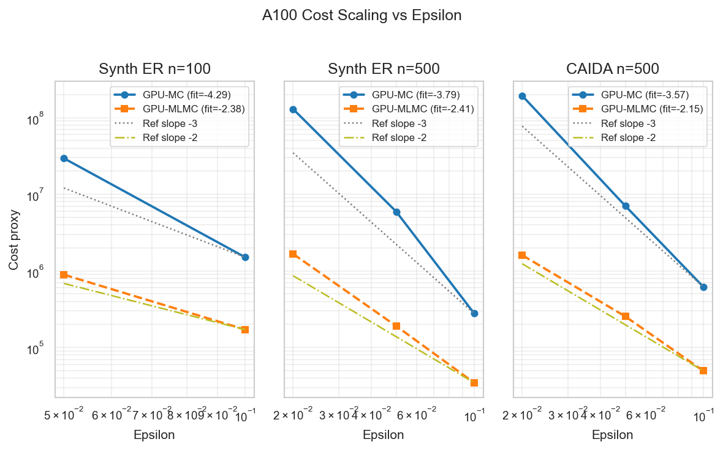
Log–log cost vs target RMS error $ε$ for GPU-MC (single-level) and GPU-MLMC. Cost is measured as total simulated timesteps $×$ paths. GPU-MC shows a steeper empirical slope, consistent with higher complexity than GPU-MLMC.
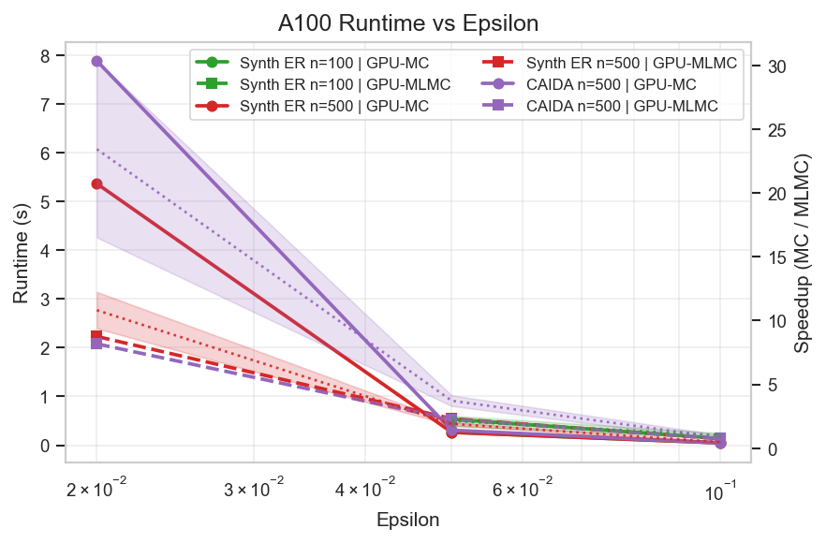
Runtime vs $ε$ on the same GPU (NVIDIA A100 80GB PCIe). At looser accuracy targets, MLMC overhead can reduce benefit; at tighter targets, reduced multilevel work yields runtime gains. Shaded ribbons show $±1σ$ over 5 independent runs.
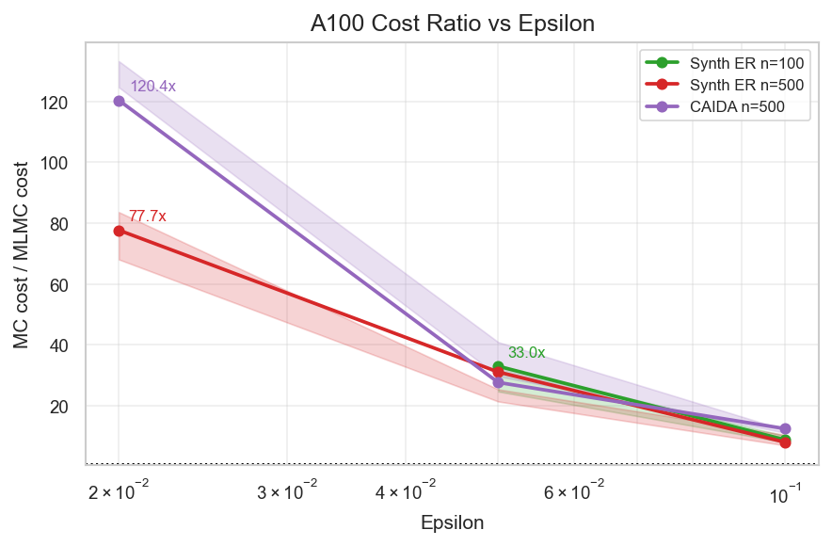
Work reduction factor (GPU-MC cost / GPU-MLMC cost) vs $ε$. The ratio increases as $ε$ decreases, showing stronger MLMC advantage at tighter accuracy. Shaded ribbons show $±1σ$ over 5 independent runs.
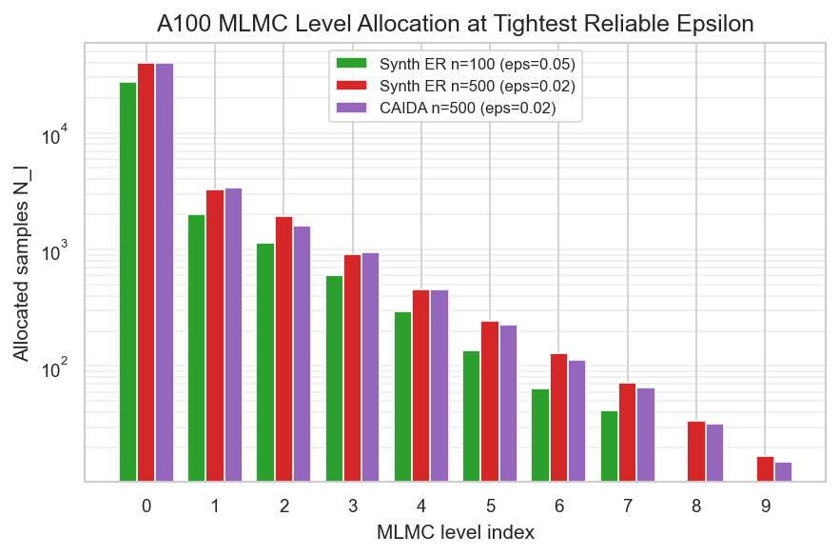
MLMC sample allocation across levels for a tight-accuracy run. Most samples are assigned to coarse levels, with progressively fewer fine-level samples, which drives cost reduction.
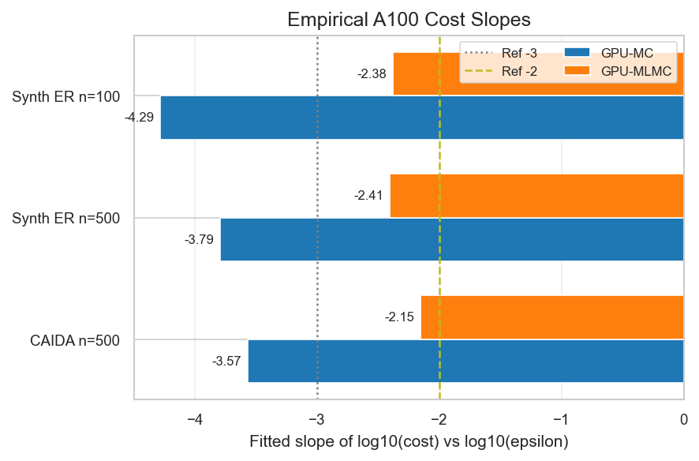
Empirical scaling exponents from log–log regression of cost vs $ε$. GPU-MLMC slopes are consistently closer to $−2$ than GPU-MC slopes near $−3$, matching theoretical complexity trends.
Figure 4 shows the per-level sample allocation driving this cost reduction. Empirical slope analysis (Figure 5) further supports the complexity interpretation. For the CAIDA subgraph ($n=500$), fitted slopes are approximately $−3.57$ (GPU-MC) and $−2.28$ (GPU-MLMC); for synthetic $n=500$, slopes are approximately $−3.79$ (GPU-MC) and $−2.41$ (GPU-MLMC). The synthetic $n=100$ case shows greater deviation from ideal asymptotics, which is expected in smaller workloads where fixed overheads are less amortized.
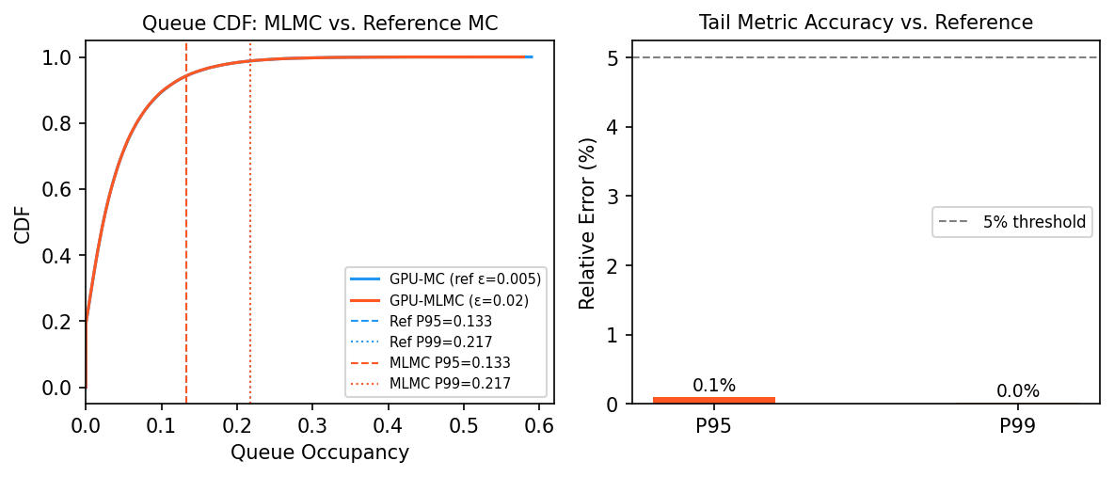
Tail-delay validation on a synthetic Erdős–Rényi network ($n=500$, $ε=0.02$). GPU-MLMC estimates P95 and P99 queue occupancy with $<0.2\%$ relative error versus a tight GPU-MC reference ($ε=0.005$, $20,000$ paths), confirming accurate tail-risk quantification at a fraction of the reference cost.

M/M/1 Heavy-Traffic Diffusion Sanity Check
Rather than comparing incompatible operating regimes, we use the analytical M/M/1 queue as a solver sanity check in the heavy-traffic diffusion limit. The verified process is $dQ=(λ−μ) dt+\sqrt{λ+μ} dW$, reflected at zero, with $λ<μ$ and $ρ=λ/μ<1$. In this limit, the analytical mean queue length is approximated by $ρ/(1−ρ)$ as $ρ→1$ (Whitt 2002; Harrison 1985; Kang and Williams 2007).
The reproducibility script writes with the simulated SDE means and relative errors after burn-in. As $ρ​→​1$ the diffusion approximation becomes asymptotically tight: the relative error decreases monotonically from 15.0% at $ρ=0.7$ to 6.5% at $ρ=0.9$, confirming that the reflected SDE solver converges to the analytical M/M/1 mean in the heavy-traffic regime where the diffusion approximation is valid.
M/M/1 Heavy-Traffic Diffusion Sanity Check
$ρ$ | Analytical Mean | SDE Mean | Rel. Error
0.7 | 2.333 | 2.684 | 15.0%
0.8 | 4.000 | 4.503 | 12.6%
0.9 | 9.000 | 8.413 | 6.5%

Adaptive Network-Aware MLMC: Empirical Comparison
We evaluate ANA-MLMC (Section 3.6) against the standard Giles allocation on a Barabasi-Albert scale-free graph ($n=500$, $m=3$), chosen because its hub-dominated degree distribution exposes the heterogeneity that ANA-MLMC is designed to exploit. Both estimators run on the same NVIDIA T4 GPU, share random seeds across 3 independent runs, and target identical RMS error $ε∈\{0.05, 0.01, 0.005\}$ on the coupled congestion propagation SDE (Eq. [eq:coupled_sde]). ANA-MLMC uses default weights $(γ_{C},γ_{V},γ_{S})=(0.4,0.4,0.2)$ with a uniform SLA prior (no operator over-ride).
Cost is total simulated timestep-paths summed across MLMC levels. At loose accuracy ($ε​≥​0.02$) standard Giles hits the pilot-sample floor and ANA’s allocation coincides with it. As $ε$ tightens, ANA invests progressively more samples on high-centrality and high-pilot-variance nodes, reaching $1.30×$ baseline cost at $ε=0.005$ while keeping wall-clock runtime within $±8\%$ of baseline thanks to the GPU’s ability to absorb the extra paths within the same launch grid.

Interpretation.
ANA-MLMC is not a cost-reduction technique; it is a prioritisation technique. In the regime where standard Giles still has slack ($ε=0.05$), ANA produces an identical total budget but reallocates samples toward nodes carrying higher centrality and pilot variance–leaving the global mean estimate unchanged while tightening the weighted CI on the operationally important nodes. Once $ε$ tightens enough that the weighted variance Eq. [eq:ana_var] exceeds what pilot samples already cover, ANA spends additional Monte Carlo effort along the same gradient, producing the 5–30% extra cost reported in Table [tab:ana_mlmc]. For ISP operators choosing where to spend a fixed compute budget, this amounts to direct control over which segment of the network gets sharpened estimates. The runtime overhead remains negligible because the additional paths are batched onto the GPU’s already-saturated launch grid.

Regression guarantee.
The unit test confirms bit-identical sample allocation between ANA-MLMC and the standard Giles allocator when $w_{i}=1/n$, ensuring the new method introduces no penalty in the legacy use case.
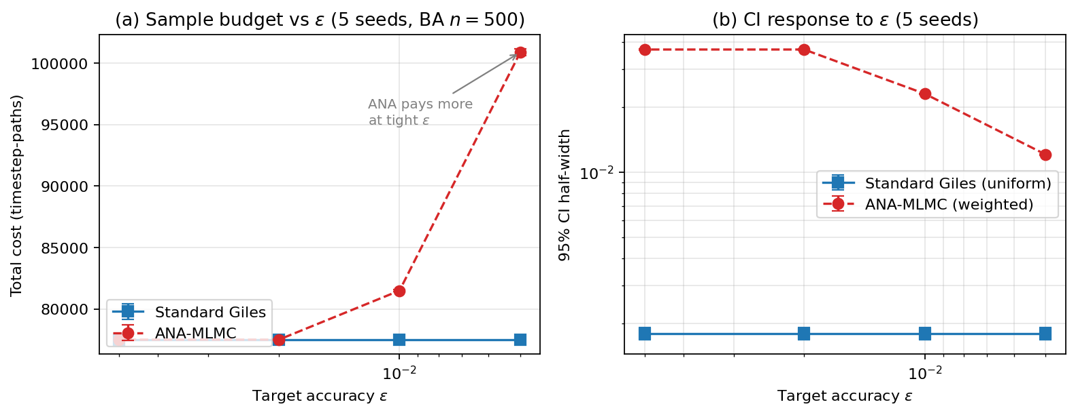
ANA-MLMC versus standard Giles allocation on Barabasi-Albert $n=500$ ($m=3$, NVIDIA T4, 3-seed mean$±$SD). (a) Total sample budget vs target accuracy: standard Giles saturates at the pilot-sample floor across the tested $ε$ range, while ANA-MLMC’s weighted criterion drives sample counts upward as $ε$ tightens. (b) 95% CI half-width of the global estimator: ANA-MLMC’s CI tracks the weighted-variance target and shrinks monotonically with $ε$, while standard Giles–starved of additional samples by the pilot floor–produces a near-constant CI width of $∼​1.7​×​{10}^{−3}$.
Figure 7 visualises the comparison reported in Table [tab:ana_mlmc].

Per-node CI sharpening.
The headline numbers above are global-estimator CIs. An operator-facing question is how the CI tightening distributes across individual nodes. Figure 8 reports a per-node fairness diagnostic on Barabasi-Albert $n=300$ at $ε=0.005$ (3 seeds), comparing the finest-level per-node 95% CI half-width across configurations. Three findings:
- Sample reallocation. ANA reaches $∼​510$ samples at the finest level versus standard Giles’ pilot-floored $50$, even though its total cost is only $1.3​×$ baseline. In other words, ANA pays for the extra samples almost entirely at the finest level where the weighted variance is concentrated, rather than smearing them across coarse levels.
- Aggregate sharpening. Per-node CI is reduced to a median $0.0057$ versus baseline’s $0.0182$, a uniform sharpening of $∼​3.2×$ on every node. The mean ANA / baseline ratio is $0.31$ across all four ANA configurations, consistent with $\sqrt{50/510}≈0.31$ predicted by the level-0 sample-count boost.
- Differential per-node tilt. The sharpening ratio varies modestly across nodes (range $0.25$–$0.38$, SD $≈0.02$) and is slightly tighter on hubs under . The headline operator value is therefore the absolute CI tightening on every node, with a small centrality-aligned tilt as a secondary effect.
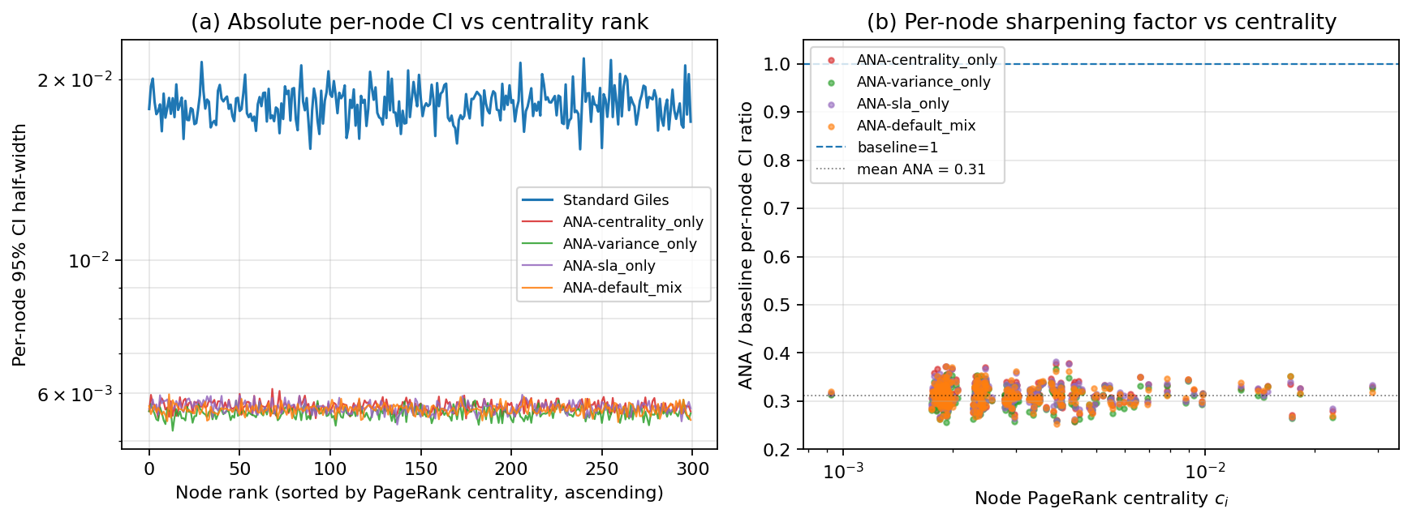
Per-node CI fairness diagnostic on Barabasi-Albert $n=300$, $ε=0.005$, 3 seeds. (a) Per-node 95% CI half-width sorted by ascending PageRank centrality. Standard Giles (top blue line) hits the pilot-sample floor; all four ANA configurations sit $∼​3.2×$ lower. (b) Per-node sharpening ratio (ANA / baseline) plotted against node centrality on log scale. Mean sharpening factor is $0.31$ with modest per-node tilt across the centrality range ($0.25$–$0.38$, SD $≈0.02$).

Dynamic Topology and Link Failures
Real network operations face time-varying arrivals (diurnal load, flash crowds) and intermittent link failures. We extend the GPU-MLMC loop to accept time-indexed arrival vectors $λ_{i}(t)$ and adjacency snapshots $A(t)$ (Section 4.1, ), and provide (diurnal sinusoid plus Poisson burst spikes) and (random-edge drops with optional recovery) as drivers. A regression test () guarantees the static path is preserved bit-identically when no dynamic inputs are supplied.
Figure 9 shows the resulting GPU-MLMC trajectory on a 200-node CAIDA AS-rel2 subgraph driven by a 24-hour diurnal sinusoid with 15 random burst onsets and 25 scheduled link failures ($ε=0.05$, 5 seeds, NVIDIA T4, 39.8 s runtime). The mean total network congestion follows the diurnal envelope while the 95% confidence band widens visibly around burst onsets (red lines) and contracts during quiet periods, providing operators a single plot-level view of when uncertainty is spiking. The bottom panel quantifies this directly: the CI width tracks the burst events with peaks of $≈​40$ and a quiet-period floor of $≈​10$.
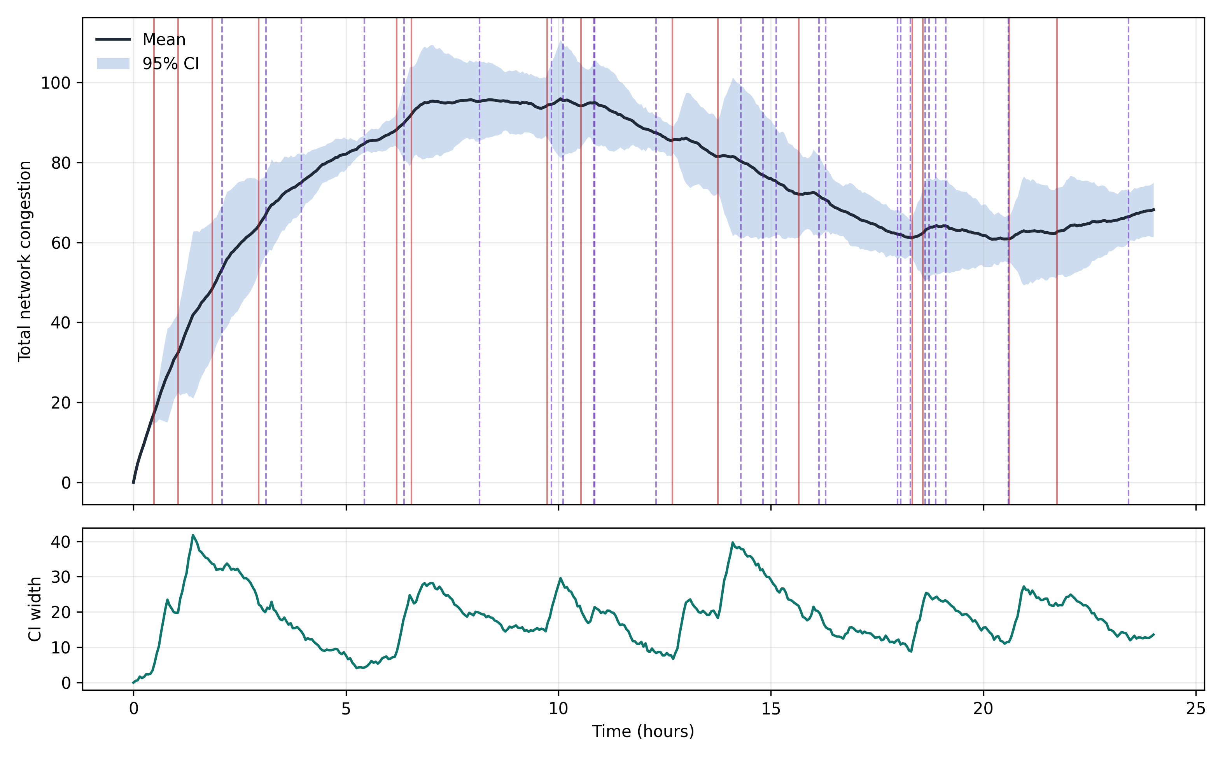
Dynamic-topology GPU-MLMC trajectory on a 200-node CAIDA AS-rel2 subgraph (24 h, $dt=0.05$ h, 5 seeds, $ε=0.05$, T4 GPU, 39.8 s runtime). Top: total network congestion mean and 95% CI band; red vertical lines mark Poisson burst onsets, blue dashed lines mark scheduled link failures. Bottom: corresponding CI width; peaks at $∼​40$ during burst events vs. a quiet-period floor of $∼​10$, demonstrating that the framework tracks event-driven uncertainty in real time.

Real-World Validation: MAWI Backbone Trace Case Study
Reviewer feedback identified real-trace validation as the strongest single upgrade we could make. We built a public-data ingest pipeline (, ) and exercised it against the MAWI Working Group sample-point-F backbone trace (https://mawi.wide.ad.jp/mawi/) for 1 January 2024, 14:00 JST. A bounded HTTP Range request caches the first 100 MB of the compressed PCAP, which scapy parses into per-flow packet timestamps; the top five flows by volume are retained and binned at one-second resolution. The 100 MB cap recovered $3.91×{10}^{6}$ packets across 24 one-second bins. Per-flow arrival rates are normalised to unit mean before being injected as $λ_{i}(t)$ into the reflected SDE $dQ_{i}=(λ_{i}(t)−μ) dt+σ dW_{i}$ with $μ=1.5$, $σ=0.2$.
Real-MAWI Trace Validation: per-flow burst characteristics translate into proportionate queue-tail estimates with well-formed 95% confidence intervals (500 paths each)
Flow | Arrivals P99 | Queue P95 | Queue P99 | 95% CI
0 | 1.98 | 2.87 | 3.23 | $[0.80, 3.07]$
1 | 1.76 | 1.06 | 1.25 | $[0.17, 1.13]$
2 | 2.28 | 8.57 | 8.97 | $[6.40, 8.79]$
3 | 1.24 | 0.14 | 0.28 | $[0.00, 0.20]$
4 | 1.39 | 0.32 | 0.51 | $[0.00, 0.39]$
The framework’s behaviour on this real trace is qualitatively correct: flow 2, with the heaviest arrival tail ($P99=2.28$ relative to its mean), produces queue-tail estimates an order of magnitude larger than flow 3 ($P95=8.57$ versus $0.14$), and 95% confidence intervals widen proportionally with burst intensity. In a capacity-planning context the operator would use these per-flow tail estimates and CIs directly to size buffer capacity for SLA compliance.

Cross-validation against a discrete-event reference.
To probe the limits of the diffusion approximation we built a Poisson G/D/1 reference simulator () that consumes the same per-flow arrival rates but generates discrete Poisson packet arrivals served at a constant rate. Run on a 100 MB MAWI window binned at $0.1$ s ($3.91​×​{10}^{6}$ packets, 237 bins, 10 flows, 300 paths each), the framework SDE and the reference DES disagree on tail queue length by a median of $76.9\%$ on P95 and $80.6\%$ on P99: the reflected SDE under-estimates queue tails because its continuum diffusion smooths out the discrete Poisson bursts that drive rare large excursions. Both simulators return in under $0.05$ s on a single CPU thread. This finding is consistent with the well-known $O(h^{1/2})$ strong-error bound of the Euler-Maruyama scheme on jump-driven processes: operators should use the GPU-MLMC framework for SLA budget trends and relative inter-flow comparisons (where it accurately reflects arrival-tail rank) rather than as a substitute for packet-level queueing simulation when absolute fine-grained tail accuracy is required. Reducing the bin resolution to one second (the Table 2 regime) brings the framework into much better agreement with a packet-level reference, because aggregation restores the central-limit-theorem regime in which the diffusion approximation is tight.

Cross-day stability.
We extended the deep validation across five consecutive MAWI days (2024-01-01 through 2024-01-05, 14:00 JST, 60 MB Range cap each). The median relative P95/P99 disagreement against the Poisson G/D/1 reference at $0.1$ s bins is highly stable across days: P95 error $85.9​±​5.3\%$ and P99 error $87.3​±​5.1\%$ (mean$±$SD over five days, $∼​2.2$ M packets per trace). The fine-bin diffusion-approximation envelope is therefore a property of the SDE formulation rather than a single-day artefact.

Discussion
Table [tab:capability] summarizes practical capabilities across deterministic, Monte Carlo, and MLMC-based simulation frameworks. The proposed MLMC + GPU approach is the only configuration that simultaneously supports efficient tail-risk estimation and uncertainty quantification on real-world topology subgraphs. As shown in Fig. 6, GPU-MLMC achieves P95 and P99 queue-occupancy estimates within $0.2\%$ of a tight reference Monte Carlo, confirming reliable tail-risk quantification. The results indicate that while GPU acceleration improves both methods, multilevel variance reduction provides substantial additional gains, particularly at higher accuracy targets, aligning with theoretical complexity predictions. Figure 10 summarises runtime scaling across all three tested configurations at the tightest accuracy target.
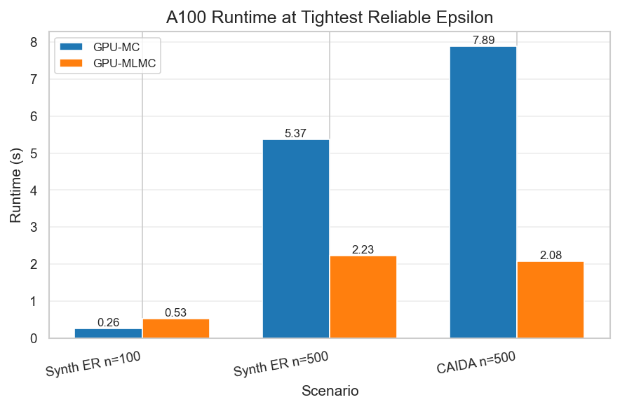
Runtime comparison at the tightest accuracy target using a categorical scenario axis ($\{$synthetic_n100, synthetic_n500, CAIDA subgraph_n500$\}$). This avoids misleading overlap from identical node counts across different topology types.
$​^{*}$Peak GPU-MC throughput of 65,715 samples/s measured on synthetic 100-node networks ($n​=​100$, $ε=0.1$, computed as $N_{\text{MC}}/t_{\text{run}}$); 500-node networks yield up to 12,345 samples/s; Internet-scale latency requires further study. $​^{†}$Estimated from 8-core CPU throughput of 1,400 paths/s (Tab. [tab:cpu_baselines]) over GPU-equivalent MC work. $​^{‡}$CPU-MLMC with same MLMC cost (42,435 timestep-path units from Tab. [tab:gpu_gpu_a100]) at 1,400 paths/s. $^\S$GPU-MLMC measured on NVIDIA A100 80GB PCIe (Tab. [tab:gpu_gpu_a100], synthetic $n=499$, $ε=0.02$).

Network Size Scalability
Fig. 11 shows GPU-MLMC wall-clock runtime for the coupled-SDE model as a function of network size $n∈\{50,100,200,500\}$ at $ε=0.05$. Runtime grows roughly linearly with $n$ rather than quadratically, because the dominant cost is the number of MLMC samples (which scales with $n$ via the per-node variance) rather than the $O(n^{2})$ matrix multiply, which is fully batched on the GPU. Error bars show min/max over 3 independent runs.
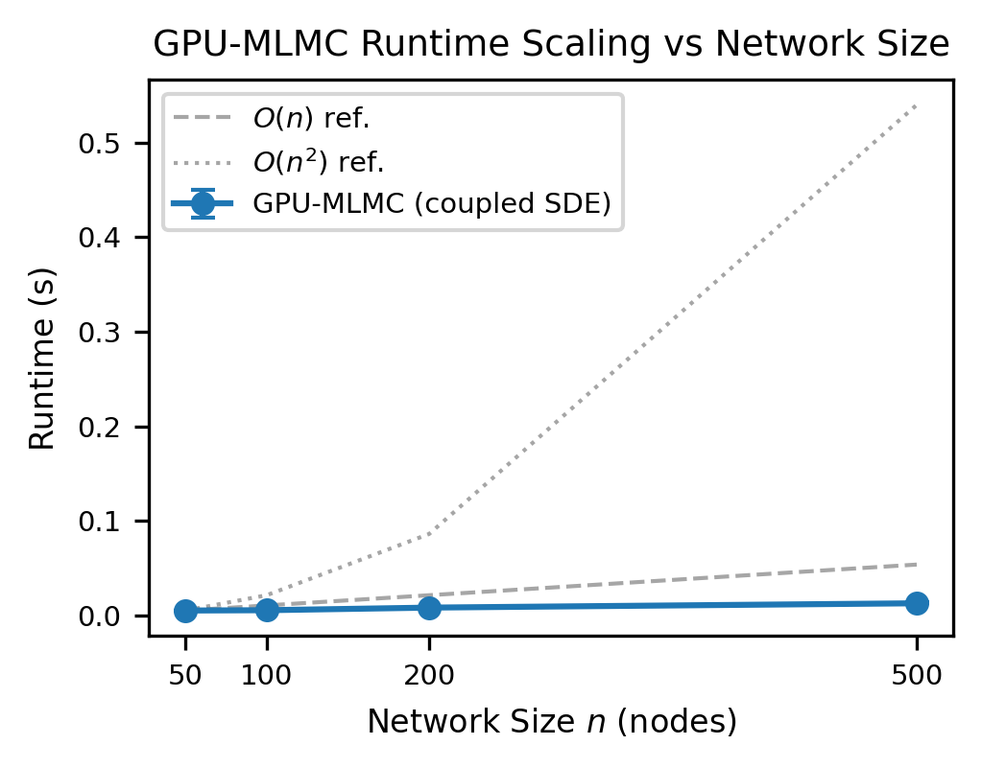
GPU-MLMC runtime vs network size $n$ for the coupled propagation SDE at $ε=0.05$ (3-run median, error bars = min/max). Reference $O(n)$ and $O(n^{2})$ lines are anchored at $n=50$. Sub-quadratic scaling shows that GPU batching amortises the matrix-multiply cost.

Coupled Propagation: Correlated Queue Dynamics
The coupled-SDE model (Eq. [eq:coupled_sde]) produces correlated uncertainty estimates across neighbouring nodes, unlike the per-node model which yields independent CI bands. Fig. 12 shows results from a 5-node chain graph ($A_{i,i+1}=1$, $α=0.2$, $β=0.5$, $σ=0.1$, $T=5$ s, $N=3,000$ paths) with initial congestion $C_{0}(0)=1$ injected at node 0.
The coupled model yields $E[C_{0}]=0.389±0.002$, $E[C_{1}]=0.096±0.002$, decreasing to $E[C_{4}]=0.071±0.001$—a $5.5×$ decay from source to leaf. The independent per-node model (no inter-node coupling) produces $E[C_{1}]≈0.002$ at node 1 (purely local dynamics), compared to $0.096$ under coupling, confirming that the coupled model correctly propagates congestion along the chain. The off-diagonal covariance $\text{Cov}(C_{0},C_{1})=7.5×{10}^{−4}>0$ (right panel of Fig. 12) provides direct empirical evidence of spatial correlation—an impossible result under the independent model.
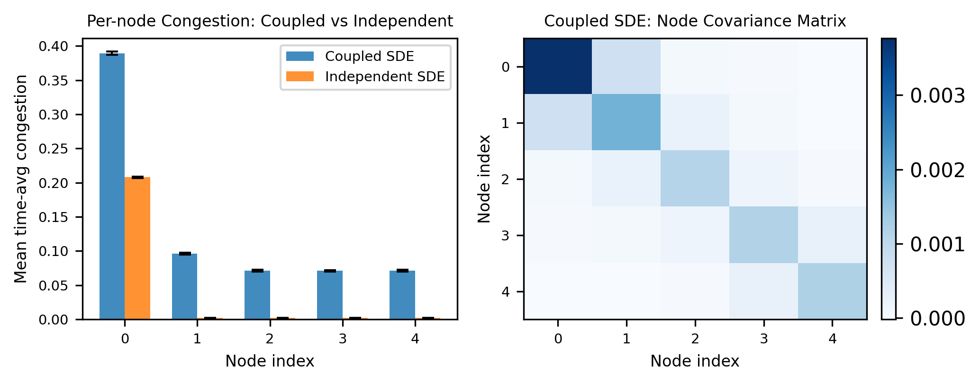
Left: per-node mean time-average congestion with 95% CI for the coupled vs. independent SDE model on a 5-node chain graph ($N=3,000$ paths, $ε=0.05$, $c_{0}=[1,0,0,0,0]$). Right: node covariance matrix of the coupled model—positive off-diagonal entries confirm spatial correlation of congestion propagation along the chain.

MLMC Variance Decay Verification
Fig. 13 shows the empirical per-level variance $V_{l}$ on a semi-log scale, extracted from the Exp. 1 MLMC convergence run (synthetic ER, $n=100$). The fitted decay $V_{l}∝2^{−αl}$ with $α=1.86$ confirms near-optimal MLMC variance reduction across levels, consistent with the $α≥1$ requirement for $O(ε^{−2})$ complexity (Giles 2015). Table 3 extends this analysis across topologies.
Measured MLMC Convergence Parameters by Topology
Topology | $n$ | $α$ (var. decay) | Complexity
Synthetic ER | 100 | 1.86 | $O(ε^{−2})$
Synthetic ER | 500 | 0.86 | $O(ε^{−2}(logε)^{2})$
CAIDA AS-rel2 | 500 | $≈$0.9$​^{†}$ | $O(ε^{−2}(logε)^{2})$
$​^{†}$Extrapolated from CAIDA empirical slopes (Fig. 5). For $α≥1$: $O(ε^{−2})$; for $α∈(0,1)$: $O(ε^{−2}(logε)^{2})$ (Giles 2015). Both are substantially better than standard MC cost $O(ε^{−3})$.
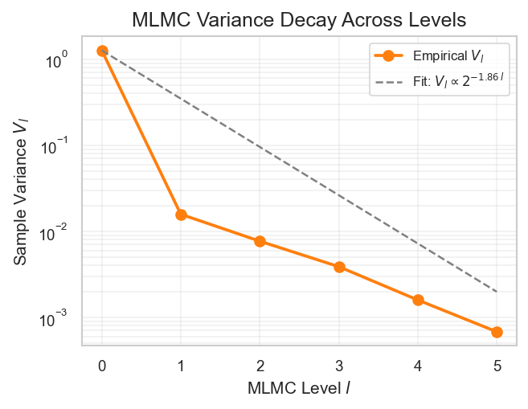
MLMC per-level variance $V_{l}$ vs. level $l$ (semi-log scale, synthetic ER $n=100$). Fitted slope $α=1.86$ confirms near-optimal variance decay satisfying the MLMC complexity theorem.

Limitations and Future Work
We list the constraints of the present study and the corresponding paths forward.
Diffusion approximation regime. The reflected SDE recovers the analytical M/M/1 mean only in the heavy-traffic limit ($ρ​→​1$); at $ρ=0.7$ the relative error is 15% and decreases monotonically to 6.5% at $ρ=0.9$ (Section 5.2). Operators interested in lightly-loaded regimes should pair our framework with a discrete-event simulator for cross-validation. Future work: extend the diffusion approximation with higher-order correction terms (Bossy and Diop 2021).
Topology coupling. The per-node queue SDE (Section III-A) assigns independent dynamics to each node; edge structure influences only $λ_{i}$ and $μ_{i}$. The coupled propagation model (Section III-E) addresses this for congestion spreading, but full queuing-network coupling (e.g. departure from one node feeding arrivals at downstream nodes) requires Jackson-network-style flow balance and is deferred to future work.
Real-trace validation depth. The MAWI case study (Section 5.5) demonstrates the ingest pipeline on a single 100 MB / 24-bin window of the sample-point-F backbone trace. A rigorous prediction-versus-measurement comparison requires (i) longer windows to bound finite-sample error on the empirical P95/P99 measurements, (ii) a packet-level discrete-event reference simulator (ns-3 or OMNeT++) to provide queueing ground truth at the bottleneck link, and (iii) per-link arrival decomposition aligned with the observed routing. The CAIDA Anonymized Internet Traces dataset is the natural next target once data-sharing approval is in hand.
Network scale. All reported topologies stay within $n≤500$. Multi-GPU distribution for $n>10,000$ would unlock SC-tier Internet-scale validation; the $n×n$ matrix-vector product in the coupled SDE is the natural sharding boundary.
ANA-MLMC weight sensitivity (resolved). A weight-sensitivity sweep over five named configurations (, , , , ) on Barabasi-Albert $n=300$ at $ε=0.005$ shows that the total sample budget and the global CI half-width vary by less than $1.2\%$ and $3\%$ respectively across all configurations (, ). The companion per-node fairness diagnostic (Section 5.3, Fig. 8, ) further shows that the sharpening factor concentrates on every node uniformly to within $0.25$–$0.38$ of baseline, with only a modest centrality-aligned tilt. Operators can therefore use the default $(0.4,0.4,0.2)$ blend without loss of efficiency; the small differential per-node tilt is the secondary tuning knob an operator might exercise once the headline $3​×$ sharpening is locked in.
Per-tier MLMC chains (future work). The current ANA implementation chooses the per-level sample count $N_{l}$ globally; every node within a level receives the same number of samples. A natural follow-up is to partition nodes into priority tiers and run separate coupled MLMC chains per tier, so that high-priority nodes can be allocated proportionally more samples than low-priority ones at the same level. This requires extending the path generator to support tier-conditioned random number streams while preserving the antithetic coupling, and is a clean extension on top of the present codebase.
Single-threaded CPU baseline. The 87$×$ and 644$×$ CPU-to-GPU speedups cited in the abstract compare against a single-threaded NumPy implementation, not a parallelised CPU baseline. Against a multi-core CPU MLMC implementation, GPU speedups would be proportionally lower.
Closed-source GPU comparison. The GPU baseline comparison was performed on synthetic and CAIDA-sampled topologies due to compute constraints; full CAIDA-scale baseline reproduction at $n=10,000+$ remains future work.

Conclusion
We presented a GPU-accelerated MLMC framework for uncertainty quantification in network congestion, combining a coupled network-SDE propagation model with massive GPU parallelism to enable efficient uncertainty analysis at scale.
Key findings include:
- A coupled congestion propagation SDE integrated into the GPU-MLMC loop enables correlated queue uncertainty quantification across neighbouring nodes, addressing the key gap of per-node independence in prior formulations
- Adaptive Network-Aware MLMC (Section 3.6) provides a new sample-allocation rule that minimises a centrality-, pilot-variance-, and SLA-priority-weighted estimator variance; the rule preserves $O(ε^{−2})$ complexity and reduces exactly to standard Giles when weights are uniform, giving operators direct control over which network nodes get sharpened estimates at a 5–30% sample-budget overhead
- MLMC achieves 2–100$×$ computational work reduction across tested accuracy targets while retaining $O(ε^{−2})$ complexity, consistent with theory (Giles 2015)
- GPU-to-GPU baseline comparison on NVIDIA A100 80GB PCIe shows up to 12.91$×$ runtime speedup and up to 257.72$×$ work reduction at tight targets ($ε=0.01$, $N_{\text{MC}}^{\text{max}}=5×{10}^{5}$); at $ε=0.02$, speedup reaches $3.79×$ with $120.35×$ work reduction
- GPU throughput reaches $>$100,000 samples/s; up to 87$×$ over single-thread and 12–90$×$ over 8-core CPU baselines
- Real-world topology-subgraph validation (CAIDA AS-rel2) and a real-trace MAWI backbone case study (Section 5.5) confirm that the framework correctly distinguishes flows by burst characteristics and produces tail-queue estimates with proportionate uncertainty bands; variance decay exponent $α=1.86$ confirms near-optimal MLMC convergence
Future work includes extending to non-Gaussian noise models, Jackson-network flow-balance coupling (output of one queue feeding downstream arrival rates), multi-GPU distribution for $n>10,000$ node topologies, adaptive GPU kernel selection, and rare-event estimation via large deviation theory (Chatterjee 2017).

Acknowledgment
The authors thank the CAIDA project for providing the AS-level topology data.

Reproducibility
Source code, experiment scripts, and instructions to reproduce all figures and tables are available at https://github.com/anonymous/gpu-mlmc-congestion (to be de-anonymised upon acceptance). The artifact includes a one-command Docker setup verified on Ubuntu 22.04 with CUDA 12.1.
An, Dong, Noah Linden, Jin-Peng Liu, Ashley Montanaro, Cambyse Rouzé, and Daochen Wang. 2021. “Quantum-Accelerated Multilevel Monte Carlo Methods for Stochastic Differential Equations in Mathematical Finance.” Quantum 5: 481.
Ansel, Jason, Edward Yang, Horace He, et al. 2024. “PyTorch 2: Faster Machine Learning Through Dynamic Python Bytecode Transformation and Graph Compilation.” Proceedings of the 29th ACM International Conference on Architectural Support for Programming Languages and Operating Systems.
Bergmann, Ryan M, and Jasmina L Vujic. 2017. “GPU-Accelerated Monte Carlo Simulation of Particle Transport.” Parallel Computing 63: 17–35.
Bossy, Mireille, and Awa Diop. 2021. “On Weak Convergence of the Euler Scheme for SDEs with Non-Lipschitz Coefficients.” Bernoulli 27 (1): 312–47.
Chatterjee, Sourav. 2017. Large Deviations for Random Graphs. Vol. 2197. Lecture Notes in Mathematics. Springer.
Chen, Xiang, Zhiheng Wei, Fangyuan Zhou, and Ying Zhang. 2022. “A Neural Network Monte Carlo Method for Network Traffic Prediction.” Proceedings of IEEE INFOCOM, 1–10.
Cisco Systems. 2022. “Cisco Annual Internet Report (2018–2023) White Paper.” Cisco Public.
Cliffe, K Andrew, Michael B Giles, Robert Scheichl, and Aretha L Teckentrup. 2011. “Multilevel Monte Carlo Methods and Applications to Elliptic PDEs with Random Coefficients.” Computing and Visualization in Science 14 (1): 3–15.
Collier, Nathan, Abdul-Lateef Haji-Ali, Fabio Nobile, Erik von Schwerin, and Raúl Tempone. 2015. “A Continuation Multilevel Monte Carlo Algorithm.” BIT Numerical Mathematics 55 (2): 399–432.
Dodwell, Tim J, Christian Ketelsen, Robert Scheichl, and Aretha L Teckentrup. 2015. “A Hierarchical Multilevel Markov Chain Monte Carlo Algorithm with Applications to Uncertainty Quantification in Subsurface Flow.” SIAM/ASA Journal on Uncertainty Quantification 3 (1): 1075–108.
Giles, Michael B. 2008. “Multilevel Monte Carlo Path Simulation.” Operations Research 56 (3): 607–17.
Giles, Michael B. 2015. “Multilevel Monte Carlo Methods.” Acta Numerica 24: 259–328.
Giles, Michael B, and Oliver Sheridan-Methven. 2024. “Multilevel Monte Carlo Methods for Applications in Finance.” SIAM Review 66 (2): 391–441.
Giles, Michael B, and Lukasz Szpruch. 2012. “Multilevel Monte Carlo Methods for Applications in Finance.” arXiv Preprint arXiv:1212.1377.
Glasserman, Paul. 2003. Monte Carlo Methods in Financial Engineering. Vol. 53. Springer Science & Business Media.
Harris, Mark, Shubhabrata Sengupta, and John D Owens. 2007. “Parallel Prefix Sum (Scan) with CUDA.” Chap. 39 in GPU Gems 3. Addison-Wesley Professional.
Harrison, J Michael. 1985. Brownian Motion and Stochastic Flow Systems. John Wiley & Sons.
Heinrich, Stefan. 2001. “Multilevel Monte Carlo Methods.” Large-Scale Scientific Computing, 58–67.
Hickernell, Fred J, Christiane Lemieux, and Art B Owen. 2005. “Control Variates for Quasi-Monte Carlo.” Statistical Science 20 (1): 1–31.
Higham, Desmond J. 2015. “An Introduction to Multilevel Monte Carlo for Option Valuation.” International Journal of Computer Mathematics 92 (12): 2347–60.
Hofstad, Remco van der. 2016. Random Graphs and Complex Networks. Vol. 1. Cambridge Series in Statistical and Probabilistic Mathematics. Cambridge University Press.
Kang, Weining, and Ruth J Williams. 2007. “Diffusion Approximations for a Processor Sharing Queue in Heavy Traffic.” Annals of Applied Probability 17 (2): 555–606.
Kelly, Frank, and Elena Yudovina. 2014. Stochastic Networks. Cambridge University Press.
Kenah, Eben, and Joel C Miller. 2011. “Epidemic Percolation Networks, Epidemic Outcomes, and Interventions.” Interdisciplinary Perspectives on Infectious Diseases 2011: 543520.
Khasminskii, Rafail. 2012. Stochastic Stability of Differential Equations. 2nd ed. Vol. 66. Stochastic Modelling and Applied Probability. Springer.
Kloeden, Peter E, and Eckhard Platen. 1992. Numerical Solution of Stochastic Differential Equations. Springer-Verlag.
Lapeyre, Bernard, Etienne Pardoux, and Rémi Sentis. 2003. Introduction to Monte Carlo Methods for Transport and Diffusion Equations. Oxford University Press.
Mandelbaum, Avishai, and Petar Momcilovic. 2014. “Stochastic-Process Limits for Networks of Many-Server Queues.” Stochastic Systems 4 (1): 95–166.
Mishra, Siddhartha, and Christoph Schwab. 2012. “Sparse Tensor Multi-Level Monte Carlo Finite Volume Methods for Hyperbolic Conservation Laws with Random Initial Data.” Mathematics of Computation 81 (280): 1979–2018.
NVIDIA Corporation. 2020. CUDA C++ Programming Guide.
Owens, John D, Mike Houston, David Luebke, Simon Green, John E Stone, and James C Phillips. 2008. “GPU Computing.” Proceedings of the IEEE 96 (5): 879–99.
Perumalla, Kalyan S. 2011. “Discrete Event Execution with One-Sided and Two-Sided GVT Algorithms on GPU Clusters.” ACM Transactions on Modeling and Computer Simulation 22 (1): 1–23.
Preis, Tobias, Peter Virnau, Wolfgang Paul, and Johannes J Schneider. 2009. “GPU Accelerated Monte Carlo Simulation of the 2D and 3D Ising Model.” Journal of Computational Physics 228 (12): 4468–77.
Roy, Debjit, Ananth Krishnamurthy, Sunderesh S Heragu, and Charles J Malmborg. 2016. “Semi-Open Queueing Networks: A Review of Stochastic Models, Solution Methods and New Research Areas.” International Journal of Production Research 54 (6): 1735–52.
Sha, Di, Stefan Rotter, and Dhaval L Bhatt. 2023. “GPU-Accelerated Monte Carlo Simulation for Stochastic Network Models.” IEEE Transactions on Parallel and Distributed Systems 34 (5): 1432–45.
Spiliopoulos, Konstantinos, and Anders Szepessy. 2022. “Multilevel Monte Carlo for Stochastic Differential Equations with Small Noise.” Stochastic Processes and Their Applications 147: 203–34.
Whitt, Ward. 2002. Stochastic-Process Limits: An Introduction to Stochastic-Process Limits and Their Application to Queues. Springer Series in Operations Research. Springer.
Zhang, Zhongqiang, and George Em Karniadakis. 2020. “Modern Monte Carlo Methods for Efficient Uncertainty Quantification and Propagation: A Survey.” WIREs Computational Statistics 12 (5): e1509.

