Research and Prototyping

10/16/2018

I ordered the following USB ISP for programming the AT89S52. It is a requirement that we be able to program the MC in circuit and not on a daughter board. Read the specs in the link.

<https://www.amazon.com/gp/product/B00AX4WQ00/ref=oh_aui_detailpage_o00_s00?ie=UTF8&psc=1>

From the description they had the following layout for programming the MC for a different chip in a TQFP 32 pin out shown below.

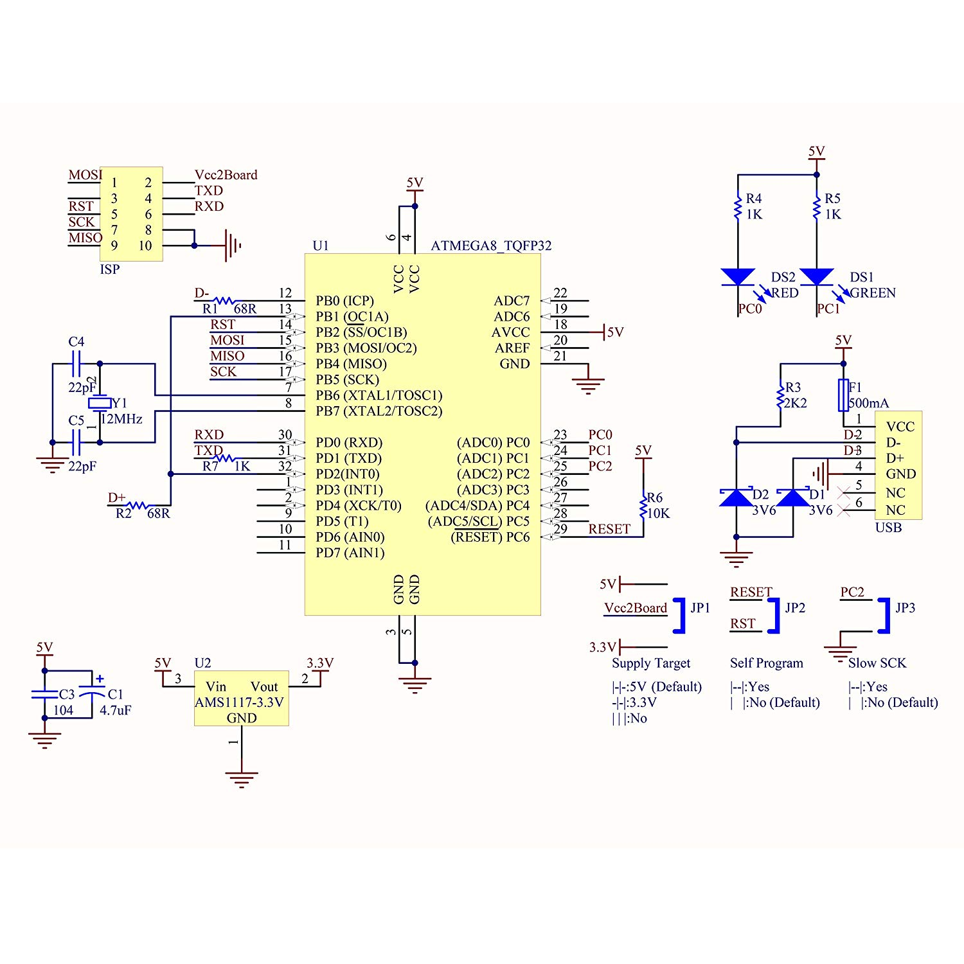

I translated the schematic for a basic pin out from the 10-pin connector for an AT89S52 in EAGLE shown below.

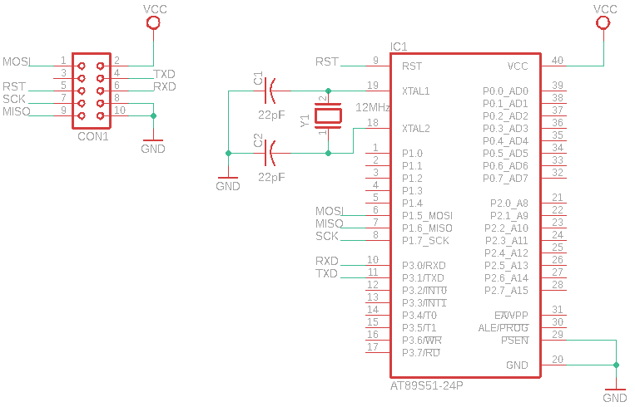

The only microcontroller I’ve ever used is the Beagle bone black from 371. I’ll need your feedback on what else this circuit needs or is missing for basic programming. I figure this is a good place to start, so we can get programming, and test functionality.

I’ve also requested free samples from ATMEL of AT89S52 in a DIL40 pin package. I have two coming that should be here in a week to a week and a half. We may want to order some that will get here faster.

The parts list from Jason’s link is below as well as a block diagram of the circuit.

|  |  |
| --- | --- |
| * [AT89S52 (8051 Microcontroller) – Buy AT89S52 Online](http://nevonexpress.com/AT89S52-8-Bit-Microcontroller-DIP-Mount-8051-Family.php) * [7 Segment Display – Buy 7 Segment DIsplay Online](http://nevonexpress.com/7-Segment-Display-CA.php) * [DC Cooling Fan – Buy DC Fan Online](http://nevonexpress.com/12v-Brushless-DC-Cooling-Exhaust-Fan.php) * [LM35 Temperature Sensor – Buy LM35 Sensor Online](http://nevonexpress.com/LM35-Temperature-Sensor-For-Arduino-Ras-Pi-Microcontroller.php) * [Relay – Buy Relays Online](http://nevonexpress.com/Buy-Relays-Online.php) * [Relay Driver IC – Buy IC’s Online](https://nevonexpress.com/Buy-IC-and-Controllers-Online.php) * [Vtg Regulator IC – Buy IC’s Online](https://nevonexpress.com/Buy-IC-and-Controllers-Online.php) * [IC Socket – Buy IC Sockets Online](https://nevonexpress.com/Buy-IC-Sockets-Online.php) * [Resistors – Buy Resistors Online](https://nevonexpress.com/Buy-Resistors-Online.php) * [Capacitors – Buy Capacitors Online](https://nevonexpress.com/Buy-Capacitors-Online.php) * [Transistors – Buy Transistors Online](https://nevonexpress.com/Buy-Transistors-Online.php) * [Cables & Connectors – Buy Cables & Connectors Online](http://nevonexpress.com/Cables-&-Connectors.php) * [Diodes – Buy Diodes Online](https://nevonexpress.com/Buy-Diodes-Online.php) * [PCB – Buy PCB & Breadboards Online](https://nevonexpress.com/Buy-PCB-Breadboards-Online.php) * [LED’s – Buy LED Online](https://nevonexpress.com/Buy-LED-Displays-Online.php) * [Transformer/Adapter – Buy Transformers & Adapters Online](http://nevonexpress.com/Transformers.php) * [Push Button – Buy Buttons & Switches Online](https://nevonexpress.com/Buy-Electronics-Buttons-Switches-Online.php) * Lamp | **Software Specifications**   * Keil µVision IDE * MC Programming Language: Embedded C |
| **Block Diagram** [http://nevonprojects.com/wp-content/uploads/2015/09/room-temperature-controller-block-small.jpg](http://nevonprojects.com/wp-content/uploads/2015/05/room-temp-block.png) | |

I think it will be a lot cheaper to order all of the parts individually, they want $105 for the kit which includes a pcb that we won’t need.

My thoughts on what we could do different for our project:

* Use a different/ more advanced temperature sensor
* Data logging
* 4 7-segment displays instead of 3
* We could have different loads to switch besides a dc fan and a light bulb
* We could build an actual enclosure to show proof of concept
* RFID tags that automatically set the temperature for a person when they walk into a room. (stolen from the lock box idea)

Some of these may be too much added work, I’ll need your feedback as to what you guys think is possible in the given amount of time.

Requirements/Specification Ideas:

* Parts list
  + Loads: Fan/lightbulb or Other
  + Temperature Sensor
  + RFID?
  + >25% SMT components
  + Correct 10-pin ribbon connector
* Temperature Range
* Sensitivity
* Power consumption
* Enclosure?
* Display
* Size
* Operation