To: OBC Committee

From: Viking Robotics Society

Subject: Robot Arm – Progress Report

Dear OBC Committee,

The following letter is to report on the progress of the Robot Arm project that is due at the end of Spring term 2020.

**Introduction**

On November 01, 2019, we have submitted the project proposal for designing a Robotic Arm for the Viking Robotics Society. Upon receiving approval for the project, we have immediately started working on designing the CAD model and planning for the project. The goal is to build a fully functional robotic arm that can draw and write from human user input. The project is currently being worked on by the members of VRS until the final submission.

**The Background**

VRS does not have a working robot that is designed and programmed by the members from scratch. All of our previous projects have been from pre-built kits. We currently have several members who are seniors and very invested in learning more about robotics. This project is initiated to give the members the opportunities to learn more about the engineering design process and nurture a new generation of new members about project management and teamwork. This project will also give the club something to show off that is of our own design.

**Work Completed**

We have completed the second iteration of the arm design and we are currently printing out more parts to start the assembly. We have also received several servos and parts that we ordered. A team is currently working on the communication and electronics of the arm. We have also been in constant contact with the Agile and Adaptive Robotics Lab graduate student to get help with the technical and challenges that we encountered in the process.

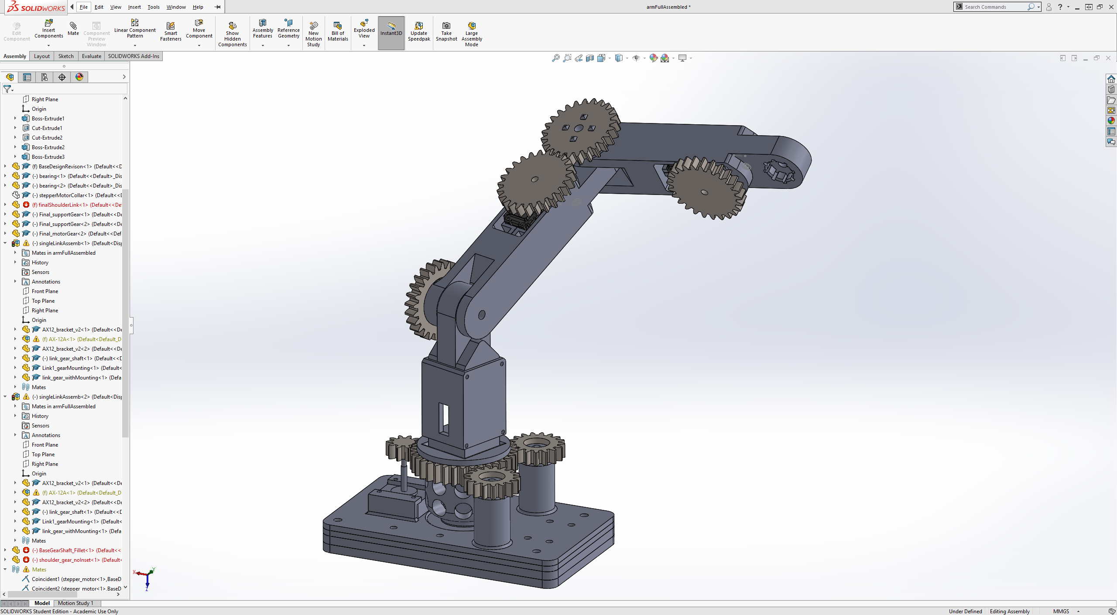

**Work to Be Completed**

We plan to have the full assembly by the end of the Winter Break; this will be the second version of the arm. During the Winter term and Spring term, the software team can start working on the programming of the arm, while the design team will work on the electronics and continuously making improvements upon the current model. We also plan to show off our current progress at the Robotics Club game night to recruit more members to help with the project.

**Anticipated Problems**

One of the servos that we ordered on November 12, 2019, has not shown up. We plan to have the full assembly to be completed during the Winter break. If we do not get the servo in time, the deadline for the project will be delayed. Additionally, the OBC committee will not be available during the break, which makes ordering replacement for the servo will be significantly challenging. I have contacted the advisor of the club to look into this issue and make sure that we will get the part in time.

The 3D printer of the club is degrading. It has broken down many times when we tried to print the parts. The parts have also been warping much more significantly than normal, which causes fitting to be challenging. We are designing our model to be 3D-printing friendly, but without a good printer, it is taking significantly longer to get parts. We will have to work with what we have. We will try to maintain the printer and fix it if necessary.

**Conclusion**

Based on the current progress, we should have the project to be completed at the end of the Spring term 2020. Despite several delays in our timeline, we are still on schedule. We plan to order several more parts that we have missed in the last order to support the project.