**Project Proposal**

**Subject and Purpose of the Proposal**

The Vikings Robotics Society (VRS) had a surge of new senior student members recently. To create a new challenge and facilitate an environment for the new members to grow, VRS proposes a more difficult project that will fit the interest of all the new members while ensuring that it is still doable within an appropriate timeline. The project is to build a 5 Degree-of-Freedom Robot arm that can manipulate complex tasks and write/draw input from a human user. The arm will have a maximum reach of 2 feet. The project has 2 main phases.

* Phase 1: Design, construct, and program the 5-DOF robot arm from scratch. The fundamental working theory of the robot arm is done in this phase. Design records will be kept meticulously for Phase 2.
* Phase 2: In the future, new members can use the fabricated arm to program more complex tasks (have 2 arms play chess against each other, etc.). This provides the opportunity for the club to grow and provide future generation learning material in robotics engineering design.

Phase 1 will be completed at the end of the 2020 school year and Phase 2 can begin in the next school year or when members express interest. This proposal is to officially launch the project and record its initiation with OBC.

**Current Team**

The current team that will be working on this project is a mixture of Mechanical Engineering and Computer Science students. Team composition includes specialization in Finite Element Analysis, Control System Theory, and Advanced Robotics Development.

Team Composition:

Project Manager: Jake Chung

System Architecture:

* Jonathan Le – Finite Element Analysis/ Mechatronics – Design Lead
* Vladi Ruchin – Mechatronics/ System Control Theory
* Yahye Egal – Mechatronics/ System Control Theory
* Michael Nguyen – Rapid Prototyping

Software Design:

* + Jason Holm – Machine Learning - Software Lead
  + David Pleshakow – Computer Science
  + Geoffrey Olson – Machine Learning

Circuitry Support:

* Anthony Bruno – Embedded System

The team is not limited to the current list. Any new member that expresses interest can still join the project.

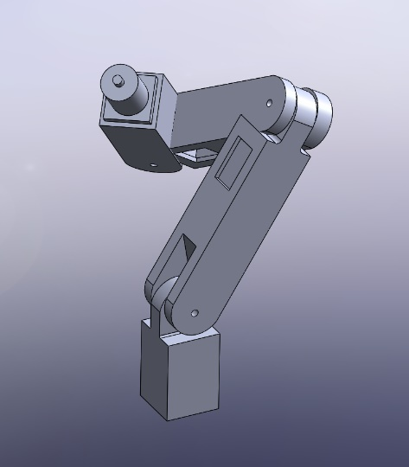**Current Progress**

The team has made some preliminary progress in designing the 3D models for the robot arm. Some dimensions are still incorrect, but the general topology of the arm has been defined (see figure).

**Collaboration**

This project is also a new opportunity for VRS to reach out to the Agile and Adaptive Robotics lab lead by Dr. Alexander Hunt to offer a technical advisor for the project. The lab has accepted the offer and provided 2 graduate students who will be on the advising board.

**Tentative timeline**

The project is expected to be completed at the end of the Spring term 2020.

**Project Website**

https://github.com/pdx-robotics/Robot-Arm