

Healthy Living for Older Adults
Senior University • Student Edition
Everyday health and enjoyable activities

Produced by SUSTech-BIO

Healthy Living • Student Edition
Contents
Part One Healthy living
1 Noticing changes in your body 5
2 Blood pressure and stroke signs 7
3 Medicines and sales pressure 9
4 Making everyday meals balanced 11
5 Gentle movement and table tennis 13
6 A safer home and calling for help 15
7 Caring for mood and memory 17
8 Preparing for a medical visit 19
Part Two Everyday interests
9 Phone photography and gentle edits 22
10 Arranging three flower stems 24
11 Radio, information, and AI 26
12 Growing and observing plants 28
13 Cards, handwriting, and memories 30
14 Musical beats and sound memories 32
Appendices
Guide 34 • A Medicine card 35 • B Emergency card 36
C1 Four-week blood pressure log 37
C2 Four-week blood sugar log 41
D Four-week action plan 45 • E Cornell notes 47
F Official sources 51 • G Figures and credits 55

Healthy Living • Student Edition
How to use this book
Choose one thing to learn
Read in any order. Start with a small health habit or an activity you enjoy.
Look, then try
Each chapter has two pages. Look at the pictures and short steps, then practice with a teacher or partner. Watching, speaking, or having someone write for you all count.
Keep a few useful notes
You do not need to memorize a page or fill every space. Use the Cornell note pages in Appendix E for things you want to remember.
Use the logs again
Appendices C1 and C2 each cover four weeks, with morning and evening spaces. Follow your healthcare professional’s measuring schedule and leave unused boxes blank.
Ask for what helps
Tell the teacher if you need larger pictures, slower speech, another demonstration, or help from a partner.
Know your local numbers
Write your local emergency number on Appendix B before using this book. The Chinese edition uses 120; emergency numbers differ by country. China-specific checking services are identified in Chapter 3.

Healthy Living • Student Edition
Part One Healthy living
Chapters 1–8
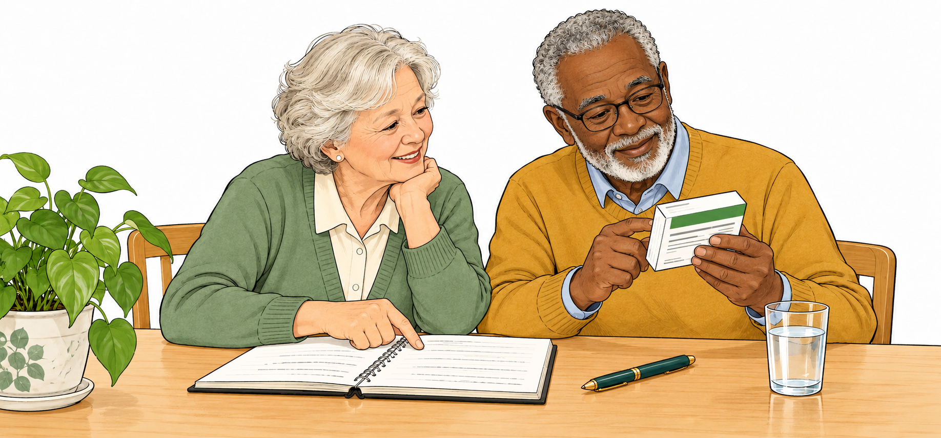
Figure 1 Learn by looking, keeping notes, and asking for help.
Start with a chapter that matters to you
Look, try, and talk. Write things down when you want to.

Healthy Living • Student Edition
1 Noticing changes in your body
This lesson Describe a change clearly and know when to ask for help.
Notice how the change happens
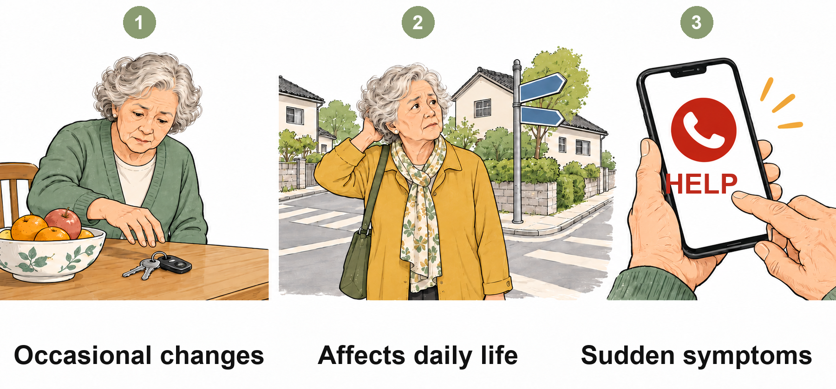
Figure 2 Occasional, repeated, and sudden changes.
1 Occasional: you misplace your keys, then find them later.
2 Repeated or affecting daily life: you often get lost on a familiar route, or cannot cook a meal you used to make. Arrange a medical assessment.
3 Sudden: watch for chest pain, severe breathlessness, a drooping face, weakness on one side, or unclear speech.
Keep safe For sudden chest pain, severe breathlessness, a drooping face, one-sided weakness, or unclear speech, call your local emergency number at once. Do not fill in a log first.

Chapter 1 • Noticing changes in your body
Tell the doctor these four things
1 When did it start? If you cannot recall a date, say something like ‘after last weekend.’
2 How often? Does it happen occasionally or every day?
3 What does it affect? For example, sleep, shopping, or walking without stopping.
4 What else has changed? Mention new medicines, fever, falls, or other recent events.
Try it together
Tell a partner about a small concern you are comfortable sharing. The listener asks one question to make it clearer. You may use an example from this book instead of your own history.
Three things to remember
1 Notice whether a change repeats, worsens, or affects daily life.
2 Note the timing, frequency, impact, and recent changes.
3 Get help first for sudden warning signs.
Keep safe Do not push through knee pain to keep up. A hot, swollen joint, sudden severe pain, or ongoing pain after a fall needs prompt medical attention. Do not take painkillers long term without medical advice.

Healthy Living • Student Edition
2 Blood pressure and stroke signs
This lesson Use the right measuring position and know how to call for help.
Sit comfortably before measuring
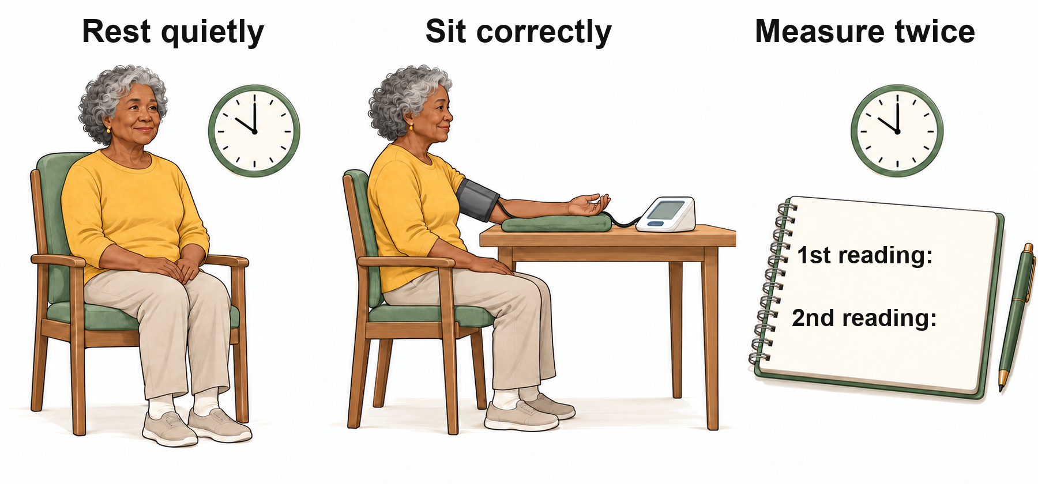
Figure 3 Rest, sit correctly, and record two readings.
1 For 30 minutes beforehand, avoid smoking, caffeine, and exercise. Empty your bladder, then rest quietly for at least 5 minutes.
2 Sit with your back supported and feet flat. Do not cross your legs. Put the correctly sized cuff on your bare upper arm, following its instructions.
3 Support your arm, with the upper-arm cuff at about heart level. Do not talk during measurement.
Keep safe Keep your feet flat, back supported, and cuff at heart level. Stay quiet. Do not change your dose based on a single reading.

Chapter 2 • Blood pressure and stroke signs
Check the face, arms, and speech
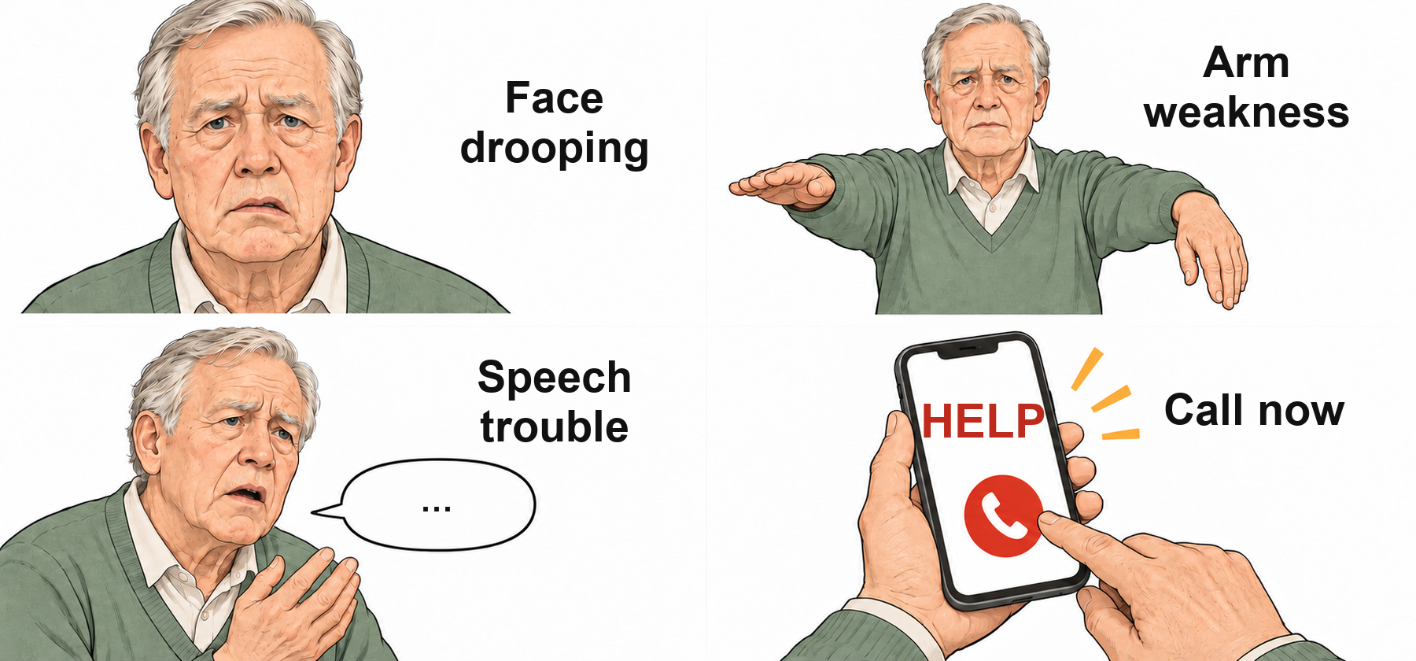
Figure 4 Face, arms, speech: call for help at once.
FACE: Does one side droop or look uneven?
ARMS: Is one arm weak or drifting down?
SPEECH: Is speech suddenly slurred or hard to understand? Any one sign means call your local emergency number now. Note when symptoms began, or when the person was last known to be well.
Try it together
Use a pretend phone without placing a call. Practice giving the address, symptoms, start time, and callback number. Never call emergency services just to practice.
Three things to remember
1 Take two readings about 1 minute apart. Write both in Appendix C1.
2 Follow your clinician’s plan for unusual readings. Do not add medicine after one reading.
3 Call for urgent help with chest pain, severe breathlessness, or stroke signs.
Keep safe Do not wait even if symptoms improve quickly. Sudden vision changes or trouble walking can also be stroke signs.

Healthy Living • Student Edition
3 Medicines and sales pressure
This lesson Read medicine information and pause before buying a health supplement.
Ask how to take each medicine
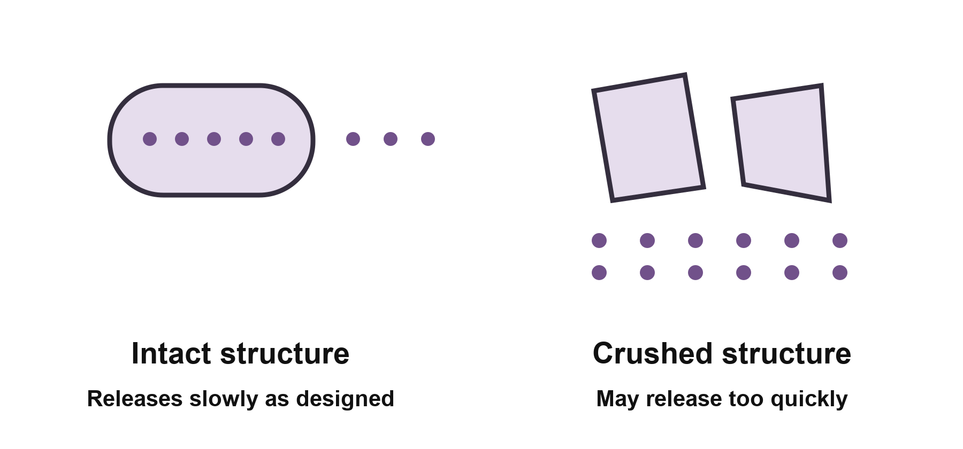
Figure 5 Changing a medicine’s structure may change its release.
1 Find the generic name, dosage form, and expiry date. Different brands may contain the same ingredient.
2 Bring all medicines, herbal products, and supplements for a pharmacist to check. Ask how much to take, when to take it, and for how long.
3 Extended-release medicines release their contents slowly. Enteric-coated medicines have a special coating. Ask a pharmacist before splitting or crushing; a score line alone does not tell you it is safe.
Keep safe Do not crush or chew extended-release medicine on your own, or automatically double a missed dose. For swallowing problems, take the packaging to a pharmacist and ask about suitable forms.

Chapter 3 • Medicines and sales pressure
Pause before paying for supplements
1 Keep the full product name, registration or filing number, manufacturer, and payment receipt.
2 For products sold in China, ask a teacher or family member to help check the Special Food Information platform via samr.gov.cn. A listing does not mean a product suits you or treats illness.
3 Ask your doctor or pharmacist before deciding. Keep evidence of disputes; China’s consumer complaint number is 12315. Never transfer money to a stranger’s ‘safe account.’
Try it together
Use an empty medicine box to find its name and dosage form. Circle anything unclear and ask a pharmacist next time.
Three things to remember
1 Follow your own latest prescription, not someone else’s directions.
2 Update Appendix A after changes. Do not follow both old and new plans.
3 Say: ‘I will keep the details and ask first. I am not paying a deposit today.’
Keep safe Supplements do not replace prescribed treatment. Pause a purchase if someone claims to cure everything, tells you to stop medicine, or demands immediate payment.

Healthy Living • Student Edition
4 Making everyday meals balanced
This lesson Add a suitable food to a familiar meal and ask when you are unsure.
Include different kinds of food
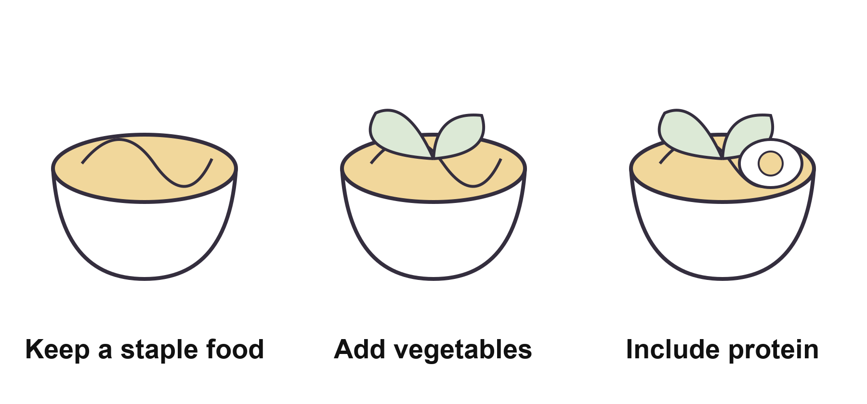
Figure 6 Add suitable foods to a familiar meal.
1 Staple foods provide energy. Fish, eggs, milk, beans, and lean meat can provide protein. Vary your vegetables and fruit too.
2 For example, add soft cooked vegetables to noodles, then an egg or tofu if suitable. Adjust the amount to your own eating plan.
3 For chewing problems, cut food smaller or cook it softer. Repeated coughing or choking needs assessment, not just smaller pieces. Plan amounts around appetite, weight, activity, and health.
Keep safe Tell a healthcare professional about ongoing weight loss, much lower intake, or repeated coughing or choking while eating. Avoid extreme diets or cutting out all staple foods.

Chapter 4 • Making everyday meals balanced
Use your own plan for long-term conditions
1 High blood pressure: use less salt, soy sauce, and salty processed food. General adult guidance is under 5 g salt a day, including salt in seasonings. Ask your clinician about your own target.
2 Diabetes: eat regularly, spread staple foods according to your plan, and limit sugary drinks. ‘Sugar-free’ does not mean unlimited. Do not delay or skip meals casually when using insulin or medicines that can cause low blood sugar.
3 Kidney disease: protein, potassium, phosphorus, and fluid needs vary. Do not copy another person’s diet. Ask before using low-sodium salt. If you have several conditions, ask for one combined plan.
Try it together
Describe a familiar meal and choose one small change. Write down questions for your clinician or dietitian. Do not add large amounts of supplements on your own.
Three things to remember
1 Vary foods and notice appetite and weight changes.
2 Use an individual plan for long-term conditions.
3 If swallowing is difficult, skip classroom food tasting.

Healthy Living • Student Edition
5 Gentle movement and table tennis
This lesson Move within your comfort level and stop if you feel unwell.
Warm up, move, then slow down
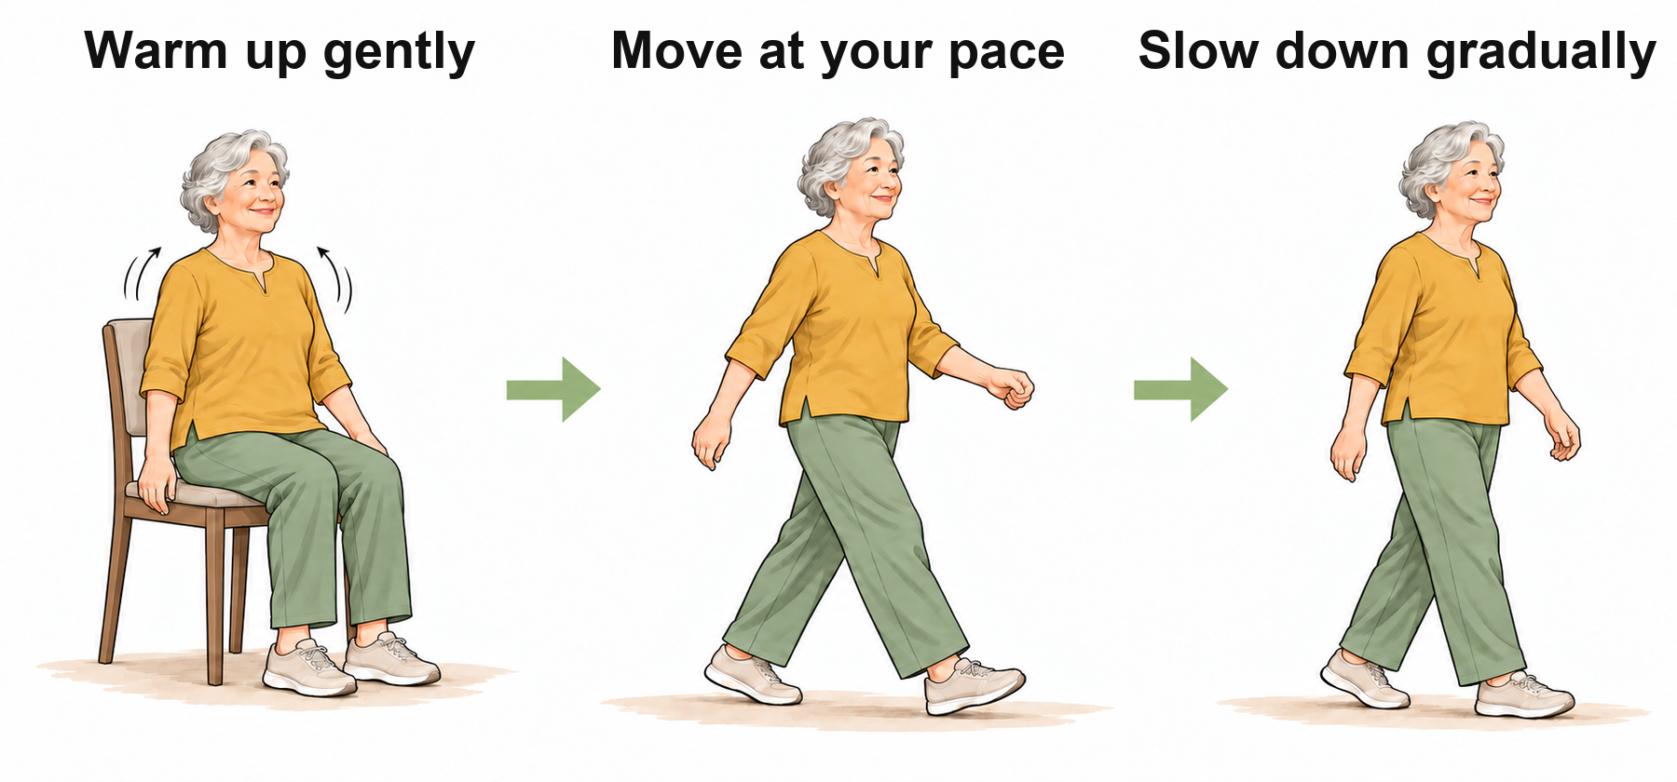
Figure 7 Warm up, move within your ability, then slow down.
1 Begin with a gentle warm-up, usually 5–10 minutes. Adjust the movements and time to your ability and medical advice.
2 Choose an activity you can do comfortably. Rest when needed; do not force yourself to reach a number of repetitions.
3 Slow down gradually at the end. Competitive lunges, dives, and smashes are not classroom movements to copy.
Keep safe Skip practical activity with fever, chest pain, marked breathlessness, or dizziness. Recent fracture, surgery, repeated falls, or unstable heart or lung disease needs medical assessment first.

Chapter 5 • Gentle movement and table tennis
Roll a ball gently with a partner
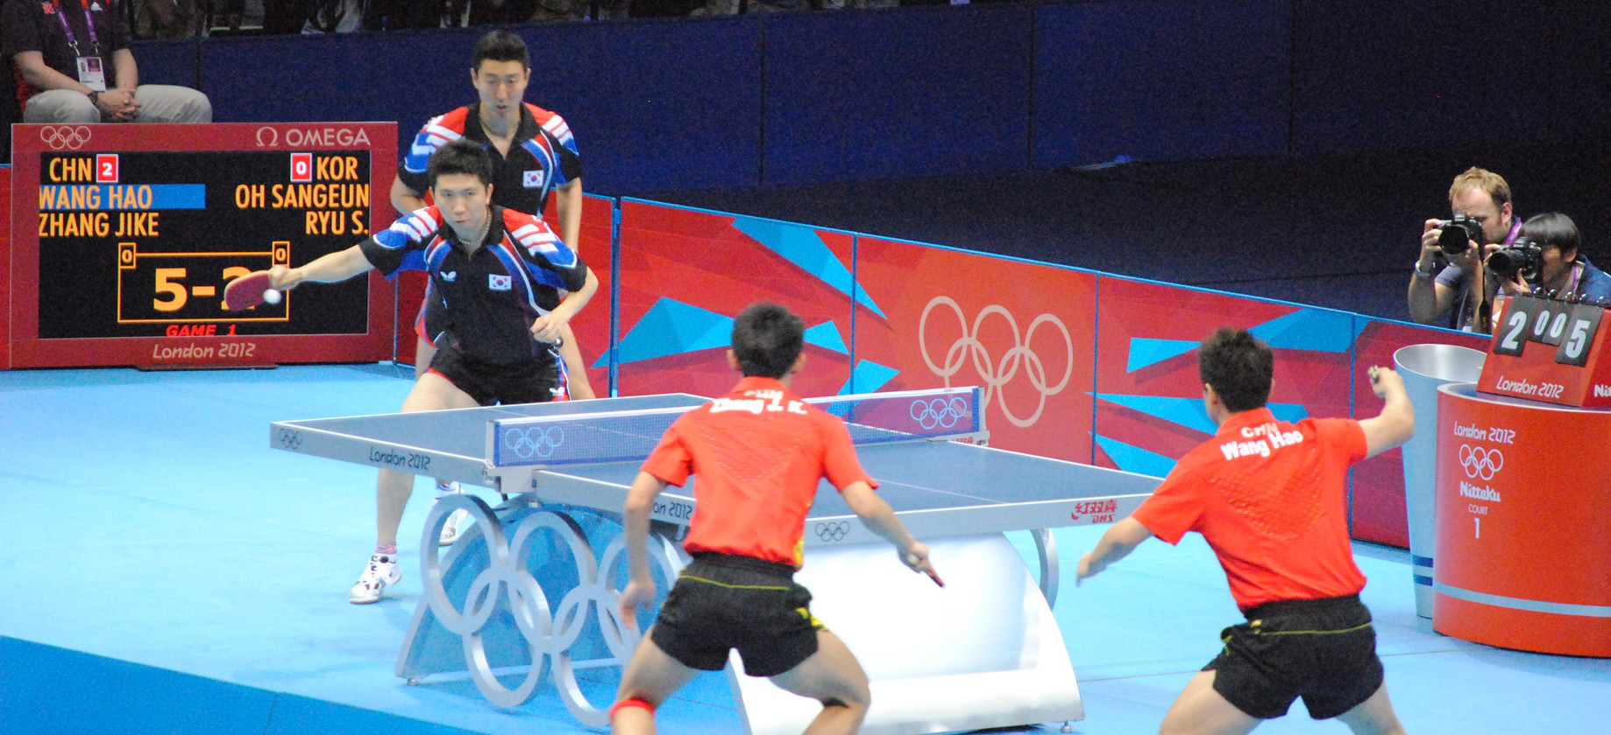
Figure 8 Team table tennis at the 2012 London Olympics. Photo: Joel Solomon.
1 Sit securely opposite a partner and gently roll a soft small ball across the table.
2 If it goes out of reach, stop and let the teacher collect it. Do not chase it.
3 Once this is comfortable, ask the teacher to show a racket grip and how to balance the ball. Standing at the table needs a separate check of your ability.
Try it together
Look at the match photo and notice how players leave space for each other. Try gentle rolling if you wish. If balance, standing, or hand movements are difficult, you can look and discuss instead.
Three things to remember
1 Keep the warm-up, activity, and cool-down within your ability.
2 Stop if unwell. Seek assessment after a recent injury or if your condition is unstable.
3 Focus on watching and cooperating, not speed or repetitions.
Keep safe Stop and ask for help for chest pain, unusual breathlessness, dizziness, palpitations, or worsening pain. Call emergency services if symptoms are severe or do not settle.

Healthy Living • Student Edition
6 A safer home and calling for help
This lesson Spot trip hazards and describe your location clearly.
Check the route you use every day
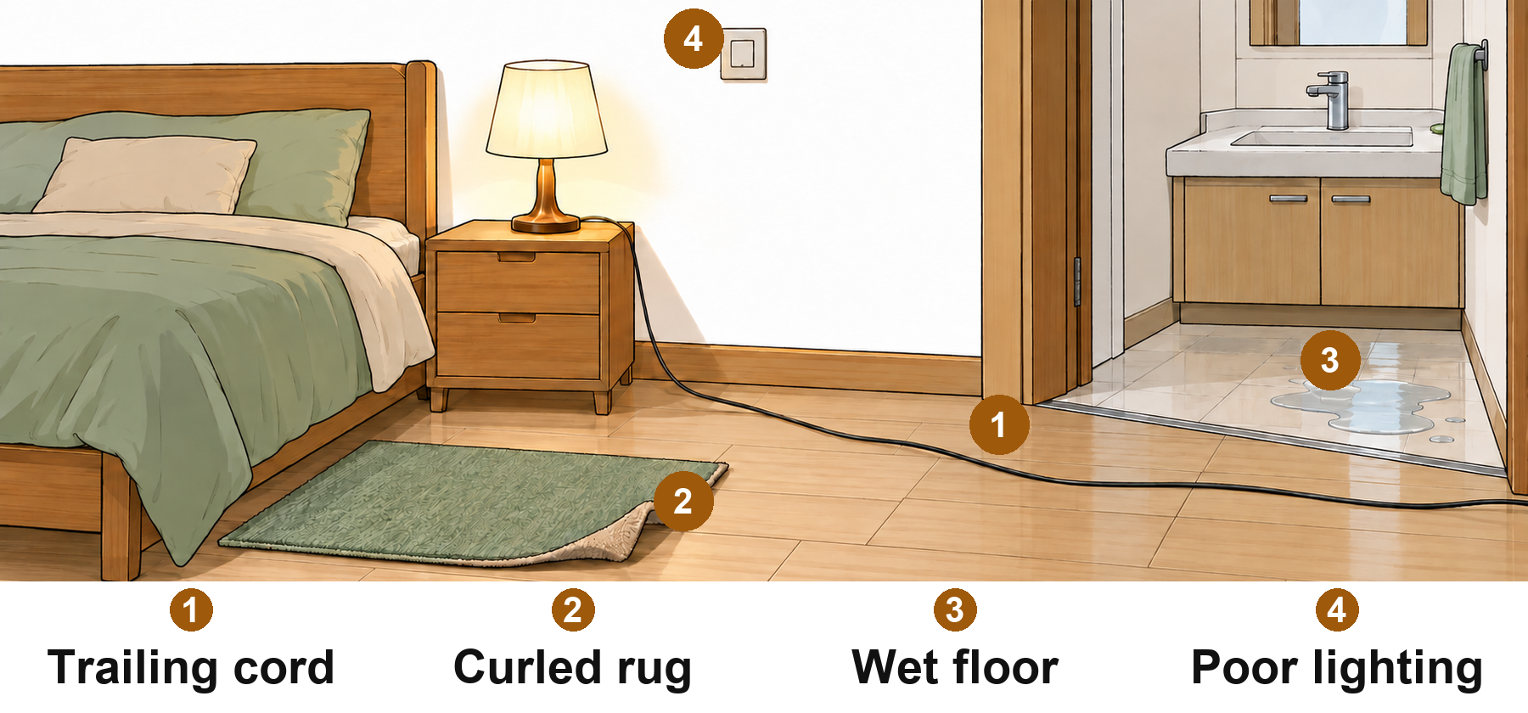
Figure 9 Find hazards along the route from bed to bathroom.
1 Look along the route from bed to bathroom for cords, curled rugs, water, and clutter.
2 Clear trip hazards and put shoes away. Keep night lights and switches easy to reach. At night, sit steadily, stand steadily, then walk.
3 Have grab rails fitted securely. Movable furniture is not a substitute. Ask family or a professional for help with alterations, heavy lifting, or reaching high places.
Keep safe After a fall, do not force someone up or drag them if there is clear pain, inability to stand, or possible injury. Check the scene is safe, call emergency services, and follow instructions.

Chapter 6 • A safer home and calling for help
When calling, say where you are first
1 Give the full address and a nearby landmark, for example: ‘Flat 301, Building 2, near the east entrance.’
2 Say what happened, when it started, and whether the person is awake and breathing normally. Describe what you actually see.
3 Give a callback number, keep the line available, and follow the dispatcher’s instructions. If possible, ask someone to meet the responders.
Try it together
Take turns with a pretend phone that does not place a call. Put your home address in Appendix B and keep the card in a fixed place. Use made-up details for classroom practice.
Three things to remember
1 Keep routes dry and clear, items within reach, and lighting and supports reliable.
2 If someone may be injured after a fall, do not pull them up or drag them.
3 Give the address, symptoms, timing, and current condition.
Keep safe If an unknown caller says a relative is in trouble and demands money, hang up. Check using a number you already have, not a new number supplied by the caller.

Healthy Living • Student Edition
7 Caring for mood and memory
This lesson Give important things a fixed place and plan a small activity you enjoy.
Write things down and keep in touch
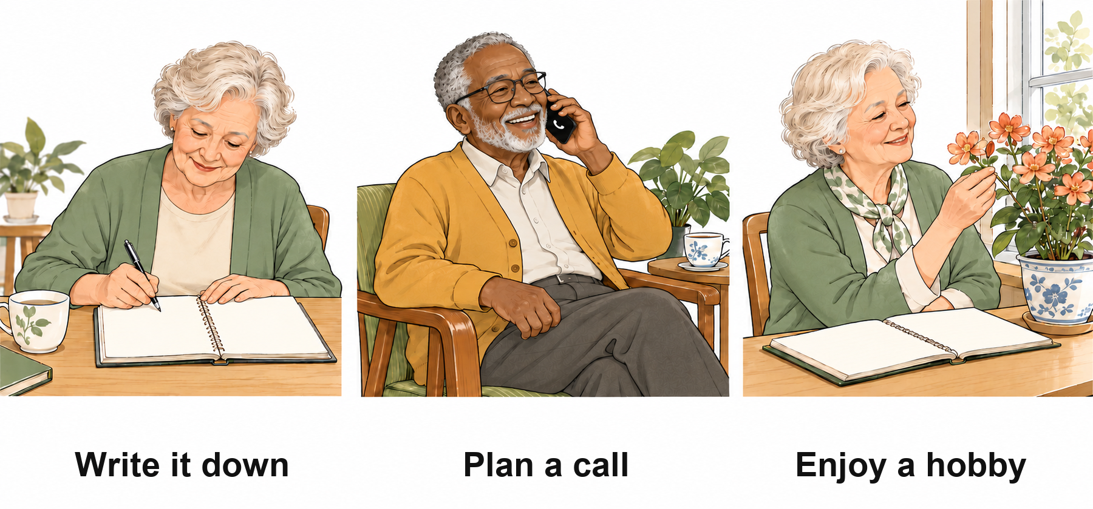
Figure 10 Write things down, plan a call, and enjoy a hobby.
1 Keep often-used items, such as keys and glasses, in a fixed place.
2 Write appointments on a large-print calendar and tick them off when done. Check medicine schedules against the latest prescription.
3 Choose a small enjoyable activity and agree on a time and companion. For example: ‘Call a friend on Wednesday afternoon.’
Keep safe Sudden confusion or a sudden change in behavior or speech needs prompt medical attention. Call emergency services at once if stroke or other emergency signs occur.

Chapter 7 • Caring for mood and memory
Talk about mood or memory concerns
1 Retirement, bereavement, and illness can affect mood. Do not dismiss every problem as ‘just getting older.’
2 If several symptoms last about two weeks and affect eating, sleep, or daily life, consult a doctor. If memory problems worsen, bring notes to an assessment.
3 When a classmate withdraws, ask gently: ‘Are you tired, finding it hard to hear, or not feeling like company?’ Let them choose whether to join in.
Try it together
Choose something you enjoy: music, a phone call, reading, or flowers. Say when you might do it and whom you might invite. You can skip sharing private experiences.
Three things to remember
1 Seek professional help when ongoing concerns affect daily life.
2 Make plans small and specific.
3 Choose something enjoyable and arrange a time and companion.

Healthy Living • Student Edition
8 Preparing for a medical visit
This lesson Bring the right records and explain your main concern.
Put these together in one bag
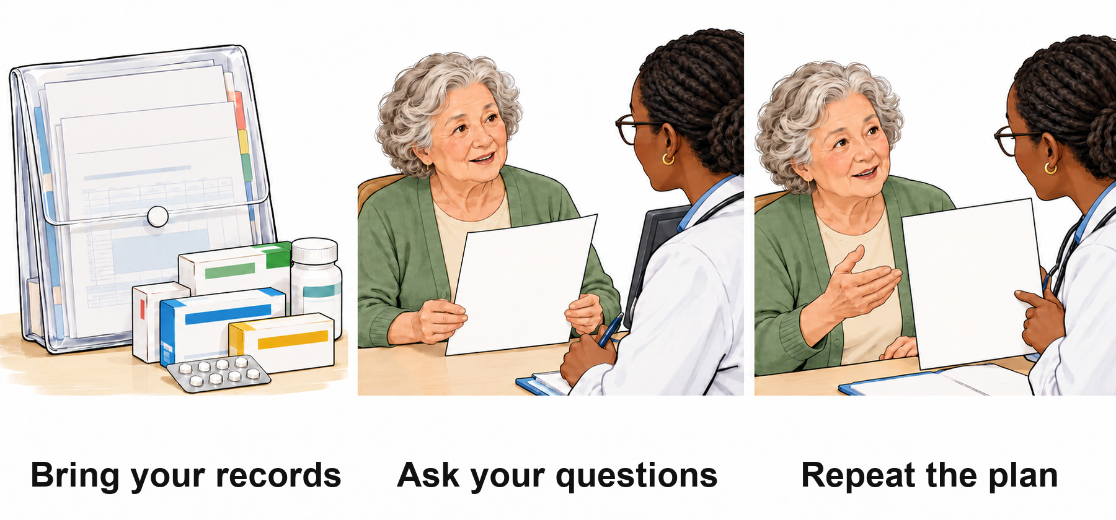
Figure 11 Bring records, ask questions, and repeat the plan.
1 Your identity document and health insurance information.
2 Previous test reports, your latest medicine list, and home blood pressure or blood sugar logs.
3 Your main question, with the start time, impact, and recent changes. An arrow on a test report is not a diagnosis; a clinician needs to interpret it in context.
Keep safe Check with the clinic whether you should fast or take your usual medicines before a test. For sudden emergency symptoms, do not wait for a routine appointment.

Chapter 8 • Preparing for a medical visit
Ask three things before you leave
1 How do I use my medicine? Repeat the dose and timing back and ask the clinician to check. Ask for written instructions if needed.
2 When is my next check? Note the date and ask whether you need to book first.
3 What means I should contact you sooner? Ask whom to contact, how, and when to seek emergency help.
Try it together
Pack a visit bag using sample records. Practice: ‘I understand that … Is that right?’ Use made-up details rather than showing your full personal medical reports.
Three things to remember
1 Start with the concern that troubles you most.
2 Bring old and new reports and the latest medicine list.
3 Do not ignore persistent symptoms because an earlier check was normal.

Healthy Living • Student Edition
Part Two Everyday interests
Chapters 9–14

Figure 12 Look, try, and share in ways that suit you.
Choose something you would enjoy
Look, try, and share. Join in in your own way.

Healthy Living • Student Edition
9 Phone photography and gentle edits
This lesson Photograph your subject clearly and change one thing at a time.
Decide what you want people to see

Figure 13 One arrangement: whole, closer, and detail.
1 Wipe the lens, sit or stand steadily, and hold the phone firmly.
2 For the whole object, check that important parts are not cut off at the edges.
3 For detail, move a little closer or try another position. A simpler background makes the subject easier to see.
Keep safe Sit or stand steadily. Do not take photos while walking or climb for a view. Ask permission before photographing people or sharing their photos.

Chapter 9 • Phone photography and gentle edits
Make a small edit, then compare

Figure 14 Compare before and after cropping.
1 Keep the original. Save an edited copy instead of overwriting it repeatedly.
2 Try a crop or a slight increase in brightness. Change one thing at a time. Undo it if bright areas lose detail.
3 If the color looks too yellow or blue, adjust color temperature gently so flowers and leaves look natural. Ask the teacher to show the controls on your own device.
Try it together
Take three pictures of one object: whole, closer, and detail. Choose one, make a single crop or brightness change, and compare it with the original.
Three things to remember
1 Decide on the subject before pressing the shutter.
2 Change one thing, then check the subject, colors, and edges.
3 Keep the original. Ask permission before photographing people or sharing photos.

Healthy Living • Student Edition
10 Arranging three flower stems
This lesson Explore height and spacing before trimming the stems.
Try the positions before you cut
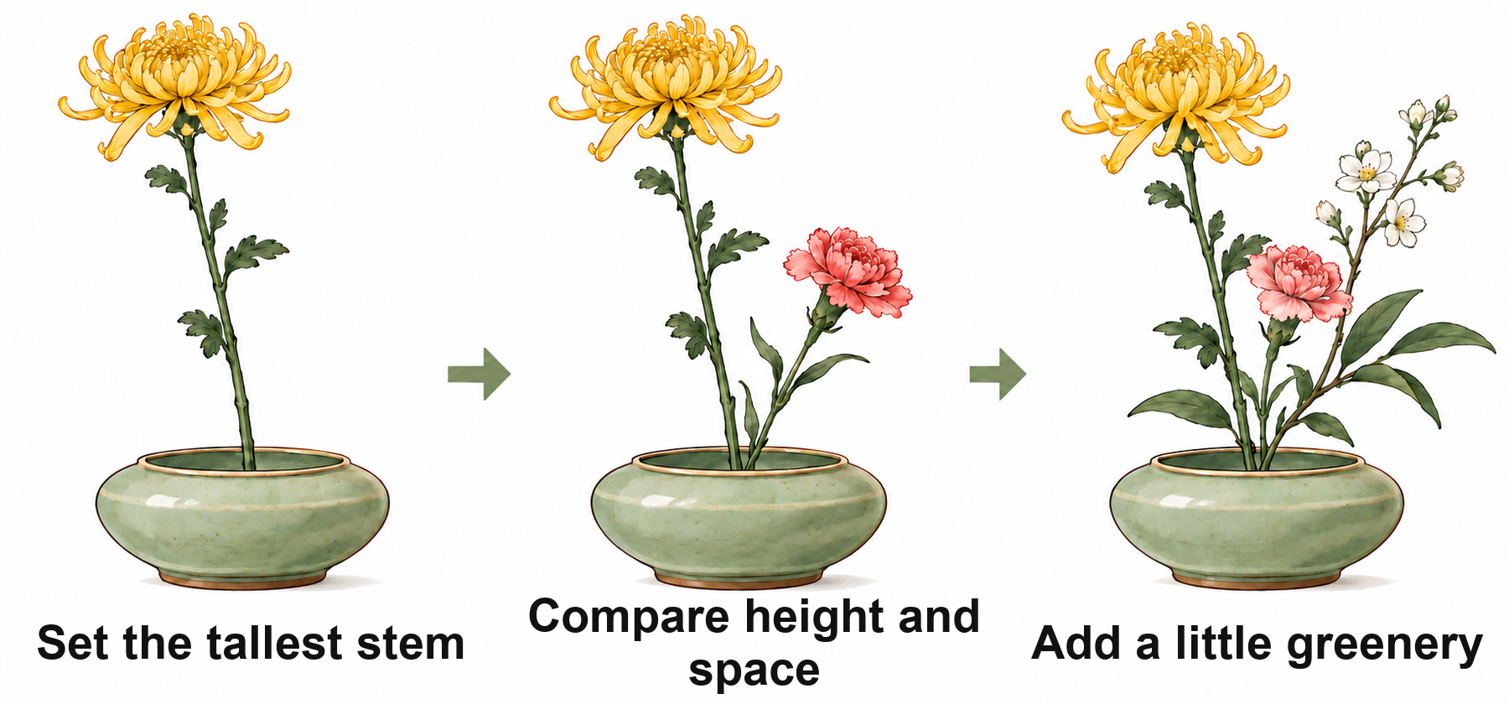
Figure 15 Set heights, compare spaces, and add a little greenery.
1 Choose the flower you want to feature and set its highest position.
2 Add a lower stem and check the space between the flower heads.
3 Add the third stem and a little greenery. You do not need to fill every gap. Compare the height beside the vase before cutting.
Keep safe Close scissors and put them down securely. Pass them handle first. Ask for pre-trimmed stems if needed. If sensitive to pollen or scent, use foliage or paper flowers.

Chapter 10 • Arranging three flower stems
Look from where it will be displayed

Figure 16 Flower arrangement. Photo: Steph Quernemoen.
1 For a dining-table centerpiece, let people see the flowers from different sides without blocking one another’s view.
2 Against a wall, choose a main viewing direction. One or two stems can suit a small desk; leave room for books and a cup.
3 Turn the vase and compare front and side views. If crowded, remove a leaf or stem before deciding whether to put it back. Remove leaves below water and change water as the flowers need.
Try it together
Use available stems or paper flowers. Compare heights beside the vase, then ask the teacher to help trim. Put the arrangement where you plan to display it and check that it fits.
Three things to remember
1 Set the heights and compare before cutting.
2 Leave space between stems and add greenery sparingly.
3 Use scissors safely and ask for help if hand movement is difficult.

Healthy Living • Student Edition
11 Radio, information, and AI
This lesson Ask clear questions and check health messages before acting.
AI can organize ideas but can be wrong
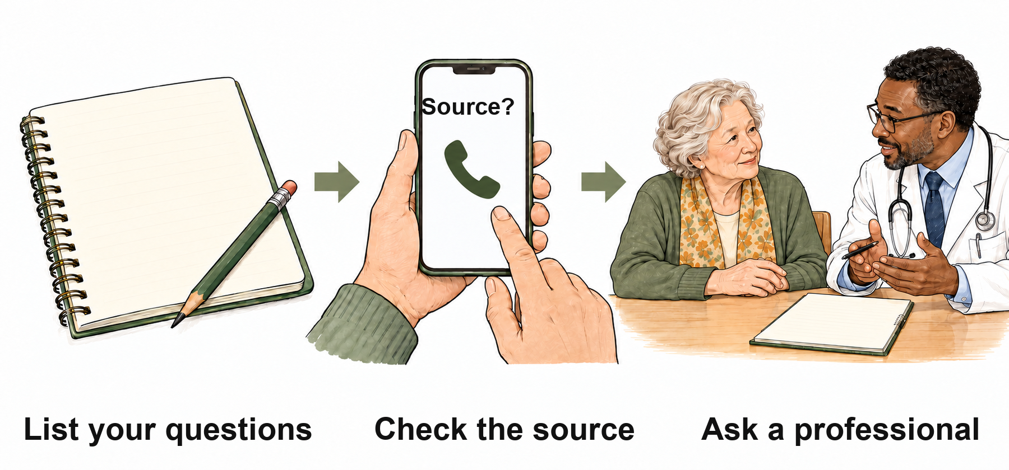
Figure 17 Ask clearly, check the source, and consult a professional.
1 Ask for one task at a time, for example: ‘Turn this paragraph into three large-print points.’
2 For a broadcast, article, or AI answer, ask who said it, when, and on what evidence. Fluent wording does not prove accuracy.
3 For research papers, policies, or health messages, ask a teacher or family member to check with the original publisher. A realistic-looking link is not enough.
Keep safe Do not treat an AI answer as a diagnosis or prescription, or use it to stop or change medicine. Do not upload identity documents, security codes, bank card details, or medical records with full identifying information.

Chapter 11 • Radio, information, and AI
Pause before following a group message
1 Do not forward it immediately or change or stop medicine because of it.
2 Keep the exact message, date, and source. Take health questions to a doctor or pharmacist.
3 Check supplements using Chapter 3. Bring unclear information to class and ask the teacher to help find its source.
Try it together
Choose an everyday question, such as learning to photograph flowers. Add: ‘Please give me three simple steps.’ You can practice with a partner using pen and paper instead of AI.
Three things to remember
1 Ask specifically and do one task at a time.
2 Check important information at its original source.
3 Take medical decisions to professionals and protect private information.

Healthy Living • Student Edition
12 Growing and observing plants
This lesson Check the light and soil at home before deciding on care.
Choose a plant that suits your home
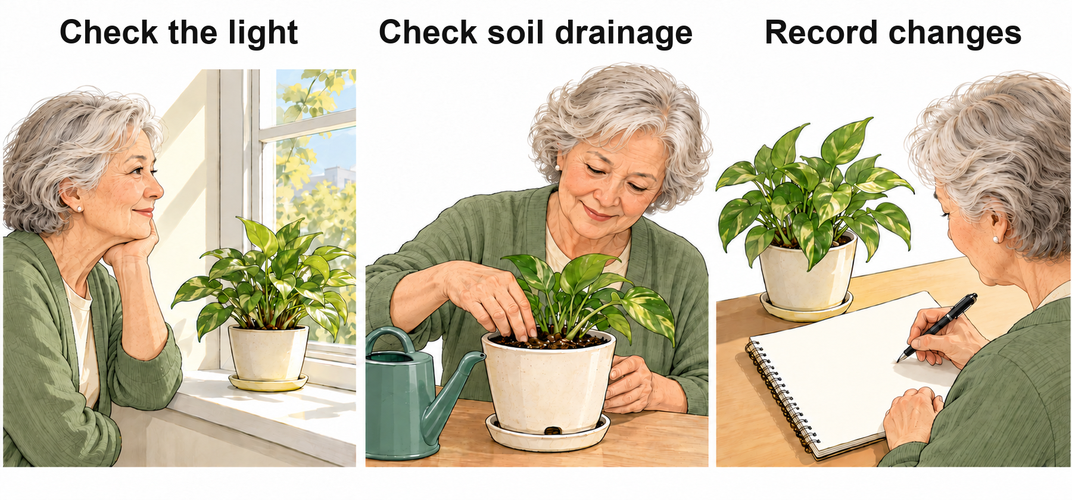
Figure 18 Check light, soil, and changes over time.
1 Tell the teacher which way your balcony faces, whether direct sun comes in the morning or afternoon, and whether it is airy or exposed to rain.
2 Check soil moisture in a way suited to the plant. Make sure the pot drains and the saucer does not stay full of water.
3 Note new shoots, yellow leaves, or drooping. Think about recent watering and light before changing anything. Do not fertilize, repot, and move into strong sun all at once.
Keep safe Keep pots away from edges and out of walkways. Do not use unfamiliar plants as food or medicine. Wash hands after handling soil and store fertilizer and tools safely.

Chapter 12 • Growing and observing plants
Keep notes so you can ask clearly
1 Write the date and what you see, such as: ‘Two lower leaves turned yellow this week.’
2 Note soil moisture and the last watering date, or keep a photo. Yellow leaves can have several causes; ask the teacher to help assess them.
3 Make one advised change, then compare after a while. Do not copy someone else’s ‘water every day’ routine.
Try it together
Choose an easy-care small plant and note changes for a week. If hand movement is difficult, ask a partner to lift or water while you observe. Do not mix pesticides in class.
Three things to remember
1 Choose plants after checking conditions at home.
2 Base watering on the plant and soil, not just the number of days.
3 Change one thing and record the date and result.

Healthy Living • Student Edition
13 Cards, handwriting, and memories
This lesson Write a clear greeting card or record a memory in a few sentences.
Leave room for three parts of a card
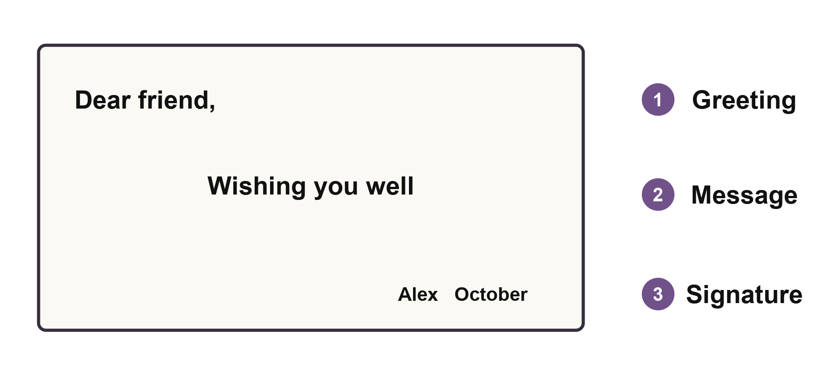
Figure 19 Separate the greeting, message, and signature.
1 Start with a greeting so the reader knows whom the card is for.
2 Write your main message in larger letters. For example: ‘Thank you for coming to the park with me last week.’
3 Add your name and the date. Leave space between the three parts; decoration can be simple. Make a draft before writing on the card.
Keep safe Pause if your fingers, wrists, or shoulders hurt. Do not grip hard for a long time to make writing neat. Store tools securely when finished.

Chapter 13 • Cards, handwriting, and memories
Tell one memory clearly
1 Start with when and where it happened, and what happened.
2 Add one sound, smell, or action you truly remember. If unsure of the year, say ‘about.’ There is no need to invent details.
3 Read it through and remove repeated ideas. Share it if you want to, or ask someone to read it for you.
Try it together
Make a greeting card or tell a three-sentence story. Ask a partner whether the writing is clear and the greeting and signature are easy to find. Fine cutting or carving is not needed.
Three things to remember
1 Separate the greeting, message, and signature.
2 Tell one event, then add one detail.
3 If writing is difficult, dictate it and check what has been written.

Healthy Living • Student Edition
14 Musical beats and sound memories
This lesson Try a steady four-beat pattern and share a memory through sound.
Follow four dots at an easy pace
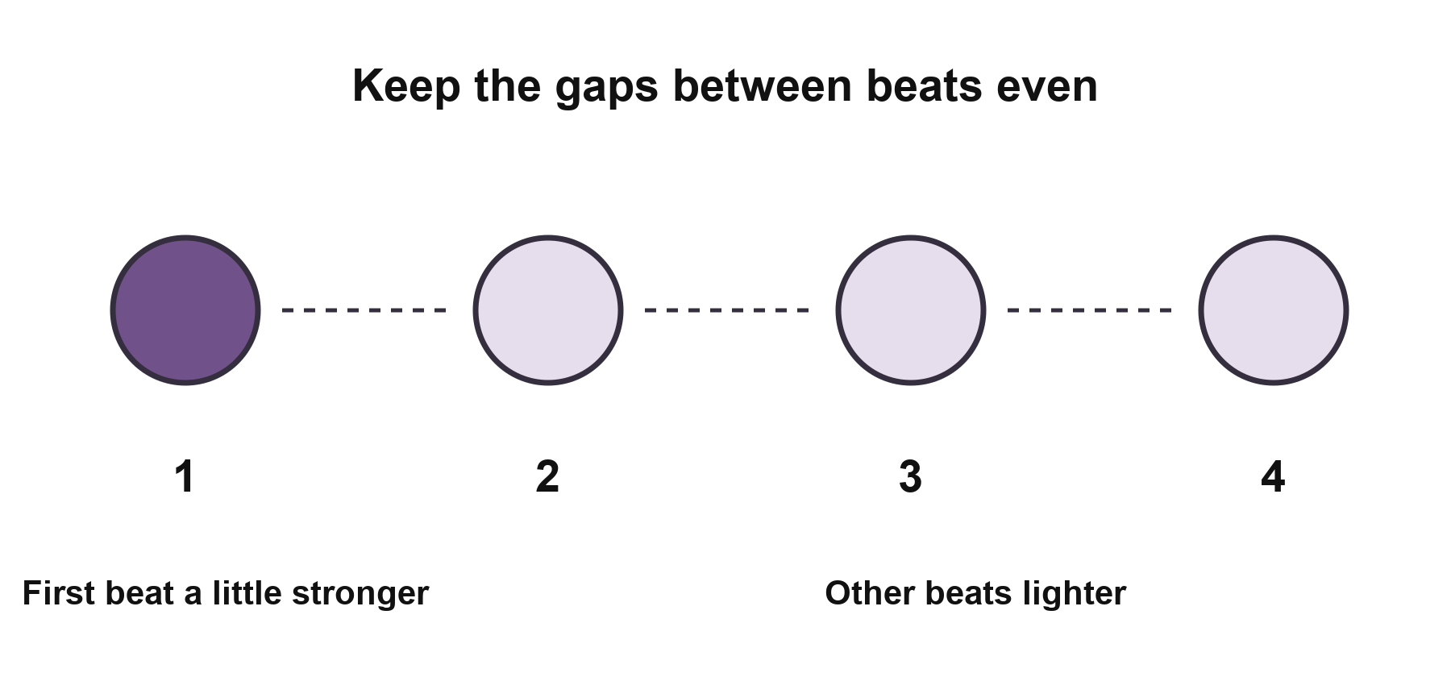
Figure 20 Keep the gaps even; make the first beat a little stronger.
1 Listen to the teacher or watch a hand signal. Count 1, 2, 3, 4 silently.
2 If you wish, tap lightly with your fingertips and keep the gaps about equal. Watching without tapping is fine too.
3 When steady, try a slightly stronger first beat and three lighter beats. You do not need loud taps or fast reactions.
Keep safe Keep sound comfortable and low enough to talk with someone nearby. Lower it or pause if it is harsh or uncomfortable. Repeated trouble hearing conversation needs professional advice.

Chapter 14 • Musical beats and sound memories
A familiar sound can start a story
1 Choose familiar music, a radio program, or a performance. Notice one sound you enjoy.
2 Begin with ‘The first time I heard this was …’ or ‘This reminds me of …’
3 Share as much as you remember. Do not correct one another for incomplete memories. Accurate singing, memorized lyrics, and complex rhythms are not required.
Try it together
Listen to one round of four even beats, then join in in a way that suits you. Share a sound memory if you wish. Ask permission before sharing someone’s story or making a recording.
Three things to remember
1 Start with steadiness, then vary the strength.
2 Listening, watching, gentle tapping, and storytelling all count.
3 Choose sounds you like and take part at your own pace.

Healthy Living • Student Edition
Appendices
Tools to use at home
Copy, fill in, and use these pages again.
A Medicine card
B Emergency contact card
C Blood pressure and blood sugar logs
D Four-week action plan
E Cornell class notes
F Official information and sources
G Figure index and image credits

Appendices • Tools to use at home
A Medicine card
Use one card for each medicine. Bring it to appointments. Check against your latest prescription and update it after changes; do not rely on memory alone.
Information | Fill in here
Name
Generic name and dosage form
Reason for taking it
Dose each time
Timing and course length
What to do if a dose is missed
Storage and precautions
Checked by and date updated

Appendices • Tools to use at home
B Emergency contact card
Fill this in with someone you trust and keep it in a fixed place. Let your contacts know where you live and what help you may need.
Information | Fill in here
Name
Full address
Landmark and directions
Local emergency number
Contact 1 and phone
Contact 2 and phone
Conditions and allergies
Where the medicine card is kept
Date updated
For an emergency, call the local number above. Tell the dispatcher the symptoms, start time, and current condition, then follow instructions.

Appendix C1 • Four-week home log
Blood pressure log Week 1
Name __________________ From __________ To __________
Write systolic / diastolic (top / bottom number), in mmHg.
Take two readings about 1 minute apart and record both.
Morning
Date | Time | 1st reading | 2nd reading | How I feel / notes
 |  | ___ / ___ | ___ / ___
 |  | ___ / ___ | ___ / ___
 |  | ___ / ___ | ___ / ___
 |  | ___ / ___ | ___ / ___
 |  | ___ / ___ | ___ / ___
 |  | ___ / ___ | ___ / ___
 |  | ___ / ___ | ___ / ___
Evening
Date | Time | 1st reading | 2nd reading | How I feel / notes
 |  | ___ / ___ | ___ / ___
 |  | ___ / ___ | ___ / ___
 |  | ___ / ___ | ___ / ___
 |  | ___ / ___ | ___ / ___
 |  | ___ / ___ | ___ / ___
 |  | ___ / ___ | ___ / ___
 |  | ___ / ___ | ___ / ___
Follow your clinician’s timing and frequency. Leave unused boxes blank.
Bring this log to visits. Do not change medicine after one reading.

Appendix C1 • Four-week home log
Blood pressure log Week 2
Name __________________ From __________ To __________
Write systolic / diastolic (top / bottom number), in mmHg.
Take two readings about 1 minute apart and record both.
Morning
Date | Time | 1st reading | 2nd reading | How I feel / notes
 |  | ___ / ___ | ___ / ___
 |  | ___ / ___ | ___ / ___
 |  | ___ / ___ | ___ / ___
 |  | ___ / ___ | ___ / ___
 |  | ___ / ___ | ___ / ___
 |  | ___ / ___ | ___ / ___
 |  | ___ / ___ | ___ / ___
Evening
Date | Time | 1st reading | 2nd reading | How I feel / notes
 |  | ___ / ___ | ___ / ___
 |  | ___ / ___ | ___ / ___
 |  | ___ / ___ | ___ / ___
 |  | ___ / ___ | ___ / ___
 |  | ___ / ___ | ___ / ___
 |  | ___ / ___ | ___ / ___
 |  | ___ / ___ | ___ / ___
Follow your clinician’s timing and frequency. Leave unused boxes blank.
Bring this log to visits. Do not change medicine after one reading.

Appendix C1 • Four-week home log
Blood pressure log Week 3
Name __________________ From __________ To __________
Write systolic / diastolic (top / bottom number), in mmHg.
Take two readings about 1 minute apart and record both.
Morning
Date | Time | 1st reading | 2nd reading | How I feel / notes
 |  | ___ / ___ | ___ / ___
 |  | ___ / ___ | ___ / ___
 |  | ___ / ___ | ___ / ___
 |  | ___ / ___ | ___ / ___
 |  | ___ / ___ | ___ / ___
 |  | ___ / ___ | ___ / ___
 |  | ___ / ___ | ___ / ___
Evening
Date | Time | 1st reading | 2nd reading | How I feel / notes
 |  | ___ / ___ | ___ / ___
 |  | ___ / ___ | ___ / ___
 |  | ___ / ___ | ___ / ___
 |  | ___ / ___ | ___ / ___
 |  | ___ / ___ | ___ / ___
 |  | ___ / ___ | ___ / ___
 |  | ___ / ___ | ___ / ___
Follow your clinician’s timing and frequency. Leave unused boxes blank.
Bring this log to visits. Do not change medicine after one reading.

Appendix C1 • Four-week home log
Blood pressure log Week 4
Name __________________ From __________ To __________
Write systolic / diastolic (top / bottom number), in mmHg.
Take two readings about 1 minute apart and record both.
Morning
Date | Time | 1st reading | 2nd reading | How I feel / notes
 |  | ___ / ___ | ___ / ___
 |  | ___ / ___ | ___ / ___
 |  | ___ / ___ | ___ / ___
 |  | ___ / ___ | ___ / ___
 |  | ___ / ___ | ___ / ___
 |  | ___ / ___ | ___ / ___
 |  | ___ / ___ | ___ / ___
Evening
Date | Time | 1st reading | 2nd reading | How I feel / notes
 |  | ___ / ___ | ___ / ___
 |  | ___ / ___ | ___ / ___
 |  | ___ / ___ | ___ / ___
 |  | ___ / ___ | ___ / ___
 |  | ___ / ___ | ___ / ___
 |  | ___ / ___ | ___ / ___
 |  | ___ / ___ | ___ / ___
Follow your clinician’s timing and frequency. Leave unused boxes blank.
Bring this log to visits. Do not change medicine after one reading.

Appendix C2 • Four-week home log
Blood sugar log Week 1
Name __________________ From __________ To __________
Circle the unit: mmol/L or mg/dL.
For timing, write fasting, before a meal, time after a meal, or bedtime.
Morning
Date | Time | Meal timing | Blood sugar | How I feel / notes
Evening
Date | Time | Meal timing | Blood sugar | How I feel / notes
Follow your clinician’s timing and frequency. Leave unused boxes blank.
Bring this log to visits. Do not change medicine after one reading.

Appendix C2 • Four-week home log
Blood sugar log Week 2
Name __________________ From __________ To __________
Circle the unit: mmol/L or mg/dL.
For timing, write fasting, before a meal, time after a meal, or bedtime.
Morning
Date | Time | Meal timing | Blood sugar | How I feel / notes
Evening
Date | Time | Meal timing | Blood sugar | How I feel / notes
Follow your clinician’s timing and frequency. Leave unused boxes blank.
Bring this log to visits. Do not change medicine after one reading.

Appendix C2 • Four-week home log
Blood sugar log Week 3
Name __________________ From __________ To __________
Circle the unit: mmol/L or mg/dL.
For timing, write fasting, before a meal, time after a meal, or bedtime.
Morning
Date | Time | Meal timing | Blood sugar | How I feel / notes
Evening
Date | Time | Meal timing | Blood sugar | How I feel / notes
Follow your clinician’s timing and frequency. Leave unused boxes blank.
Bring this log to visits. Do not change medicine after one reading.

Appendix C2 • Four-week home log
Blood sugar log Week 4
Name __________________ From __________ To __________
Circle the unit: mmol/L or mg/dL.
For timing, write fasting, before a meal, time after a meal, or bedtime.
Morning
Date | Time | Meal timing | Blood sugar | How I feel / notes
Evening
Date | Time | Meal timing | Blood sugar | How I feel / notes
Follow your clinician’s timing and frequency. Leave unused boxes blank.
Bring this log to visits. Do not change medicine after one reading.

Appendices • Small steps you choose
D Four-week action plan
Choose one thing you want to do and split it into four small steps. For example: take three photos, try a new view, make one crop, then share what you learned.
What I choose and why I want to start
____________________________________________________
Week 1
What will I do, when, and what help do I need?
____________________________________________________
____________________________________________________
One sentence afterward: what happened, or what got in the way?
____________________________________________________
Week 2
What will I do, when, and what help do I need?
____________________________________________________
____________________________________________________
One sentence afterward: what happened, or what got in the way?
____________________________________________________

Appendices • Small steps you choose
D Four-week action plan
Week 3
What will I do, when, and what help do I need?
____________________________________________________
____________________________________________________
One sentence afterward: what happened, or what got in the way?
____________________________________________________
Week 4
What will I do, when, and what help do I need?
____________________________________________________
____________________________________________________
One sentence afterward: what happened, or what got in the way?
____________________________________________________
Looking back after four weeks
What would I like to continue, and what would make it easier?
____________________________________________________
____________________________________________________

Appendices • Space for your own notes
E Cornell class notes
Date ______________ Class ___________________________
Key words and questions | Main notes
After-class summary
What did I learn and what would I like to try at home?

Appendices • Space for your own notes
E Cornell class notes
Date ______________ Class ___________________________
Key words and questions | Main notes
After-class summary
What did I learn and what would I like to try at home?

Appendices • Space for your own notes
E Cornell class notes
Date ______________ Class ___________________________
Key words and questions | Main notes
After-class summary
What did I learn and what would I like to try at home?

Appendices • Space for your own notes
E Cornell class notes
Date ______________ Class ___________________________
Key words and questions | Main notes
After-class summary
What did I learn and what would I like to try at home?

Appendices • Further reading
F Official information and sources
Use the website and search title below, or select a title in the electronic copy. Original sources are retained from the Chinese edition, checked on 19 October 2026.
01 Home blood pressure
American Heart Association
Home Blood Pressure Monitoring
Website: heart.org
Search the exact English title. You can also ask a healthcare professional to demonstrate.
02 Recognizing stroke
National Health Commission of China
World Stroke Day 2025 campaign materials
Website: nhc.gov.cn
Chinese-language source explaining the Chinese stroke recognition mnemonic.
03 Medicine dosage forms
Peking University Sixth Hospital
How to take medicines in special dosage forms
Website: pkuh6.cn
Chinese-language article. Ask a pharmacist about your exact product.

Appendices • Further reading
F Official information and sources
04 Checking supplements and complaints
State Administration for Market Regulation of China
Special Food Information and 12315 platforms
Website: samr.gov.cn
China-specific services. Find Special Food Information under Services; use 12315.cn for consumer complaints.
05 Food choices in later life
Chinese Nutrition Society
Core recommendations from the Dietary Guidelines for Chinese Older Adults 2022
Website: dg.cnsoc.org
Chinese-language guideline. Ask a teacher for help locating the original title.
06 Diet and long-term conditions
National Health Commission of China
Dietary guidance for adults with hypertension and diabetes 2023
Website: nhc.gov.cn
Chinese-language guidance. Use an individual plan from your healthcare team.

Appendices • Further reading
F Official information and sources
07 Eating with kidney disease
National Institute of Diabetes and Digestive and Kidney Diseases
Healthy Eating for Adults with Chronic Kidney Disease
Website: niddk.nih.gov
Search the English title. Ask your clinician or dietitian about individual amounts.
08 Warm-up and warning signs
American Heart Association
Develop a Physical Activity Plan for You
Website: heart.org
Search the English title. Ask a healthcare professional about your own activity plan.
09 Preventing falls at home
National Health Commission of China
Press conference transcript dated 9 April 2026
Website: nhc.gov.cn
Chinese-language transcript covering falls and night lighting.

Appendices • Further reading
F Official information and sources
10 Mood in later life
National Institute on Aging
Depression and Older Adults
Website: nia.nih.gov
Search the English title. Ask for help reading the key points if needed.
11 AI health information
World Health Organization
WHO calls for safe and ethical AI for health
Website: who.int
Check the original organization and publication date.
12 Memory changes
National Institute on Aging
Memory Problems, Forgetfulness, and Aging
Website: nia.nih.gov
Search these key words on the official website.
13 Safe listening
World Health Organization
Deafness and hearing loss Safe listening
Website: who.int
Search Safe listening on the official website.
Website layouts may change. If a link moves, return to the official site and search the title. Bring personal health questions and your records to a healthcare professional.

Appendices • Figures and image sources
G Figure index
Figure numbers match the Chinese student edition. The English artwork uses real-font labels and newly adapted characters.
01 Learn by looking, keeping notes, and asking for help. Page 4
02 Occasional, repeated, and sudden changes. Page 5
03 Rest, sit correctly, and record two readings. Page 7
04 Face, arms, speech: call for help at once. Page 8
05 Changing a medicine’s structure may change its release. Page 9
06 Add suitable foods to a familiar meal. Page 11
07 Warm up, move within your ability, then slow down. Page 13
08 Team table tennis at the 2012 London Olympics. Photo: Joel Solomon. Page 14
09 Find hazards along the route from bed to bathroom. Page 15
10 Write things down, plan a call, and enjoy a hobby. Page 17
11 Bring records, ask questions, and repeat the plan. Page 19
12 Look, try, and share in ways that suit you. Page 21
13 One arrangement: whole, closer, and detail. Page 22
14 Compare before and after cropping. Page 23
15 Set heights, compare spaces, and add a little greenery. Page 24
16 Flower arrangement. Photo: Steph Quernemoen. Page 25
17 Ask clearly, check the source, and consult a professional. Page 26
18 Check light, soil, and changes over time. Page 28
19 Separate the greeting, message, and signature. Page 30
20 Keep the gaps even; make the first beat a little stronger. Page 32
The cover and Figures 13, 14, and 16 use crops from one flower photograph. Image credits follow.

Appendix G • Sources and permissions
Image credits
Teaching illustrations
Figures 1–4, 7, 9–12, 15, and 17–18 are AI-assisted illustrations adapted and checked for this edition. Text is added separately using real fonts. The remaining simple diagrams are redrawn from the Chinese edition.
Flower photography
Cover and Figures 13, 14, and 16: Steph Quernemoen, Pexels photo 29039353. Cropped, resized, and combined under the Pexels License.
Original: pexels.com — search 29039353
License: pexels.com/license
Olympic event photography
Figure 8: Joel Solomon, 2012 Summer Olympics Men’s Team Table Tennis Final 1, photographed 7 August 2012. Source: Wikimedia Commons, CC BY 2.0. Cropped and resized.
Original: commons.wikimedia.org — search the title
License: creativecommons.org/licenses/by/2.0/
Team identity
Logo supplied by SUSTech-BIO and retained as provided.

