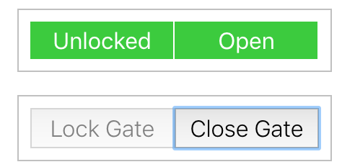
Locked = false, closed = false getByText = Close Gate
toggleClosed is available
tohavebeencalled(1)
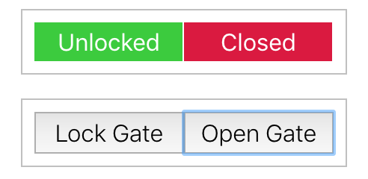
Locked = false, closed = true getByText = Open Gate
The user can go any direction BUT toggleLocked and toggleClosed are available
tohavebeencalled(1)

Locked = false, closed = true getByText = Lock Gate
The user can go any direction BUT toggleLocked and toggleClosed are available
tohavebeencalled(1)
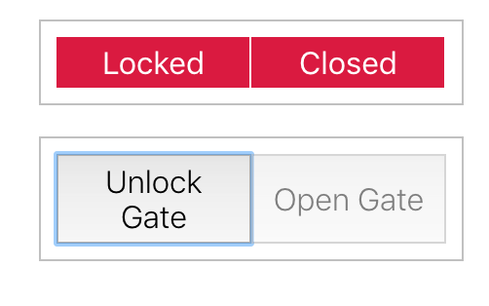
Locked = true, closed = true getByText = Unlock Gate need to access toggleLocked
tohavebeencalled(1)

