The display seems to be very similar to controls except there are no toggles to deal with. Also, since this is just screen rendering there are no toHaveBeenCalled things to think about
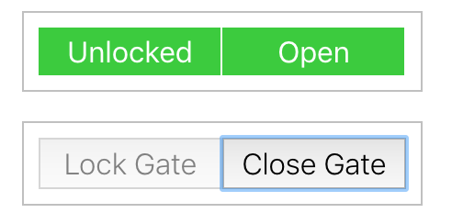
Locked = false, closed = false getByText = Close Gate

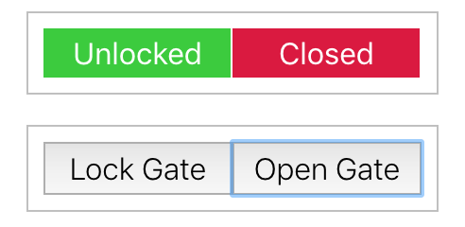
Locked = false, closed = true getByText = Open Gate

Locked = false, closed = true getByText = Lock Gate
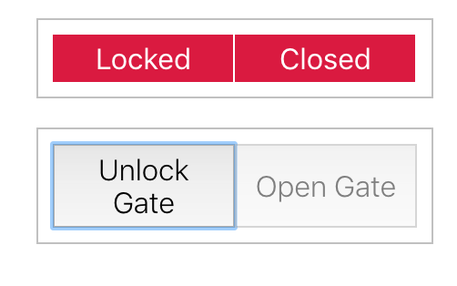
Locked = true, closed = true getByText = Unlock Gate

