﻿Chapter 1
Project Defined (according to PMI): A temporary endeavor undertaken to create a unique product, service, or result; A complex, non-routine, one-time effort/task limited by time, budget, resources, and performance specifications designed to meet customer needs.
Major Characteristics of a Project
• Has an established objective
• Has a defined life span with a beginning and an end
• Involves several departments and professionals
• Involves doing something never been done before
• Has specific time, cost, and performance requirements/constraints
﻿Versus Program: A group of related projects designed to achieve a common goal over an extended period of time
Program Management: A process of managing a group of ongoing, interdependent, related
projects in a coordinated way to achieve strategic objectives
• Project: completion of a required course in project management
• Program: completion of all courses required for a business major e.g. complete a college degree
﻿
Routine, Repetitive Work
Taking class notes
Daily entering sales receipts into the accounting ledger
Responding to a supply-chain request
Practicing scales on the piano
Routine manufacture of an Apple iPod
Attaching tags on a manufactured product

Projects
Writing a term paper
Setting up a sales kiosk for a professional accounting meeting
Developing a supply-chain information system
Writing a new piano piece
Designing an iPod that is approximately 2 X 4 inches, interfaces with PC, and stores 10,000 songs
Wire-tag projects for GE and Wal-Mart
﻿Customer training: arms customers with the knowledge and skills they need to use a product or service effectively. Example: business offering courses, guidance, documentation
Project Lifecycle: 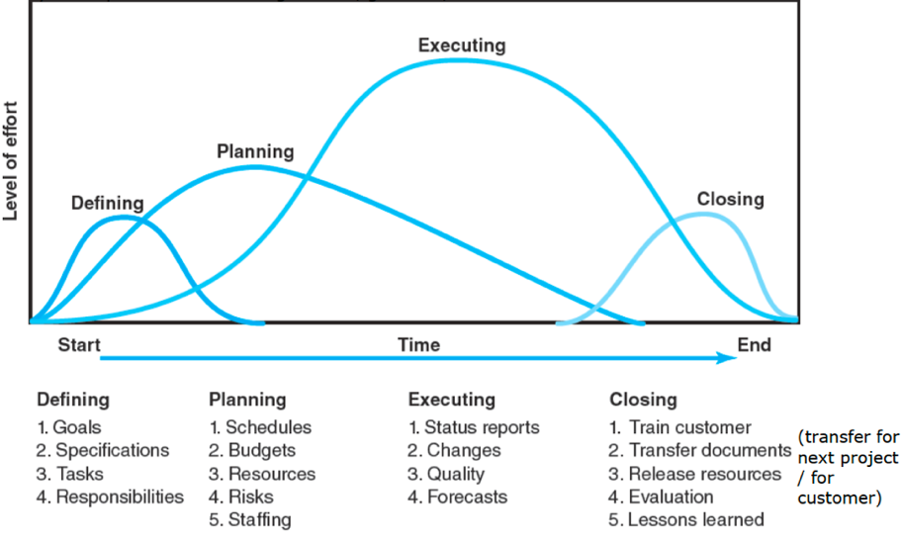
Note: Delivering=Closing.

﻿The Challenge of Project Management
- The Project Manager:
• Manages temporary, non-repetitive activities and frequently acts independently of the formal organization.
• Marshals resources for the project.
• Is the direct link to the customer.
• Works with a diverse troupe of characters.
• Provides direction, coordination, and integration to the project team.
• Is responsible for performance and success of the project.
• Must induce the right people at the right time to address the right issues and make the right decisions.
﻿
- Factors leading to the increased use of project management:
• Compression (shortening) of the product life cycle (6 months to 3 years nowadays compared to 10-15 years, 30 years ago)
• Knowledge explosion
• Triple bottom line (planet, people, profit): ﻿no longer simply focus on maximizing profit; must ﻿ reduce carbon imprint and utilize renewable resources
• Increased customer focus, decreased product focus
• Small projects represent big problems
• Development of third world and closed economies
• Companies downsizing

Agile Project Management (Agile PM)
• Is a methodology emerged out of frustration with using traditional project management processes to develop software. Now being used across industries to manage projects with high levels of uncertainty.
• Employs an incremental, iterative process sometimes referred to as a ‘rolling wave’ approach to complete projects.
• Focuses on active collaboration between the project and customer representatives, breaking projects into small functional pieces, and adapting to changing requirements.
• Is often used up front in the defining phase to establish specifications and requirements, and then traditional methods are used to plan, execute, and close the project.
• Works best in small teams of four to eight members.
﻿Rolling Wave Development
• Iterations typically last from one to four weeks. Each iteration is a small project.
• The goal of each iteration is to make tangible progress such as define a key requirement, solve a technical problem, or create desired features to demonstrate to the customer.
• At the end of each iteration, progress is reviewed, adjustments are made, and a different iterative cycle begins.
• Each new iteration subsumes the work of the previous iterations until the project is completed and the customer is satisfied
﻿
Today: A Socio-Technical Approach
The Technical Dimension (The “Science”): scope, WBS, schedules, res.allocation, baseline budget, status report.
• Consists of the formal, disciplined, purely logical parts of the process.
• Includes planning, scheduling, and controlling projects.
The Sociocultural Dimension (The “Art”): Leadership, problem solving, teamwork, negotiate, politics, customer expectation
• Involves the contradictory and paradoxical world of implementation.
• Centers on creating a temporary social system within a larger organizational environment that combines the talents of a divergent set of professionals working to complete the project

Chapter 2

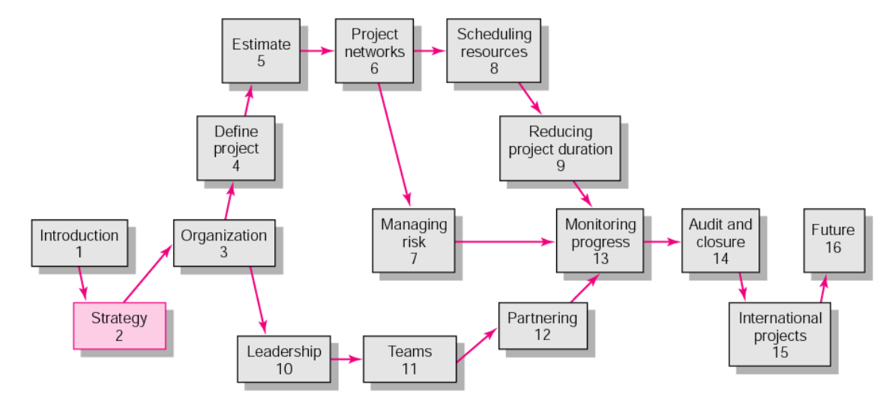
﻿project managers find it valuable to have a keen understanding of Project selection process and Strategic Management
The intended outcome of strategy/projects integration is: Best use of scare organization resources, Clear organization focus, Improved communication across projects and departments
Strategy considered to be under purview of senior management is
a. Beneficial to the Project Manager
b. Old school thinking
c. Depended on company goals
d. A new school of management thought
e. Necessary in a company structure
Which of the following is not true for strategic management?
It should be done once each year just before developing the operating plan
It supports consistency of action at every level of the organization
It positions the firm to meet the needs of its customers
It develops an integrated and coordinated long-term plan of action
Project managers who do not understand the role that their project plays in accomplishing the organization's strategy tend to make the following mistakes:
Trying to solve every customer issue
Focusing on low priority problems
Focusing on the immediate customer
Overemphasizing technology as an end in and of itself

Why Project Managers Need to Understand the Strategic Management Process
• Changes in the organization’s mission & strategy
– Project managers must respond to changes with appropriate decisions about future projects >< current projects.
– Project managers who understand their organization’s strategy can become effective advocates of projects aligned with the firm’s mission ﻿(by explaining to senior management)
﻿ Intel use differentiation strategy: uniqueness is advantage of competition
Toyota follow quick response strategy: try to release new kinds of car
﻿For stakeholders: PM must explain why it's important to invest in the company
﻿
Strategic Management
– Provides the theme & focus of the future direction for the firm.
• Responding to changes in the external environment — environmental scanning
• Allocating scarce resources of the firm to improve its competitive position — internal responses to new action programs
– Requires strong links among mission, goals, objectives, strategy, & implementation.
﻿
Four of Activities of the Strategic Management Process
1. Review and define the organizational mission.
﻿Who define mission and vision: board management, founder, CEO.
2. Analyze & formulate strategies (they based on mission and visions)
3. Set objectives to achieve strategies.
4. Implement strategies through projects
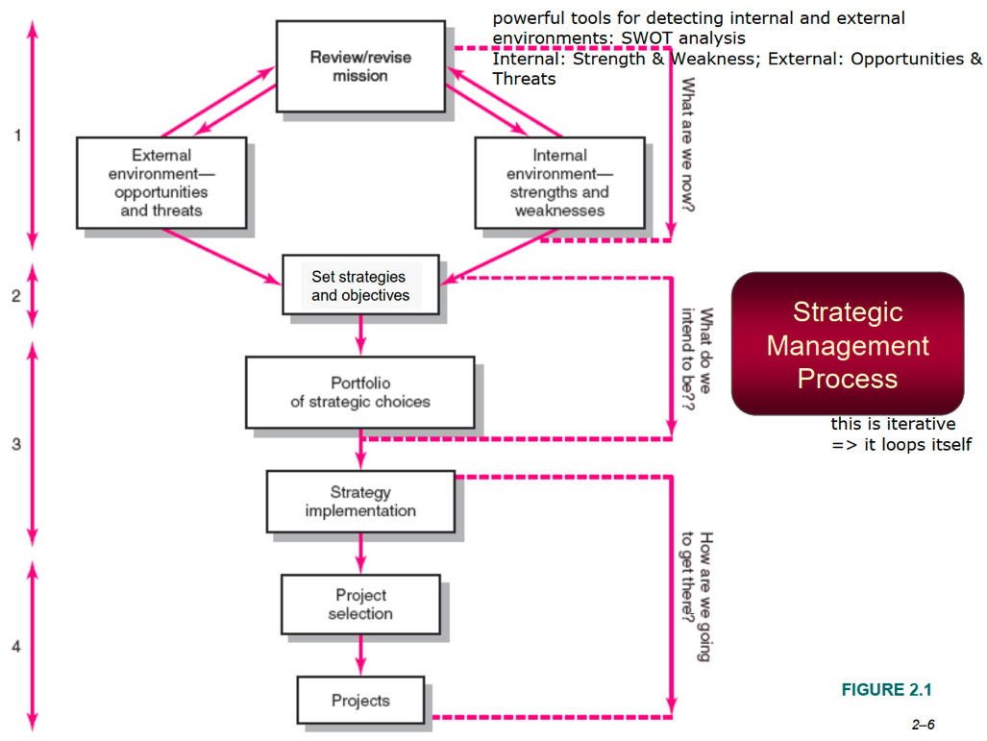
﻿Objective Characteristics: Specific - Measurable - Assignable - Realistic - Time-related
﻿
Project Portfolio Management Problems
• The Implementation Gap: The lack of understanding & consensus on strategy among top management & middle-level (functional) managers who independently implement the strategy.
• Organization Politics: Project selection based on the persuasiveness & power of people advocating the projects.
• Resource Conflicts & Multi-tasking: The multi-project environment creates interdependency relationships of shared resources which results in the starting, stopping, & restarting projects.

Benefits of Project Portfolio Management
• Builds discipline into project selection process.
• Links project selection to strategic metrics.
• Prioritizes P. proposals across a common set of criteria, rather than on politics or emotion.
• Allocates resources to Ps that align with strategic direction.
• Balances risk across all projects.
• Justifies killing Ps that do not support organization strategy.
• Improves communication & supports agreement on P. goals

Classification of Projects
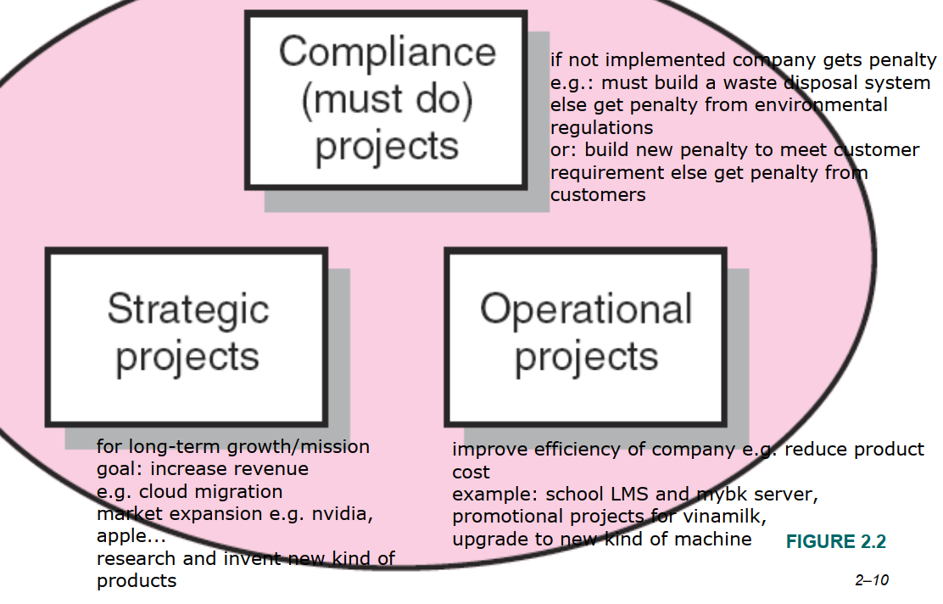

﻿Portfolio Management System
• Selection Criteria
– Financial: payback, net present value (NPV), internal rate of return (IRR)
– Non-financial: P. of strategic importance to the firm.
﻿
Non-financial criteria
• Larger market share
• Difficulty of competitors to enter the market
• An enabler product
• Core technology for next-generation products
• Dependency reduction on unreliable suppliers
• Preventing of government intervention and regulation

﻿Multi-criteria decision making process
a) Identify a group of projects which are not dominated
• Polygon model: ﻿B is dominated by A -> B is dominated ALT because A is equal or better than B in all criterias
• Electre model
﻿Helps select “better” alternatives
No transitive property
Identify the group of non-dominated alternatives: Kernel group (Kernel group can be empty)
﻿Algorithm: Firstly, Add 2 in kernel group.
Because ALT 2 is better than ALT 1 so ALT 1 is removed from graph.
Now since ALT 1 is removed, ALT 4 and 5 is non-dominated.
Add ALT 4 to kernel group (or ALT 5, whatever). So we remove adjacent ALTs of ALT 4, which is ALT 3,6,7.
The non-dominated current ALT is ALT 5.
Add ALT 5 to kernel group. Remove all adjacent ALTs of ALT 5 which is ALT 8 => Kernel: {2,4,5}
• Performance - Cost model: Fixed output approach, fixed input approach
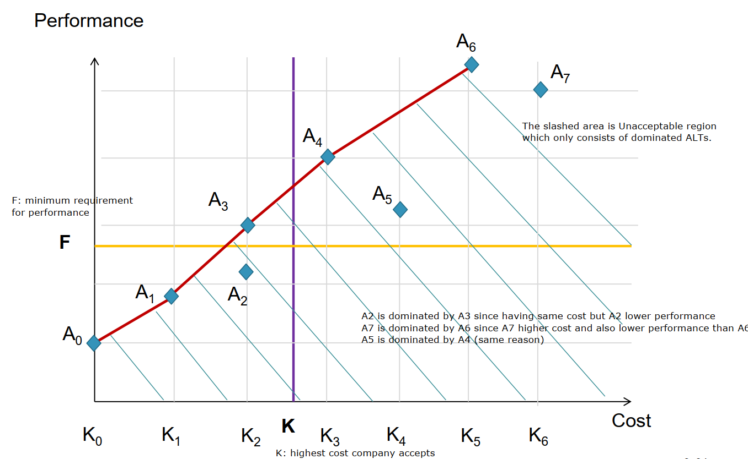
Effective frontier: non-dominated set of alternatives

b) Define the best project among non-dominated alternatives
Two multicriteria selection models:
- Checklist model (most frequently used)
- Weighted criteria model aka Multi-weighted scoring model (đi thi xài cái này): Use several weighted selection criteria to evaluate project proposals. Will include quantitative, qualitative criteria. Projects with higher scores are considered more desirable. Each criterion is assigned a weight
• Collective utility model
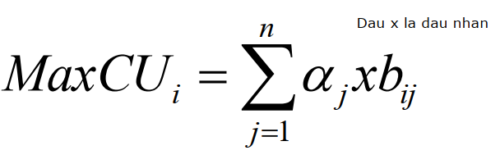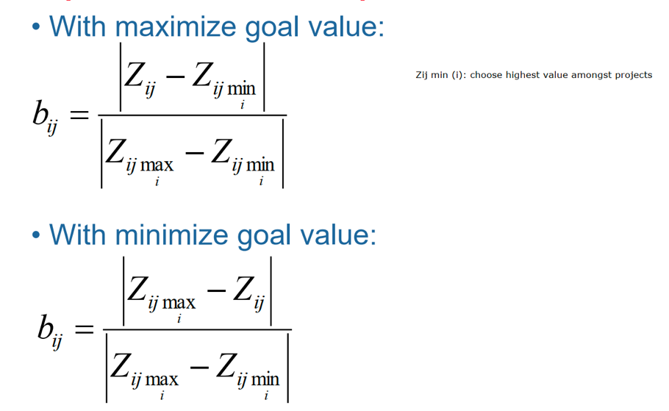
• Compromise model
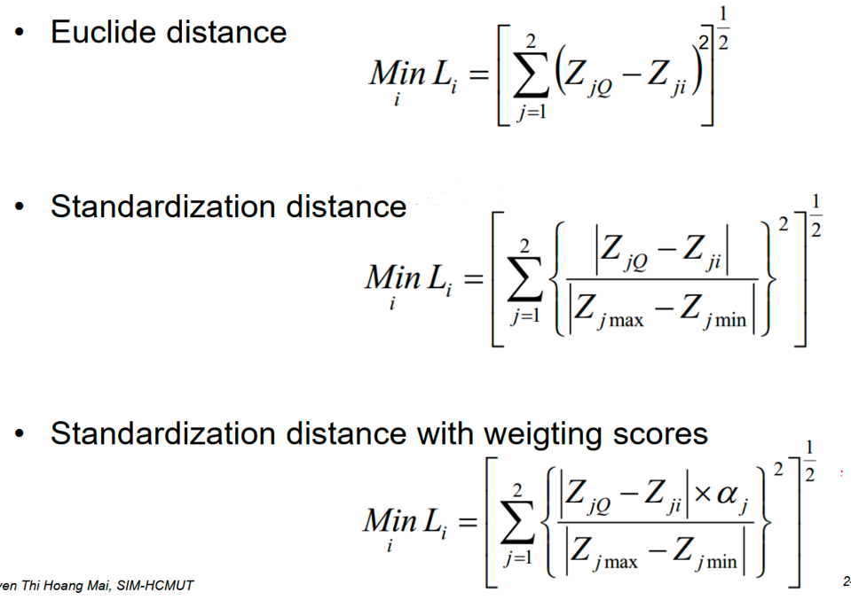

﻿Applying a Selection Model
• Project Classification: Deciding how well a strategic / operations project fits the organization’s strategy.
• Selecting a Model: Applying a weighted scoring model to bring projects to closer with the organization’s strategic goals.
• Reduces the number of wasteful projects
• Helps identify proper goals for projects
• Helps everyone involved understand how & why a project is selected
﻿
Project Proposals
• Sources and Solicitation of Project Proposals
– Within the organization
– Request for proposal (RFP) from external sources (contractors & vendors)
• Ranking Proposals and Selection of Projects
– Prioritizing requires discipline, accountability, responsibility, constraints, reduced flexibility, & loss of power.
• Managing the Portfolio
– Senior management input
– The priority team (project office) responsibilities
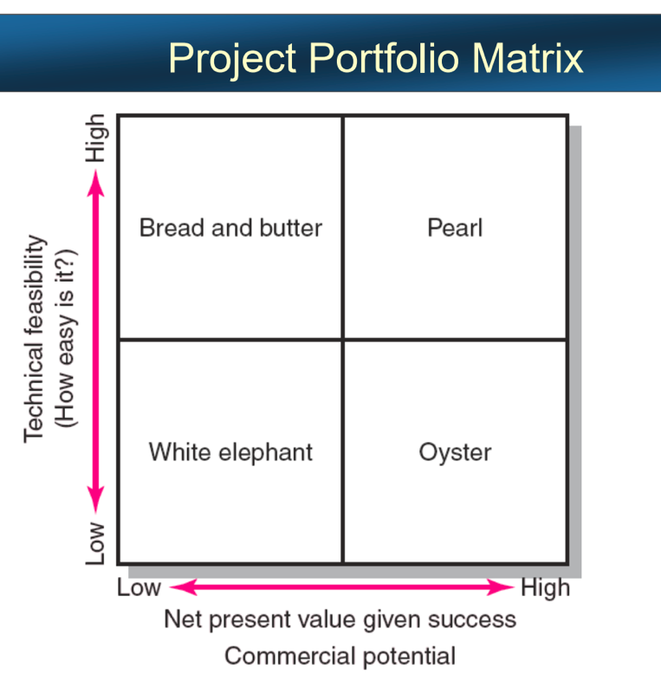
﻿• Bread-&-butter projects: Involve evolutionary improvements to current products&services.
• Pearls: Represent revolutionary commercial advances using proven technical advances.
• Oysters: involve technological breakthroughs with high commercial payoffs.
• White elephants: at one time showed promise but are no longer viable.
Sacred cow: a belief, custom, etc. that people support and do not question or criticize

Chapter 3. ORGANIZATION: STRUCTURE & CULTURE

Which of the following combinations represents the extremes of project organization?
Project and balanced matrix organizations
Functional and dedicated project teams
Strong matrix and balanced matrix organizations
Strong matrix and functional organizations
Project and strong matrix organizations
Matrix organization is a hybrid form in which a horizontal project management structure is overlaid in the normal functional hierarchy.
The structure that manages projects within the existing organizational structure is functional organization.
Kim is reviewing a proposed project. The scope of the project is narrow with a lot of in-depth expertise required and it will take a short period of time to complete. The best choice for organizing the project is functional organization.
A project team that operates with a full-time project manager as a separate unit from the rest of the organization is structured as a projectized organization.
Which of the following is an advantage of a functional project management organization?
Good integration across functional units
Strong motivation of project team members
Maximum flexibility in the use of staff
Shorter project duration

﻿Project Management Structures
• Challenges to Organizing Projects
+ The uniqueness&short duration of Ps. relative to ongoing longer-term organizational activities (short >< long)
+ The multi-disciplinary & cross-functional nature of Ps. creates authority & responsibility dilemmas.
• Choosing an Appropriate PM. Structure: The best system balances the needs of the P. with the needs of the organization (balance >< change).
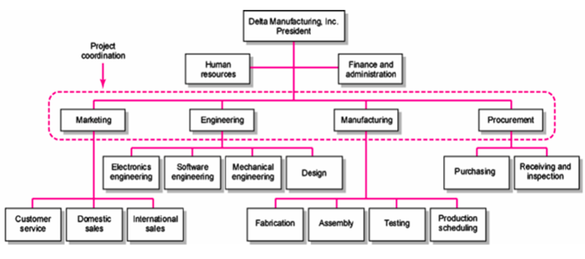
﻿1. Functional organization
– Different segments of the project are delegated to respective functional units (segment # function).
– Coordination is maintained through normal management channels (co-ordination >< separation).
– Used when the interest of one functional area dominates the project or one functional area has a dominant interest in the project’s success (functional area >< project’s success)
VD: Trường ĐH Bách khoa
﻿Advantages: No Structural Change, Flexibility, In-Depth Expertise, Easy Post-Project Transition
• Disadvantages: Lack of Focus, Poor Integration, Slow, Lack of Ownership
Nếu nguồn lực ít thì nên chọn Cấu trúc chức năng
﻿Keyword: Chia sẻ dữ liệu, chia sẻ nguồn lực chung, ít phức tạp, 1 loại công nghệ.

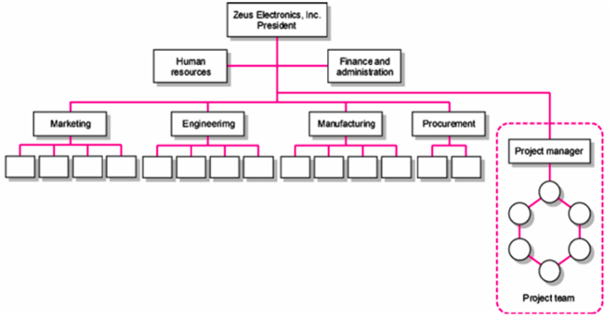
﻿2. Dedicated Teams
–Teams operate as separated units under the leadership of a full-time PM
– In a projectized organization where Ps. are the dominant form of business, functional departments are responsible for providing support for its teams.
Ví dụ: Các công ty xây dựng
﻿Advantages: Simple, Fast, Cohesive, Cross-Functional Integration
• Disadvantages: Expensive, Internal Strife, Limited Technological Expertise, Difficult Post-Project Transition
Keyword: ﻿Cần phản hồi nhanh, nhiều loại công nghệ, phức tạp, ít ổn định.
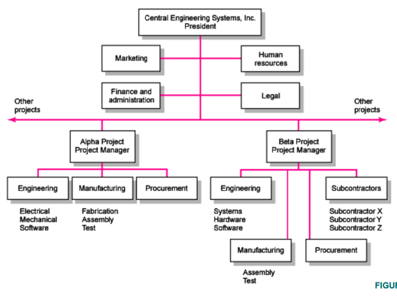
﻿3. Matrix Structure
– Hybrid organizational structure (matrix) is overlaid on the normal functional structure/hierarchy.
• Two chains of command (functional & project)
• Project participants report simultaneously to both functional and project managers.
– Matrix structure optimizes the use of resources.
• Allows for participation on multiple projects while performing normal functional duties.
• Achieves a greater integration of expertise and project requirements.
﻿3.1. ﻿Division of Project Manager & Functional Manager Responsibilities in a Matrix Structure
Functional Manager: How will it be done? How will the project involvement impact normal functional activities? How well has the functional input been integrated?
Project Manager: What has to be done? When should the task be done? How much money is available to do the task? How well has the total project been done?
Negotiated Issues: Who will do the task? Where will the task be done? Why will the task be done? Is the task satisfactorily completed? ﻿
3.2. Different Matrix Forms
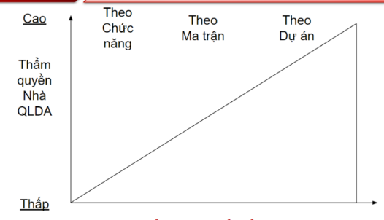
• Functional (also Weak or Light-weight) Form: Matrices in which the authority of the functional manager pre-dominates & the project manager has indirect authority.
• Balance (or Middle-weight) Form: The traditional matrix form in which the project manager sets the overall plan & the functional manager determines how work to be done.
• Strong (Heavy-weight) Form / Project-based form: Resembles a project team in which the project manager has broader control & functional departments act as subcontractors to the project.
Lưu ý: Thẩm quyền PM tỉ lệ nghịch với Functional managers

• Advantages: Efficient, Strong Project Focus, Easier Post-Project Transition, Flexible
• Disadvantages: Dysfunctional Conflict, Infighting, Stressful, Slow

﻿Choosing the Appropriate Project Management Structure
• Organization (Form) Considerations
– How important is the project to the firm’s success?
– What percentage of core work involves projects?
– What level of resources (human & physical) are available?
﻿ • Project Considerations
– Size of project
– Strategic importance
– Novelty & need for innovation
– Need for integration (number of departments involved)
– Environmental complexity (number of external interfaces)
– Budget & time constraints
– Stability of resource requirements
﻿Organizational Culture: A system of shared norms, beliefs, values, & assumptions which bind people together, thereby creating shared meanings. The “personality” that sets it apart from other organizations.
- Provides a sense of identify to its members.
- Helps legitimize the management system of the organization.
- Clarifies & reinforces standards of behavior
﻿Key Dimensions Defining an Organization’s Culture (below is example):
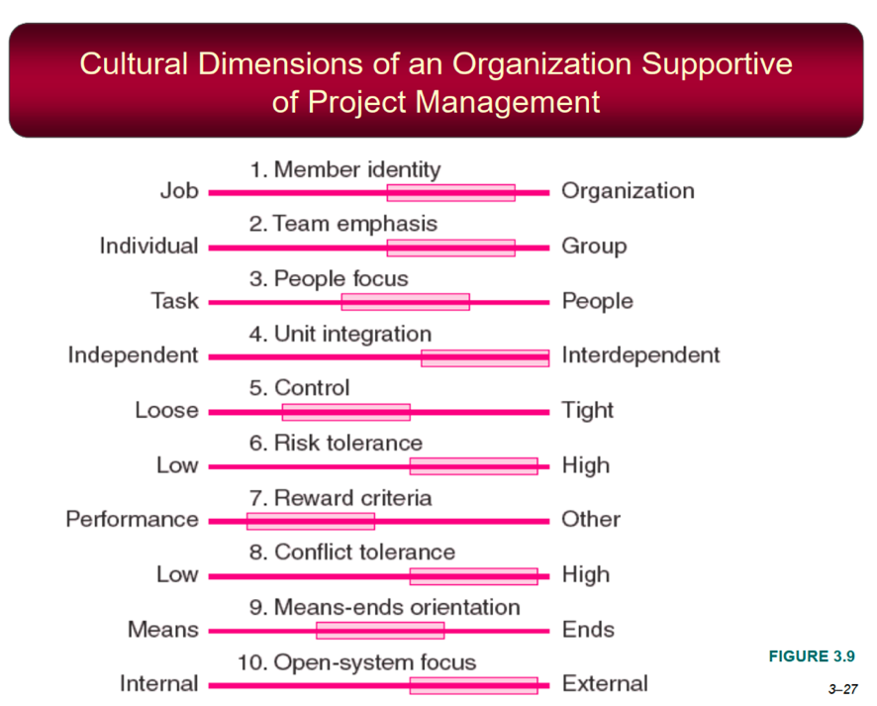
This cultural profile indicates that the organization values teamwork, people, interdepartmental collaboration, risk-taking, performance-based rewards, and adaptability.
Identifying Cultural Characteristics: Study the physical characteristics of an organization; Read about the organization; Observe how people interact within the organization; Interpret stories & folklore surrounding the organization.
Challenges for PM in Navigating Org Cultures: Interacting with the culture & subcultures of the parent organization; with the project’s clients or customer organizations; with other organizations connected to the project
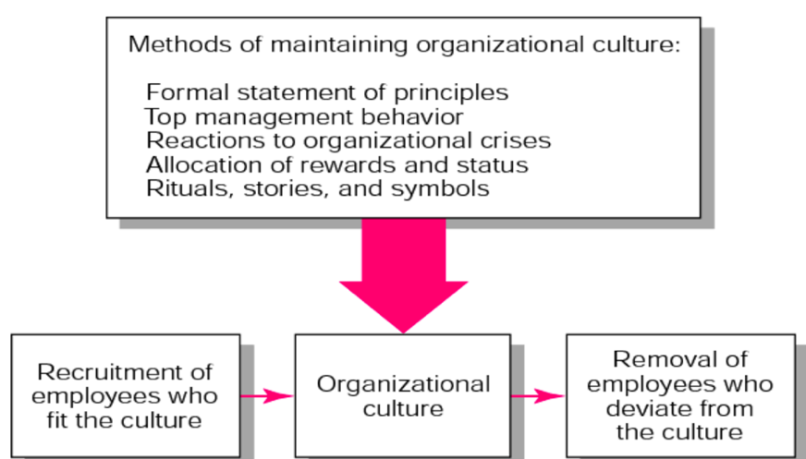
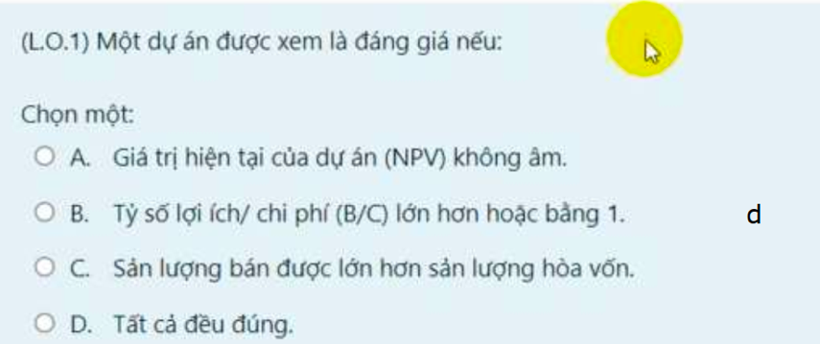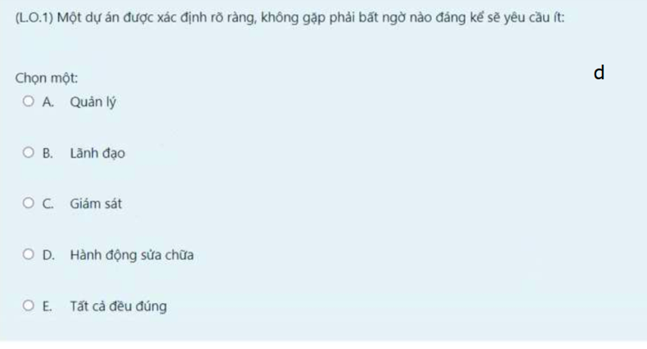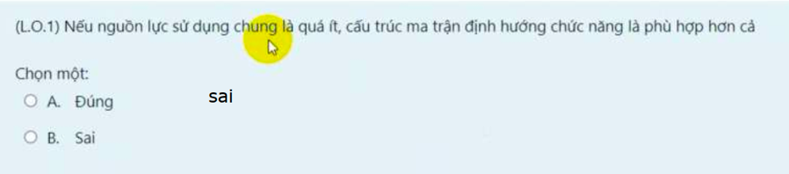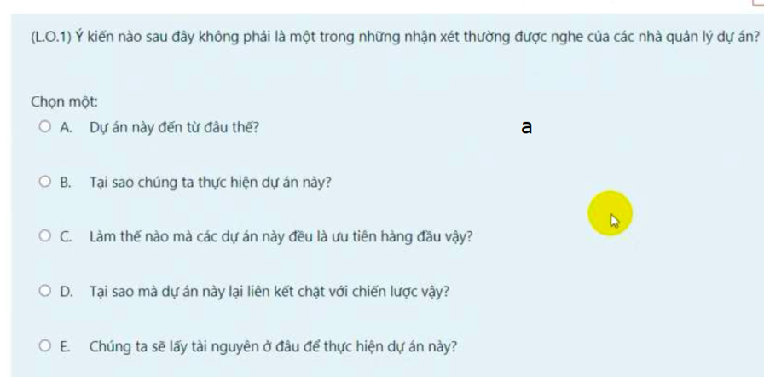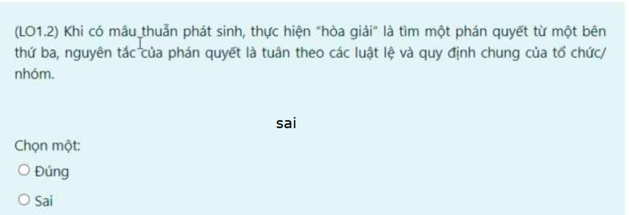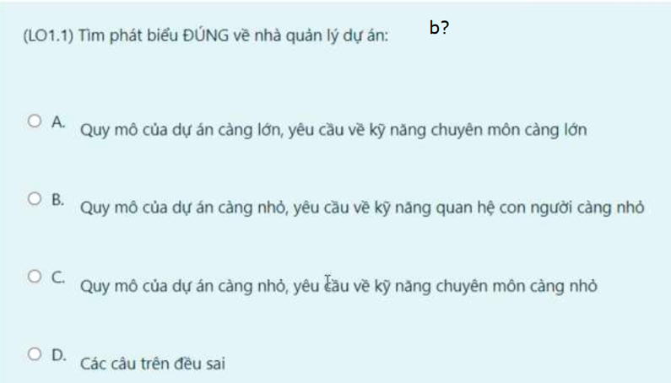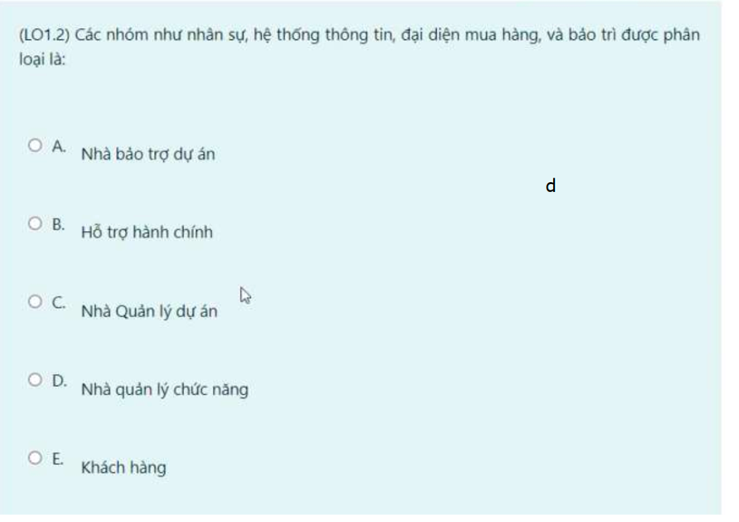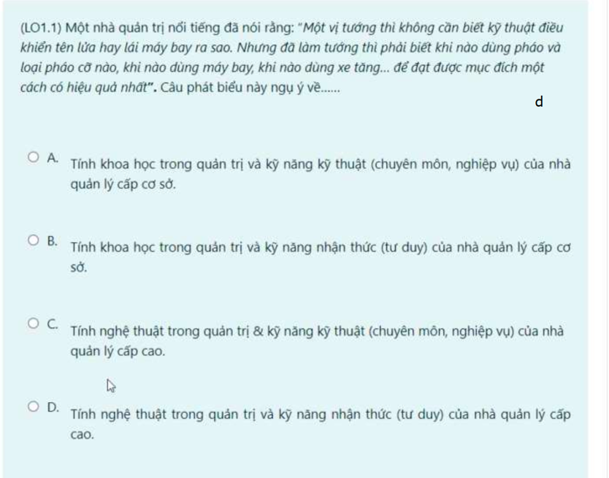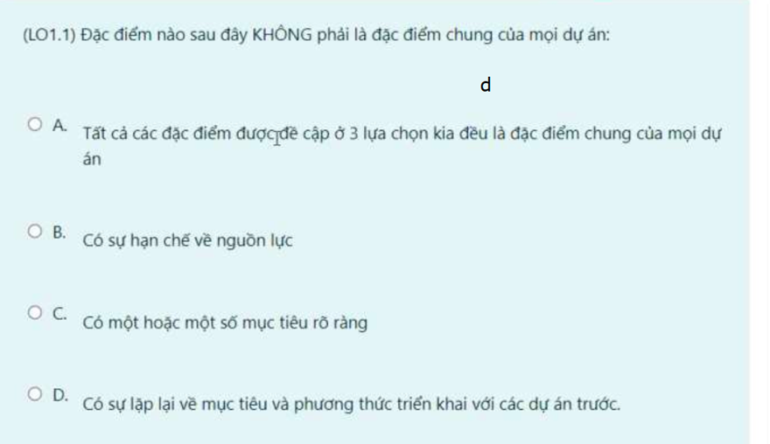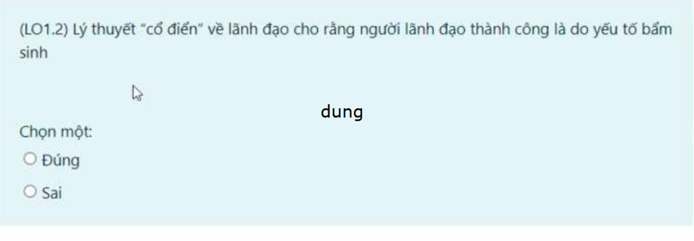
MegaComputers, Inc. has assigned a project manager for each of the five new-product teams. The managers as well as the project team members work on the projects on a full-time basis. The structure being used is project organization.
A project management system provides a framework for launching and implementing project activities within a parent organization.
Matrix management violates the management principle of
A) Span of control
B) Unity of command
C) Parity principle
D) Empowerment
E) All of these management principles
The project structure that is ranked as least effective is Functional organization.
From the list below, which is not a primary characteristic of organization culture?
A) Control
B) Team emphasis
C) History
D) Conflict tolerance
E) Risk tolerance

