0－1． 変更履歴 Tracked changes
Ver | 変更履歴  What's changed? | 作成者  author | 変更理由  Change reason | 日付  date | 正式発行  Official publication
2.00 | New | VC-based LBS |  | 2021/09/06 | －
3.00 | 1) Remove mod-related specifications  ※One  3． Service Contents Table  6－11． Map Content  6－14． Map distribution portal site  6－19． Map update (Map Distribution Center)  ※Chapter all  3－2． Map update by communication equipment  3－3． Map update by update media  5－2． Map update by communication equipment  5－3． Map update by update media  6－12． Update area  6－13． Suppression of delivery data (updated data)  6－15． G-BOOK Support Center Service  6－18． Recovery of map data  6－22． What to do when a map update conflict  2) Fixed map updates to all updates  6－5． Map update service period  6－6． Map update service rights accrual and termination conditions  6－7． Behavior after the end of the map update service  6－8． Map update billing model  6－9． Maintain map renewal service periods  3) 1) Correct the chapter numbers of the following and chapters  6． Service Requirements Table  9． How to operate  4) Remove differential update related from QOS  7． QOS (Quality of Service)  5) Add a supplement to all updates  ５－２－２． Basic movements (normal system)  6) Removed qr code display for all european direction updates  5－2－3． Requirements for HMI specifications  7) Revised to exclude European and Australian countries  5－1－1． Target countries and regions  5－2－1． Target countries and regions  8) Added the entire renewal service period for Lexus/Toyota models  6－5． All renewal service periods  9) Revised notification processing regarding service deadlines  ５－１－２． Basic movements (normal system)  10) Removed "17CY"  6－5． All renewal service periods  6－9． Maintain all renewal service periods  11) Remove "_Overseas" from the name of the content specification  6－10． Freshness of information  7． QOS (Quality of Service)  12) Removed "Toyota and"  6－16． Number of years of system support  13) Changed the "In-vehicle navigation" to "in-vehicle machine"  ５－１－２． Basic movements (normal system)  14) Added Section 10  Map update and triggers, logging, and parameters.  Updated the QoS section | VC-based LBS  TMNA |  | 2021/11/19  2022/3/8 | 〇
1.00 | New | VC LBS |  | 2022/3/31 | ○
RFQ 3.2 | Accepted Changes and created version RFQ 3.2 | TMNA |  | 2022/4/5
1.10 | 和英併記  Also in Japanese  5-1-2  QAに対応し、対象仕向を日本だけに修正  According JIRA(WNSDK24-295), modifying the description for target country toward only for JP  QAに対応し、図中に英訳を追記  According JIRA(WNSDK24-295), adding the description for each figure in English. | VC LBS  飯島 Iijima |  | 2022/7/21 | 〇
v1.10 | 5-2 Updated Section ▲1.10 WNSDK24-661  5-2-1 Added EU as a supported region ▲1.10  5-2-2 Added the EU map update flow for users/dealers ▲1.10  5-2-3 QR code support for EU ▲1.10 | TMNA Yazid Kadir |  | 2022/7/11 | 〇
1.20 | 5-1-1 Temporary map update  5-2-1 Full map update  対象国・地域 Target countries and regions  対象国・地域の表を削除  Delete target countries and regions  6-5. 全更新サービス期間 Map renewal service period  欧州GSR-ISA法規要件により、全地図更新サービスの欧州無償7年を追記  In order to comply with GSR-ISA regulation, add the description for full map update service for 7 years free period in EU.  6-16. システム耐用年数 Number of years of system support  欧州GSR-ISA法規要件により、欧州の全地図更新サービス終了期間14年間の参照先を追記。  In order to comply with GSR-ISA regulation, add the description for reference of full map update service for 14 years from the last vehicle production in EU.  6-17 更新動作中のほか機能への影響について Impact on functions during update operation  JIRA QA(DC24-5025)に対応し、該当箇所の記載を削除  To comply with JIRA QA(DC24-5025), delete the request for some description. | VC Agent/LBS  飯島 Iijima |  | 2022/8/12 | ○
1.50 | 6-5全更新サービス期間 Map renewal service period  地図認証、法規対応必要項目に▼Rを追記  Add the description as ▼R for countries which need map approval or to apply regulation. | VC Agent/LBS  飯島 Iijima |  | 2022/9/21 | ○
1.60 | 誤記訂正/Modification for the typo  対象JIRAチケット/Affected JIRA ticket: DCQA24-471  ・５－１－２．基本動作（正常系） Basic movements (normal system)  ・５－２－２．基本動作（正常系） Basic movements (normal system)  誤記訂正/Modification for the typo  対象JIRAチケット/Affected JIRA ticket: WNSDK24-3006  ・目次Target regionの情報は、『24MM_Navi_Target region for 522 common requirement spec Ver.*.**.xlsx』で管理する為、『5-1-1.Target country/region』、『5-2-1.Target countries and regions』を取り消し線で削除。  The table of contents for “Target region” should be referred with the different file of “24MM_Navi_Target region for 522 common requirement spec Ver.*.**.xlsx”. The strikethrough was added for the both of the table of contents “5-1-1.Target country/region” and “5-2-1.Target countries and regions”. | VC Agent/LBS  Kashima | [理由]  誤記訂正  Modification for the specification document | 2022/12/16 | ○
1.60  Phase2 | To comply with DCQA24-463, updated the procedure in 5-2-2 to add clarity for regions that require USB update. | TMNA Yazid Kadir |  | 2022/12/16 | 〇
1.70 | NVJ24-9469  5-1-2.基本動作（正常系）内の一時地図更新の協調表示の機能廃止  Deprecated functionality for highlighting temporary map updates | VC Agent/LBS  Kumagai | サービス有効性を再検証し廃止  Revalidate service effectiveness and abolish | 2022/3/17 | -
 | 機能追加/Function addition  変連番号:DC24-9609, DC24-13146  対象JIRAチケット/Affected JIRA ticket: WNSDK24-3274  ・５－２－２．基本動作（正常系） Basic movements (normal system)  標準ダイアグにて地図品番が出力できることを追記。  Add the description for output the parts number of map via standard diag.  機能追加/Function addition  変連番号:DC24-9612,DC24-12704  対象JIRAチケット/Affected JIRA ticket: WNSDK24-3287  ・５－２－２．基本動作（正常系） Basic movements (normal system)  地図更新時のソフト更新が必要な際の対応について追記  Add the description which shows the behavior at the timing of the software update combined map update. | VC Agent/LBS  Iijima | SU法規要件のトレサビ取得のため、21MMキャリーで個別対応していたダイアグ出力を標準ダイアグで対応することで標準化を実現。  To apply to UN-R156 for traceability of map, we carried 21MM spec to output the traceability information in unique way. We can realize standard way.  地図更新時にナビとして独自にソフト更新をする場合、SUMS認証が必要となってしまうため、ナビ地図とソフト更新を疎に作る。  When HU update the software with using scheme inside navigation map update, it is necessary to get additional SUMS certification, so we design each update both map data and software with separately. | 2022/3/17 | -
1.70 | 正式発行  Official Release | VC Agent/LBS  Kashima | Ver1.70正式発行する為  To release ver1.70 | 2023/3/17 | 〇
1.71 | 5-2-2: Updating USB update wording and region flags as discussed in WNSDK24-3558, DCQA24-463. ▲1.71 | TMNA Anna Shelukha | Clarify process of updating the map. | 2023/3/22 | 〇
3.50 | 7. QOS (サービス品質Quality of Service)  【仕様明確化/Spec clarification】  【対象JIRA/ Affected JIRA】  DC24-25998/WNSDK24-5990  【変更内容】  全更新サービスにおいて、『RSASSA-PKCS1-v1_5』に対応し、ハッシュ値をSHA-256の仕様にする内容を追加。  Regarding the full map update  service, we added that the content  of “『RSASSA-PKCS1-v1_5』 must be  complied and Hash value must be  developed based on 『SHA-256』 spec.” | LBS  Kashima | Clarification for the RSA( Reliability, Availability and Serviceability) specification of the full map update service | 2023/12/15 | 〇

6.10 | ５－２－２．基本動作（正常系） Basic movements (normal system)  ６－５．全更新サービス期間 Map renewal service period -3.00  【仕様明確化/Spec clarification】  【24MM(CV#2)/SU(PreCV)/CDC(PreCV)】  【対象JIRA/ Affected JIRA】  DC24-37285/WNSDK24-6879/ WNSDK24-6880  【変更内容】  ▽Rの図をテキストにて"▽R"に変更する  The picture of "▽R" is changed to text font "▽R". | LBS  Kashima | The regulation check action has been led by 3DPV, then 3DPV requested related members to change the picture of “▽R” to text “▽R” to be find the point with text search. | 2024/5/31 | 〇
6.20 | 7. QOS (サービス品質Quality of Service)  【仕様変更/Spec change】  【CDC(PreCV)】  【対象JIRA/ Affected JIRA】  DC24-40560/WNSDK24-7097  【変更内容/Change content】  ・参照セキュリティ仕様書の説明誤記修正  ・Reference of Information Security Requirements Specifications is modified for the correction.  変更前: 21CY_情報セキュリティ要求仕様書  Before: 21CY_ Information Security Requirements Specifications  変更後: 24CY_情報セキュリティ要求仕様書  After: 24CY_ Information Security Requirements Specifications  ・暗号化方式の変更  Change of Encryption method  変更前/Before: RSASSA-PKCS1-v1.5  変更後/After: EDCSA  ・セキュリティのリプロに関する項目を削除  Deletion for the Repro topic for security. | LBS  Kashima | RSASSA-PKCS1-v1.5（鍵長2048bit）の暗号化方式は、2041年以降は、セキュリティ強度要件上、使用不可となる為、暗号化方式の変更が必要。  また、リプロに関する記載は本仕様書に記載ないため、セキュリティの項目からリプロに関する記載削除  The encryption scheme of ”RSASSA-PKCS1-v1.5”(key length 2048bit) is going to be prohibited due to the low security level from 2041 year. The encryption scheme must be changed from current one.  And, the related “Repro” information is deleted from security item because there is no explanation for “Repro” content in this document | 2024/6/28 | 〇
6.30 | 7. QOS (サービス品質Quality of Service)  【仕様変更/Spec change】  【24MM(CV#2)/SU(PreCV)】  【対象JIRA/ Affected JIRA】  DC24-37986(№1204)/WNSDK24-7097  【変更内容/Change content】  24MM/SUに対しても、Ver6.20のCDC変更対応(DC24-40560)を実施  The same HENREN content(DC24-40560) of CDC is applied to 24MM/SU as well.  ６－５．全更新サービス期間 Map renewal service period  【仕様変更/Spec change】  【24MM(CV#2)/SU(PreCV)/CDC(PreCV)】  【対象JIRA/ Affected JIRA】  DC24-42027(№1246)/WNSDK24-7151  【変更内容/Change content】  全更新サービス期間の修正対応  The modification for map renewal service period correction. | LBS  Kashima | CDCと24MM/SUで変連が分かれており、仕様書発行タイミングがそれぞれ別の為。  The HENREN is separated between CDC and 24MM/SU, and the specification update timing also separated.  全更新サービス期間の記載内容が間違っていた為  Map update period content was not correct. | 2024/8/30 | 〇
6.60 | ５－２－２．基本動作（正常系） Basic movements (normal system)  【仕様明確化/Spec clarification】  【24MM(1A)/SU(PreCV)/CDC(PreCV)】  【対象JIRA/Affected JIRA】  DC24-55857(No.1470)/WNSDK24-7382 WNSDK24-7881/ WNSDK24-7882/ WNSDK24-7883  【変更内容/Change content】  ソフト更新に関する内容を削除  Delete the comment related to SW update | LBS  Kashima | SU法規(UN-R156)観点で、地図更新画面遷移内にソフト更新に繋がる画面遷移を入れるべきでないと判断した為。  From the SU regulation(UN-R156) point of view, we judged that the screen transition for map update should not have the SW update screen transition. | 2024/12/13 | 〇
7.20 | 【24SU/CDC(CV)】  DC24-63294（SUCDC-109）  各種サービス要求仕様書から006_性能要求_Performance_RequirementにQOSを統合Integrate QOS from various service requirement specifications into "006_性能要求_Performance_Requirement" | LBS  Shoya Moriyama |  | 2025/3/14
7.30 | 【24SU TW CONNECTED(CV)）】  変連№DC24-51648（SU-033）  【変更】  5-1.通信機器による一時地図更新  ・台湾HYB化に伴い、台湾仕向においてもサービス期間終了後の動きについても明記  5-1. Temporary map update by communication equipment  In line with the HYB transition in Taiwan, it is also specified for shipments to Taiwan regarding actions taken after the service period ends. | LBS  Shoya Moriyama | 台湾HYB化対応 | 2025/4/15
目次 table of contents
0－1． Change history 1
0－2． Term Definition 4
1． Aim of service 5
2． Main use scene 5
3． Service Description 5
3－1． Temporary map update by communication equipment 5
3－2． Map update by telecommunications equipment ▲3.005
3－3． Map update by update media ▲3.006
３－２． Full Update 6
4． System Configuration Figure 7
5． Operation Overview / HMI Image 8
5－1． Temporary map update by communication equipment 8
5－1－1． Target country/region 8 ▲Ver1.60
５－１－２． Basic Movements (Normal) 8
5－1－3． Demand 11 for HMI specifications
5－1－4． Custom Item 11
5－1－5． Exception operation (abnormal system) 11
5－1－6． Others 11
5－2． Map update by telecommunications equipment PAGEREF _Toc87878056 \h ▲3.0012
5－2－1． Target countries and regions 12
５－２－２． Basic action (normal system) 12
5－2－3． Demand 12 for HMI specifications
5－2－4． Custom Item 12
5－2－5． Exception operation (abnormal system) 13
5－2－6． Others 13
5－3． Map update by update media 14
5－3－1． Target countries and regions 14
５－３－２． Basic movements (normal) 14
5－3－3． Request for HMI specifications 14
5－3－4． Custom Item 14
5－3－5． Exception operation (abnormal system) 15
5－3－6． Others 15
５－２． Full Update 16
5－2－1． Target countries and regions 16 ▲Ver1.60
５－２－２． Basic action (normal system) 16
5－2－3． Requirement for HMI specifications 16
5－2－4． Custom Item 17
5－2－5． Exception operation (abnormal system) 17
5－2－6． Others 17
6． Service Requirement 18
6－1． Temporary map update service period 19
6－2． Temporary map update service right accrual and termination condition 19
6－3． Behavior after the temporary map update service ends 19
6－4． Temporary map update billing model 19
6－5． Map renewal service period 19
6－6． Map Renewal Service Rights Accrual and Termination Conditions 20
6－7． Behavior after the completion of all map update service 21
6－8．all update billing model 22
6－9． Management of all map renewal service period 22
6－10． Freshness of Information 23
6－11． Map Content 23
6－12． Update Area ▲3.0024
6－13． Suppression of delivery data (updated data) (3.0025)
6－12． Map distribution portal site 25
6－15． G-BOOK Support Center Service -3.0025
6－13． Operation confirmed write environment 26
6－14． Service-enabled 27
6－18． Recovery of map data ▲3.0028
6－15． Map Update (Map Distribution Center) 28
6－16． System support 28
6－17． Impact on functions during update operation
6－22． What to do when there is a map update conflict ▲3.0030
7． QOS (Quality of Service) 31
8． Trends and Comparision of Other Companies 47
9． How to Operate 50
10．Map Update and Triggers 51

0－2． 用語定義 Term definition
本書で使用する専門用語、造語について以下に列挙する。
Technical terms and coined words used in this book are listed below.
用語 term | 説明 explanation
全更新  Full update | 年に２～４回リリースされる地図年度版データによって、すべての地図データを最新のバージョンに更新する処理  The process of updating all map data to the latest version with map year data released 2-4 times a year or more.
ポータルサイト  Portal site | ユーザーが地図更新用のデータをダウンロードする為のwebサイト  Websites for users to download data for map updates
VIN | 車両識別番号（Vehicle Identification Number）  Vehicle Identification Number
ライセンスキー  License key | 全更新を行う時に必要とするキー。車載機を特定するIDと更新する地図DBの組み合わせで作成する。  The key required to make all updates. It is created by a combination of id that identifies the in-vehicle machine and the map DB to be updated.
有料ライセンスキー  Paid license key | 課金を行って入手したライセンスキー  License key obtained by charging
無料ライセンスキー  Free license key | 地図更新サービス期間中のみ使用できるライセンスキー。課金を行うことなく入手できる。  A license key that can only be used during the map update service period. Available without charging.

サービスの狙い Aim of service
本サービスは、ユーザーに最新の地図を提供し、道案内としてのナビの利便性向上及びNavi協調車両統合制御に必要な情報の鮮度向上を行うことを目的とする。
The purpose of this service is to provide users with the latest maps, improve the convenience of navigation as directions, and improve the freshness of information necessary for Navi cooperative vehicle integration control.

主な利用シーン Main usage scenes
- 車の運転時に、意識せず最新の地図DBを使用したい
When driving a car, I want to use the latest map DB without being conscious
- オフライン時でも新しい地図DBを使用したい
I want to use a new map DB even when I am offline
- 有事の際でもユーザーが必要とする地図DBを最適に使用したい
I want to use the map DB that the user needs optimally even in the event of an emergency
- ユーザーがWEB上で地図データを入手し、地図DBを更新したい
Users want to obtain map data on the web and update map DB
- 販売店に入庫時に、地図DBを更新したい
I want to update the map DB when I enter the store

地図更新概要
Overview of Map Updates
- ACC ONで地図更新を開始
Map Update at ACC On
- （オンライン時）ズームイン/アウト、マップスクロールの際に地図更新
Map Update Zoom In/Out, Map Scroll (while online)
- （オフライン時）ズームイン/アウト、マップスクロールの際に地図更新
Map Update Zoom In/Out, Map Scroll (while offline)
- 事前にダウンロードした地図を使って、目的地に向かってルートを探索
Routing to destination within Pre-Downloaded Map
- 事前にダウンロードした地図の範囲を超えて、目的地に向かってルートを探索
Routing to destination outside Pre-Downloaded Map
- ルート探索なしに地図更新
Map Update without Routing
- 地図更新実施（車載機内蔵地図）
Update in Progress (Incremental Map Update)
- ネットワーク圏外エリアでの動作制約を軽減する
Mitigating No-Network Areas
- 地図更新のエラーと注意喚起
Map Update Errors and Alerts
- サーバーパラメータを更新する
Map Update Server Parameters

サービス内容 Service Content
サービス内容 Service Content
通信機器による一時地図更新  Temporary map update by communication equipment | ○ | ○ | ○
Map update by telecommunications equipment ▲3.00 |  | ○
Map update by update media ▲3.00 |  | ○ |  | ○
全更新  Full update |  |  |  | ○ | ○

通信機器による一時地図更新
Temporary map update by communication equipment
・センターに格納される最新の地図DBを取得し、最新の地図情報を使用できるサービスを提供する
・ Provide a service that can obtain the latest map DB stored in the center and use the latest map information
・センターの地図DBをナビのキャッシュ上に一時的に保持して、ナビ使用中にオフラインとなっても最新の地図使用を継続できるようにする
・ Temporarily keep the map DB of the center on the navigation cache so that you can continue to use the latest map even if you are offline while using navigation
※センター地図の更新頻度の詳細は「付録：地図更新コンテンツ要求仕様書」を参照
* For details on the update frequency of the center map, please refer to "Appendix: Map Update Content Request Specifications"

３－２． Map update by communication equipment▲3.00
・ Provide a service that can acquire map DB stored regularly in the center and update the map DB of navigation
・ Even if the map DB at the factory is freshness at L / O (1 part number), it can be updated to the new map DB by the time the user uses navigation
* For details on the update frequency of the center map, please refer to "Appendix: Map Update Content Request Specifications"

３－３． Map update by update media▲3.00
・ Provide a service that allows users to obtain map update data stored regularly in the center and update the map DB of navigation
* The updated media is assumed to be USB.
* For details on the update frequency of the center map, please refer to "Appendix: Map Update Content Request Specifications"

全更新 Full update
・ナビに全更新メディアを接続して、すべての地図DBを更新できるサービスを提供する
・ Provide a service that can update all map DB by connecting all update media to navi
・ライセンスキーによって、ナビが更新可能な更新メディアを判断する
・ Determine which update media navigation can update by license key
・ナビの地図データより新しい地図データの場合に更新する
Update in the case of map data newer than navi map data
※更新メディアは、USBを想定
* The updated media is assumed to be USB.

システム構成図 System configuration diagram
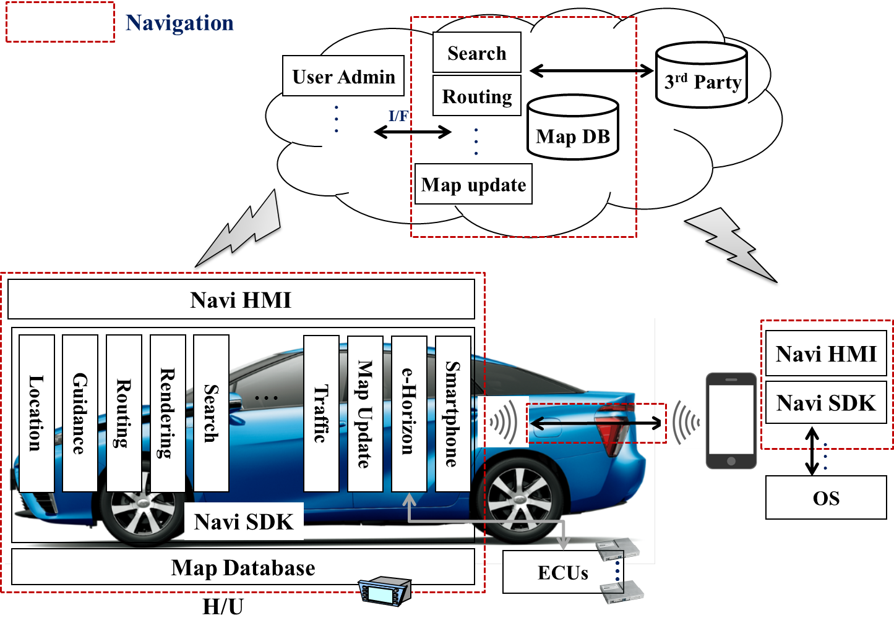

動作概要/HMIイメージ Operation Overview/HMI Image

通信機器による一時地図更新
Temporary map update by communication equipment

対象国・地域 Target countries and regions ▲1.20
No | サービス  service | 対象仕向け Target
 |  | 日本 Japan | 北米 North America | 欧州 Europe | オセアニア Oceania | 東南アジア Southeast Asia | インド India | 中近東 Middle East | 中南米 South america | 南アフリカ South Africa | 台湾 Taiwan | 香港・マカオHong Kong and Macau | 中国 China
1 | Temporary map update | ○ | ○ | ○ | ○ | ― | ― | ― | ― | ― | ― | ― | ―
▲3.00

基本動作（正常系） Basic movements (normal system)

サービス概要 Service Overview
・センターに新しい地図データを配置し、通信により常時最新の地図データを取得する。
・ Place new map data in the center and always acquire the latest map data by communication.
・ユーザー体験について
About user experience
①自宅から目的地を移動する際に、自宅周辺、ルート沿いをセンターの最新地図DBで案内する
(1) When moving from home to the destination, guide the area around your home and along the route with the latest map DB of the center
②目的地に到着後、目的地周辺をセンターの最新地図DBで案内する
(2) After arriving at the destination, guide the destination area with the latest map DB of the center
③ルート案内中に通信オフライン状態が発生した場合も、センターの最新地図DBで案内継続する
(3) Even if a communication offline state occurs during route guidance, continue to guide with the latest map DB of the center
(センター地図DBをキャッシュしている範囲内で動作)
(Works within the range where the center map DB is cached)
但し、ナビ契約が切れた場合はキャッシュデータを利用しなくてよい
However, if the navi contract expires, you do not have to use cache data.

■: センターの地図DBキャッシュCenter Map DB Cache
→: Guide Route 案内ルート

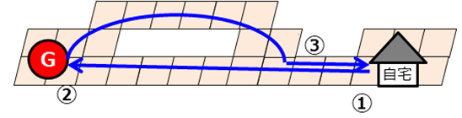

・ From one month before the end of the service period, display a screen indicating that the service period will expire soon
・サービス期間終了の場合は、ユーザーに再契約を促す通知をする。(JP/台湾のみ▲7.30（24SU TW CONNECTED(CV)） ▲Ver1.10)
・ In the case of the end of the service period, notify the user to re-contract. ▲3.00
(Only for JP and Taiwan ▲7.30（24SU TW CONNECTED(CV)）▲Ver1.10)
・更新された道路（開通から一定期間内の道路 ▲Ver1.60）は強調表示すること。道路を選択することで更新情報（道路名称や開通日など）を表示すること。(JPのみ ▲Ver1.10)
・ Highlight the updated roads (please within a certain period of time from the opening). Display updates (such as road name and opening date) by selecting a road.
(Only for JP ▲Ver1.10)▲1.70

サービス要件 Service requirements -3.00
- センターの地図DBをキャッシュ上に保持して、オフライン時、およびACCオフオン後でも最新地図を継続して使用可能なこと。
- Keep the center map DB on the cache and continue to use the latest map when offline and after ACC is on off.
- 取得する地図データバージョンはセンターで保持しているバージョンとなる。
- The map data version to be acquired is the version held in the center.
- センター側の地図が新しく、車載側の地図にはない道路で探索する必要がある場合は、センターから「案内に必要なデータ(音声データ、描画データ含む)」もダウンロードし目的地までは最新の道路ネットワークで案内できるようにする。この時、道路に関するデータを優先的に取得すること。
- If the map on the center side is new and it is necessary to search on a road that is not on the map on the in-vehicle navigation machine side, download "data necessary for guidance (including voice data and drawing data)" from the center so that it can be guided to the destination on the latest road network. At this time, preferentially acquire data on roads.
- 一時地図配信で取得したローカル地図DBにない道路を走行する場合の案内機能は、ローカルDBを最新に更新した場合と同等レベルの案内とすること。
- The guidance function when driving on a road that is not in the local map DB acquired by temporary map delivery should be at the same level as when updating the local DB up to date.
- センターからの通知で地図データの取得範囲、取得対象の地図コンテンツを変更可能なこと。
- The range of the acquisition of the map data and the map content to be acquired can be changed by notification from the center.
- サービス期間はセンターで管理すること。
- The service period must be managed by the Center.
- 地図全更新の実施時、センターの地図バージョン更新検知時にはキャッシュ削除すること。
- When all map updates are performed, and when the map version update of the center is detected, the cache should be deleted.
- 一時地図配信データ取得(通信)開始/終了条件
- Temporary map delivery data acquisition (communication) start / end conditions
  - 開始条件 Start condition
ACC－ON時
  - 終了条件 To condition
ACC－OFF時

- 主要機能動作要求
- Main functional action requirements
  - 探索/POI検索機能:
  - Explore/POI search function: ▲3.00
車載内でキャッシュしている一時地図配信データとローカルDBをそれぞれ参照し、より最適な情報を提供する。
It provides more optimal information by referring to temporary map distribution data and local DB cached in the in-vehicle navigation machine, respectively.
※補足:車載での探索では、センターから取得したエリアと車載機が保持しているエリアの
境界付近の道路ネットワークは接続保証されないことに注意。
* Supplementary note : In the search with an in-vehicle navigation machine, the area acquired from the center and the area held by the in-vehicle machine
Note that road networks near the perimeter are not guaranteed connectivity.
The area which has map data only in vehicle.
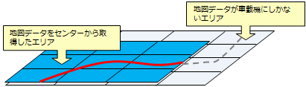
The area in map which downloaded from server.
センターから取得した最新Verの地図データ上には存在する道路が車載機の旧Verのデータには存在しない可能性有り。
There is a possibility that the road that exists on the map data of the latest Ver obtained from the center does not exist in the data of the old Ver of the in-vehicle machine.
⇒その場合、目的地までの探索ができない。
⇒ In that case, you will not be able to search to your destination.

  - 案内/ロケーション機能 Information/Location Features:
各機能に必要な範囲の一時地図配信データを使用して各機能を実現する。
Each function is realized using temporary map delivery data within the range required for each function.
自車位置移動に伴い一時地図配信データをセンターから再度取得する。
Temporary map distribution data is acquired again from the center with the movement of the vehicle position.
※取得範囲・取得タイミングは各社検討し機能仕様書に反映すること。
* The scope and timing of acquisition should be examined by each company and reflected in the functional specifications.
It is necessary to get the data along route for route searching function.
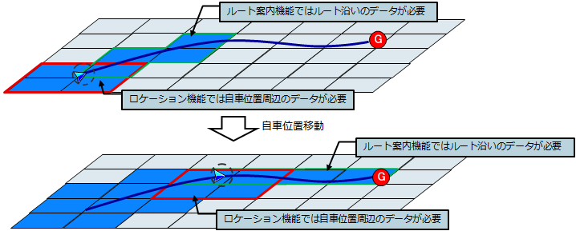
It is necessary to get the data around
the current position for location function.
It is necessary to get the data along route
for route searching function.
Moving location
It is necessary to get the data around
the current position for location function.
【一時地図配信データ取得イメージ(案内/ロケ)】
[Temporary map delivery data acquisition image (guide / location)]

  - 地図描画機能 Map drawing function: ▲3.00
- 車載機は、ローカル地図DBを参照し地図描画する。
The in-vehicle navigation machine maps DB by referring to the local map DB.
車載機は、センターに一時地図配信データ取得要求を送信する。
The in-vehicle navigation machine sends a request to acquire temporary map distribution data to the center.
(自車位置周辺等を中心とした描画エリア、かつ、表示縮尺により該当するレイヤを要求すること。)
(Request a drawing area centered around the vehicle position, etc., and the corresponding layer according to the display scale.)
センターは車載機に一時地図配信データを送信する。
The center sends temporary map delivery data to the in-vehicle navigation machine.
車載機は受信した一時地図配信データを使用して、地図を描画する。
The in-vehicle navigation machine draws a map using the received temporary map delivery data.
また、渋滞情報も取得した一時地図配信データに合わせて表示する。
In addition, traffic jam information is also displayed according to the acquired temporary map delivery data.
It is necessary to get the data around the current position.
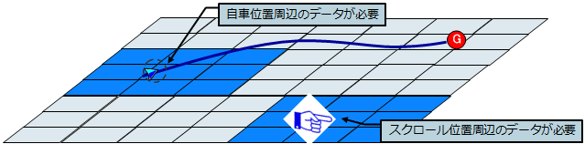
It is necessary to get the data around the scrolled position.

【一時地図配信データ取得イメージ(地図描画)】
[Temporary map distribution data acquisition image (map drawing)]

HMI仕様に対する要求 Requirements for HMI specifications
特になし
None in particular

ユーザー設定項目 Custom items
特になし
None in particular

例外動作（異常系） Exception operation (abnormal system)
- 通信できない等の理由でセンターから一時地図の情報取得に失敗し、キャッシュ地図DBによる動作を継続できない場合は、ローカル地図DBにて動作させる。
- If the information acquisition of the temporary map is failed from the center due to reasons such as not being able to communicate, and the operation by the cache map DB cannot be continued, it is operated by the local map DB.

その他 other
特になし
None in particular

5－2． Map update by telecommunications equipment ▲3.00

5－2－1． Target countries and regions
No | service  Complies with Post21DCM standards (center-only) | Target Target
 |  | Japan | North America | Europe | Oceania | Southeast Asia | India | Middle East | South america | South Africa | Taiwan | Hong Kong and Macau | China
2 | Map update by communication equipment | ○ | ― | ○ | ○ | ― | ― | ― | ― | ― | ― | ― | ―

５－２－２． Basic movements (normal).

Service Overview
【Main Action】
Automatic update at the start-up of navigation
- User starts navigation (DCM equipped machine)
- Automatically get the latest map data and start updating
- When the update is complete, switch the map to the latest state the next time ACC-ON

Service requirements
・ In order to make the map DB shipped to the factory one part number, it is possible to update without restrictions on the freshness difference between the local map DB and the update data.
Others are "6. Service Requirements

5－2－3． Requirements for HMI specifications
Automatic update at the start-up of navigation
When the update is complete, switch the map to the latest state the next time ACC-ON

5－2－4． Custom items
None in particular

5－2－5． Exception operation (abnormal system)
・ If an error occurs while downloading data, perform a default retry.
If the default retry does not return, discard the data being downloaded and return it to the state it was in before the update started.
・ If the download data is detected as incorrect, discard the download data and return it to the state before the update starts.
・ If an abnormality occurs during the update of the map, discard the data in the middle of the update and return it to the state before the update starts.
・ If ACC-OFF occurs during data download and update, the next ACC-ON process will be resumed.

5－2－6． other
None in particular

5－3． Map update by update media ▲3.00

5－3－1． Target countries and regions
No | service | Target Target
 |  | Japan | North America | Europe | Oceania | Southeast Asia | India | Middle East | South america | South Africa | Taiwan | Hong Kong and Macau | China
3 | Map update by update media | ○ | ― | ― | ― | ○ | ○ | ○ | ○ | ○ | ○ | ○ | ―

５－３－２． Basic movements (normal).

Service Overview
【Main Action】
Updates stored on update media
- Users get updates from map update sites
- Storing update data on update media
- Connecting update media to navigation
- User performs update start operation
- Get the latest map data for the update area and start updating
- When the update is complete, switch the map to the latest state the next time ACC-ON

Service requirements
・「6. Service Requirements

5－3－3． Requirements for HMI specifications
None in particular

5－3－4． Custom items
None in particular

5－3－5． Exception operation (abnormal system)
・ If the update is not possible due to the factors of the update media, notify the user to that effect.
・ If an error occurs during data copying, perform a default retry.
If the default retry does not return, discard the data being copied and return it to the state it was in before the update started.
・ If the update media is discharged during data copy, cancel the data copy.
・ If the copy data is detected as illegal, discard the copy data and return it to the state before the update starts.
・ If an abnormality occurs during the update of the map, discard the data in the middle of the update and return it to the state before the update starts.
・ If ACC-OFF occurs during data copying and updating, process will be resumed the next ACC-ON.

5－3－6． other
None in particular

全更新 Full update

対象国・地域 Target countries and regions ▲1.20
No | サービス  service | 対象仕向け Target
 |  | 日本 Japan | 北米 North America | 欧州 Europe | オセアニアOceania | 東南アジアSoutheast Asia | インド India | 中近東 Middle East | 中南米 South america | 南アフリカ South Africa | 台湾 Taiwan | 香港・マカオ Hong Kong and Macau | 中国 China
1 | 全更新  Full update | ○  ― | ○ | ○ | ○ | ○ | ○ | ○ | ○ | ○ | ○ | ○ | ―
▲3.00

基本動作（正常系） Basic movements (normal system)

サービス概要 Service Overview
【主要動作 Main Action】
・全更新メディアによる全更新
・All updates by all update media
- ナビに全更新メディアを接続する
Connect all update media to navigation
- ライセンスキーを入力する
Enter your license key
- 全更新メディアから最新の地図データを取得して更新開始する
Get the latest map data from all update media and start updating
- 更新が完了したら、更新完了した旨をナビ上に通知する
When the update is complete, notify navigation that the update is complete

※ソフトウェア更新が必要な場合は、③の動作前に実施する
* If software update is required, perform before (3) works
▲Ver6.60 24MM(1A)/SU(PreCV)/CDC(PreCV)
※③の動作開始後は、更新完了までユーザー操作無しで動作する
* After the operation of (3) starts, it operates without user operation until the update is completed.
・地図パッケージ内の対象国について、センターなし仕向けにおいても追加/削除ができること
・For eligible countries in the map package, it is possible to add / remove even for tailoring without centers
▲Ver1.60
例)ウクライナの法規対応により、全欧地図データにおいてウクライナのみを表示することができるなどを販売店やダイアグを通して設定できるようにすること
Example) In response to Ukrainian laws and regulations, it is possible to set up the display of Ukraine in all European map data through dealers and diagnostics
※追加にあたっては現地の法規/認証や生産工程での作業に制約があり、対応方法毎に協議して決められるよう複数の対応手段を提供できること。
* There are restrictions on local laws/ certifications and work in the production process, and multiple response measures can be provided so that they can be decided by consultation for each response method. ▲3.00
▽R ・UN-R156法規に対応するため、ナビ地図DB内に地図品番情報を格納、標準ダイアグにて地図品番が出力できること。 ▲Ver1.70 ▲Ver6.10(24MM(CV#2)/SU(PreCV)/CDC(PreCV))

To comply UN-R156 regulation, navi map DB has map parts number information
inside of itself, and the output of map parts numbers of map can be
executed via the standard diag.
・全地図更新をした場合、出力する地図品番は更新後のものとすること。▲Ver1.70
When HU is finished full map update, the output of map parts number should be the updated one.
・出力する地図品番は、マイナー符号も含めること。送信する地図品番のフォーマットは46F発行の標準ダイアグ仕様に準拠すること▲Ver1.70
The output of map parts number should also be involved Minor sign.
The format in order to send map parts number should apply to the standard diag spec which is released by 46F.

詳細はSpec 513:MMCANダイアグ機能仕様書_24MM_Diagnostic_CAN_specification。
The detail is mentioned in the “Spec 513:MMCANダイアグ機能仕様書
_24MM_Diagnostic_CAN_specification”.

・全地図更新時に、地図DBの「ナビSDK最低動作保証バージョン」情報を確認、ナビSDKの
バージョンと比較し、ナビSDKのバージョンが古ければリプロ画面へ遷移すること。▲Ver1.70
When the map update, check the map DB content which is ”Navi SDK Version information which guarantees working with this map”, compare it with SDK version. If the SDK version is older than DB one’s, move to the repro screen.

▲1.10 [EU/AU] ▲Ver1.60 Phase2
Full Update by USB
- [EU] On a computer browse to ESTORE application online store application online (e.g.: in case of EU, E-store/TechDoc)
[NA/AU] On a computer browse to online store application
▲1.71 [EU/AU]
Full Update by USB
① On computer browse to online store application: E-store
- Authenticate as user and select map version
- Download and save new map version to USB
- Insert USB in vehicle USB drive and begin update of HU maps
- When the update is complete, notify navigation that the update is complete
* If software update is required, perform before (4) works
* After the operation of (4) starts, it operates without user operation until the update is completed.
* For eligible countries in the map package, it is possible to add / remove even for tailoring without centers

HMI仕様に対する要求 Requirements for HMI specifications
・全更新メディアによる全更新
・All updates by all update media
更新する地図バージョンを表示する
View the map version to update
更新中は進捗状態、残り時間を表示する
Show progress status and remaining time during update
更新が完了したら、更新完了した旨をナビ上に通知する
When the update is complete, notify navigation that the update is complete
・ .▲1.10 [EU]
< The map update ID > European direction and information that can be determined whether or not it is during the entire update service period can be displayed on the in-vehicle machine screen with a QR code.▲3.00

ユーザー設定項目 Custom items
特になし
None in particular

例外動作（異常系） Exception operation (abnormal system)
- 全更新メディアの異常を検知した場合は、異常がある旨をナビ上に通知し、全更新を開始しない。
- If an abnormality of all update media is detected, notify the navigation system that there is an abnormality and do not start all updates.
- データコピー中にACC-OFFが発生した場合は、次回ACC-ON時に処理を再開する。
- If ACC-OFF occurs during data copying, resume processing the next time ACC-ON.
- データコピー中にエラーが発生した場合は、既定のリトライを実施する。
既定のリトライで復帰しない場合は、更新エラー画面を表示する。
- If an error occurs during a data copy, perform a default retry.
If the default retry does not return, the update error screen is displayed.
- 更新エラー画面には、更新開始日、ライセンスキー、更新メディア、エラーコード、エラー発生工程を表示する。
- The update error screen displays the update start date, license key, update media, error code, and error occurrence process.
- 更新エラー後、ACCオフオンがあった場合は、前回のレジューム地点からデータコピーを再開する。
- If acc is off on after an update error, resume the data copy from the previous resume point.

その他 other
< Europe market>If there are several map packages in the one market such as Europe market, the full map update must be available without any restrictions for each map package.
(e.g.: Must be available to perform the full map update from Turkey to Europe .)
▲1.00

サービス要件 Service requirements
▲3.00
サービス要件 Service requirements
一時地図更新サービス期間
Temporary map update service period
一時地図更新サービス権利発生と終了条件
Temporary map update service rights accrual and termination conditions
一時地図更新サービス終了後の振る舞い
Behavior after the temporary map update service ends
一時地図更新課金モデル
Temporary map update billing model
全更新サービス期間
Map renewal service period
全更新サービス権利発生と終了条件
renewal service rights accrual and termination conditions
全更新サービス終了後の振る舞い
Behavior after the end of the map update service
全更新課金モデル
full update billing model
全更新サービス期間の管理
The entire map renewal service period
情報の鮮度
Freshness of information
地図コンテンツ
Map Content
Update area
Suppression of delivery data (updated data)
地図配信ポータルサイト
Map distribution portal site
G-BOOK Support Center Service
動作確認済み書込み環境
Operation-confirmed write environment
サービス対応
Service-ready
Recovery of map data
地図更新（地図配信センター）
Map update (Map Distribution Center)
システム対応年数
Number of years of system support
更新動作中のほか機能への影響について
Impact on functions during update operation
What to do when a map update conflict

一時地図更新サービス期間 Temporary map update service period
本サービスは一時地図配信サービスフラグONの間、一時地図配信のサービスを受けることが出来る。
This service can receive temporary map distribution service service during temporary map distribution service flag ON.

一時地図更新サービス権利発生と終了条件 Temporary map update service rights accrual and termination conditions
一時地図配信サービスフラグはセンターで管理する。
Temporary map distribution service flags are managed by the center.

一時地図更新サービス終了後の振る舞い Behavior after the temporary map update service ends
一時地図配信サービス終了後は、利用する場合に課金が必要となる。
After the temporary map distribution service ends, you will need to pay when using it.

一時地図更新課金モデル Temporary map update billing model
ユーザーがWEB上で課金することで、センターで管理する期間を延長することができる。
By charging on the web, the period of management in the center can be extended.

全更新サービス期間 Map renewal service period -3.00
本サービスは新車（新規車載機）購入後、数年間課金を行わず無料ライセンスキーによる全更新サービスを受けることが出来るサービスである。
This service is a service that allows you to receive all renewal services with a free license key without charging for several years after purchasing a new car (new in-vehicle machine).

ケース case | サービス期間 Service period
新車購入時  もしくは  新規車載機購入時(※1)  When purchasing a new car  or  When purchasing a new in-vehicle unit (*1) | n（※2）年間、課金を行わず地図全更新サービスが行える。  n(*2) For years, you can perform a map update service without charging.
有料ライセンスキーによる  全更新時  By paid license key  When fully updated | 全更新を行い、その後m（※2）年間 と、  全更新メディア内に設定しているメディア提供有効期限p（※2）年の期間の短い期限の間、課金を行わず地図全更新サービスが行える。  All updates are made, and then m(*2) years and  During the short period of the media provision expiration date p (*2) year set in all renewal media, all map renewal services can be performed without charging.
- 1 想定しているケースは地図更新対応用品車載機購入時
- 1 The assumed case is at the time of purchase of a map update compatible product in-vehicle machine
- 2 17CY is n=3, m=2, p=5 Lexus model is n=3, m=2, p=5, Toyota model is n=5, m=2, p=7 ▲3.00
24CY Japan: No free period
24CY AU/Row: n=3、m=2、p=5
▲Ver6.30(24MM(CV#2)/SU(PreCV)/CDC(PreCV))

2124CY Europe market: n=7 ▼R ▽R, m=2, p=5 ▲1.00 ▲1.20
▲Ver6.10(24MM(CV#2)/SU(PreCV)/CDC(PreCV))

(a)新車購入後、直ぐに（例：半年後）
全更新を行った場合

サービス期間の考え方

n年

メディア提供有効期限

（b）全更新

m年延長

(c)全更新日+m年後の日時がメディア提供有効期限を超える場合

(b)全更新日+m年後の日時がメディア提供有効期限内の場合

全更新版発行年月日＋p 年迄延長

（c）全更新

m年

全更新版発行年月日+p年迄有効

全更新メディア内に、設定

m年

（a）全更新

（n – a）年延長

a年（＜ n - m）

新車購入

全更新

全更新実施タイミングとサービス終了日の関係

(a) Immediately after purchasing a new car (e.g. six months later)
When all updates are made

Concept of service period

n years

Media offer expiration date

(b) Full update

m-year extension

(c) When the date and time after all renewal date + m exceeds the media provision expiration date

(b) If the date and time after all renewal date + m is within the media provision expiration date

Extended to all updated version issue date +p year

(c) Full update

m years

Valid until all updated issue date +p year

Within all update media, set

m years

(a) Full update

(n – a) year extension

ayear (< n - m）

Buy a new car

Full update

Relationship between timing of all updates and end-of-service

全更新サービス権利発生と終了条件 Renewal Service Rights Accrual and Termination Conditions ▲3.00
本サービスの権利は新車（新規車載機）購入後とする（下表参照）。
The rights to this service shall be after the purchase of a new car (new in-vehicle vehicle) (see table below).
即開始としないでユーザーがサービスを始めたいタイミングから開始とすると、10、20年後まで地図の更新サービスを保証する必要が出てしまうため上記考え方としている。
If the user starts from the timing when they want to start the service without starting immediately, it is necessary to guarantee the map update service until 10 or 20 years later, so the above idea is considered.
以下の条件で地図更新サービス期間が開始、終了される。
The map update service period starts and ends under the following conditions.
ケース  Case | 地図更新サービス期間開始  Map update service period started | 地図更新サービス期間終了  Map renewal service period ends
新車購入時  もしくは  新規車載機  購入時  When purchasing a new car  or  New in-vehicle equipment  At the time of purchase | 下記いずれかの条件を満たした時（※1）  (ⅰ)走行距離100km経過時  (ⅱ)サプライヤー工場出荷後1年経過時  When any of the following conditions are met (*1)  (i) When the mileage has passed 100 km  (ii) One year has passed since the supplier factory was shipped. | 地図更新サービス期間経過時  When the map update service period has elapsed
有料ライセンスキーによる  全更新時  By paid license key  When fully updated | 有料ライセンスキーによる  全更新を行った時  By paid license key  When all updates are made | 下記いずれかの条件を満たした時  (ⅰ)サービス期間経過時  (ⅱ)次回有料ライセンスキーによる全更新時  ただし、サービス期間開始直後などに有料ライセンスキーによる全更新をしたことで、全更新をしないユーザーより全体のサービス期間が短くなることがないようにする（※２）。  When one of the following conditions is met  (i) When the service period has elapsed  (ii) At the next renewal with a paid license key  However, by updating all with the paid license key immediately after the start of the service period, the overall service period will not be shorter than that of users who do not renew all (*2).
- １ ただし、（ⅰ）（ⅱ）の条件を満たす前のユーザー操作による地図更新は受け付ける
1 However, we accept map updates by user operations before meeting the conditions of (i)(ii)
- ２ サービス期間の延長の考え方
2 Concept of extending the service period

全更新サービス終了後の振る舞い Behavior after the end of all map update service ▲3.00
全▲3.00更新サービス終了後は、地図全▲3.00更新サービスを利用する場合に課金が必要となる。
After the map all ▲3.00 update service ends, you will need to pay when using the map all ▲3.00 update service.
ただし地図全▲3.00更新中は更新終了まで継続する
However, all maps will continue until the end of the update during the 3.00 update.

△更新用データ取得
▲更新メディア車載機挿入時
サービス期間

＜ケース１＞ △ ▲ ： 全更新を行なう

＜ケース２＞ △ ▲ ： 全更新を行なわない
＜ケース３＞ △ ▲ ： 全更新を行なわない
＜ケース４＞ △ ▲ ： 全更新を行なう

＜ケース５＞ △ ▲ ： 全更新を行なう
＜ケース６＞ △ ▲ ： 全更新を行なわない

△Data acquisition for updating
▲When inserting the update media in-vehicle machine
Service period

< Case 1> △ ▲ : Make all updates

case 2 > < △ ▲ : Do not make all updates
< Case 3 > △ ▲ : Do not make all updates
< Case 4> △ : Complete updates

< Case 5> △ ▲ : Complete updates
< Case 6> △ ▲ : Do not make all updates

サービス終了後はサービス期間中に最後に更新された地図の状態で使用出来る。
After the end of the service, it can be used in the state of the last updated map during the service period.

map全更新課金モデルRenewal billing model▲3.00
一定期間課金を行わずサービスが受けられるような仕組みとするために、新車購入時、新規車載機購入時、全更新時に課金を行う（※１）ビジネスモデルとする。(データ取得毎に課金を行うビジネスモデルとしない)
In order to create a system that allows users to receive services without charging for a certain period of time, the company will charge at the time of purchase of a new car, when purchasing a new in-vehicle device, and when all updates are made into a business model (*1). (It is not a business model that charges for each data acquisition)
※１ 課金タイミングは新車購入時、新規車載機購入時、全更新時、何れかであっても、全てのタイミングであっても良い。
*1 The billing timing may be at the time of purchase of a new car, at the time of purchase of a new in-vehicle unit, at the time of all renewal, or any timing.

Management of 全更新サービス期間の管理all map renewal service period ▲3.00
    - 本サービスのサービス期間は車載機毎に管理するものとする
The service period of this service shall be managed for each in-vehicle machine
(地図全更新時など、ユーザーが新しい地図購入時に、古い地図にサービス期間が残っていても原則としてサービス期間の引継ぎ(残存期間の新地図データへの加算)は行わない)
(in principle, the service period will not be transferred
(addition to the remaining period to the new map data)
even if the service period remains on the old map when the user purchases a new map, such as when the map is fully updated)
※ただし、以下ケースについては特別にサービス期間の引継ぎを行う
* However, for the following cases, specialTake over the service period
- 無償保証期間内の車載機故障に伴う地図交換時は残りのサービス期間を交換した車載機に設定すること
When replacing the map due to an in-vehicle machine failure during the free warranty period, set the remaining service period as an in-vehicle machine that has been replaced.
- 新車購入もしくは新規車載機購入後、1年以内に地図全更新を行った場合は旧地図に付帯していたサービス期間を新地図のサービス期間として付け替えることを可能とすること
If the map is fully updated within one year after purchasing a new car or a new in-vehicle machine, it is possible to replace the service period incidental to the old map as a service period for the new map.
- （(ii)に該当しない場合）地図全更新時、旧地図に付帯するサービス期間が残っていた場合、上限n(※1)日まで新地図のサービス期間に加算する
If the service period incidental to the old map remains at the time of total map renewal (if it does not fall under (ii), it will be added to the service period of the new map up to the upper limit n (*1) date
    - サービス期間はユーザーによって変更出来ないように工場、販売店、メーカーダイアグ画面など、多数の関係者がサービス期間を容易に設定出来ないシステムにするようにすること
Ensure that the service period is a system that cannot be easily set by a large number of parties, such as factories, dealers, and manufacturer diagnostic screens, so that the service period cannot be changed by the user.
    - 将来サービスモデルが変更され、サービス期間の年数が変更されることも考慮し、年度更新版地図リリース時に任意のサービス期間の設定が出来るようにすること
In consideration of future service models and changes in the number of years of service periods, any service period can be set at the time of annual update map release
- １ 17CY▲3.00 n=60 とするn=60

情報の鮮度 Freshness of information
本サービスで提供する情報の鮮度（※１）を『付録：地図更新コンテンツ要求仕様書_海外▲3.00』に記す。
The freshness (*1) of the information provided in this service is described in "Appendix: Map Update Content Request Specifications _ Overseas ▲3.00".
※１ 本サービスで意味する情報の鮮度とは地物の変更（道路の開通、変更など）からセンターに登録され車載機への配信準備が完了するまでの期間とする。
*1 The freshness of the information meant in this service is the period from the change of the local thing (opening of the road, change, etc.) to the time until it is registered at the center and ready to be delivered to the in-vehicle device.

(例えば情報の鮮度を10日間とした場合)
(For example, if the freshness of the information is set to 10 days)


PM3:00
▼開通

PM3:00
▼配信準備完

10日間



earth
PM3:00
Opening of Doors
PM3:00
▼Delivery preparation completed
10 days

地図コンテンツ Map Content
- 本サービスで提供する情報は、『地図更新コンテンツ要求仕様書』に記載する。
The information provided in this service shall be described in the "Map Update Content Request Specification".
- In order to reduce the amount of communication data, the center should not send information that is not necessary for each type of in-vehicle (*1)
*1 For example, VGA/EGA in-vehicle units do not send images of the type that are not necessary. ▲3.00
- A center mechanism that allows DCM and update media to change the type of information provided when using different media
*2 For example, send images only for updated media▲3.00

6－12． Update area▲3.00
It is necessary to reduce the amount of communication data by updating by wireless communication such as DCM. Therefore, in order to deliver the most useful information for users, the service is realized by the following mechanism. Details will be described in the "Map Update Content Request Specifications".
- It is possible to change the update area depending on the road level (*1)

A
B
C
(Example)
A : Intercity high speed, city expressway, toll road, national route 1
B : National highways 2, 3 digits, main local roads, prefectural roads, general roads
C : Fine Street Road

*1 If you want to reduce the amount of data due to the large amount of communication in the future, the distance parameters of A, B, and C above can be adjusted on the center side assuming that the amount of data may be increased by lowering the price of the packet fee.

- To make it a mechanism that can determine the renewal area by the customer's action area (*2)

*2 User's action area: Home registration point, destination, etc.
home
(Example)
Update the L-square map to the center of your home as an action area
L
destination
s
G
(Example)
Update the map of s square to the destination center as an action area
* 17CY shall be L = 80 km, s = 10 km.

6－13． Suppression of distribution data (updated data) -3.00
In this service, updating by wireless communication such as DCM requires a small amount of communication data. Therefore, it is necessary to meet the following requirements.

- In order to reduce the amount of communication data, the center only delivers the changed part of the property (attribute unit) (do not deliver the part without change)
- However, if the amount of communication data increases when delivered on an attribute basis, it may be distributed together.
- Do not distribute changes below the accuracy of the source so that there are no changes in features (opening of roads, changes, etc.) but are not delivered only by changes on data. In addition, it is a mechanism that can confirm that
- In order to reduce the amount of communication data, the delivery data format should be a format that has a small amount of data and can be converted and updated by an in-vehicle machine.
- In order to reduce the amount of communication data, when distributing to DCM, deliver the update data that was in the map ver of the in-vehicle machine

地図配信ポータルサイト Map distribution portal site
地図配信ポータルサイトは、ユーザーが車載機の地図を更新したい時に、PC（例えばユーザー自宅のPC）からアクセスする。ポータルサイトでは、更新データをダウンロードする事が出来る。
The map distribution portal site is accessed from a PC (for example, a PC at the user's home) when the user wants to update the map of the in-vehicle device. On the portal site, you can download the update data. In addition, the portal site shows the recent major updates (scheduled updates, updated) and allows users to know the status of the latest maps in the center, so that users know when to download data. (When updating at the same time as 17CY, notifications on the map distribution portal site may be common) ▲3.00
By user operation, detailed update road display and update POI display for each state can be performed. ▲3.00

６－１５． G-BOOK Support Center Service▲3.00
The G-BOOK Support Center Service is a service that creates media for renewal on behalf of users who do not use any of the other update means of this service, and a service that responds to user inquiries as a map update inquiry window.

About agency service for media creation for renewal
- When entering the train from the user, identify the map link system, and conduct hearings about the prefectures you want.
- To obtain information necessary for sending media such as user's name and address
- Make sure the user is during the map delivery service period
- When multiple pieces of media are made, marking and packing for each media so that the user knows the order in which they are inserted into the in-vehicle machine.
- The media to be used must comply with the contents of "6-18.Operation confirmed writing environment"

About map update inquiry service
- When calling from a user or dealer, we will conduct hearings about phenomena, map version information, conversion engine version information, map update status, G-BOOK usage status (availability, CDF access date and time), vehicle information (vehicle type, navigation type, first year registration date, etc.).
- The contact can obtain the latest conversion engine version information and updated road information and respond to users or dealers.
- The contact can contact the navimaker with information collected from the user or dealer and respond to the user or dealer with the treatment method.

動作確認済み書込み環境 Operation-confirmed write environment
本サービスでは更新手段としてUSBを使用する。動作を確認したメディア（USB）、ライティングソフト、デッキを明確にすること。
Usb is used as an update method in this service. Make the media (USB), lighting software, and decks that have been confirmed to work.

サービス対応 Service-ready
・修理対応について
About repair correspondence
車載機交換時または地図メディア交換時、サービス期間を含め、ユーザーの地図状態に戻せるような仕組みとすること。
A system that can be returned to the user's map state, including the service period, when replacing in-vehicle aircraft or when exchanging map media.
ユーザーの地図状態に戻せない場合は、サービス期間内である場合には最新の地図状態に戻すこと。サービス期間外の場合には、地図メディア交換による対応とする。
If it is not possible to return to the user's map state, if it is within the service period, return to the latest map state. In the case outside the service period, the correspondence is made by the map media exchange.

不具合車載機品
否地図メディア不良時
地図メディア
不良時
地図メディアレスのリンク品
にユーザーが使用していた
地図メディアを組み込む
サービス期間内
サービス期間外
地図メディアを最新の地図
状態に更新する。

地図メディア交換による
運用とする。

Defective in-vehicle equipment
No map media when bad
Map Media
When bad
Map Medialess Links
Users were using
Incorporate map media
Service period
Out of service period
Map Media latest maps
update to a state.

By map media exchange
to be operated.

・サービス期間の移行について
About the transition of the service period
地図メディア交換もしくは、車載機交換時に、元のサービス期間を引き継げること。
To take over the original service period when exchanging map media or in-vehicle equipment.

不具合車載機品
地図メディア/車載機の両交換時
地図メディアまたは、車載機のどちらかを
交換時
販売店で故障部品の代品交換時に、サービス期間を引き継げること。
販売店が、ユーザーのサービス期間をメーカへ連絡し、メーカでサービス期間を紐付けした代品を準備して、代品交換すること。

Defective in-vehicle equipment
When exchanging both map media and in-vehicle equipment
Either map media or in-vehicle
At the time of replacement
To take over the service period at the time of replacement of defective parts at the dealer.
The dealer shall contact the manufacturer about the user's service period, prepare a substitute linked to the service period by the manufacturer, and replace the substitute.

・サービス期間のロバスト性について
・ About robustness of service period
サービス障害等によって、本来のサービス期間分のサービスを受けられないユーザーが発生した場合、救済策としてすでにサービス期限の切れた車載機を地図更新する仕組みを用意すること。
In the event of a user who is unable to receive the service for the original service period due to a service failure, etc., as a remedy, prepare a mechanism to update the map of the in-vehicle device that has already expired.

6－18． Recovery of map data ▲3.00
Recovery > by < data distribution
If you have problems with the map conversion engine or delivery package,
Provide a mechanism that can deliver map data for recovery to users and recover by replacing files.

地図更新(地図配信センター) Map update (Map Distribution Center)
24時間、365日配信可能であること
Available 24 hours a day, 365 days a year
将来的な接続端末数増加に伴い、機器増設や負荷分散が可能なシステム構成とすること
With the increase in the number of connected terminals in the future, it is possible to configure a system that can add equipment and load balance.
将来的な地図配信データの増加に伴う負荷、容量の増加及びセキュリティの強化に対して拡張が可能なシステム構成とすること
System configurations that can be scaled to increase the load, capacity and security of future increase in map delivery data
システム構成は、障害時に切替できるように冗長化されていること
The system configuration must be redundant to be switched in the event of a failure.
障害発生によるサービス停止は、20分以内であること
Service outages due to failures must be within 20 minutes
障害発生時は、メンテナンスのお知らせが出せるようにすること
In the event of a failure, be able to notify you of maintenance.
不正アクセスに対し24時間、365日監視すること
24/7 monitoring of unauthorized access
管理者（※１）機能にはアクセス制限を設けること
Restrict access to administrator (*1) functions
サーバ毎にウィルスチェックを行うこと
To check for viruses on a server-by-server basis
ウィルスのパターンファイルは、最新の状態に保たれていること
Virus pattern files must be kept up to date
G-BOOK Support Center operates from 9:00 a.m. to 6:36 p.m. -3.00
※１ センター内に入る時、センター内端末を操作する時
*1 When entering the center, when operating the terminal in the center

システム対応年数 Number of years of system support
車両流動終了後の更新期間は、以下を参照のこと。▲1.20
「20.3 (common) navigation map request (center map, factory bundled, supply map) 2.3 地図更新版 Map update version」
Refer to “20.3 (common) navigation map request (center map, factory bundled, supply map) 2.3 地図更新版 Map update version” for the map update period after finishing vehicle production.

本サービスの対応はトヨタが該当車載機で提供する最後の地図年度更新版リリース後m年とする。
The response to this service will be m year after the release of the last map year update version provided by Toyota on the relevant in-vehicle equipment.
m年目以降は本サービスを利用出来ない。
This service cannot be used after the m year.
“m”の設定年数については、トヨタと協議の上決める。
The number of years to set "m" will be decided after consultation with Toyota. ▲3.00

最後の地図年度更新リリース
m年
サービス期間：（m–a）年
a年
（a）年度更新版購入
（b）年度更新版購入
サービス期間：0年
サービス終了時期
yy/mm/dd

p年
メディア提供有効期限
yy/mm/dd

Last Map Year Update Release
m years
Service period: (m–a) year
a年
(a) Purchase of annual renewal
(b) Purchase of the annual renewal version
Service period: 0 years
End of service
yy/mm/dd

p years
Media offer expiration date
yy/mm/dd

更新動作中のほか機能への影響について Impact on functions during update operation
■全更新中のほか機能への影響
■During all updates, as well as functional impact
全更新中は、ナビ機能の使用を制限する。
During all updates, limit the use of navigation functions.
ほか機能の動作を実施しない手順とすること。
Procedures for not performing other functions.

■Impact on functions during map update -3.00
Normal operation is possible when the user makes an update while using the vehicle. Points to be especially noted are described.
・ Driving safety (including defogga), security, help net function not affected. (Update GPS coordinates even if there is no map data)
Entertainment function
Do not cut off the sound during the update operation, including switching map data.
Call function ▲1.20
Be able to make calls, receive calls, or make calls. If you update the map during a call, you can continue the call. (Do not end the call due to the update operation)
Air conditioning function
To function. (The air conditioning function does not temporarily stop due to the update operation.)
・地図切替えの為、自動で再起動する場合は、事前に機能の中断をユーザーに告知すること。
・ If you want to restart automatically for map switching, notify the user of the interruption of the function in advance. ▲1.20

6－22． What to do when mapping update competition -3.00
Competitive Priorities (Metal Rules)
Base policy
- Don't create a situation where you can't update. (e.g., when the radio wave environment is bad and data acquisition cannot be resumed, it is possible to update with USB)
- If there is data (*1) that can be replaced at ACC OFF / ON, replace it.
*1: Manage replaceable data in the division unit of the delivery package.
- Prioritize map update processing with the latest user operations.

QOS (サービス品質Quality of Service)
各種サービス要求仕様書から006_性能要求_Performance_Requirementに
QOSを統合
Integrate QOS from various service requirement specifications into "006_性能要求_Performance_Requirement"
▲7.20（24SU/CDC：CV）

▲3.00
 | 本サービス該当の  QOS項目 |  | 対象動作、機能 |  | レベル
動作 | 動作速度 |  | 全更新処理  （全更新地図データコピー開始～全更新地図データコピー終了）  ※リプロの有無によらない、地図データコピー時間 |  | 30分以内
 |  |  | DCM  配信パッケージダウンロード開始から、地図データ更新終了まで |  | 75分以内  対象データ：  ・２都道府県、３年分の更新  ・全国配信対象、３年分の更新  参考値：  ※更新時間はデータ量に依存するので、以下は目安の数値である。  ・自宅周辺80Km四方、１週間分の更新  →約15分  ・目的地周辺10Km、３年分の更新  →約10分  ・全国配信対象、1週間分の更新  →約15分  ・対象データ：300Kbyte  →約10分
更新メディア内配信パッケージ
転送開始から地図データ更新終了まで
各種サービス要求仕様書から006_性能要求_Performance_RequirementにQOSを統合  Integrate QOS from various service requirement specifications into "006_性能要求_Performance_Requirement"  ▲7.20（24SU/CDC：CV） |  |  | アプリ参照DB差し替え |  | 5秒以内  DB：2004/05-12月DB  更新データ：1.5ヶ月（情報検索系以外）  更新エリア：豊田市トヨタ町中心80Km＊80Km
 |  |  | USB検知 | USB挿入～更新SW表示完了 | 10秒以内
 |  |  | DCMダウンロード(自動) | ACC ON CDFによる「更新データあり」の応答受信～ダウンロード完了 | 15秒以内  サービス期間確認  センターとのコネクション確立  細街路バージョン情報抽出  自宅周辺地図更新要否判定  自宅周辺配信パッケージダウンロード  配信パッケージの整合性確認（チェックサム）
 |  |  |  | 「案内開始」SW押下～ダウンロード完了 | 15秒以内  サービス期間確認  センターとのコネクション確立  細街路バージョン情報抽出  自宅周辺地図更新要否判定  自宅周辺配信パッケージダウンロード  配信パッケージの整合性確認（チェックサム）
 | 各種サービス要求仕様書から006_性能要求_Performance_RequirementにQOSを統合  Integrate QOS from various service requirement specifications into "006_性能要求_Performance_Requirement"  ▲7.20（24SU/CDC：CV） |  | USBコピー | コピー中画面表完了～更新中画面表示完了 | 30秒以内  更新対象配信パッケージコピー  配信パッケージの整合性確認（SHA1）
 |  |  | DB差換え（ナビ起動中差換えのケース） | 準備完了インジケータ押下～差換え後のDBで再探索完了 | （30＋3）秒以内
 |  |  | 画面切替 | 準備完了インジケータ押下 ～地図切替中画面表示完了 | 0.1秒以内
 |  |  |  | 準備完了インジケータ押下） ～エスカッションSWが反応出来るようになるまで | 0.5秒以内  HMI仕様規定に準拠
 |  |  | 差換え | 地図切替中画面表示完了～差換え後のDBで地図表示完了（経路強調除く） | 30秒以内  地図データ差し替え  地図データ再読み込み  地図表示
 |  |  | 再探索 | 差換え後のDBで地図表示（経路強調除く）  差換え後のDBで再探索完了 | 2秒以内  地図データ再読み込み  再探索  渋滞情報考慮際探索
 |  |  | 再検索 | 差換え後のDBで地図表示（経路強調除く）  周辺施設(5ジャンル)表示完了 | 1秒以内  地図データ再読み込み  再検索  周辺施設表示完了
 |  |  | マップ  マッチング | 差し替え後のDBで地図表示 | DB差し替え前の道路にマッチング
 |  |  | DB差換え（ACC ON直後差換えのケース）  各種サービス要求仕様書から006_性能要求_Performance_RequirementにQOSを統合  Integrate QOS from various service requirement specifications into "006_性能要求_Performance_Requirement"  ▲7.20（24SU/CDC：CV） | ACC ON ～差換え後のDBで再探索完了 | 30秒以内
 |  |  | 差換え | ACC ON～差換え後のDBで地図表示完了（経路強調除く） | 30秒以内  オープニング画表示  地図データ差し替え  地図データ再読み込み  地図表示
 |  |  | 再探索 | 差換え後のDBで地図表示（経路強調除く）  差換え後のDBで再探索完了 | 2秒以内  地図データ再読み込み  再探索  渋滞情報考慮際探索
 |  |  | 再検索 | 差換え後のDBで地図表示（経路強調除く）  周辺施設(5ジャンル)表示完了 | 1秒以内  地図データ再読み込み  再検索  周辺施設表示完了
 |  |  | 全更新 | 全更新処理  全更新開始～全更新終了 | 30分以内  全更新処理  サービス期間更新
 | 動作制限 | 他機能からの影響  ※地図メディアにアクセスする機能 | 地図更新 |  | ・他機能動作時に一時停止  ・他機能停止後に自動で再開
 |  | ACC ON後の起動 | 地図更新 |  | ナビ機能が使用可能
 |  |  | 地図差替え |  | オーディオ機能が使用可能
 |  | ACC OFF時の動作 | 地図更新、地図差替え  地図全更新 |  | 次回起動時に、更新中、差替え中のデータがある場合、自動で再開
 |  | 走行規制 | (走行中のユーザー操作として)  地図更新開始 |  | ユーザー操作可能
 |  |  | (走行中のユーザー操作として)  地図差替え開始 |  | ユーザー操作可能
 |  |  | (ユーザー操作後の内部処理)  地図更新、地図差替え |  | 変換処理、差替え処理は動作継続
 |  | 通信不可時 | DCMダウンロード |  | 通信ｷｬﾝｾﾙ。通信圏内復帰後、自動でﾀﾞｳﾝﾛｰﾄﾞ再開
 | フェールセーフ処理 |  | 地図更新 |  | 変換前データに復旧し、ナビ動作可能
コンテンツ | 鮮度 |  | 地図更新データ |  | ※2１ ▲3.00
 | 精度 |  | 地図更新データ |  | ※2１ ▲3.00
 | 対象 |  | 更新コンテンツ |  | ※2１ ▲3.00
 | 検査 |  | データ評価 |  | ※5２ ▲3.00
 | セキュリティ | 改竄防止  複製防止 | 地図更新データ・サービス期間 |  | 暗号化コードを付与※3  ▲3.00
 |  |  | リプロデータ ▲Ver6.20 |  | リプロ仕様に準拠 ▲Ver6.20
検査 | 組み合わせ検査 |  | 新しいソフトまたは地図リリース |  | すでにリリースされているソフトまたは地図との組み合わせによる動作を保証すること
部品交換 | 記録コンテンツ保護 |  | 地図更新（サービス期間情報） |  | 交換前サービス期間を継続
 |  |  | 地図更新（地図データ） |  | 不整合が起きた状態から復帰し、ナビ動作可能
- １ 詳細は『付録：地図更新コンテンツ要求仕様書_海外』を参照 ▲3.00
各種サービス要求仕様書から006_性能要求_Performance_RequirementにQOSを統合
Integrate QOS from various service requirement specifications into "006_性能要求_Performance_Requirement"
▲7.20（24SU/CDC：CV）

- ２ 詳細は『付録：基地図評価項目』、『付録：地図オーサリング検査項目』を参照 ▲3.00
- ２３ 暗号化方法は標準規格で定められたものとする
セキュリティ対策要件については、以下仕様書を参照とする。
『190_21CY24CY_情報セキュリティ要求仕様書』 ▲Ver6.20 ▽R (24MM(CV#2)/SU(PreCV)/CDC(PreCV)) ▲Ver6.30
- ３ 詳細は『付録：基地図評価項目』、『付録：地図オーサリング検査項目』を参照
- 4 全更新サービスにおいて、『RSASSA-PKCS1-v1_5ECDSA』にて対応すること。ハッシュ値は『SHA-256』仕様を使用する事。(本内容はUN-R156 SU法規の認証届け出内容且つ UN-R155 サイバーセキュリティ法規内容)。▲3.50 ▲Ver.6.20 ▽R (24MM(CV#2)/SU(PreCV)/CDC(PreCV)) ▲Ver6.30
各種サービス要求仕様書から006_性能要求_Performance_RequirementにQOSを統合
Integrate QOS from various service requirement specifications into "006_性能要求_Performance_Requirement"
▲7.20（24SU/CDC：CV）

 | This service applies to  QOS projects |  | Target behavior, function |  | level
action | Speed of action |  | Full update process  (All update map data copy start ~ All update map data copy end)  * Map data copy time regardless of the presence or absence of repro |  | Within 30 minutes
 |  |  | DCM  From the start of distribution package download to the end of map data update |  | Within 75 minutes  Target data:  Renewal for 2 prefectures and 3 years  ・ Nationwide distribution target, renewal for 3 years  Reference values:  * Since the update time depends on the amount of data, the following is a numerical value of the standard.  ・ 80km square around the home, updated for one week  → is about 15 minutes  ・ 10km around the destination, renewal for 3 years  → about 10 minutes  ・ Nationwide distribution target, update for one week  → is about 15 minutes  Target data: 300Kbyte  → about 10 minutes
各種サービス要求仕様書から006_性能要求_Performance_RequirementにQOSを統合  Integrate QOS from various service requirement specifications into "006_性能要求_Performance_Requirement"  ▲7.20（24SU/CDC：CV） |  |  | In-media update delivery package  From the start of transfer to the end of map data update
 |  |  | App Reference DB Replacement |  | Within 5 seconds  DB: DB 2004/05-December  Update data: 1.5 months (other than information retrieval system)  Update area: Toyota City Toyota Town Center 80km*80Km
各種サービス要求仕様書から006_性能要求_Performance_RequirementにQOSを統合  Integrate QOS from various service requirement specifications into "006_性能要求_Performance_Requirement"  ▲7.20（24SU/CDC：CV） |  |  | USB detection | USB insertion to update SW display completed | Within 10 seconds
 |  |  | DCM download (automatic)  各種サービス要求仕様書から006_性能要求_Performance_RequirementにQOSを統合  Integrate QOS from various service requirement specifications into "006_性能要求_Performance_Requirement"  ▲7.20（24SU/CDC：CV） | Acc ON CDF receives response to "with updated data" and completes download | Within 15 seconds  Check service duration  Establish a connection with the Center  Narrow street version information extraction  Judgment of whether or not to update the map around the home  Download delivery packages around your home  Consistency check of delivery packages (checksum)
 |  |  |  | "Guide start" SW press ~ download completion  各種サービス要求仕様書から006_性能要求_Performance_RequirementにQOSを統合  Integrate QOS from various service requirement specifications into "006_性能要求_Performance_Requirement"  ▲7.20（24SU/CDC：CV） | Within 15 seconds  Check service duration  Establish a connection with the Center  Narrow street version information extraction  Judgment of whether or not to update the map around the home  Download delivery packages around your home  Consistency check of delivery packages (checksum)
 | 各種サービス要求仕様書から006_性能要求_Performance_RequirementにQOSを統合  Integrate QOS from various service requirement specifications into "006_性能要求_Performance_Requirement"  ▲7.20（24SU/CDC：CV） |  | USB Copy | Copy screen table complete to update screen display complete | Within 30 seconds  Copy of the delivery package to be updated  Delivery Package Integrity Verification (SHA1)
 |  |  | DB replacement (case of navo startup replacement) | Readiness indicator press - re-search completed in db after replacement | Within (30+3) seconds
 |  |  | Screen switching | Ready indicator press ~ Map switching screen display completed | Within 0.1 seconds
 |  |  |  | Ready indicator press) - until the escutsion SW can react | Within 0.5 seconds  Complies with HMI specifications
 |  |  | Replacement  各種サービス要求仕様書から006_性能要求_Performance_RequirementにQOSを統合  Integrate QOS from various service requirement specifications into "006_性能要求_Performance_Requirement"  ▲7.20（24SU/CDC：CV） | Map display completed in DB after map switching screen display completion to replacement (excluding route enhancement) | Within 30 seconds  Map data replacement  Reload map data  Map display
 |  |  | Explore again | Re-search completed in the DB after the map display (excluding route enhancement) replacement  in the db after the replacement | Within 2 seconds  Reload map data  Explore again  Search when considering traffic jam information
 |  |  | Re-search | Map display (excluding route enhancement)  peripheral facilities (5 genres) display completed  in the DB after replacement | Within 1 second  Reload map data  Re-search  Peripheral facility display completed
 |  |  | map  各種サービス要求仕様書から006_性能要求_Performance_RequirementにQOSを統合  Integrate QOS from various service requirement specifications into "006_性能要求_Performance_Requirement"  ▲7.20（24SU/CDC：CV）  matching | Map display in the db after replacement | Matching to the road before DB replacement
 |  |  | DB replacement (case of replacement immediately after ACC ON) | ACC ON ~ Re-search completed in the db after replacement | Within 30 seconds
 |  |  | Replacement | Map display completed in ACC ON to converted DB (excluding route enhancement) | Within 30 seconds  Opening picture display  Map data replacement  Reload map data  Map display
 |  |  | Explore again | Re-search completed in the DB after the map display (excluding route enhancement) replacement  in the db after the replacement | Within 2 seconds  Reload map data  Explore again  Search when considering traffic jam information
 |  |  | Re-search  各種サービス要求仕様書から006_性能要求_Performance_RequirementにQOSを統合  Integrate QOS from various service requirement specifications into "006_性能要求_Performance_Requirement"  ▲7.20（24SU/CDC：CV） | Map display (excluding route enhancement)  peripheral facilities (5 genres) display completed  in the DB after replacement | Within 1 second  Reload map data  Re-search  Peripheral facility display completed
 |  |  | Full update | All update process  start to end all updates | Within 30 minutes  Full update process  Service period renewal
 | Movement restrictions | Impact from other functions  * Function to access map media | Map update |  | Pause during other function operation  Automatically resumes after stopping other functions
 |  | Start-up after ACC ON | Map update |  | Navigation function is available
 |  |  | Map replacement |  | Audio functionality available
 |  | Action when ACC OFF  各種サービス要求仕様書から006_性能要求_Performance_RequirementにQOSを統合  Integrate QOS from various service requirement specifications into "006_性能要求_Performance_Requirement"  ▲7.20（24SU/CDC：CV） | Map update, map replacement  Full map update |  | The next time you start up, if there is data that is being updated or being replaced, it will resume automatically
 |  | Driving regulations | (As user operation while driving)  Start of map update |  | User-operateable
 |  |  | (As user operation while driving)  Start of map replacement |  | User-operateable
 |  |  | (Internal processing after user operation)  Map update, map replacement |  | Conversion process, replacement process continues operation
 |  | When communication is not possible | DCM Download |  | Communication cancellation. Automatic download resume after returning to the communication range
 | Fail-safe processing |  | Map update |  | Recovers to data before conversion and can operate navi
content | freshness |  | Map update data |  | ※2１ ▲3.00
 | precision |  | Map update data |  | ※2１ ▲3.00
 | target |  | Updated content |  | ※2１ ▲3.00
 | inspection |  | Data assessment |  | ※5２ ▲3.00
 | security | Tamper-proof  Anti-replication | Map update data service period |  | Give encryption code*3  ▲3.00
 |  |  | Reprodata ▲Ver6.20 |  | Compliant with repro specifications  ▲Ver6.20
inspection | Combination inspection |  | New software or map releases |  | Ensure operation in combination with software or maps that have already been released
Parts replacement | Record content protection |  | Map update (service period information) |  | Continue pre-replacement service period
 |  |  | Map update (map data) |  | Returns from the state where inconsistencies occurred, and navigation operation is possible
- 1 For details, refer to Appendix: Map Update Content Requirements Specifications _Overseas (3.00)
各種サービス要求仕様書から006_性能要求_Performance_RequirementにQOSを統合
Integrate QOS from various service requirement specifications into "006_性能要求_Performance_Requirement"
▲7.20（24SU/CDC：CV）

- 2 For details, see Appendix: Base Map Evaluation Items and Appendix: Map Authoring Inspection Items (3.00)
- 23 Encryption methods shall be as defined in the standard
For security measures requirements, refer to the following specifications.
"190_21CY24CY_ Information Security Requirements Specifications" ▲Ver6.20 ▽R (24MM(CV#2)/SU(PreCV)/CDC(PreCV)) ▲Ver6.30
- 3 For details, please refer to "Appendix: Base Map Evaluation Items" and "Appendix: Map Authoring Inspection Items"

各種サービス要求仕様書から006_性能要求_Performance_RequirementにQOSを統合
Integrate QOS from various service requirement specifications into "006_性能要求_Performance_Requirement"
▲7.20（24SU/CDC：CV）

- 3 For the Map Update process defined in section 10

- When online data is available via connection to server, map data in use by the user (defined as viewing, routing through, or searching) should be updated within 350 milliseconds.
- Map data housed on server should be updated daily with fixes for:
  - map data
  - POIs
  - Corrections to supplier map authoring as necessary

- 4 『RSASSA-PKCS1-v1_5ECDSA』 must be complied for the full map update service. Hash value must be developed based on 『SHA-256』 spec. (This content is for the submission document of SU regulation(UN-R156), and CS regulation is related(UN-R155)) ▲3.50 ▲Ver6.20 ▽R (24MM(CV#2)/SU(PreCV)/CDC(PreCV)) ▲Ver6.30

他社動向・比較 Trends and Comparisons of Other Companies
■地図更新 Map update
・Audi 最大3エリア選択更新 年4回(3か月ごとに自動更新)
・Audi up to 3 area selection update 4 times a year (automatic update every 3 months)
・BMW アメリカとカナダを13エリアに分割 ユーザーはそのうち1エリアを更新エリアに指定 年4回
・BMW America and Canada divided into 13 areas Users designate one of them as update area 4 times a year
■ 全更新 Full update
・Audi SDによる更新 年2回 $280 初回5回は無料
・Audi SD update twice a year $280 The first 5 times is free
・BMW USBによる更新 年4回 $135
・Renewal by BMW USB 4 times a year $135
・Benz SD･USBによる更新 年1回 3年無料
・Benz SD / USB update once a year 3 years free
・Honda (Garmin) https://www.garmin.com/en-US/maps/updates/
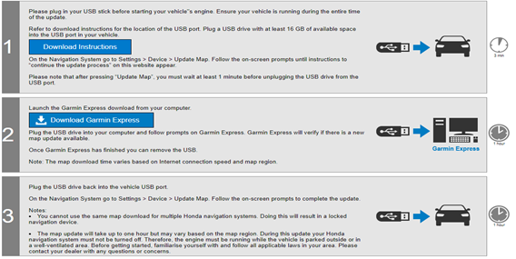

    - 16GBのUSBを車両に差し、Update Mapを選択し、情報取得 作業時間・・・3分
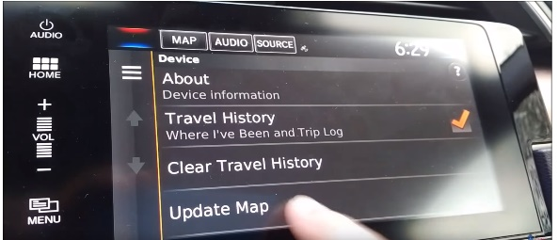
Insert a 16GB USB into the vehicle, select the Update Map, and obtain information Working time...
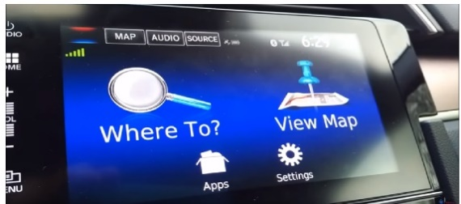
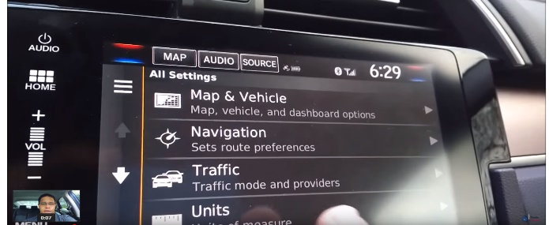
    - ・オンラインサイトで地図購入
Map purchase on the online site
・Garmin Express(PC上で動作するアプリ)でダウンロード
Download with Garmin Express (an app that runs on a PC)
・USBメモリーに転送
Transfer to USB memory stick
・USBをメモリーへ車に持ち込む
Bring USB into the car to the memory
作業時間・・・1時間
Working hours: 1 hour
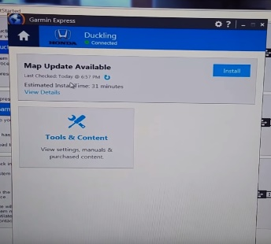
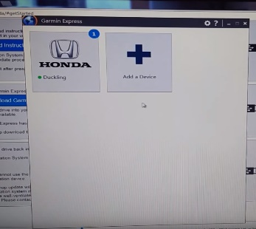

    - USBを車両に差し込んで地図更新 1時間
1 hour to update the map by plugging the USB into the vehicle
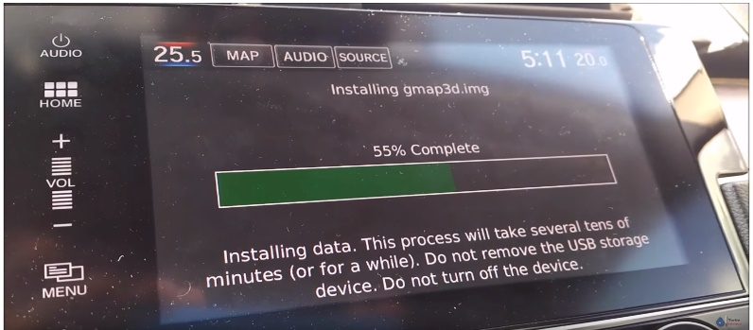

・GM DISCによる更新 年1回 $129
・Renewal by GM DISC once a year $129
オンラインサイトで作業。VIN番号を入れて購入する仕組み
Working on an online site. How to purchase with a VIN number
Next Generation Infotainment 2.5 System Map Update
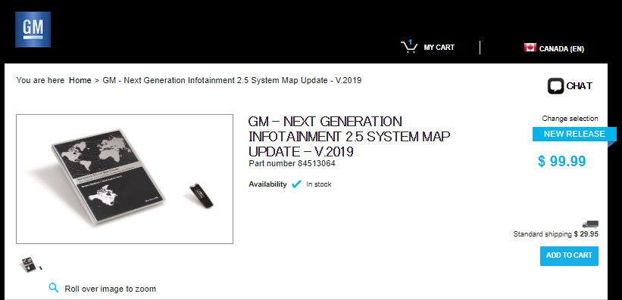

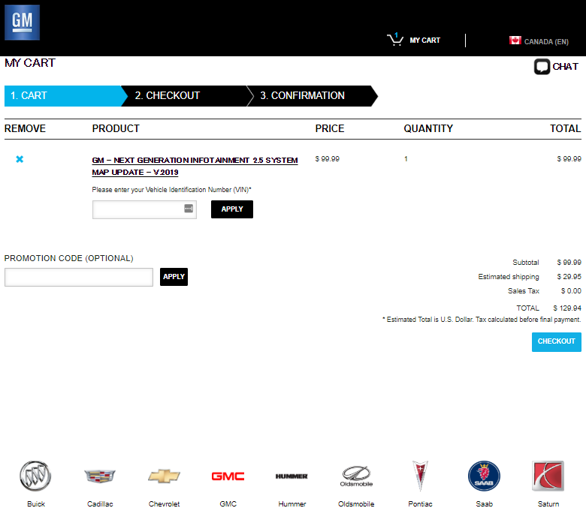

VIN番号を入力して購入する
Enter your VIN number to buy

運用方法 How to operate

車載機 In-vehicle equipment
以下章を参照 See the following chapters
6-3、6-7、6-9、6-16、6-18、6-21、6-22、6-17▲3.00

サービス service
以下章を参照 See the following chapters
6-1、6-2、6-4、6-5、6-6、6-8、6-10、6-11、6-12、 6-13、6-14、6-15、6-17、6-19、6-20、6-16▲3.00

Map Update Process
4.1 Map Update configuration diagram
This illustration is provided to explain the requirements for map updates, it is not an architectural proposal.

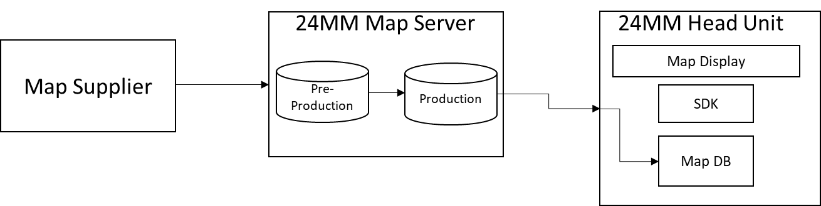
- Map Supplier, provides updated maps to 24MM Map Server
- Pre-Production, supplier ingests and store updates in pre-production and performs functional and non-functional QA/Testing
- Production, Updated maps are promoted to Production from Pre-Production after QA/Testing
- Map DB on HU, HU Flash memory that contains the regional maps for the HU. This Map DB shall not be invalidated over the lifetime of the vehicle. These maps are used in no-connectivity scenarios.

- Map Update Process
  - Head Unit initiates request for Map Updates
  - HU receives updates for defined area around CVP
  - 24MM Map Server delivers updated map tiles to HU
  - HU replaces old tiles in Map DB with updated tiles
  - Updated Map Tiles not in the pre-defined area around CVP are updated as needed based on user action
  - This process also applies to renderer if it requires a separate Map DB

Map Update at ACC On

Target countries and regions
No | service | Target
 |  | Japan | North America | Europe | Oceania | Southeast Asia | India | Middle East | South america | South Africa | Taiwan | Hong Kong and Macau | China
1 | By telecommunications equipment | ― | ○ | ○ | ○ | ― | ― | ― | ― | ― | ― | ― | ―

Basic movements (normal system)

Service Overview
The HU requests updated map tiles from the sever for map update to the latest available version if any. This downloaded map tile(s) are stored on HU, until overwritten by the next updated map tile (s). If the subscription status changes to No navigation or cancel, download map shall be stored on head unit but shall not be displayed to user.
- HU will download map data for an area specified by “Map Update at ACC-On” as defined in section “Map Update Server Parameters” of this document. (This value is configurable and controlled from server side)
- If a map around CVP is stored on head unit and server updates to that map area exist, map needs to be incrementally updated.
  - If new radius overlaps existing radius, download new map area and update portion that over laps existing map area
The HU and the server discuss which portions of the map need updating. And when a mismatch between the map data between the stored map on HU and the same area map data on server is found, the stored map should be updated.

Requirements for HMI specification
This process is transparent and does not require user input or feedback.

Custom Items
Download range | [25] mile radius around CVP. The numbers are provisional and controlled on server side.
Map Layer | All Layers
POIs | Specified POI categories:  Gas stations, Charging Stations, Police Stations, Hospitals, Major chain restaurants, Parking, Favorites and Recent(s)  Attributes: Name, LAT/LON, address, genre, phone, hours of operation

Exception operation (abnormal system)
If map update is interrupted, ACC Off, it automatically resumes at next ignition On
If the subscription status changes to No navigation or Cancel, download map shall be stored on head unit but shall not be displayed to user.

Other
None in particular

Map Update Zoom in and Zoom out, map scroll (Online)

Target countries and regions
No | service | Target
 |  | Japan | North America | Europe | Oceania | Southeast Asia | India | Middle East | South america | South Africa | Taiwan | Hong Kong and Macau | China
1 | By telecommunications equipment | ― | ○ | ○ | ○ | ― | ― | ― | ― | ― | ― | ― | ―

Basic movements (normal system)

Service Overview
The user performs one of the below actions:
- User zooms out on the map
- User zooms in on the map
- User scrolls the map on right side (at any zoom level)
- User scrolls the map on left side (at any zoom level)
- User scrolls the map upwards (at any zoom level)
- User scrolls the map downwards (at any zoom level)

- When user is zooming out from default scale, the HU shows online map area in
accordance with zooming use case defined in Map Display Specification.
- When user is zooming in from default scale, the HU shows online map area around CVP.
- User can see the online map on the left side of CVP.
- User can see the online map on the right side of CVP.
- User can see the online map upwards from CVP.
- User can see the online map downwards from CVP.

Requirements for HMI specification
None in particular

Custom Items
Download range | [25] mile radius around CVP. The numbers are provisional and controlled on server side.
Map Layer | All Layers
POIs | Specified POI categories:  Gas stations, Charging Stations, Police Stations, Hospitals, Major chain restaurants, Parking, Favorites and Recent(s)  Attributes: Name, LAT/LON, address, genre, phone, hours of operation

Exception operation (abnormal system)
- If map update is interrupted, ACC Off, it automatically resumes at next ignition On
- If the subscription status changes to No navigation or cancel, download map shall be stored on head unit but shall not be displayed to user.

Other
None in particular

Map Update Zoom in and Zoom out, map scroll (Offline)

Target countries and regions
No | service | Target
 |  | Japan | North America | Europe | Oceania | Southeast Asia | India | Middle East | South america | South Africa | Taiwan | Hong Kong and Macau | China
1 | By telecommunications equipment | ― | ○ | ○ | ○ | ― | ― | ― | ― | ― | ― | ― | ―

Basic movements (normal system)

Service Overview
The user performs one of the below actions:
- User zooms out on the map
- User zooms in on the map
- User scrolls the map on right side (at any zoom level)
- User scrolls the map on left side (at any zoom level)
- User scrolls the map upwards (at any zoom level)
- User scrolls the map downwards (at any zoom level)

In all of the below cases, map stored in the Head Unit flash memory is used until the Head Unit can re-establish connectivity to the server.
1. When user is zooming out from default scale, the HU shows online map area in
accordance with zooming use case defined in Map Display Specification.
2. When user is zooming in from default scale, the HU shows online map area around CVP.
3. User can see the online map on the left side of CVP.
4. User can see the online map on the right side of CVP.
5. User can see the online map upwards from CVP.
6. User can see the online map downwards from CVP.

Requirements for HMI specification
None in particular

Custom Items
Map Layer | All Layers
POIs | Specified POI categories that are stored on the HU

Exception operation (abnormal system)
- If map update is interrupted, ACC Off, it automatically resumes at next ignition On
- If the subscription status changes to No navigation or cancel, download map shall be stored on head unit but shall not be displayed to user.

Other
None in particular

  - Routing to destination within Pre-Downloaded Map
    - Target countries and regions
No | service | Target
 |  | Japan | North America | Europe | Oceania | Southeast Asia | India | Middle East | South america | South Africa | Taiwan | Hong Kong and Macau | China
1 | By telecommunications equipment | ― | ○ | ○ | ○ | ― | ― | ― | ― | ― | ― | ― | ―
    - Basic movements (normal system)

Service Overview
The user sets a destination within the downloaded map area. A route is set from CVP to destination. Detailed map around the route is downloaded regardless of the zoom level. This map update is incremental and shall cover for the areas of map that have changed compared to map tiles on the server side.

    - Requirements for HMI specification
None in particular

    - Custom Items
Map Layer | All Layers
POIs | All POIs as specified in the map style

    - Exception operation (abnormal system)
- If there is a loss of connectivity, goes offline, at any time the Head Unit immediately switches to map stored in HU flash. The user experience is not interrupted.
    - Other
None in particular

  - Routing to destination outside Pre-Downloaded Map
    - Target countries and regions
No | service | Target
 |  | Japan | North America | Europe | Oceania | Southeast Asia | India | Middle East | South america | South Africa | Taiwan | Hong Kong and Macau | China
1 | By telecommunications equipment | ― | ○ | ○ | ○ | ― | ― | ― | ― | ― | ― | ― | ―
    - Basic movements (normal system)

Service Overview
User sets destination outside the downloaded map display area. The Head Unit fetches the map tiles necessary to display the route at an appropriate zoom level such that the user can see the overview of the route.

  - When the user starts the route, additional map tiles for all zoom levels are fetched.
  - If the user never starts the route, no additional data is downloaded

    - Requirements for HMI specification
None in particular

    - Custom Items
Map Layer | All Layers
POIs | All POIs as specified in the map style

    - Exception operation (abnormal system)
- During Route planning only the necessary tiles for route overview are fetched to minimize the impact on data consumption.
- In an attempt to minimize data use, map data is fetched as the CVP travels along the route. Enough data is fetched to allow the full user experience, this parameter is server configurable. For example, planning a route from Dallas to New York City would not fetch all of the map tiles necessary to fully execute the route but incrementally as the route progresses.
    - Other
None in particular

  - Map Update without Routing
    - Target countries and regions
No | service | Target
 |  | Japan | North America | Europe | Oceania | Southeast Asia | India | Middle East | South america | South Africa | Taiwan | Hong Kong and Macau | China
1 | By telecommunications equipment | ― | ○ | ○ | ○ | ― | ― | ― | ― | ― | ― | ― | ―
    - Basic movements (normal system)

Service Overview
The user is driving within the pre-downloaded area or outside of the pre-downloaded area without an active route.
- As the pre-downloaded map is already available, user can see downloaded POI’s and roads in detail on map display. Map area is incrementally updated as user drives through it.
- When the user is driving outside the downloaded area, then the HU will be continuously in contact with the server and download the map tiles around CVP.

    - Requirements for HMI specification
None in particular

    - Custom Items
Map Layer | All Layers 25 miles around CVP ( server configurable )
POIs | All POIs as specified in the map style

    - Exception operation (abnormal system)
- If there is a loss of connectivity at any time, the HU automatically switches to map tiles in HU flash memory. The user experience is not interrupted or otherwise notified about the switch.

    - Other
None in particular

  - Update in Progress (Incremental Map Update)
    - Target countries and regions
No | service | Target
 |  | Japan | North America | Europe | Oceania | Southeast Asia | India | Middle East | South america | South Africa | Taiwan | Hong Kong and Macau | China
1 | By telecommunications equipment | ― | ○ | ○ | ○ | ― | ― | ― | ― | ― | ― | ― | ―
    - Basic movements (normal system)

Service Overview

The Head Unit is connected to the server and is updating map tiles in the background while any of the below conditions occur:
- User goes to the navigation/ map display screen or home screen
  - The map display screen is available to the user for searching POI and routing when incremental Map update is in progress in background. After completion of incremental map update, user will be able to see, use these updated tiles for search of POI and routing.
- The Head Unit is turned off, ACC OFF, during incremental map update
  - The map update resumes from the point it was left before the ACC cycle. Incremental map update data becomes permanent data on head unit storage.
- Incremental map update not successful for any reason
  - Map tiles are returned to the previous version
  - The Head Unit reports the error(s) to the server with enough details to later identify the HU for troubleshooting

    - Requirements for HMI specification
None in particular

    - Custom Items
Map Layer | All Layers
POIs | All POIs as specified in the map style

    - Exception operation (abnormal system)
- If there is a loss of connectivity at any time, the HU automatically switches to map tiles in HU flash memory.
- The user experience is not interrupted or otherwise notified about the switch.

    - Other
None in particular

  - Mitigating No-Network Areas
    - Target countries and regions
No | service | Target
 |  | Japan | North America | Europe | Oceania | Southeast Asia | India | Middle East | South america | South Africa | Taiwan | Hong Kong and Macau | China
1 | By telecommunications equipment | ― | ○ | ○ | ○ | ― | ― | ― | ― | ― | ― | ― | ―
    - Basic movements (normal system)

Service Overview
- User sets destination. HU identifies 'no network' areas in the middle of the route.
  - HU connects to the server and downloads map for the no-network areas so that user has a good experience even in an offline scenario. This occurs during route planning and calculation.
- User is driving without routing. HU identifies ‘no network’ areas are coming up in 25 miles ahead user is currently driving. 25 miles is server configurable.
  - HU connects to the server and downloads map for the no-network areas so that user has a good experience even in an offline scenario. This occurs when the system detects the user approaching the no-network area.
    - Requirements for HMI specification
None in particular

    - Custom Items
Map Layer | All Layers
POIs | All POIs as specified in the map style

    - Exception operation (abnormal system)
- If there is a loss of connectivity at any time, the HU automatically switches to map tiles in HU flash memory.
- The user experience is not interrupted or otherwise notified about the switch.

    - Other
None in particular

  - Driving through GeoFence
    - Target countries and regions
No | service | Target
 |  | Japan | North America | Europe | Oceania | Southeast Asia | India | Middle East | South america | South Africa | Taiwan | Hong Kong and Macau | China
1 | By telecommunications equipment | ― | ○ | ○ | ○ | ― | ― | ― | ― | ― | ― | ― | ―
    - Basic movements (normal system)

Service Overview
  - Driving through a specific zone can trigger additional map downloads of predefined data such as marketplace specific metadata.
  - Driving through a geofence can trigger additional map downloads of data unique to the geofence such as marketplace specific metadata.
  - Geofences support complex polygons that match the geographic specifics of the area to be geofenced and are not simply a lat/lon used for a center point with some radius.
    - Requirements for HMI specification
None in particular

    - Custom Items
Map Layer | All Layers
POIs | All POIs as specified in the map style

    - Exception operation (abnormal system)
- If there is a loss of connectivity at any time, the HU automatically switches to map tiles in HU flash memory.
- The user experience is not interrupted or otherwise notified about the switch.

    - Other
None in particular

  - Map Update Errors and Alerts
    - Target countries and regions
No | service | Target
 |  | Japan | North America | Europe | Oceania | Southeast Asia | India | Middle East | South america | South Africa | Taiwan | Hong Kong and Macau | China
1 | By telecommunications equipment | ― | ○ | ○ | ○ | ― | ― | ― | ― | ― | ― | ― | ―
    - Basic movements (normal system)

Service Overview

In the event of an error during map update, the below table outlines how the error is handled and the user experience.

Sr. No. | Error between Navi and.. | Trigger | Result
1 | Map Update Server | Internal server error. Incremental map data is not made. | Do not send Map Data.
2 | Map Update Server | Internal System error of Server (E.g. Cannot send a response) | Send Error code to client server. No notification to user.
3 | Navi Server | Error of Map Data from server. Data is not according to the Specification | Send error code to server. No notification to user.
4 | Map Update Server | Communication error during caching map | Retry up to specified number of times.
5 | Map Update Server | Communication error during area update. | Roll back to previous state before updating
6 | Onboard Routing Engine | Routing Fails due to mismatched map version or missing map data | Notification of Failure presented to the user
    - Requirements for HMI specification
None in particular

    - Custom Items
None in particular

    - Exception operation (abnormal system)
None in particular

    - Other
None in particular

  - Map Update Server Parameters
    - Target countries and regions
No | service | Target
 |  | Japan | North America | Europe | Oceania | Southeast Asia | India | Middle East | South america | South Africa | Taiwan | Hong Kong and Macau | China
1 | By telecommunications equipment | ― | ○ | ○ | ○ | ― | ― | ― | ― | ― | ― | ― | ―
    - Basic movements (normal system)

Service Overview

The following table outlines the map update configuration parameters that can be controlled from the Server. The availability of these parameters allows the Navigation Product Owner to make adjustments to map update without changing Head Unit and Map Server software. Specific values for each parameter in the below table is defined in 0.1_NA_EU_AU_P24MM_Navigation - Server Control Panel Requirements.

No | Parameter | Comment
1 | Area around CVP when Routing | This parameter dictates how much map data around CVP is updated while the user is actively routing
2 | Area around CVP when not routing | This parameter dictates how much data around CVP is updated when the user is not routing
3 | Long Route Pre-Fetch | This parameter dictates how much map data is downloaded for Long Routes ( Dal to NYC)
4 | Mitigating No Network Areas | This Parameter dictates how much data around “No Network Areas” is pre-fetched at Route Planning
5 | Map Update at ACC-On | This Parameter dictates how much data around CVP is updated at Ignition-On
6 | Zoom/Scroll | This Parameter dictates how much data is fetched when the user scrolls or zooms to an area that is not pre-downloaded or outdated.
    - Requirements for HMI specification
None in particular

    - Custom Items
1. All parameters defined in this section can be updated by the Map Server Admin by editing a text configuration file that clearly defines each parameter and it’s current value.
2. Once updated, the configuration file is automatically read by the Map Server and the values become part of the active configuration.
3. This customization should be governed by a Release Management Process

    - Exception operation (abnormal system)
None in particular

    - Other
None in particular

