# Title

# Introduction

* Motivation
* Wide reading
* Understanding
* Summarise numerical methods

# Results

* Important results

Present the excess energy per molecule and excess pressure for systems along isotherms T*=0.75, 1.00, 1.25, 1.50.

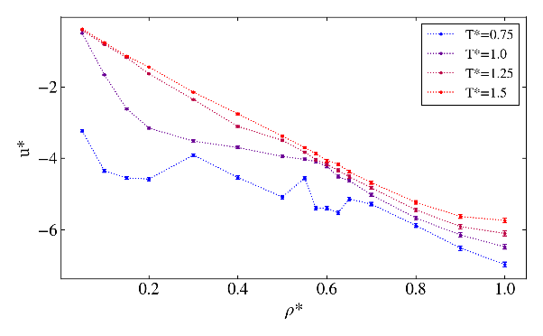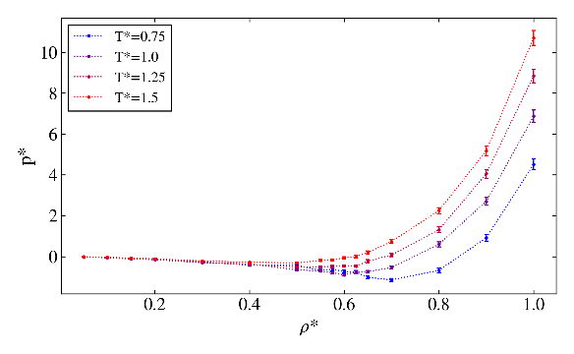

* Physical implications
* Verify code

Systems were simulated at liquid and vapour like densities along isotherms T*=0.85, 0.90. The excess energy per molecule and excess pressure obtained were compared to results published by NIST for those same initial parameters. Figure [] shows the results of this comparison.

* Numerical convergence

Integration step

Plot g(sigma) against MC steps for low, med, high: dens and temp.

* Contribution & innovation

# Conclusion & Abstract

* Succinctly summarise
* Further investigation

# Presentation

* Clearly written
* Graphs, tables, formatting