# Title

# Abstract

# Introduction

Volume fraction: phi

# Method

Metropolis Monte Carlo

Begin with the particles in an ordered FCC lattice within the container.

Conventional periodic boundary conditions are applied.

Apply random perturbations to the system (i.e. random moves to particles). These are applied sequentially to the particles rather than randomly like some other papers.

Is there merit to applying the moves randomly?

Random moves applied until there is no structure remaining.

The amplitude of the random moves is adjusted in this equilibration stage such that 30% to 50% of moves are accepted.

Why do we keep the acceptance between 30% and 50%?

The system is now in an isotropic state.

This isotropic state is verified visually [and my plotting PCF – not indicative of any structure?]

Now apply a larger set of random moves. Samples of the system configuration are taken at a constant interval and the pair correlation function is calculated.

Pair correlation function: $g\left(r\right)=\frac{n_{real}}{n_{ideal}}$

From the pair correlation function, we calculate the configuration energy per particle, u, and the deviation of the system pressure from the ideal gas case.

Configuration energy per particle: $u=2πρ^{2}\sum_{i=1}^{n}{u(r_{i})g\left(r_{i}\right)r_{i}^{2}Δr}$

Pressure: $P-ρkT=-\frac{2π}{3}ρ^{2}\sum_{i=1}^{n}{\frac{∂u\left(r_{i}\right)}{∂r_{i}}g\left(r_{i}\right)r_{i}^{3}Δr}$

# Model

Modelled particles in a box interacting by the Lennard-Jones potential.

Reduced units [put this here or in the introduction?]

Do not make any quantum corrections

The effect of the Lennard-Jones interaction is computed for particles with a radial distance of up to half the length of the container. This truncation is for computational ease.

Should/can any corrections be added to the results? Some papers truncated their interaction at 3sigma.

# Results

Show pair distribution functions in various stages. Discuss the interpretations for each of these.

Plot of the configuration energy and the deviation of our system’s pressure from the ideal case (referred to as pressure hereon) as a function of the volume fraction

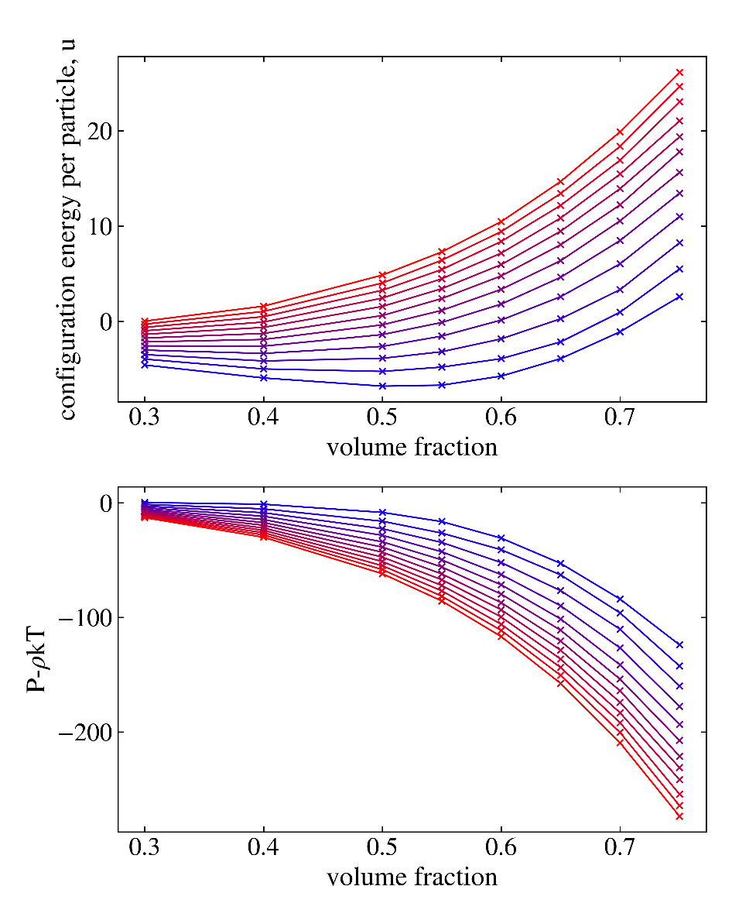

See that pressure decreases with increasing volume fraction. Configuration energy increases for larger isotherms greater than [some value] but for lower isotherms we see the existence of a local minimum at a volume fraction of approximately 0.55.

For which reduced temperatures do we get a local minimum in the configuration energy?

Increasing the temperature of the system causes an increase in the configurational energy and decrease in the pressure. This effect is larger at larger volume fractions.

Analyse this rate of change of configuration energy and pressure with temperature as a function of the volume fraction. Why is the effect more significant at larger volume fractions?

What are the physical interpretations of positive and negative configuration energy and pressure?

Compare our results to equations of state.

Discuss the effect of the bin width on the results.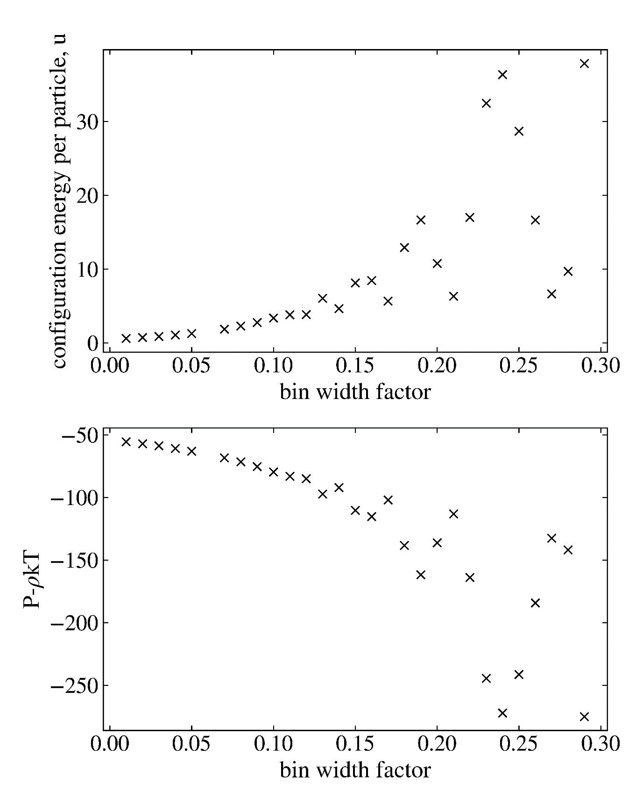

Obviously for continuation limit when we transfer the integral to a sum in computing configuration energy and requires small $Δr$. As visible the bin width influences the final computed values – they vary smoothly up to approximately 0.12 beyond which the effect becomes chaotic.

What bin width was chosen in the end? How are the results impacted? What effect does varying the bin width have on a full set of results across many volume fractions?

# Discussion

# Conclusion