Reading the station ID from NICAM using the MSP34x5G

Werner PE1OBW and David PE1MUD have developed a method to transmit a station ID (CALL) using the additional data bits present in each NICAM frame.
Version 1.4 of the Digital Baseband (see fm-atv.nl) is capable of transmitting the first eight characters of the “MSG” field—originally intended for CW identification on FM channels—as a station ID through these additional data bits.
The NICAM specifications reads:
4.2.3 Additional Data (AD)
Eleven additional data bits AD0 to AD10 (see figure 1) are reserved for future applications yet to be defined.
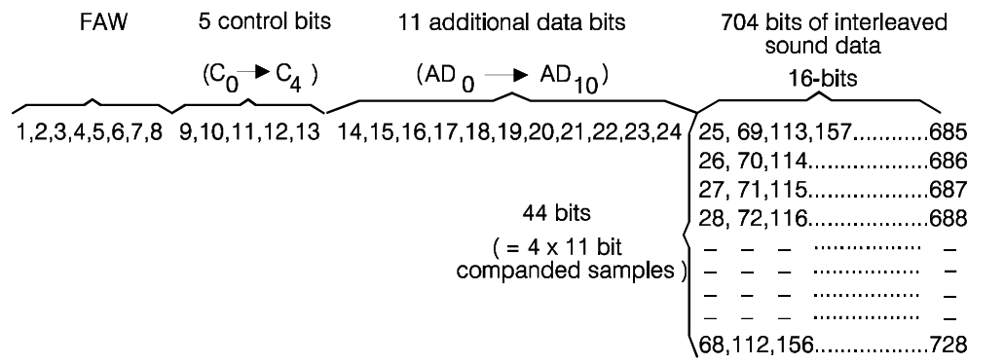

The MSP34x5G series of NICAM decoders from Micronas provides registers that allow access to the additional data via the I²C interface.
Register C_AD_BITS (0x0023) holds the three least significant bits (LSBs) of the additional data, while ADD_BITS (0x0038) contains the most significant bits (MSBs).
In the Digital Baseband, the LSBs are used to indicate the character position (0..7), and the MSBs encode the character itself.
Because access to the additional data occurs via I²C, there are some practical limitations. I²C reads are not fast enough to capture every NICAM frame, and since two separate registers must be read, the retrieved data may originate from different frames.
Furthermore, unlike the interleaved audio data, the additional data bits are not protected by parity.
Both of these issues are mitigated by a relaxed encoding scheme, in which the data for one character and its position is transmitted over a period of approximately 120 ms. For our 8 characters this means we can read them in approximately 1 second.
This extended timing allows the MSP device to be read multiple times and provides an opportunity for basic error detection and correction.

The following pseudocode enables near-flawless station ID reception, even in transmissions affected by a high bit-error rate:

# While NICAM is synced, continuously read station ID data from NICAM additional data bits
# using the MSP341x (via I²C interface).

Read the position bits # Indicates the character index (0..7)
Read the character # Actual data bits representing one ASCII character
Read the position bits again # Read again to confirm data consistency

# Verify data consistency:
If both position readings are equal:
# This likely means the character and position belong to the same NICAM frame
If the character is printable:
# Accept only valid ASCII characters to reject noise or bit errors
Add the character to the circular buffer[20] for that position
# Each of the 8 positions maintains its own circular buffer

# Repeat this process continuously for all 8 character positions
Repeat continuously
# Ideally, read data 10 times or more per 120ms

# From the accumulated data:
From each circular buffer:
# Select the most frequently received character — the statistically correct one
Determine the character that occurs most frequently
Display it at its corresponding position in the station ID string

# Handle NICAM sync loss:
If NICAM sync is lost for more than two seconds:
# Prevent displaying stale or corrupted data
Clear and reset all circular buffers

