**Kitchen electronics: Heating Sausages**

**Heat up your sausages without a stove.**

* **Take a sausage and stick at both ends of the sausage one metal fork into the meat.**
* **The fork is connected to the electronic dimmer with a wire.  
  ( all together this will form a loop).**
* **Switch on the power**
* **Slowly increase the light with the dimmer**
* **You will see that your sausage is becoming hot.**

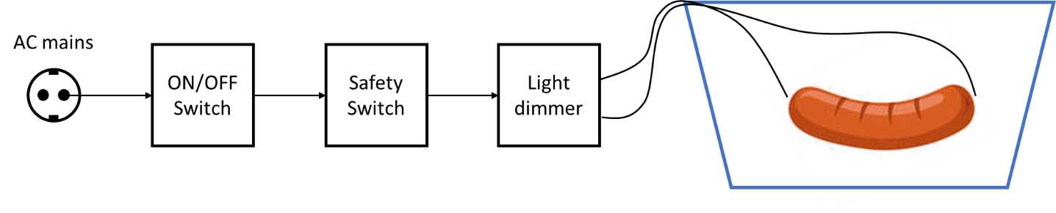

**Please note:**

* **Keep the lid closed when heating the sausage.**
* **The sausage can burst open when heated**