**Kitchen electronics: Microwave experiments**

**Who doesn’t know him? The Swedish chef from the Muppet show. A lunatic in a kitchen doing weird things. Therefore, the activity can also be called “Everything you are not allowed to do by your mother in the microwave”.**

**In this activity the participants, while being supervised, will be allowed to experiment with a Microwave oven.**

**Take one of the materials and put it in the microwave. Turn up the power and see what’s happening.**

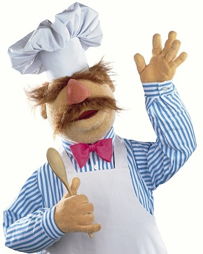**Note: Take care of personal safety and use an old microwave because he can break down.**

**Material to be experimented with:**

* **light bulbs (old type with wire)**
* **fluorescent tube light**
* **Eco-lamps**
* **Apples**
* **Nails**
* **Aluminium foil**
* **Raw eggs (sure?)**
* **Electronic pcb.**
* **Old phones**