**Outdoor Pac Man Instruction card**

**This game will learn to communicate in an efficient way using 2-way radios (walky-talkies).**

**The winner is the team that collected the most cups from the Pac Man playground.**

* **Make 2 teams of 2 persons**
* **Both teams have 2 walky-talkies to communicate**
* **Per team,** 
  + **1 player is blindfolded on the Pac Man playground and has a bucket,**
  + **1 player is at a distance to the Pac Man playground.**
* **The player off the playground, is steering the player in the playground by commands on the walky-talky.**
* **The player in the playground is collecting cups in the bucket.**

**Rules:**

* **You cannot leave the lanes**
* **Don’t cheat with the blindfolds**

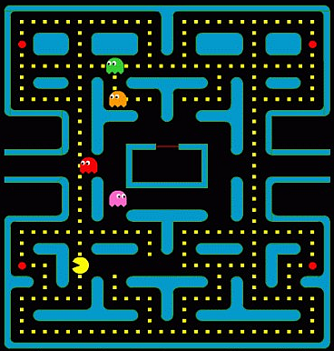**Level of difficulty:**

1. **Both teams use different channels.**
2. **Both teams use the same channel.**