**Radio foxhunt -   
Amateur radio direction finding (ARDF)**

**Instruction card**

**In one of the boxes is a transmitter hidden.**

**Using the direction finder receiver the box can be identified that contains the transmitter.**

**There at two methods to identify the box:**

1. **Signal strength**
2. **Triangulation**

**Signal strength (difficulty = low)**

**You are allowed to get in close proximity of the box.**

**When you get closer to the transmitter the signal will get stronger. The box with the strongest signal will contain the transmitter.**

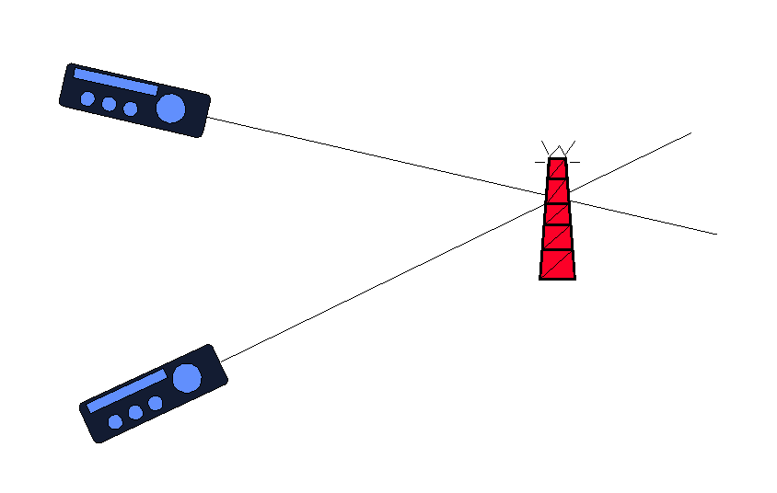**Triangulation (difficulty = high)**

**You are not allowed to get in close proximity of the box.**

**Using the direction sensitivity of the antenna it is possible to determine the direction from which the signal is received.**