**Clap-light Instruction card**

**Solder your own electronics kit: The clap-light.**

**The clap-light is a lamp that can be controlled by clapping in your hands. When laying in your sleeping bag you do not have to get out to switch on the light. Just clap in your hands.**

**The clap-light is sold including a 9V battery**

**Price: kr 550 ( € 5,-)**

**The clap-light can be used with any infra-red remote control.**

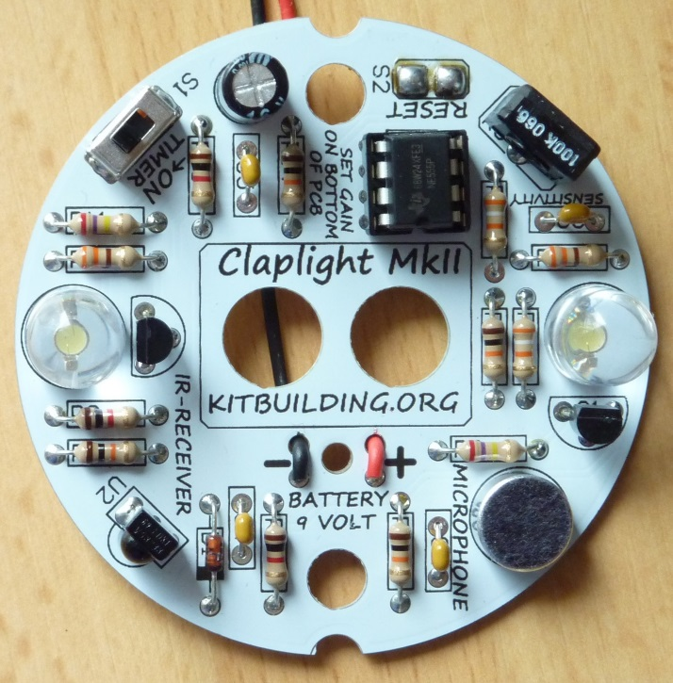

* **Buy a clap-light**
* **Collect the tools**
* **Use the instructions**
* **Solder your kit**
* **Let staff check your soldering**
* **Return your tools and obtain your battery**
* **Test the clap-light**
* **Use it!**