**Component bar Instruction card**

**With this activity, the participant will create figures or jewellery form electronic components from the component bar or which they harvested themselves from old (electronic)equipment.**

**Harvesting components will allow the participant to explore the wondering world of electronic equipment from everyday life.**

**Figure examples:**

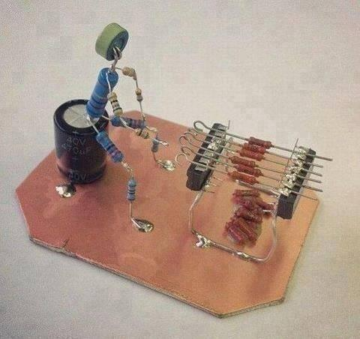 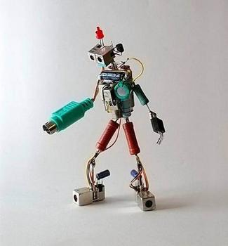 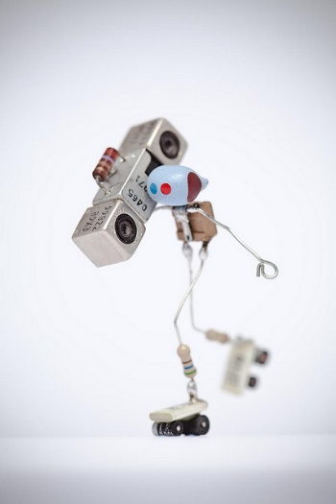 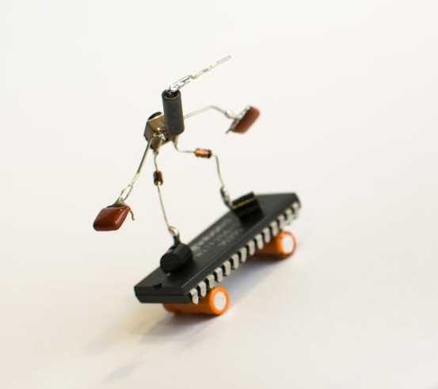 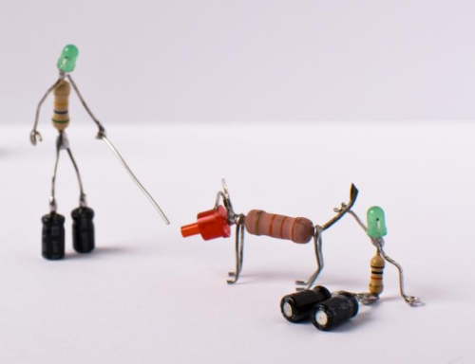

**Jewellery examples:**

