**Milestones Instruction card**

**The object of the game is to place the Scout events in the correct historical order.**

**To do this, place the plates in the correct ascending order next to each other as shown in this picture.**

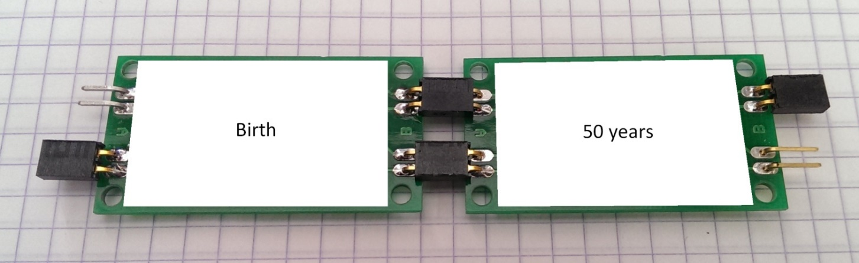

**To verify the solution, a special component has to be connected at each end of the row of plates. If the order of plates is correct, an optical (or acoustic) signal will be seen (or heard).**