# Arduino Rotor Manual V1.0

The PE1MEW Arduino Rotor Controller V1.0 is a program to work as a rotor controller that can be used with any drive unit. The rotor controller is using time as a measure of direction change. Version 1.0 works with drive units from Channel Master, Stolle, Conrad and other similar types.

The PE1MEW Arduino Rotor Controller V1.0 van be used without modification on Arduino boards. For a instruction how to build a PE1MEW Arduino Rotor Controller see the hardware documentation at Github <link>

This manual will describe all functions of the PE1MEW Arduino rotor V1.0.

# License

Creative Commons License

The PE1MEW Arduino Rotor Controller program is licensed under a [Creative Commons Attribution-NonCommercial 4.0 International License](http://creativecommons.org/licenses/by-nc/4.0/) by [PE1MEW](http://pe1mew.nl) E-mail: [pe1mew@pe1mew.nl](mailto:pe1mew@pe1mew.nl)

The program is using Arduino Libraries as provided by Arduino <link> and are unmodified. For the license for these libraries see <link>

The program is using the Adafruit Neopixel library for controlling the Neopixel ring that is used as compass card. The Adafruit Neopixel library is used unmodified. . For the license for these libraries see <link>

## About the manual

This manual is using icons to indicate the priority or type of some information. The used icons are:

|  |  |
| --- | --- |
| http://icons.iconarchive.com/icons/emey87/trainee/48/Signal-attention-icon.png | Attention: Important information about the topic that will affect operation of the Rotor Controller. |
| http://icons.iconarchive.com/icons/kyo-tux/delikate/512/Info-icon.png | Information: Additional information about the topic, not mandatory for the proper functioning of the Rotor Controller. |
|  | Observe: Observe the object mentioned. |

## Definitions

|  |  |
| --- | --- |
| PE1MEW Rotor Controller | The program programmed in the Arduino that offers functions described in this manual |
| Rotor Controller | The box on which the controls are to control the drive unit. |
| Drive Unit | Unit installed outdoor on which the antenna is installed to be aimed. |
|  |  |
|  |  |
|  |  |
|  |  |

## Display

|  |  |
| --- | --- |
| The rotor controller is equipped with a 24 RGB LED compass card. Between two leds the step is 15 degrees. The compass card is oriented North (at the top of the compass card). North is the first LED of the compass card. See Figure 1. | Figure 1: Arduino Rotor Controller Compass card with winds. |
| The Rotor Controller can control rotors that rotate 360 degrees and have their stop at North direction. See Figure 2. | Figure 2: Arduino Rotor Controller rotation capability |

## Controls

The PE1MEW Rotor Controller is using 2 buttons to control all functionalities. Instructions can be given by press a button at a time or by pressing both buttons at the same time.

In this manual Instructions are identified using the following icons:

Button-actions are visualized using a button with a hand where the number of buttons pressed is shown.

|  |  |  |  |
| --- | --- | --- | --- |
| Figure 3: No buttons | Figure 4: Button 1 | Figure 5: Button 2 | Figure 6: Buttons (1&2) |

To allow specific functions Powering the Rotor Controller can be required. A comined action of powering the Rotor Controller and pressing button(s) is visualised using 2 icons.

|  |  |  |
| --- | --- | --- |
| Figure : Connect power |  | Figure : Combine action powering and pressing buttons |

## Starting PE1MEW Rotor Controller

The rotor controller can operate in 4 modes:

1. Normal operation
2. Set brightness
3. Synchronize
4. Test and calibration

When powered the Rotor Controller will test the status of the buttons to select the mode of operation.

|  |  |
| --- | --- |
|  | No buttons are pressed at power-up.  The Rotor Controller goes in to normal operation. In this mode the Rotor controller will control the drive unit. |
|  | Button 1 is pressed at power-up.  The Rotor Controller goes in to “set brightness” operation. In this mode the illumination of the LED compass card can be set. |
|  | Button 2 is pressed at power-up.  The Rotor controller will synchronize the Rotor Controller with the Rotor. |
|  | Both button 1 and 2 are pressed at power-up.  The Rotor Controller goes in to “test and Calibration mode“. In this mode the all hardware can be tested, Rotor Controller and Drive unit can be synchronized, and turn-time to rotate 360 degrees can be calibrated. |

# Normal Operation (Mode 0)

This is normal operation of the PE1MEW Rotor Controller.

|  |  |
| --- | --- |
|  | Normal operation is started when no buttons are pressed at start-up. |

Entering normal operation, the Rotor Controller will display the actual direction of the drive unit. The actual antenna direction is read from memory and is the last known antenna direction before the Rotor Controller is powered-off.

|  |  |
| --- | --- |
| http://icons.iconarchive.com/icons/emey87/trainee/48/Signal-attention-icon.png | In the case that the direction read from memory is not the same as the actual antenna direction, Synchronization can be obtained by performing  Test 4: , from the Test and Calibration Mode. |

The leds can show three colors:

* Green: The green led indication shows the current antenna direction and that the drive unit is not running.
* Blue: The blue led shows the direction to which the drive unit shall turn.
* Red: The red led shows the actual direction of the drive unit while the rotor is running. The Drive unit turns to the set direction.

### Controlling the direction of the antenna

Controlling the antenna direction is done using the two buttons on the Rotor Controller.

|  |  |
| --- | --- |
|  | To rotate the drive unit Counter Clock Wise (CCW) to 360 degrees,  press button 1. |
|  | To rotate the drive unit Clock Wise (CW) to 0 degrees,  press button 2. |
|  | When no buttons are pressed direction is not changed |
|  | Pressing two buttons has no effect.  When two buttons are pressed direction is not changed |

### Rotor controller is IDLE

When the drive unit is in the direction set, the rotor is stopped. This is indicated with a green LED in the direction of the antenna.

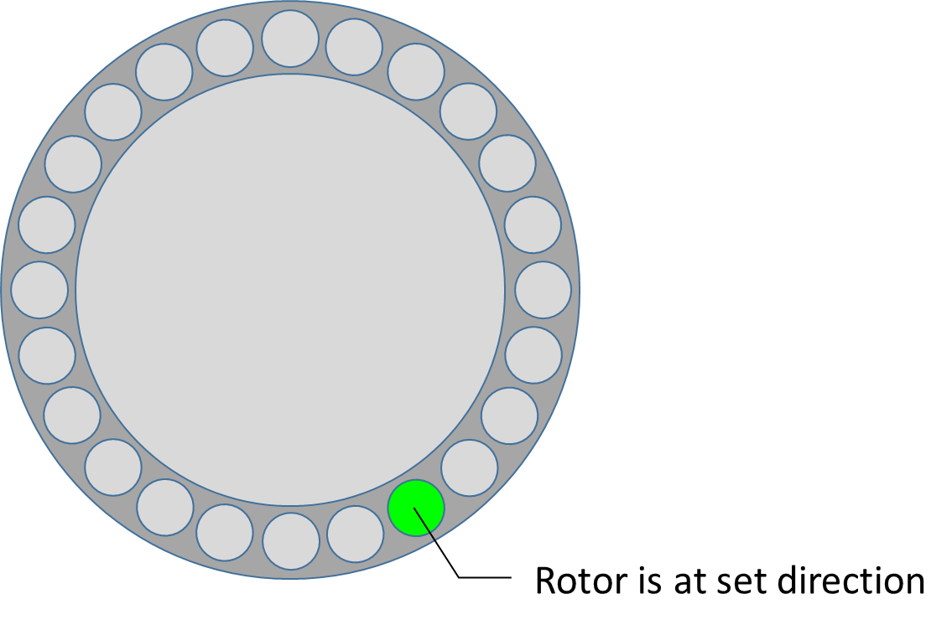

Figure : Actual antenna direction, rotor is not running.

### Aiming the antenna in a direction

|  |  |
| --- | --- |
|  | While pressing button 2 the Rotor Controller direction (blue led) will change direction Counter Clock Wise.  Immediately the Rotor Controller will detect that the Rotor is not correctly aimed and start rotating the antenna in the direction indicated by the blue led. |

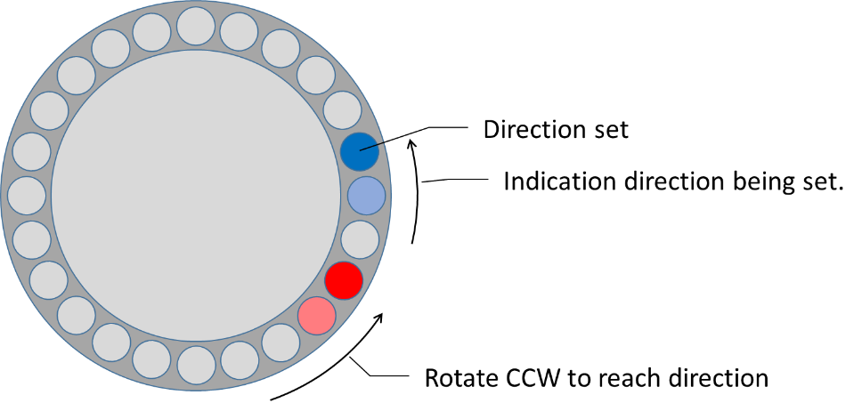

Figure : Setting direction (blue) and rotating (red)

|  |  |
| --- | --- |
|  | When the direction to which the antenna shall be aimed button 1 is released.  The Rotor Controller will continue to turn the antenna until the wanted direction is reached. See Figure 11. |

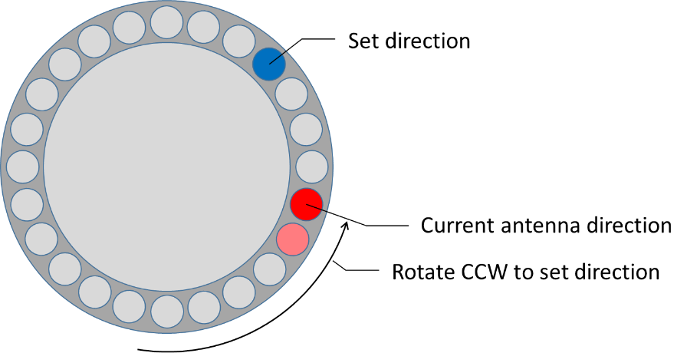

Figure : Rotor Controller turning antenna to wanted direction.

When the Antenna reaches the wanted direction the Rotor is stopped while the led is indicates that the rotor has stopped. See Figure 12.

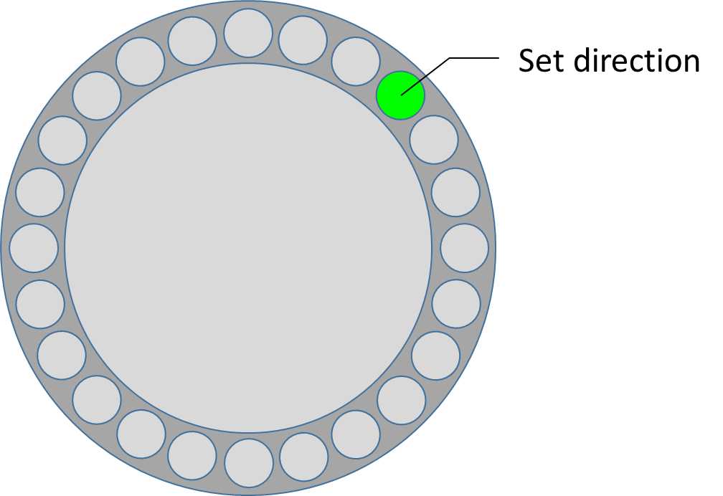

Figure : Rotor Controller IDLE Rotor direction is equal set direction

# Test and configuration modes

## Mode 1: Set Brightness

|  |  |
| --- | --- |
|  | Set Brightness mode is entered when button 1 is pressed when the Rotor Controller is powered. |

In this mode brightness of the LED display can be configured. Led 1 of the Compass card will be white and the brightness can be set from 0 to 255 using button 1. When the end is reached (255), the setting will continue at 0 and cycle.

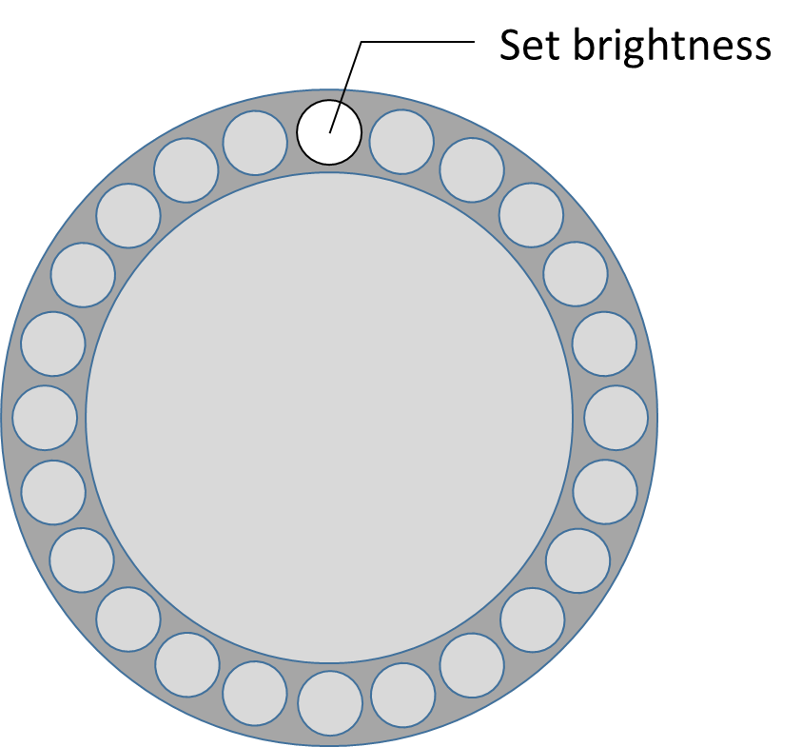

Figure 13: Setting brightness mode.

When Brightness setting mode is ended the new brightness setting is stored in memory.

|  |  |
| --- | --- |
|  | To change brightness press button 1. |
|  | To end brightness setting and store value in memory, press buttons. |

## Mode 2: Rotor Controller and Rotor synchronization

A counter clockwise movement is performed to synchronize the rotor Controller with the drive unit for proper operation. Synchronization takes slightly over one minute.

After severe storms, or an extended period of use, the rotator may appear to position the antenna incorrectly. First try to re-synchronize the system. If this fails, the antenna or drive motor may be misaligned on the mast.

|  |  |
| --- | --- |
|  | Rotor synchronization is started when button 2 is pressed when the Rotor Controller is Powered. |

Immediately after switching to Rotor Controller and Rotor synchronization mode the Rotor Controller will perform the following actions:

1. Rotate the rotor North (0 degrees) Counter Clock Wise
2. Wait for confirmation by the user (e.g. Press button 1)
3. Rotate the rotor North (360 degrees) Clock Wise
4. Return to normal operation.

These steps are visualised in Figure 14.

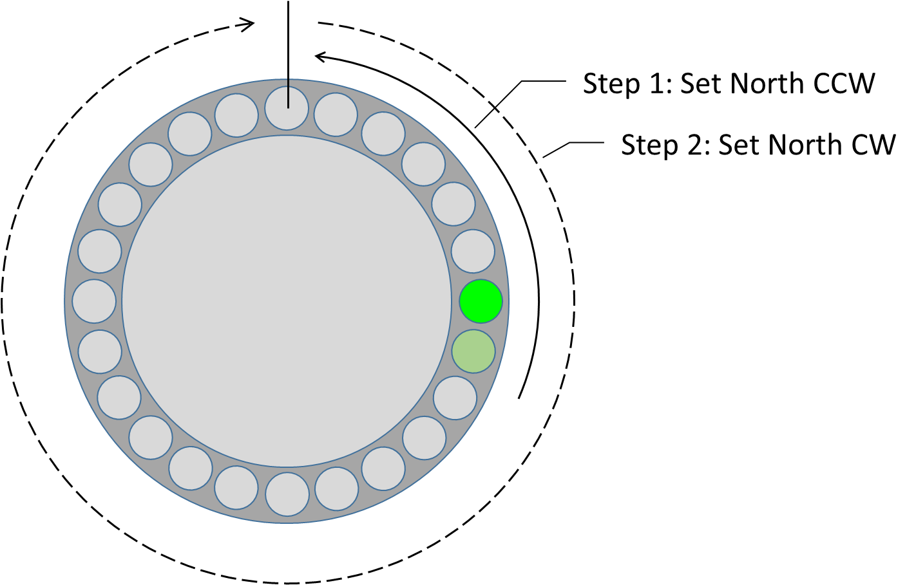

Figure 14: 2 steps of Rotor synchronization.:

When finished the Rotor Controller will start Normal Operation.

|  |  |
| --- | --- |
|  | To Abort Rotor Synchronization at step 1, press both buttons. |

## Mode 4: Test and calibration mode

Test and calibration mode is used to test all hardware of the Arduino Rotor Controller.

|  |  |
| --- | --- |
|  | To enter Test and calibration mode, press button 1 and 2 at power-up.  To indicate that Test and Calibration mode is active the Compass card will show a blue led at North. |

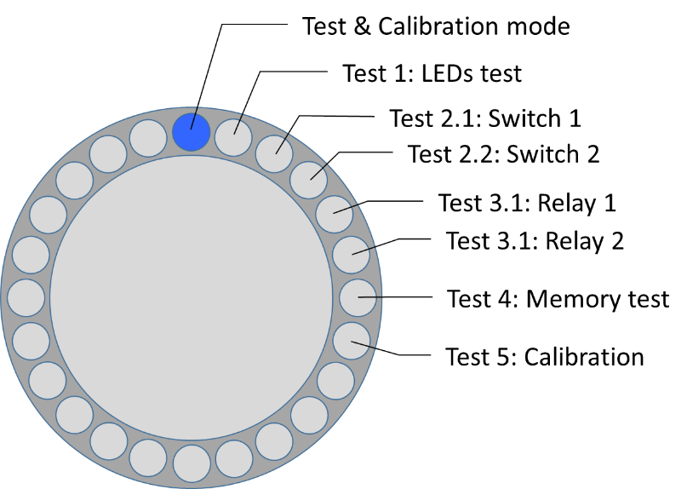

Figure : Test and calibration modes

In test and calibration mode all parts of the Arduino rotor Controller hardware is tested. The following test are performed:

1. LED test
2. Switch (button) test
   1. Switch 1
   2. Switch 2
3. Relay test
   1. Relay 1
   2. Relay 2
4. Memory test
5. Calibration of rotor timing.

### Test 1: All leds

Immediately after starting test and calibration mode test 1 will is the first test. This test requires user operation to perform the tests.

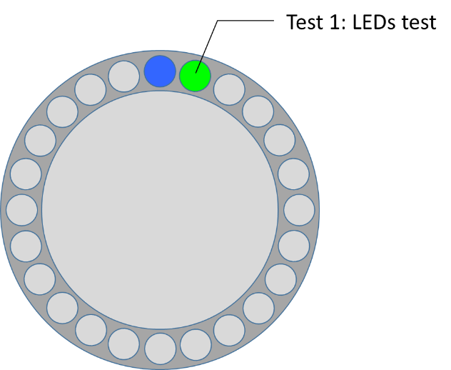

Figure : Test and calibration mode test 1

|  |  |
| --- | --- |
|  | In this test the Compass card shall displaying a moving rainbow. All leds shall color.  To start test 1 press button 1. |

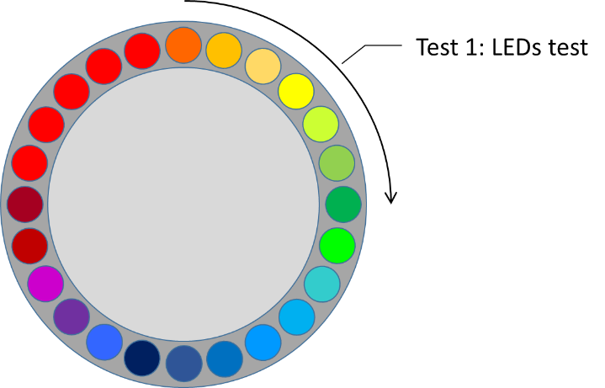

Figure : Rainbow example

|  |  |
| --- | --- |
|  | Pressing two buttons ends test 1 and start switch testing. |

### Test 2: Switch test

When entering test 2 led 3 and 4 will be blue. This test requires user operation to perform the tests.

|  |  |  |
| --- | --- | --- |
|  | | Test 2.1: Switch 1. When switch 1 (button 1) is pressed led 3 will be green. When the switch is released led 3 will be blue. |
|  | | Test 2.2 Switch 2. When switch 2 (button 2) is pressed led 4 will be green. When the switch is released led 3 will be blue. |
| http://icons.iconarchive.com/icons/emey87/trainee/48/Signal-attention-icon.png | During test 1, both buttons cannot be pressed at the same time to light both leds. This will be interpreted as a command for the test mode. | |

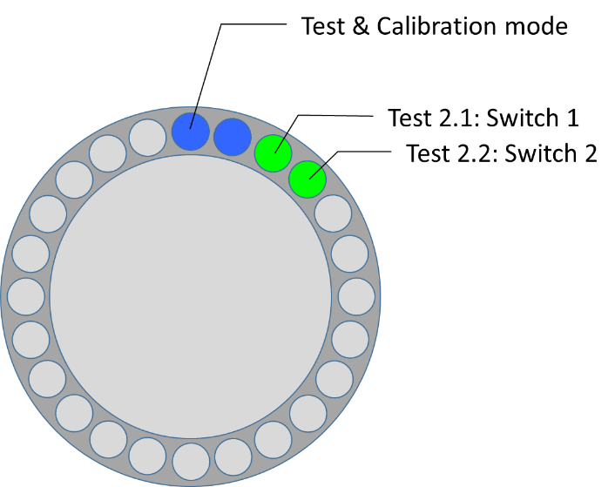

Figure : Leds indicating switch 1 and 2.

|  |  |  |
| --- | --- | --- |
|  | | Pressing two buttons ends test 2 and start the next test. |
| http://icons.iconarchive.com/icons/emey87/trainee/48/Signal-attention-icon.png | Ending the test can only be done when one of the two switches was previously pressed. | |

### Test 3: Relay test

When entering test 3 led 5 and 6 will be blue. This test requires user operation to perform the tests.

|  |  |  |
| --- | --- | --- |
|  | | Test 3.1: relay 1: When button 1 is pressed relay 1 will be activated. When button 1 is released relay 1 will release. Synchronous with the activation and release of relay 1, led 5 will be green or blue. |
|  | | Test 3.2: relay 2: When button 2 is pressed relay 2 will be activated. When button 2 is released relay 2 will release. Synchronous with the activation and release of relay 2, led 6 will be green or blue. |
| http://icons.iconarchive.com/icons/emey87/trainee/48/Signal-attention-icon.png | During test 2, both buttons cannot be pressed at the same time to light both leds. This will be interpreted as a command for the test mode. | |

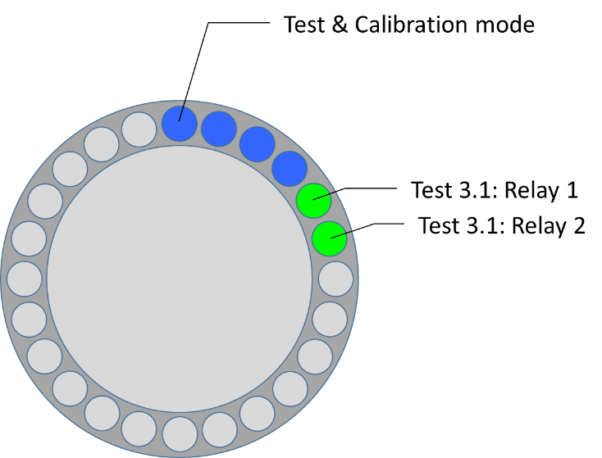

Figure : Leds indicating relay 1 and 2.

|  |  |  |
| --- | --- | --- |
|  | | Pressing two buttons ends test 2 and start the next test. |
| http://icons.iconarchive.com/icons/emey87/trainee/48/Signal-attention-icon.png | Ending the test can only be done when one of the two switches was previously pressed. | |

### Test 4: Memory

When entering test 4 led 7 will be blue. This test is automated. It requires no user operation to perform the tests.

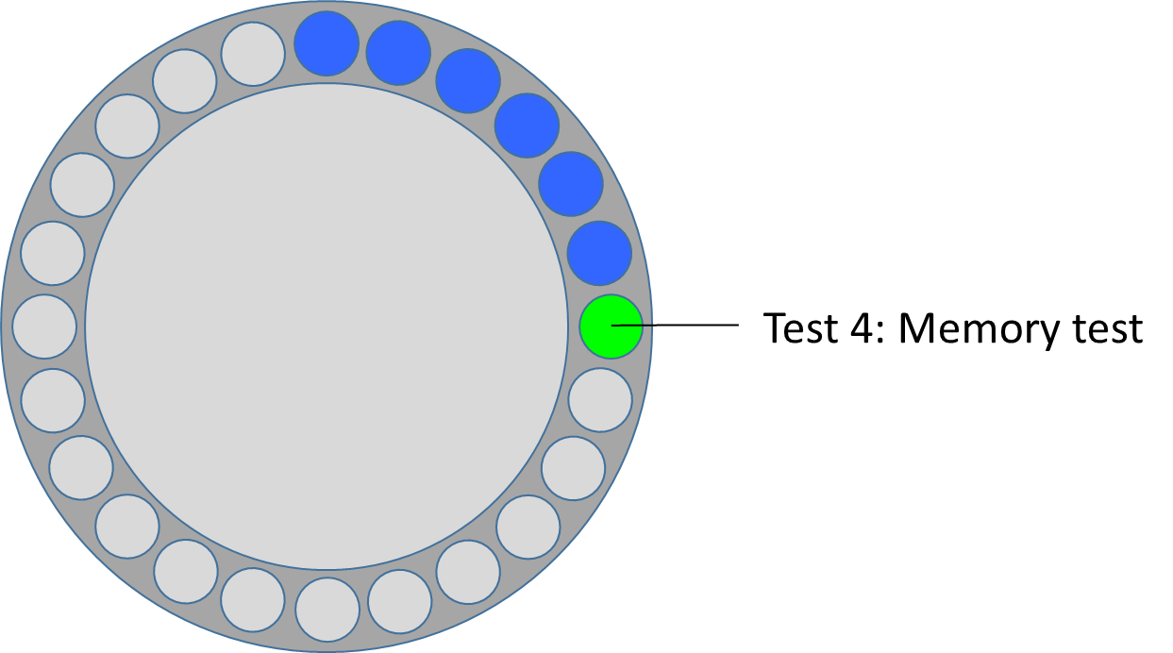

Figure : Led 7 memory test

|  |  |
| --- | --- |
|  | Press button 1 to start test 4 |

Memory operation will be verified. The following steps are executed:

1. Current memory will be read and stored temporary.
2. Memory will be written with ones and verified. If this action fails led 7 will be red.
3. Original memory values are written back in memory and verified. If this action fails led 7 will be red.
4. When all three actions are successful, led 7 will be green. When led 7 turns red the test is failed.

|  |  |
| --- | --- |
| http://icons.iconarchive.com/icons/emey87/trainee/48/Signal-attention-icon.png | When memory test fails the EEProm of the microprocessor is defect. This can be solved by either changing the address of the used EEProm memory to another address or replace the microprocessor or Arduino board. |

|  |  |  |
| --- | --- | --- |
|  | | Pressing two buttons ends test 2 and start the next test. |
| http://icons.iconarchive.com/icons/emey87/trainee/48/Signal-attention-icon.png | Ending the test can only be done when one of the two switches was previously pressed. | |

### Test 5: Calibration

When entering test 5 led 8 will be blue. The calibration of the Rotor Controller requires user operation.

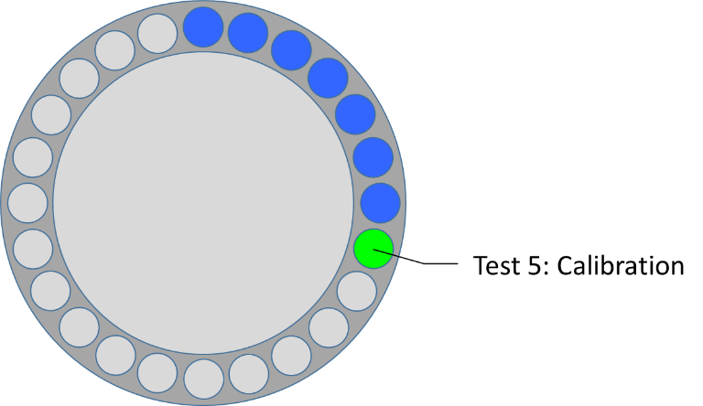

Figure : Led 7 memory test

Calibration is required when the Rotor Controller is used for the first time. As the initial setting of the Rotor Controller is 1 minute for 360 degrees, this might not fit the drive unit connected tot he Rotor Controller.

|  |  |
| --- | --- |
| http://icons.iconarchive.com/icons/emey87/trainee/48/Signal-attention-icon.png | For this test visual inspection of the drive unit and control of the buttons at the same time is mandatory. |

To calibrate the Rotor Controller, the following steps are executed:

1. Manually rotate the antenna to 360 degrees(North)
2. Measure time to rotate fully from 360 to 0 degrees (North to North over South)
3. Stop measurement when 0 degrees is reached and antenna rotation stops.

|  |  |
| --- | --- |
| http://icons.iconarchive.com/icons/kyo-tux/delikate/512/Info-icon.png | The calibration process can be aborted without affecting the calibration settings.  To about the calibration process, power-off an –on the Rotor Controller. |

The aim of step 1 is to set the drive unit completely CW in the North direction. This has to be done manually as calibration is required. Therefore the timing of the Rotor Controller is set to maximum. This will result in a slow moving red actual direction indicator while the drive unit is turning faster.

|  |  |
| --- | --- |
|  | Press button 1 to start calibration.  The drive unit starts turning CW. |

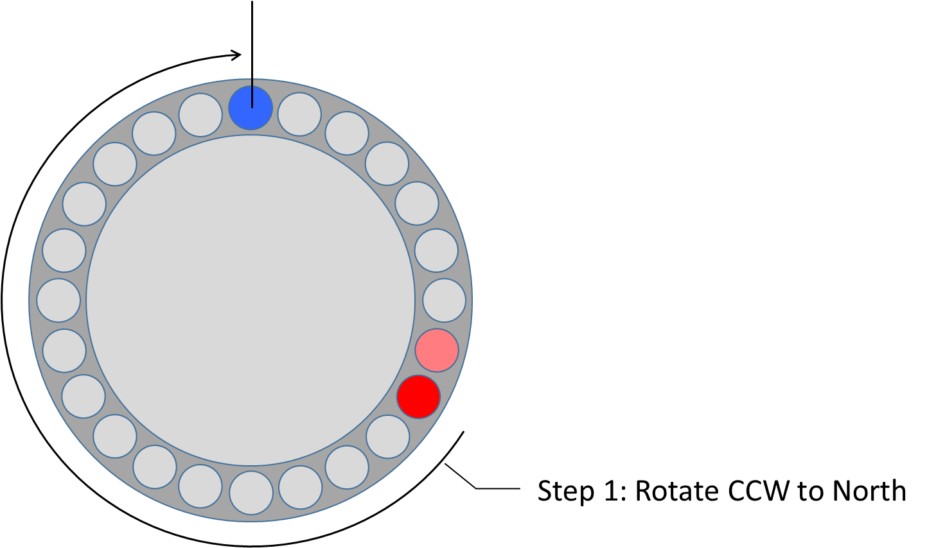

Figure : Rotor Controller indication Antenna is turning CW.

|  |  |  |
| --- | --- | --- |
|  | Observe the antenna rotation. The antenna shall turn to North over South westbound. When the antenna stops the rotor is at its end position. | |
| http://icons.iconarchive.com/icons/emey87/trainee/48/Signal-attention-icon.png | To prevent damage to the drive unit keep the time at which the drive unit is at its stop while the motor is running a short as possible. | |
|  | | When the antenna stops turning CW: press button 2.  Now the drive unit is ready the timing measurement will start automatically. |

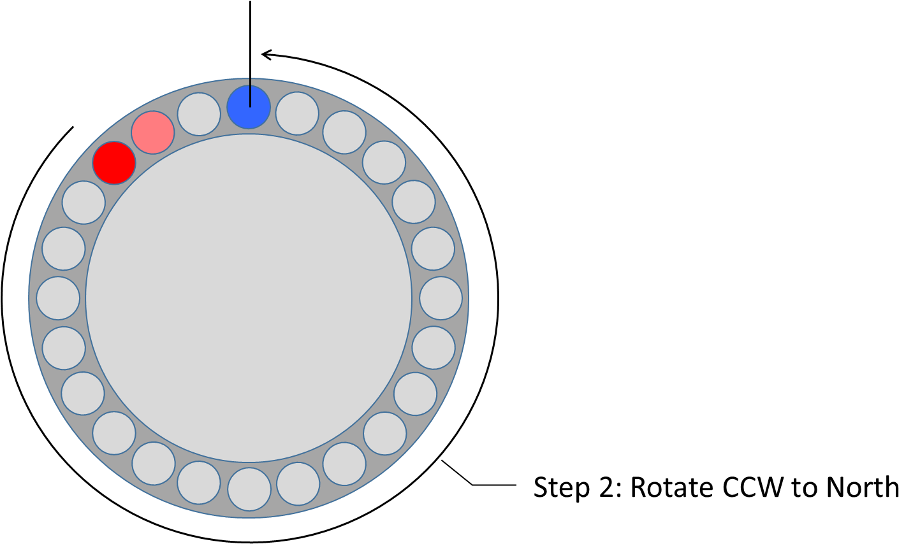

Figure : Rotor Controller indication Antenna is turning CCW.

|  |  |  |
| --- | --- | --- |
|  | Observe the antenna rotation. The antenna shall turn to North over South eastbound.  When the antenna stops the rotor is at its end position. | |
| http://icons.iconarchive.com/icons/emey87/trainee/48/Signal-attention-icon.png | To prevent damage to the drive unit keep the time at which the drive unit is at its stop while the motor is running a short as possible. | |
|  | | When the antenna stops turning CCW: press button 1.  Now the drive unit is ready the timing measurement will stop.  The green led will indicate that the measurement is ended. |

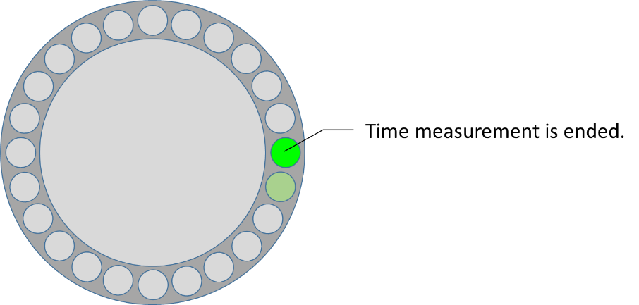

Figure : Rotor Controller indication timing measurement is ended.

|  |  |  |
| --- | --- | --- |
| http://icons.iconarchive.com/icons/kyo-tux/delikate/512/Info-icon.png | Until this moment calibration values are not altered. Aborting calibration will not affect calibration values. | |
|  | | Pressing two buttons ends will store timing measurement in memory.  The Rotor Controller returns to normal operation with new calibration values. |

### Test overview

This table can be used as a ckecklist when running tests on the PE1MEW Arduino Rotor Controller.

|  |  |  |
| --- | --- | --- |
| Test | Expected operation | Fail / Pass |
| 1 | Pass when a moving rainbow is displayed on the comps card is displayed |  |
| 2.1 | Pass when pressing button 1 will toggle led 3 |  |
| 2.2 | Pass when pressing button 2 will toggle led 4 |  |
| 3.1 | Pass when pressing button 1 will activate relay 1 |  |
| 3.2 | Pass when pressing button 2 will activate relay 2 |  |
| 4 | Pass when led 5 will show green, fail when led 6 shows red |  |
| 5 | No fail-pass condition | xxxxxxxxxxxxx |