# PE1MEW TTN Mapper node V1.0 – Quick Reference Card

**Front view:**

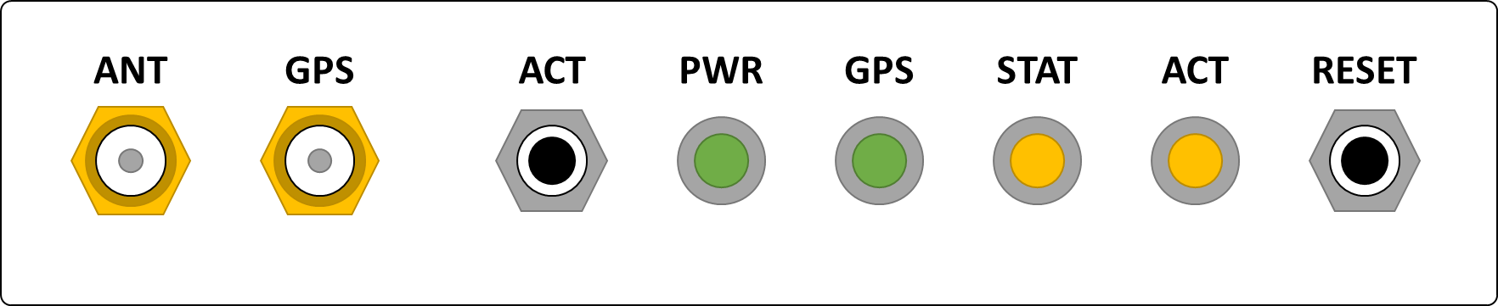

|  |  |
| --- | --- |
| **LED – indication:** | **Meaning:** |
|  | Power: LED is off = Operation failed. The microprocessor has no power. External or internal power failure. |
|  | Power: LED is on = Normal operation. |
|  |  |
|  | GPS: LED is off = No GPS data. Operation failed.  The microprocessor does not receive data from the GPS. |
|  | GPS: LED is blinking slowly = GPS data received. Operation inhibited.  The microprocessor does receive data from the GPS but GPS has no FIX. |
|  | GPS: LED is on = GPS has FIX. Normal operation.  The microprocessor does receive valid data from the GPS. |
|  |  |
|  | Status: LED is off = No information. Normal operation. |
|  | Status: LED is on = Node is within geo-fence. Operation inhibited.  Transmissions are inhibited. Manual override allowed. |
|  |  |
|  | Activity: LED is off = No transmission. Normal operation. |
|  | Activity: LED is on = Transmission active. Normal operation. |
|  | GPS: LED is blinking rapidly = Radio configuration failed. Operation failed. |
|  |  |
|  | RESET: Resets the node. |
|  | ACT: Press ACT-button > 6 seconds during “Geo-fence” will initiate one transmission. Immediately the ACT-led will indicate a transmission. |

# PE1MEW TTN Mapper node V1.0 – Quick Reference Card

**Operation:**

|  |  |
| --- | --- |
|  | Powering: After applying power to the PE1MEW TTN Mapper initialisation will start and finish with all leds switched on to indicate proper functioning. After the led test the GPS led will start blinking to indicate reception of GPS data. When the GPS has a FIX the GPS led will be on and normal operation will start. |
|  | Transmissions are continuously with a 3 second delay between transmissions. A transmission is indicated with the ACT-led temporary switched on. |
|  | When the node is within a geo-fence the STAT-led is on. In a geo-fence transmissions are inhibited. |
|  | While within a geo-fence a transmission can be initiated by pressing the ACT-button more than 6 seconds. |

**Installation:**

|  |  |
| --- | --- |
|  | The PE1MEW TTN Mapper node requires a 12V DC power supply. 12V connection is through the wire at the back of the node. |
| http://icons.iconarchive.com/icons/emey87/trainee/48/Signal-attention-icon.png | Voltages between 12 and 40 Volts are allowed.  Polarity shall be observed. |
|  |  |
|  | Reverse-SMA connector. Antenna shall be for usage at 868 MHz. |
|  | SMA connector. GPS antenna shall be equipped with preamplifier. |
| http://icons.iconarchive.com/icons/emey87/trainee/48/Signal-attention-icon.png | The GPS antenna connector carries 5 V DC and shall be prevented form short circuit situations. |