HEALTH TERMS AND DEFINITIONS
TERM | DEFINITION | COMMENTS
Acute | Short term, with extreme symptoms | Acute disease lasts is brief but develops quickly, with marked signs such as fever and pains (acute appendicitis)
Chronic | Long-term, developing gradually with lesser symptoms, usually causing more permanent damage | Chronic disease involves intermittent acute episodes eg. Rheumatoid arthritis
Communicable | Infections that can be spread from one person to another | Eg. measles, flu, HIV, COVID-19
Comorbidities | Two or more co-existing but unrelated medical conditions | Most COVID-19 deaths are often associated with having other comorbidities such as hypertension or diabetes
Complications | New additional (secondary) problems arising after original disease begins | Hypertensive patient develops diabetes as a complication
Diagnosis and tests | Identification of a specific disease via evaluation of signs and symptoms | Laboratory tests and other tools are used to verify several factors to confirm diagnosis
Disease risk | The product of the probability of a disease event happening and the magnitude of its impact | Unprotected sex, injecting drugs puts one at risk of HIV disease infection
Drivers | Social, economic or physical factors that affect disease outcomes, either by changing the behaviour of disease ‘sources’ or ‘pathways’, or by acting directly on ‘outcomes’ | Poverty, human behaviour, lifestyle and environment can be drivers of disease
Disease sources | Phenomena or biological events that: give rise to potential new diseases; enable existing diseases to become more harmful; enable existing diseases to infect new hosts; or enable existing diseases to spread to new areas | Malaria parasite is hosted by the Anopheles mosquito
Disease pathways | Mechanisms or routes by which a disease organism can transfer from one host to another, within or between species | Disease can spread from saliva to hand to mouth. HIV spreads through bodily fluids.
Epidemic | Outbreaks of disease within a given area, with many cases of disease | HIV commenced as an epidemic
Epidemiology | The science of transmission, occurrence and distribution of disease | This helps in understanding risk factors, drivers and patterns of disease
Etiology | The causative factors of disease; when the cause is unknown it is termed as idiopathic, if treatment, procedure of error is responsible it is termed as iatrogenic | Etiologic agents include congenital defects, genetic or inherited disorders, viruses, bacteria, immune dysfunction, metabolic..etc
Latent | An initial ‘silent’ disease stage in which no clinical signs are evident | May be referred to as the incubation period
Lesion | A specific change in tissue that may be microscopic or highly visible | Blisters or pimples on the skin
Manifestation | Clinical signs and evidence and symptoms of disease | Redness, swellings, fever
Morbidity | Disease rates within a group | Functional impairment that certain conditions cause upon the population
Mortality | Indicates the relative number of deaths from a particular disease | Mortality rates of Malaria and cancer are higher compared to other diseases
Occurrence | Disease occurrence is tracked by its incidence (number of new infections) and prevalence (number of existing infections) | Prevalence is always higher than its incidence
Onset | The spread of development disease, which may be sudden and obvious (acute) or insidious, with gradual progression and vague or mild symptoms | Eg. Gastroenteritis onset may be described as acute and Hepatitis onset may be described as insidious
Outcomes | Plants and animals at the individual, community and ecosystem or farming system level, and humans at individual and societal levels that are affected by infectious diseases.
Pathogenesis | Development of disease | Also refers to the sequence of events involved in tissue changes associated with disease progression
Precipitating factors | Conditions that trigger acute episodes | Eg. high cholesterol diet may predispose a patient to angina but the actual angina attack is precipitated by extreme physical activity
Predisposing factors | Factors which make a person vulnerable to disease. Prevention is closely linked to predisposing factors and etiology | Eg. exposure to cigarette smoke or asbestos is a predisposing factor to cancer
Prodromal | The time of early disease development when a patient is aware of a non-specific change in the body | Eg. fatigue, headache, loss of appetite
Prognosis | The probability/likelihood of recovery or other outcomes | Averages are used to determine probability figures used in prognosis of disease
Recovery | Period of recuperation and return to normal
Remissions | Subsiding disease symptoms | They say one doesn’t recover from Cancer, one is always in remission
Sequelae | Potential unwanted outcomes of a primary condition | Eg. paralysis after recovery from a stroke
Signs | Objective indicators of disease that are obvious to others | Eg. fever or skin rash
Subacute | A state that is neither acute nor chronic, having a rather recent onset or relatively rapid change | Eg. subacute bacterial endocarditis, in which the conditions worsens before its fatal
Subclinical | A state of existing in some other pathologic conditions wherein no obvious manifestations occur | Eg. kidney damage progressing to renal failure before any signs manifest
Syndrome | A collections of signs and symptoms occurring together | Usually occurs in response to a certain condition
Therapy | Therapeutic interventions or treatment measures to promote recovery or slow progress of disease | Eg. drugs, surgery, behaviour change or phsiotherapy
World Health Organisation and CDC

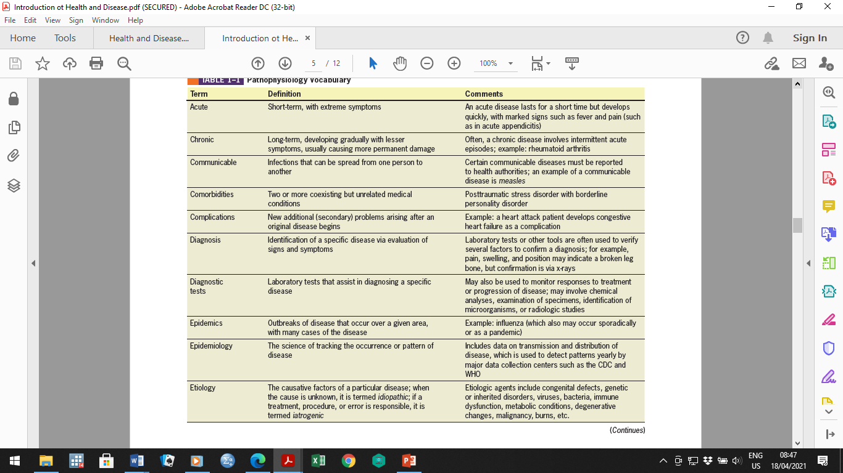

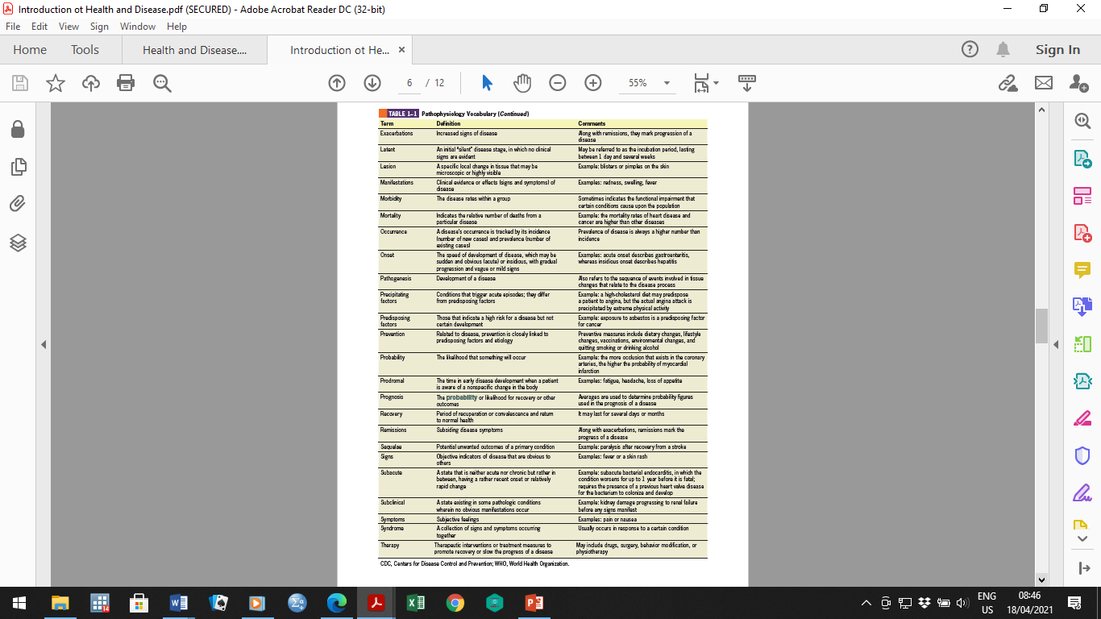

(Please note that your participation in these forums may contribute to 5% of your overall marks)

