**FEDERAL UNIVERSITY, NDUFU ALIKE, IKWO**

**STUDENTS’ INDUSTRIAL WORK EXPERIENCE SCHEME (SIWES)**

**A REPORT OF SIX (6) MONTHS INDUSTRIAL WORK EXPERIENCE AT PROJECTS**

**DEVELOPMENT INSTITUTE (PROUD), ENUGU (FEDERAL MINISTRY OF SCIENCE AND TECHNOLOGY)**

**BY**

**EKEH ONYINYECHI NENE**

**REGISTRATION NUMBER**

**FUNAI/BA/14/0902**

**DEPARTMENT: FINE AND APPLIED ARTS**

**COURSE TITLE: SIWES**

**COURSE CODE: FAA 322**

**IN PARTIAL FULFILLMENT FOR THE AWARD OF A BACHELOR OF ART DEGREE (B.A) IN FINE AND APPLIED ART**

**OCTOBER, 2017**

DEDICATION

To the almighty God and everyone who have in one way or the other cared for me during my industrial training.

ACKNOWLEDGEMENT

I express my profound gratitude to all who contributed in various dimensions during this industrial training.

Especially my supervisor. Mr Echim. For his good act of supervision. I sincerely wish to thank Mr Mark Abuh for his willingness to assist in checking and correcting me.

I also wish to express my gratitude to Philip Chima for his faithful advice, my gratitude also goes to the Head of department for his concern and effort about our industrial training.

A special thanks goes to Mrs Emelogu Chinenye who have always called to know if am doing fine and to Justin Okpala for his assistance financially and other wise.

Thanks to my Mum, Aunty and uncle for their prayers advice and financially. May the almighty God reward everyone in abundance.

Amen!

PREFACE

I did my industrial training at project development Institute (PROUD) at their basic and ceramic production department. PRODA make use of P. O. P molds this enable them to mass produce there works through the method of slip cast. They also make the molds themselves. PRODA is a research Institute so most students get their project works to be worked on.

They run test on clay to know the plasticity, strength and shrinkage ability. The process of doing these have been reported, the works produced have also been analyzed and discussed.

0.0 INTRODUCTION The students Industrial Work Experience Scheme (SIWES) is a

Skills Training Programme designed to expose and prepare students of

Universities, Polytechnics/Colleges of Technology/Colleges of Agriculture and Colleges of Education for the Industrial Work situation they are likely to meet after graduation. The scheme also affords students the opportunity of familiarizing and exposing themselves to the needed experience in handling equipment and machinery that are usually not available in their Institutions. Before the establishment of the scheme, there was a growing concern among our Industrialists that graduates of our Institutions of Higher learning lacked adequate practical background studies preparatory for employment in Industries. Thus, the employers were of the opinion that the theoretical education going on in higher institutions was not responsive to the needs of the employers of labour. It is against this background that the rationale for initiating and designing the scheme by the Fund during its formative years – 1973/74 was introduced to acquaint students with the skills of handling employers’ equipment and machinery. The ITF solely funded the scheme during its formative years. But as the financial involvement became unbearable to the Fund, it withdrew from the Scheme in 1978. The Federal Government handed over the scheme in 1979 to both the

National Universities Commission (NUC) and the National Board for Technical Education (NBTE). Later the Federal Government in November 1984 reverted the management and implementation of the SIWES Programme to ITF and it was effectively taken over by the Industrial Training Fund in July 1985 with the funding being solely borne by the Federal Government.

1.0 OBJECTIVE OF SIWES Specifically, the objectives of the Students Industrial Work Experience Scheme (SIWES) are to: a) Provide an avenue for students in institutions of higher learning to acquire industrial skills and experience in their course of study, which are restricted to Engineering and Technology including Environmental studies and other courses that may be approved. Courses of NCE (Technical), NCE Agriculture, NCE (Business), NCE (Fine and Applied Arts) and NCE (Home Economics) in Colleges of Education are also included.

b) Prepare students for the industrial work situation they are to meet after graduation; c) Expose students to work methods and techniques in handling equipment and machinery that may not be available in their institutions. d) Make the transition from school to the world of work easier, and enhance students contacts for later job placement;

1. Provide students with an opportunity to apply their knowledge in real work situation thereby bridging the gap between theory and practice; and
2. Enlist and strengthen employers, involvement in the entire educational process and prepare students for employment in Industry and Commerce.

2.0 ROLES OF BODIES INVOLVED IN THE MANAGEMENT OF SIWES PROGRAMME

The Federal Government, the Industrial Training Fund (ITF), the Supervising Agation

(NBTE), National Commission for Colleges of Education (NCCE), Employers of Labour

and Institutions have specific roles assigned to them in the management of the SIWES

Programme. The roles are as follows: -

2.01 Federal Government

1. To provide adequate funds to the Industrial Training Fund through the Federal Ministry of Industries for the Scheme.
2. To make it mandatory for all Ministries, companies and Parastatals to offer places for

the attachment of students in accordance with the provisions of Decree No. 47 of

1971 as amended in 1990. The relevant provisions of the decree are as follows:

Section 7A (1)(b) stipulates as follows: shall accept students for industrial attachment purposes

The Decree under section 7A(2) stipulates penalties in default of section 7A(1)(b).

Section 7 (2)

“Any employer who is in breach of the provision of the sub-section (1) of this section should be guilty of an offence under this Act and liable to conviction:

(a) in the case of a body corporate, to a fine of N5,000.00 for the first breach and

N10,000.00 for subsequent breach; and(b) In the case of Chief Executive, Secretary or other principal officers of the company to a fine of N1, 000.00 or two years imprisonment without option of fine for each subsequent breach.”

2.02 THE INDUSTRIAL TRAINING FUND

The Fund is to:

1. Formulate policies and guidelines on SIWES for distribution to all the SIWES participating bodies, institutions and companies involved in the scheme.
2. Regularly organize orientation programmes for students prior to their attachment, iii) Receive and process Master and Placement Lists from the Institution and Supervising Agencies, i.e. (NUC, NBTE, NCCE); iv) Supervise students on Industrial Attachment

v) Disburse Supervisory and Students allowances vi) Organise biennial SIWES National Conference and Annual SIWES Review Meeting; vii) Provide insurance cover for students on attachment; viii) Provide logistics and materials necessary for effective administration of the scheme, such documents as – ITF Form 8, ITF Form 8A the SPE 1and SIP A forms. (see Appendix A) ix) Ensure the visitation (tours) of ITF officers to the Supervising Agencies,

Institutions, Employers and students on attachment.

x) Provide information on companies for attachment and assist in the industrial placement of students. xi) Continuously review and carry out research into the operation of the SIWES. xii) Vet and process students’ logbooks and ITF form 8.

2. 03 THE SUPERVISING AGENCIES (NUC, NBTE AND NCCE)

These Agencies are to:

i) Ensure the establishment and accreditation of SIWES Units in institutions under their jurisdiction; ii) Direct for the appointment of full-time SIWES Co-ordinators; iii) Ensure adequate funding of the SIWES units in all the institutions.

1. Vet and approve master and placement lists of students from participating institutions and forward same to the ITF;
2. Develop, monitor and review job-specifications in collaboration with the institutions towards the maintenance of National minimum Academic Standard for all the programmes approved for SIWES;
3. Liaise with ITF and participate in the biennial SIWES National Conference and other relevant SIWES seminars, conferences and workshops.
4. Continuously monitor and review the job specifications of all the courses;
5. Research into the development of SIWES in line with advances in technological development; ix) Regularly review courses qualified for SIWES in collaboration with other bodies;

x) Liaise with the ITF, to ensure the implementation of all Federal Government policies on the scheme.

PRODA

Brief history of PRODA

Brief History

PRODA was a creation of the defunct East Central State Government under Edict No. II of 1971. It was charged with the broad function of generating and catalyzing industrialization by carrying out industrial research from the laboratory stage to the pilot plant stage, and by rendering consultancy services to Governments, industry and individuals. It is, therefore, one of the oldest Research Institutes in the Federal Ministry of Science and Technology (FMST).

When in 1976, East Central State was split into Anambra and Imo States, The

Federal Government recognized the need not to balkanize PRODA by the

emerging states and hence took it over as a Federal Government Research Institute under Decree No.5 of 1977; still retaining its acronym 'PRODA' and motto; 'Industrialization Through Self-Reliance. In 1980 with the creation of the Federal Ministry of Science and Technology, it became one of the Institutes.

Location

Project development instituted (PRODA). Emene industrial layout Enugu.

Mission Statement

To facilitate the development and deployment of science and technology apparatus to enhance the pace of socioeconomic development of the country, through appropriate technological inputs into productive activities.

Vision Statement

To make Nigeria one of the acknowledged leaders of the scientifically and technologically developed nations of the world.

PRODA's MANDATE

PRODA function through a Governing Board which reports to the Federal Ministry of Science and Technology, the supervising ministry. The board determines the policy guidelines of the Institute and in its absence, its authority transfers to the Supervising Ministry.

The Institute's Management Committee is made up of six Heads of Departments and chaired by the Director General/Chief Executive Officer, who is responsible for the day to day running of the Institute.

Materials science and technology, including metallurgy, foundry work, plastics and synthetic fibres;

Processing of ceramic materials and other solid based minerals for industrial use, including development of ceramic, glass and mineral technology;

Processing of local foodstuffs of economic value;

Mechanical engineering including engineering design, fabrication, machining and other processes;

Coal utilization;

Electrical and electronic elements particularly electrical generators, motors, transformers and switchgear;

Science laboratory equipment development including apparatus for teaching of the physical sciences and engineering;

Economic evaluation of research results to establish their viability in industrial projects;

Technical, analytical and consultancy service for existing and planned industries; and

Any other related matters as may be determined from time

Management of the Institute

PRODA function through a Governing Board which reports to the Federal Ministry of Science and Technology, the supervising ministry. The board determines the policy guidelines of the Institute and in its absence, its authority transfers to the Supervising Ministry.

The Institute's Management Committee is made up of six Heads of Departments and chaired by the Director General/Chief Executive Officer, who is responsible for the day to day running of the Institute.

I and other I.T students at PRODA

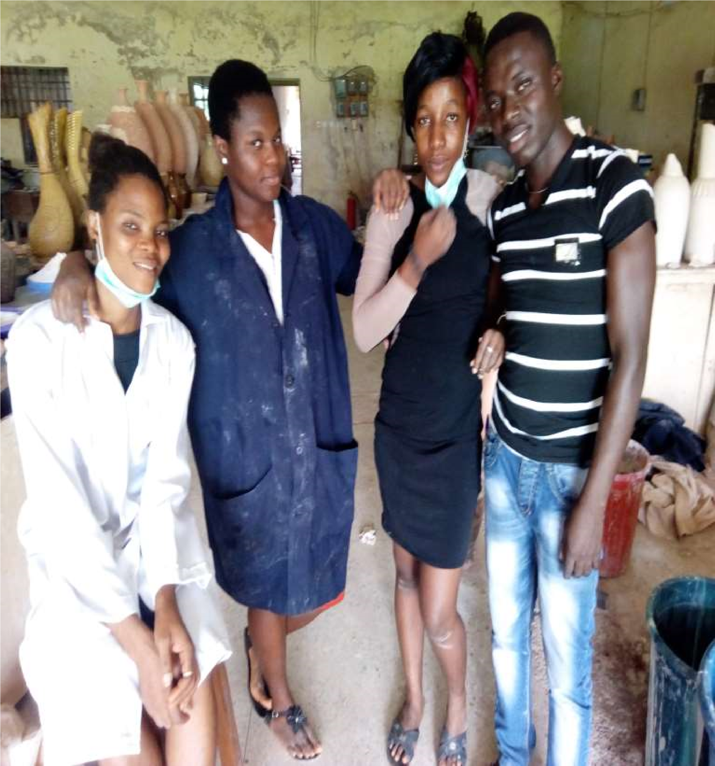

WHAT IS CERAMICS.

Pots and other articles made from clay hardened by heat.

Made of clay that has been heated to a very high temperature so that it becomes hard

THE NATURE OF CLAY.

Clay is the decomposition of the feldspethic rock into minute particles or tiny crystals which is made up of alumina, silica and chemically combined water. It can be expressed in its purest form in the following molecular composition: Al2O3:2SiO2:2H2O.

Physical properties of clay:

1. Plasticity
2. Power of suspension
3. Slaking properties
4. Shrinkage
5. Texture
6. Green strength

PLASTICITY

This can be defined as the property of yielding under pressure without cracking and then retaining the new shape after the pressure is removed.

POWER OF SUSPENSION

This is the property of finely grained clay to remain in suspension in water for hours with out settling at the bottom of the container. The power of suspension is needed more in casting process where the clay in the mold are required to hold themselves. Texture

The plasticity, green strength , shrinkage e.t.c of a clay ware are affected by the particle size and shape of the clay grains. This is called the texture of the clay. A sieve test is used to determine the coarseness or fineness of a clay.

Shrinkage

This is a drying property, when clay is made wet and plastic, the particles are all coated with films of water. During drying the water films are removed by evaporation, and the clay perticles are drawn together until they touch each other. This loss of water and drawing together of the particles results in shrinkage of the ware.

Slaking properties

When a clay is soaked, water penetrates the clay, wetting it , it swells and breaks into smaller pieces. The moro loosely the clay is bounded together, the quicker it will disintegrate pr slake

The principal oxides found in clays are:

1. Silica
2. Alumina
3. Iron oxide
4. Pyrite
5. Calcium oxide
6. Alkali oxide
7. Carbonaceous matters.

Silica

This occurs in clays as quartz SiO2 and when the quartz grains are large to be seen with the naked eyes, they appear as sand, and the clay is described as sandy. Excess quartz in clay lads to dunting or cracking during firing.

Alumina

Al2O3 it is usually present in clay, compounded with SiO2. Clays very in alumina are often very refractory.

Iron oxide

Iron oxide in clay leads to discolouration both in the raw and fired state. Hematite, fez03 imarts red colours to clays both in the raw and fired states. Pyrite

feS2 iron sulphide this s common in fireclays and leads to specking or dark spots in the clay after firing

Calcium oxides

This denote the presence of calcium carbonate or dolomite in clays. It is a fluxing material but when it occurs in nodular form it causes “time popping” which is not only unsightly but also shatters the ware.

Alkali oxide

K20, Na2O these act as fluxes and lowers the firing temperature of clays. They occur in very small quantities and many a times are of little effect.

Carbonaceous matter

This is derived from the contaminations of clays by vegetables matters. it can impart black colours to clays.

Types of clays

1. Primary clay: these are those clays which have been formed on the site of their parent rocks and have not been transported, either by water wind or glacier. Primary clay when they have been cleared of rock fragments tend to be relatively pure and free from contamination with non-clay minerals. This is because most primary clay originate from beds of more or less pure feldspar, a rock which is relatively easil broken down by water alone.
2. Secondary clay: this is the type of clay that is found outside its original place of formation which must have been transported to the place by the agent of erosion.

PREPARATION OF CLAY:

Clay can be found in the fields, along the bank of rivers and streams in the dry river beds, lakes, creek, or steam beds. It is always advisable to dig from deposited with thin overburden.

Clay are full of impurities as dug out of the ground and they require to be refined or washed before use. It is essential to remove the unwanted roots, sticks, excess sand, pebbles etc.

To process I to mix clay with water [blunting] probably in drums or plastic containers to form a watery suspension. This is then sieved [any sieve size similar to the ones used in sieving cassava or maize can do] the sieved suspension is allowed to stand. The fine grit settles at the bottom, the clay suspension settles next. It’s then covered by the supernatant water. The water is decanted and the clay is scooped out to harden into a plastic state. The fine grit at the bottom of the container where available the clay scooped out can be dried on plaster bats or bricks properly laid out for the purpose.

When the clay does not seem to contain much visible impurities and is in a dry condition it could be grounded in a wooden matter, and thoroughly mixed with

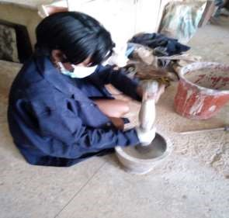water, the water being added a little at a time.

Until the right plastic consistency is obtained. It is advisable to allow the clay to stay overnight after the water addition before final mixing. Any lump left in the clay can be picked out during the mixing. For ease in moulding, and safety of the ware in drying and firing, moulding clay should be homogeneous, free from lumps. Wedge boards could be used in the slicing or cutting, or a piece of wire held taut and drawn through the lump or mass of clay. After wedging, the clay is then kneaded in the jelly roll or bull face fashion. Spirally turning and pressing and rolling the clay mass until it it feels smooth and shows a more uniform consistency.

STEPS FOR SLIP CAST

The materials needed are as follows:

1. Plaster mould
2. Large rubber bands
3. Paper or plastic coffee cup
4. Gallon porcelain slip ware
5. Clay sponge

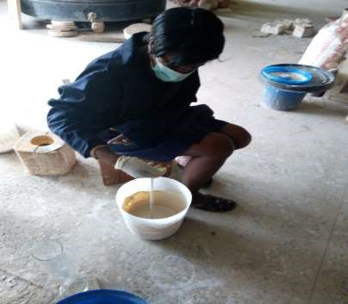

Turn your gallon of slip ware horizontally and roll back the front for 5 minutes to get the slip well mixed, you can also shake the gallon up and down but keep in mind it will be heavy .

1. Take the empty plastic/paper coffee cup that you gathered from the materials list and fill it up with slip from the gallon, once you have done this place it aside for now.
2. Get your mould ready by making sure the inside is clean and dry. Match up the two halves of the mould by making sure the pin holes are aligned. This will ensure a sealed closure and no leakage when slip is poured into it.
3. When the two halves of your moulds are together, fasten them with the large rubber band, make sure they are nice and strong. This will keep the two halves together and further ensure no leakage.
4. Once you have placed the rubber band around your mould and secured it, flip the mould hole up.
5. Take the coffee cup filled with slip and pinch the edge of the cup to make a nice pouring spout. This ensure no spillage and that the slip will flow out of the cup nice and smoothly. We are doing this because the pore holes in our moulds are not so large and we want to decrease the amount of spillage.
6. Pour slip into the mould once and slowly, fill the mould until it is almost to the brink.
7. Once you have finished pouring slip into the mould, you must wait for a certain amount of time for a desired thickness to build along the walls of the mould. While this is happening you will realize that the slip is getting lower and lower. This is happening because your slip is building up on the inside of the mould, it's literally soaking the liquid slip into the mould walls.

Thus, resulting in the lowering of the slip level;

10mins - 1/6 inch thick

15mins - 1/8 inch thick

30mins - 3/16 inch thick

40mins - 1/4 inch thick, you can wait for the settling amount of time you desire.

1. You will begin to see layers of slip building up along the wall of the mould as you keep refilling it.
2. Once you've waited to your desired thickness, begin to pour out your slip from the mould slowly; make sure you are not completely flipping the entire mould over but rather tilting it so that the slip pours out from one side of the mould. This allows for cleanliness and ease of pouring. After you are sure that all excess slip has been poured out of the mould, tilt it against the wall for a couple of minutes to ensure that every drop of slip has leaked out
3. Place your mould hole down into a piece of paper towel and allow for further drainage for about 10mins.
4. Tilt the mould to its side and allow for drying of the slip inside the mould. Wait approximately two hours before releasing the mould.
5. Once you have waited for 2 hours you can release the mold to see if the casting piece is ready to fall out. You can determine this by seeing if the casted piece is slightly separating away from the walls of the mold.
6. Remove the casted piece from the mold by pulling slightly on it. A good cast should allow the piece to just fall out. Do not pull too hard as this may tear the piece. If it is giving you trouble wait a few minutes before trying again.
7. Trim away the bottom portion of your cast with the clay cutting knife. This excess piece is always trimmed away as it is build up along the mold where the reservoir was.
8. Wipe away the seam line and clean up the edge, bottom and any other inconsistencies in the clay cast.

Now the work is OK for slow drying and firing.

DRYING OF POTTERY WARES

Pots are usually dried slowly, to prevent warping and cracking. Ceramic wares are also dried thoroughly to prevent explosion in the biscuit fire resulting to the shattering of the pots. As a rule, the more plastic clays and the bigger pottery forms are dried more slowly than the open or frigged bodies and small or thin wares.

In drying, as the water on the surface of the pot is evaporated, the water in the interior travels to the surface. In fast drying, the rate of flow of water to the surface that a large mixture gradient is created. This differential in the moisture content of the interior and surface tends to set up differential shrinkage quite pronounced in thick wares which leads to cracking.

HOW TO FIRE A CERAMIC WARE

The bone dry green ware is fragile and must be loaded into the kiln with a great deal of care. The kiln is closed and heating slowly begins. A slow temperature rise is critical during the beginning of the bisque firing, the last of the atmospheric water is more driven out of the clay. If it is heated too quickly, the water turns into steam while inside clay body, causing the clay to burst.

When a kiln reaches about 160F, the chemically bonded water will begin to be driven off. By the time the clay reaches 930F, the clay becomes completely dehydrated. At this point the clay is changed forever; it is now a ceramic material.

The bisque firing continues until the kiln reaches about 1730F. At this temperature, the pot has sintered making it less fragile while remaining porous enough to accept the application of glazes.

After the desired temperature has been reached the kiln is now turned off, the cooling is slow to avoid breaking the pots due to stress from the temperature change.

EFFECTS OF HEAT ON CLAY

1. Completion of drying (pre-drying).
2. Removal of chemically combined water.
3. Quartz inversion
4. Decomposition of carbonate and sulphates.
5. Oxidation of organic matter.
6. Vitrification.

1. COMPLETION OF DRYING: No matter how dry a claywork looks it still have some water in it. Dry clay body is hygroscopic. In firing, the temperature is raised slowly to ensure a safe escape of any moisture left in the pots. If the initial temperature is too high, the moisture in the interior of the pot quickly changes into water vapour or steam which builds up pressure inside the ware and this ware explodes.
2. REMOVAL OF CHEMICALLY COMBINED WATER: Clay is made up of alumina, silica, chemically combined waters and impurities in the form of acidic and basic oxides. (Al²O³ 2SiO².2H²O-Al²O³.2SiO²+2H²O). At temperatures between 500-700C clay looses it's chemically combined water, leaving a weak body. In this temperature range,the firing must be slow not only to accommodate the steam pressure, but also the shrinkage that occurs as a result of loss of chemical water and gases from organic material.
3. QUARTZ INVERSION: Free silica or quartz in clay behaves differently from the silica that is chemically bonded with other components. At 575° quartz crystal changes from the stable alpha form to a beta form with a rapid volume expansion of about 2-3cm on cooling also at 575°C the beta quartz changes again to the alpha form with a volume contraction of the same magnitude, therefore if the firing or cooling is rapid around this temperature region, singing or cracking of the pot will result.
4. DECOMPOSITION OF CARBONATES AND SULPHATES: Some clay contain carbonates of calcium CaCo3, magnesium MgCo3, Iron FeCo3. At temperature of 600-1000°C these decompose into the oxides yielding CO² in addition. The oxide been active fluxes react with the Al²O³ and SiO². These reactions cause no trouble.
5. OXIDATION OF ORGANIC MATTER: Organic matter in clay burns off at Red heat, between 350-900°C. If the pot is fired too rapidly that the pores seal off before the oxidation is complete,the interior of the piece is not oxidized, and black colouring occurs.
6. VITRIFICATION: As firing continues, the fluxes in the clay or body start to soften and to form glass progressively. The temperature at which initial melting and sintering starts depends on the materials present. Between 850°&1050°C, crystal transformations begin and at about 1010°C fine needle-like particles called mullite. 3Al²O³.OSiO², begin to appear embedded in the glassy matrix.

HOW TO MAKE A COIL POT

1. Flatten piece of clay of about 1/4m thickness. Use rolling pin or a slab roller to flatten the slab. Cut slab to desired dimensions, ahead of time prepare clay coil by hand or with extruder. Make sure your pre made clay coils are covered with plastic to keep them soft. Coils dry out very quickly.
2. Score the slip slab and lay the first layer of coil. Push the coil firmly into the slab. Cut first layer of coil as illustrated below to insure perfect fit around the parameters of the slab. Remove the unused coil piece and blend the

joint. Pinch/scrape the coil with one finger into the slab smoothly using your finger, a rib or a wooden tool.

1. Place the next layer of coil pinch and smooth and in previous layer. When merging tow layers, make sure that one hand is supporting the clay on one side while the other pushing/smudging the other side.
2. Keep adding layers, you can add upto three at a time before blending and smoothing, when cutting a slab or fit, make the cut in a different place to insure that two joints are not directly one above the other.
3. To widen the pot, use longer coils. If taking a break cover your work and pre made coils. So that the clay will remain most and soft.
4. Use the same method as to create the pot rim "un-smoothed" as if making a large pot it might be too soft to hold it's full weight. Cover it and allow it to set for a while before proceeding. When starting again, the next coil added must be skipped and scored to the existing pot.
5. Use a paddle to bith the shape the pot and strengthen the coil wall. Dry slowly by covering the pot loosely with plastic before bisquing.

HOW TO MAKE TILES

METHOD ONE

1. Begin with good clay, duchess the designed for sculpting and that has small and large - sized grog.
2. Check the temperature at which you will fire the clay.
3. Ensure that the clay u will use will mature at that temperature.
4. Work the clay when it is fairly dry.
5. Ensure that your clay tiles are at list 1/2inch (1.3cm) thick.
6. Roll a slab of clay into a hard working surface from which your clay can be easily removed.
7. Use a slab roller to flatten the clay.
8. Calculate the diameter of ball of clay that is needed to reach your tile size, including shrinkage.
9. Determine the clay ball that ended up to be the correct dimensions of your tile and use that weight for the rest of the clay.

METHOD TWO

Using a press method.

1. Construct a bottomless wooden frame.
2. Pound the clay into the frame.
3. Cut off the excess clay.
4. Allow the clay dry slightly or use a spray lubricant to avoid having it stick to the wooden frame.
5. Push the clay out of the frames bottom using a strong material the same size of the clay in the frame.

METHOD THREE

using a cut method

1. Make a metal or wooden template.
2. Cut the tiles after the clay have dried to a leather consistency.
3. Allow to dry slowly by covering with a plastic bag.

DRYING

1. Cover the tiles with a plastic bag.
2. Place the tiles between two piece of sheet-rock, plywood or plastic grids.

FIRING

1. Incise a slab of clay with a 3.94 inch long(100mm) long.
2. Fire the salad at that approximate temperature.
3. Measure the line after firing to determine shrinkage rate.
4. Shack your tiles ontop each or place the tiles in a tiles setter for bisquing firing or place tiles on a flat surface for glaze firing.
5. Create a moat to protect your tiles and ensure even firing using bars of clay.

**CHAPTER FOUR**

**CONCLUSION**

The SIWES program undergone in PRODA, Enugu has afforded me an ample exposure to some of the practical ceramics aspects. I’ve been opportune to know and carefully handle sophisticated equipments. I gained experience on how to slip casting and make molds, procedures on how to dry ceramic wares, how to fire ceramic wares with both electric and local kiln, how to make tiles and how to make coil pots. The program was highly beneficial, interesting, enlightening and successful and I can say that all the set objectives were achieved.

RECOMMENDATION

Although SIWES has and is still achieving quite a lot of its stated objectives, nevertheless the following recommendations are suggested to improve the qualitative context of the program:

Sending students specifically to establishments where the stipulated aims and objectives of SIWES would be achieved.

Payment of befitting allowance to students to help them during the training

One piece mold

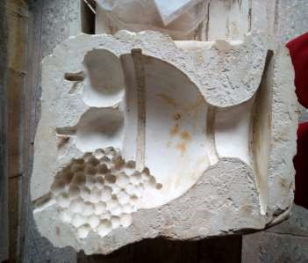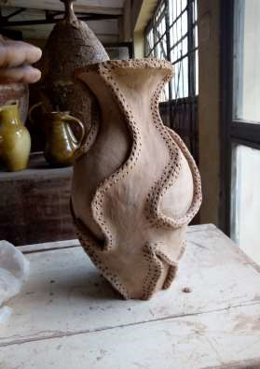

s

lip casting

ceramics

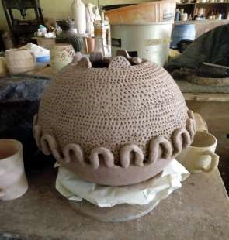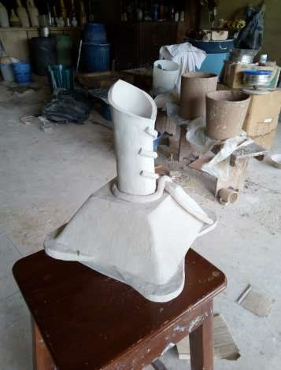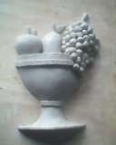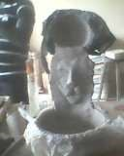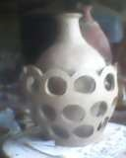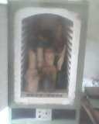

Coil and pass mold ceramics.

Press mold ceramics

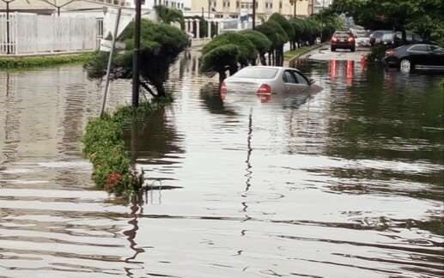

All my works were lost because of this flood

REFERENCES

Mr Mark Abu

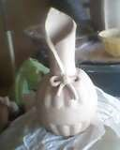Mr Phillip chima

SIWES web site