* 1. Bridge got created when trying install vm using virt-manager: virbr0 (Even though the VM creation failed virbr0 was created.)

It automatically gets the IP 192.168.122.1 from libvirt daemon.

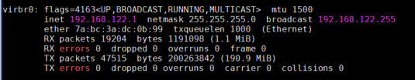

It is attached to automatically created virbr0-nic.

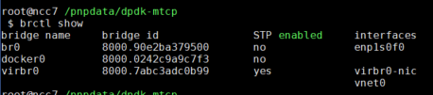

* 1. “default “ network will be created automatically and it should be active:

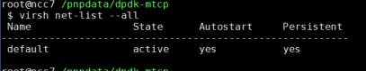

Edit the default network config like the following: virsh net-edit default

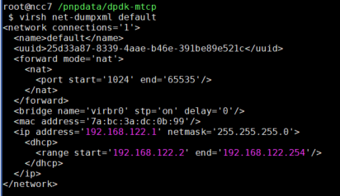

* 1. Create vm using virt-install.

virt-install \

--debug \

--name test_1 \

--cpu host-passthrough \

--ram 2048 \

--vcpus 4 \

--disk path=test_1.qcow2,size=10 \

--network network=default \

--os-type linux \

--graphics none \

--console pty,target_type=serial \

--location=Fedora-Server-dvd-x86_64-29-1.2.iso --extra-args="console=ttyS0"

* 1. After creating vm still connectivity was not there. Had to do the following in the vm:
     1. declare -x http_proxy=<http://proxy-us.intel.com:911>
     2. declare -x https_proxy=<http://proxy-us.intel.com:912>
     3. declare -x socks_proxy="http://proxy-us.intel.com:1080"