
Final Project Report
Production-Style MLOps for Server Log Anomaly Detection
Evidence-based English report | Data collected: 2026-07-01T20:52:31+07:00
Team Member | Report Contribution Focus
Mai Văn An | Project Lead and MLOps Architecture
Nguyễn Thanh Bình | API Serving, Security, and Runtime Validation
Phạm Đình Hoàng | Model Training, Evaluation, and Explainability
Nguyễn Tuấn Dũng | Observability, CI/CD, and Documentation

Report Purpose
This document rewrites the original slide summary into a more complete English report with project context, architecture, evidence metrics, screenshots, tables, and executive recommendations.

Report Structure
# | Section | Reader Value
1 | Executive Summary | High-level conclusion, evidence highlights, and key recommendation.
2 | Detailed Slide Summary | Expanded version of the original summary with metrics and operational meaning.
3 | Architecture and Implementation | How the MLOps stack moves from data to served predictions and retraining.
4 | Model and Runtime Evidence | Model quality, production predictions, load testing, latency, and auditability.
5 | Observability and Governance | Monitoring, explainability, fairness, retraining, and CI/CD readiness.

The report is written for an academic evaluation audience that needs both technical credibility and an executive-level explanation of why the project is production-oriented.

Executive Summary
Executive conclusion
Project demonstrates a complete MLOps reference stack for server-log anomaly detection: model training, registry management, authenticated serving, audit logging, observability, alert routing, and retraining workflows are all represented in one runnable Docker Compose environment.

The project goes beyond a standalone machine-learning notebook by packaging the anomaly detector as an operational system. The stack includes Airflow for orchestration, MLflow and MinIO for experiment and artifact management, FastAPI for secured inference endpoints, PostgreSQL for prediction audit trails, Prometheus and Grafana for live telemetry, and Alertmanager for alert-to-retraining automation.
The collected evidence shows strong model performance and stable demo runtime behavior: precision, recall, and F1-score are each 97.37%; production evidence includes 400 prediction requests with 108 anomalies; API p95 latency is 0.05 seconds; and the Locust smoke load test recorded 7.20 requests per second with zero failures.
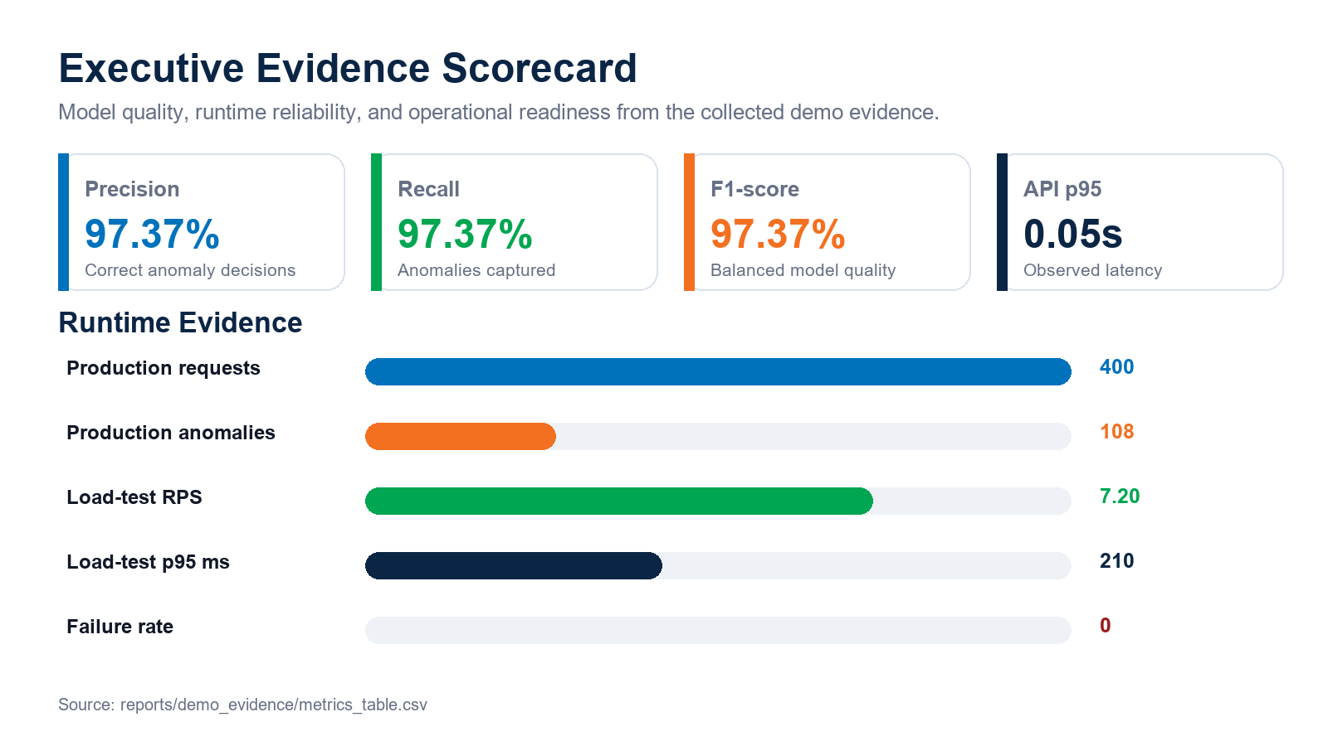
Figure 1. Evidence scorecard generated from reports/demo_evidence/metrics_table.csv.

Evidence Highlights
Area | Evidence | Interpretation
Model quality | Precision/Recall/F1 = 97.37% | The Isolation Forest model performs consistently on the available labeled validation evidence.
Runtime reliability | p95 latency = 0.05s; API errors = 0 | The FastAPI service handled demo traffic without recorded runtime errors.
Operational evidence | 400 production requests; 108 anomalies | The system records prediction behavior and supports downstream monitoring.
Load testing | 7.20 RPS; p95 = 210 ms; failure rate = 0 | The local smoke scenario indicates a stable demo serving path.
Governance | Explainability + fairness endpoints | The system exposes interpretable feature impact and segment-level anomaly-rate checks.

Executive Takeaways
- The project should be presented as a production-style reference stack because it connects model training, serving, logging, monitoring, alerting, and retraining rather than stopping at offline evaluation.
- The strongest evidence points are the consistent model metrics, zero recorded API errors, low p95 latency, and complete observability path through Prometheus and Grafana.
- The main limitation is concept drift: without ground-truth production labels, the project can monitor data drift and prediction distribution drift but cannot yet measure post-deployment accuracy drift.
- The recommended next step is to harden secrets, persistence, alert thresholds, and larger load tests before treating the stack as a realistic pilot system.

Detailed Slide Summary
This section rewrites the original slide summary into a fuller English presentation narrative. It can be used as a speaker-note source for a final project presentation or as the condensed executive brief inside the report.
Slide Topic | Expanded Summary | Why It Matters
Objective | Build a production-style MLOps stack for detecting anomalies in server metrics. | The project targets operational monitoring, not only offline model evaluation. Concept drift with ground-truth labels is intentionally out of scope because production labels are not available.
Architecture | Raw metrics flow through validation, preprocessing, feature engineering, Isolation Forest training, MLflow tracking, registry promotion, FastAPI serving, PostgreSQL audit logging, and Prometheus/Grafana monitoring. | The architecture shows separation of model lifecycle, serving, observability, and retraining responsibilities.
Model Result | Precision 0.973684, recall 0.973684, F1-score 0.973684, false positive rate 0.001466, training rows 720. | The model evidence supports a strong demo-quality anomaly detector, with low false-positive behavior on the available validation data.
Production Runtime | 400 requests, 108 anomalies, API p95 latency 0.05s, API error count 0, load-test p95 210 ms, p99 360 ms. | Runtime telemetry suggests the demo stack is responsive and observable under local smoke traffic.
Observability | Prometheus scrapes FastAPI metrics; Grafana visualizes request rate, p95 latency, anomaly rate, and drift signals; Alertmanager routes warning alerts. | This gives operators the minimum feedback loop required to understand serving health and model behavior.
Explainability and Fairness | SHAP tree explainer is used for feature impact; operational fairness is measured by server_id segment with max anomaly-rate gap 1.0. | The fairness report is not about human protected classes; it checks whether operational segments behave differently and need investigation.
Retraining and CI/CD | The /retrain endpoint supports drift checks and forced retraining; Alertmanager can trigger the Airflow retraining DAG; CI runs linting, tests, Docker builds, Trivy scans, image publish, and integration checks. | The system demonstrates a credible path from monitoring signal to retraining and redeployment readiness.

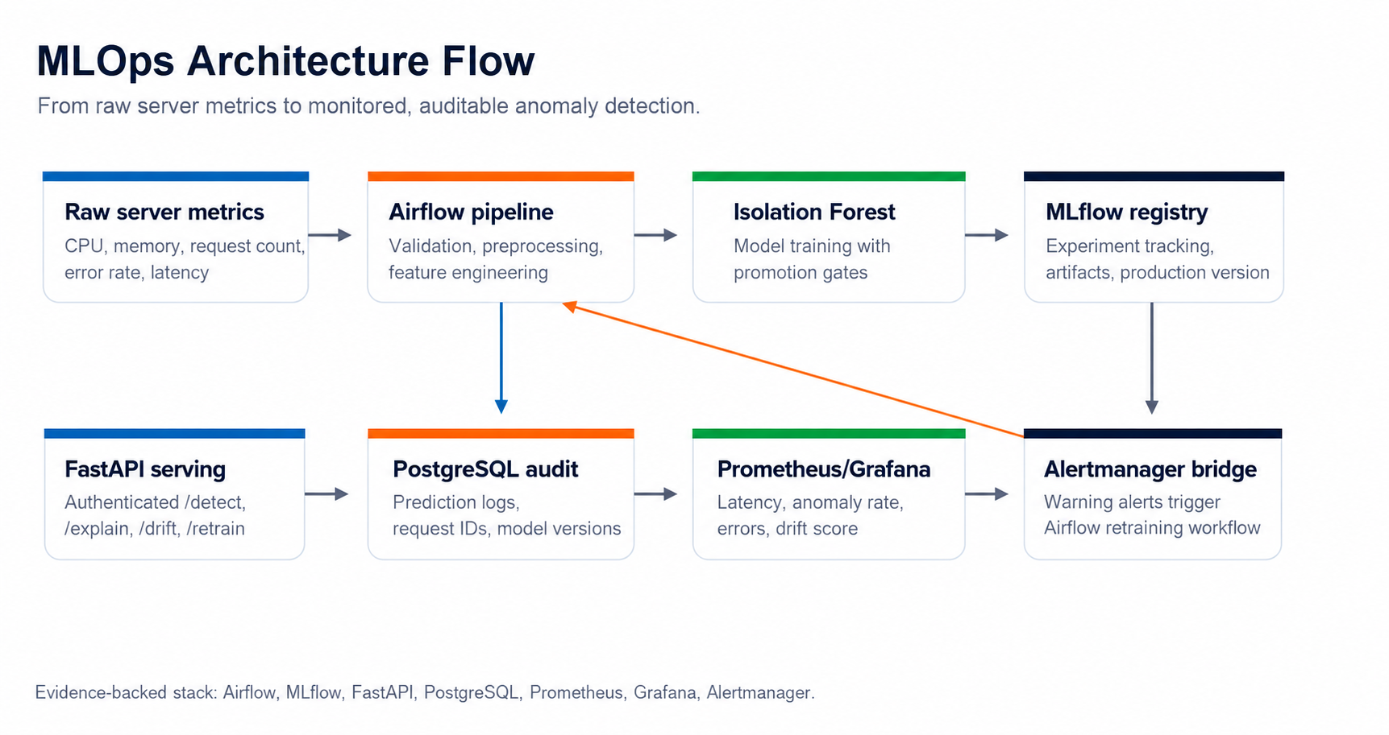
Figure 2. High-level architecture flow rewritten from the slide summary.

Architecture and Implementation
The architecture is intentionally production-oriented while remaining runnable on a laptop. Docker Compose coordinates the service layer, while each major production concern is represented by a dedicated component.
Layer | Key Components | Purpose
Data and feature layer | Raw server metrics, validation, preprocessing, rolling features, interaction features | Prepares reliable feature vectors for anomaly detection.
Model layer | Isolation Forest, promotion gates, local registry, optional MLflow alias sync | Controls which model version becomes production-ready.
Serving layer | FastAPI endpoints: /detect, /explain, /drift, /fairness, /retrain | Provides authenticated inference and operational checks.
Audit layer | PostgreSQL prediction_logs with request_id, status, prediction, score, version | Creates traceability for every served prediction.
Observability layer | Prometheus metrics, Grafana dashboards, Alertmanager routes | Tracks health, latency, anomaly rate, drift, and alert state.
Automation layer | Airflow DAGs plus Alertmanager bridge | Connects monitoring signals to retraining workflows.
Delivery layer | GitHub Actions, Ruff, pytest, Docker build, Trivy scan, GHCR publish | Demonstrates repeatable quality gates and image delivery.

Service Evidence
The evidence package includes screenshots for the running services. These visuals support the claim that the project is not only code-complete but also demonstrable through operational interfaces.
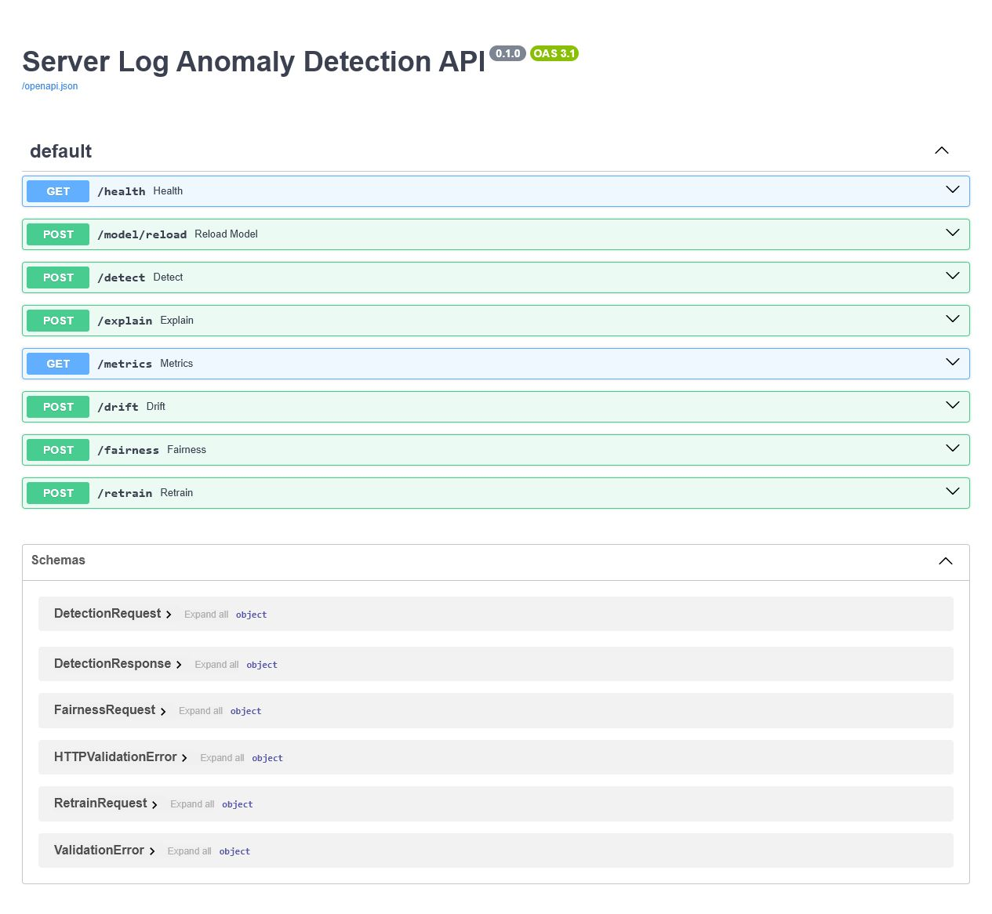
Figure 3. FastAPI documentation surface for authenticated serving endpoints.
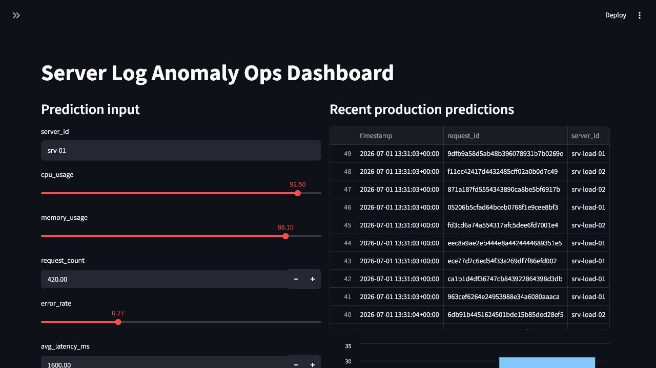
Figure 4. Streamlit operations dashboard for demo interaction and monitoring visibility.

Model and Runtime Evidence

Model Quality
Metric | Value | Source | Interpretation
Precision | 0.973684 | models/latest/metrics.json | High proportion of predicted anomalies are correct in validation evidence.
Recall | 0.973684 | models/latest/metrics.json | High proportion of true anomalies are captured.
F1-score | 0.973684 | models/latest/metrics.json | Balanced quality across precision and recall.
False positive rate | 0.001466 | models/latest/metrics.json | Low false-positive behavior in the available labeled data.
Training rows | 720 | models/latest/metrics.json | Training evidence volume for the demo dataset.
Production model | v2 | FastAPI /health | The API loaded the production model from the local registry.

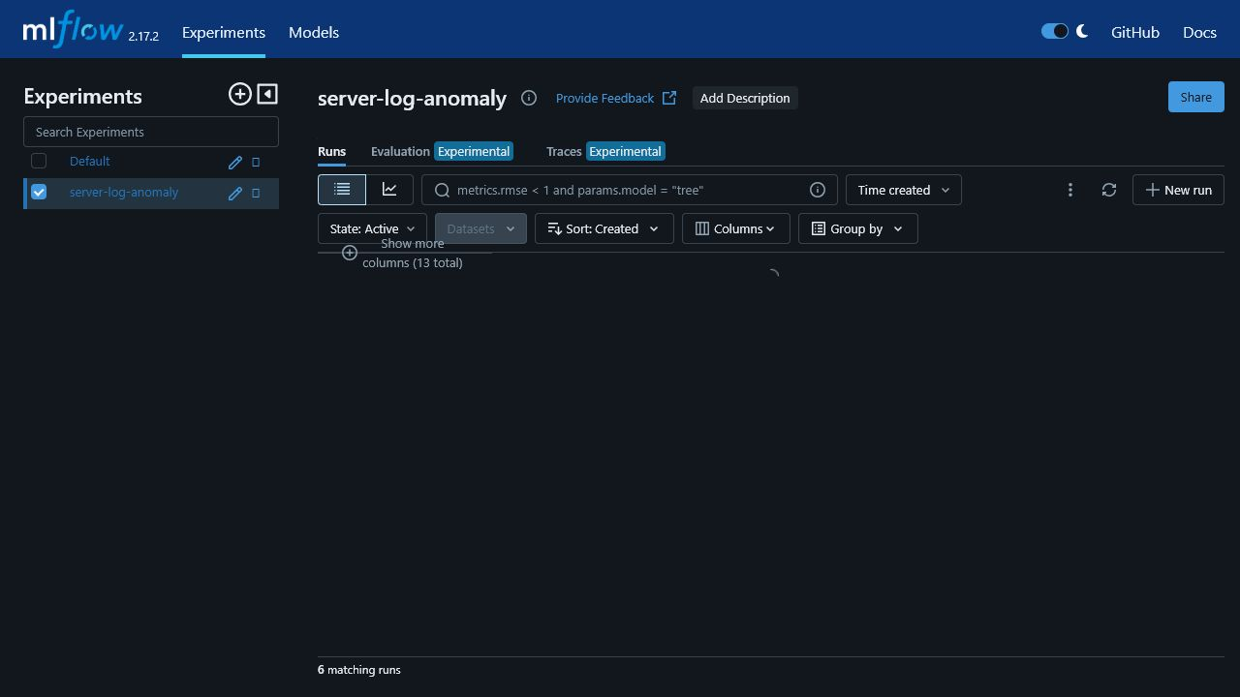
Figure 5. MLflow experiment evidence for model tracking and metrics.

Production Runtime and Load Test
Runtime Metric | Value | Source | Operational Meaning
Production requests | 400 | PostgreSQL prediction_logs | Predictions are persisted for audit and analysis.
Production anomalies | 108 | PostgreSQL prediction_logs | Observed anomaly volume across the demo production traffic.
Rolling anomaly rate | 0.375 | Prometheus | Operational signal used for monitoring and alerting.
API p95 latency | 0.05s | Prometheus | Serving response time remains low in the demo environment.
API error count | 0 | Prometheus | No API errors were recorded in the evidence snapshot.
Load-test RPS | 7.20 | Locust CSV | Smoke-level throughput for the local demo stack.
Load-test p95 / p99 | 210 ms / 360 ms | Locust CSV | Tail latency remains acceptable for demonstration traffic.
Load-test failure rate | 0 | Locust CSV | No failures were observed in the captured run.

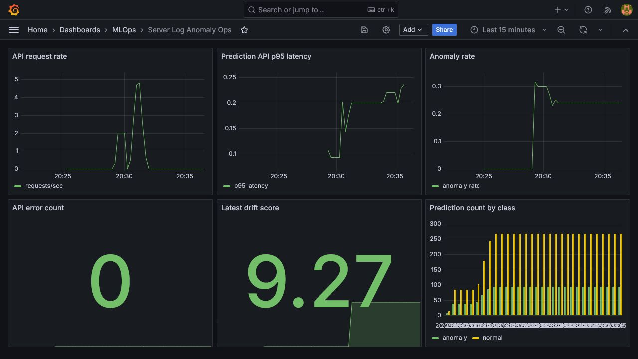
Figure 6. Grafana dashboard evidence for serving and model telemetry.

Observability, Explainability, and Governance

Explainability
The explainability endpoint completed with method `shap_tree_explainer` for model version `v2` from `local_registry`. For the sample anomalous request, the model returned risk level `medium` and anomaly score -0.156397.
Feature | Input Value | Impact | Direction
error_rate | 0.32 | 0.833543 | raises_anomaly_risk
traffic_error_pressure | 2184.0 | 0.828311 | raises_anomaly_risk
request_count | 520.0 | 0.820555 | raises_anomaly_risk
p95_latency_ms_roll_mean_3 | 2600.0 | 0.790517 | raises_anomaly_risk
error_rate_roll_mean_3 | 0.32 | 0.788234 | raises_anomaly_risk
p95_latency_ms | 2600.0 | 0.750149 | raises_anomaly_risk
avg_latency_ms | 1700.0 | 0.720553 | raises_anomaly_risk
avg_latency_ms_roll_mean_3 | 1700.0 | 0.687806 | raises_anomaly_risk

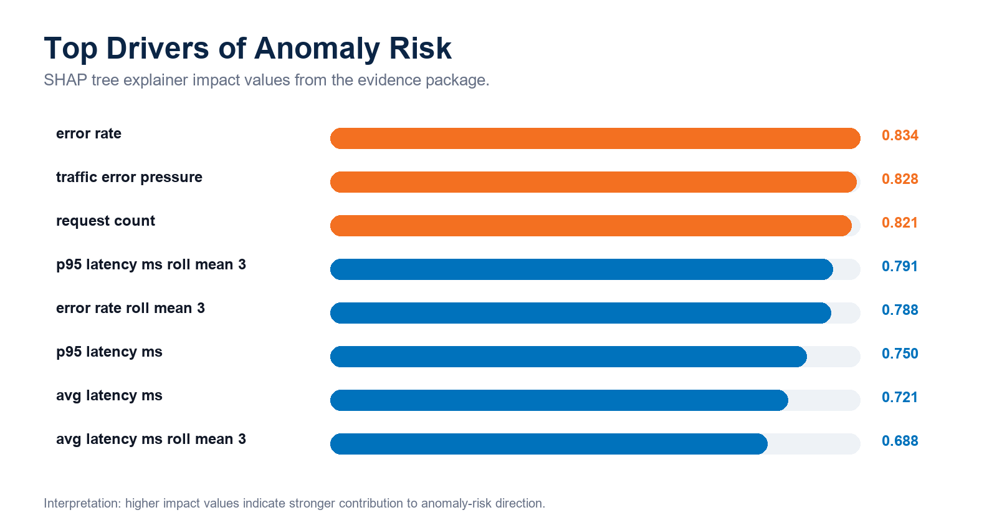
Figure 7. Top feature impacts for anomaly-risk explanation.

Fairness by Operational Segment
The project does not process human protected attributes. The fairness check therefore measures parity over an operational segment, server_id, so the team can detect whether some servers receive unusually different anomaly rates.
Group | Requests | Anomaly Rate | High-Risk Rate | Avg. Score
srv-01 | 87 | 0.298851 | 0.000000 | 0.122592
srv-02 | 47 | 0.000000 | 0.000000 | 0.240296
srv-03 | 26 | 1.000000 | 0.000000 | -0.122432
srv-load-01 | 184 | 0.000000 | 0.000000 | 0.234501
srv-load-02 | 56 | 1.000000 | 0.000000 | -0.162331

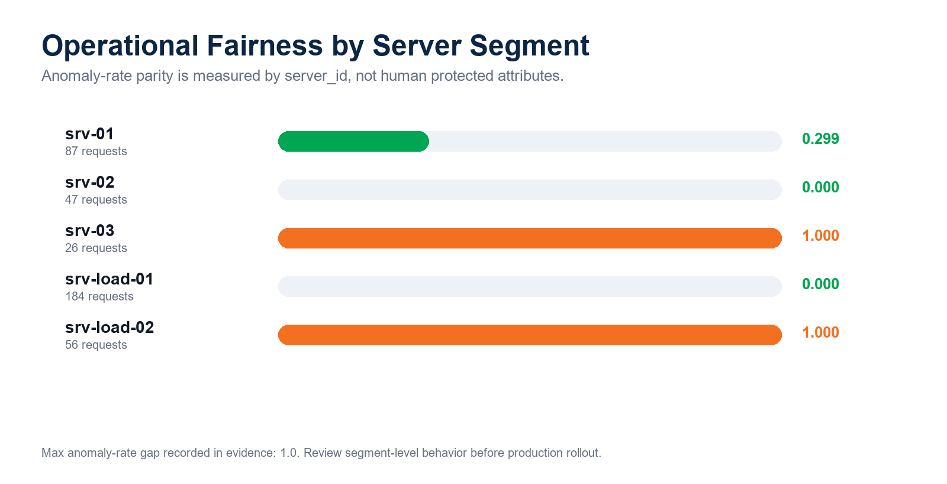
Figure 8. Segment-level anomaly-rate comparison from fairness evidence.
Governance note
The recorded fairness max gap is 1.0. This does not prove unfairness toward people; it flags operational segment imbalance that should be investigated before production rollout.

Retraining and CI/CD Readiness

Retraining Workflow
The stack includes both manual and automated retraining paths. The /retrain endpoint can check drift or force a new training job, while the Alertmanager bridge can receive alerts such as DataDriftDetected and HighAnomalyRate and trigger the Airflow retraining DAG through the Airflow REST API.
Check | Value | Source | Meaning
Data drift detected | True | FastAPI /drift | Current production features differ from the training reference window.
Prediction drift detected | False | FastAPI /drift | Prediction distribution did not drift above threshold in the captured evidence.
Max data drift score | 9.232209 | FastAPI /drift | Largest feature-level drift signal.
Retraining triggered | False | FastAPI /retrain | No drift above threshold
Active alerts | DataDriftDetected, HighAnomalyRate | Prometheus ALERTS | Alertmanager routing is demonstrable in the evidence snapshot.

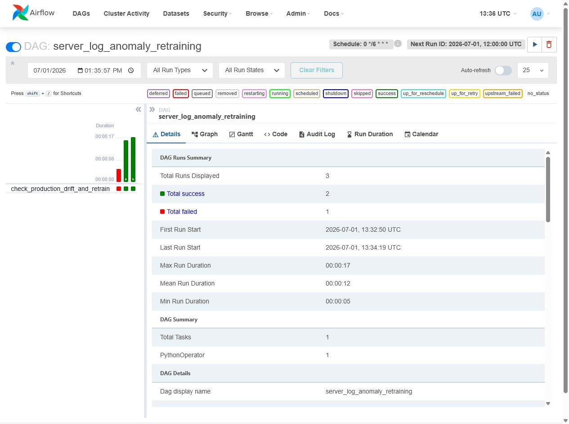
Figure 9. Airflow retraining DAG evidence.

CI/CD Evidence
The latest recorded CI run in the local evidence package is run #34 on branch `main`. Completed jobs include Python quality gates, Docker build/scan/publish, and Compose integration testing; the local CD deploy job was queued in the captured evidence.
Job | Status | Conclusion | Started | Completed
Python quality gate | completed | success | 2026-06-30T16:29:00Z | 2026-06-30T16:29:50Z
Docker build, scan, and publish | completed | success | 2026-06-30T16:29:52Z | 2026-06-30T16:32:17Z
Compose integration test | completed | success | 2026-06-30T16:29:52Z | 2026-06-30T16:31:14Z
Local CD deploy | queued | n/a | 2026-06-30T16:32:17Z | n/a

Recommendations and Conclusion

Recommended Next Steps
- Replace local demo credentials with managed secrets before sharing or deploying outside a classroom environment.
- Persist model registry metadata and artifacts outside application containers for production durability.
- Add ground-truth label capture when available so concept drift and post-deployment model quality can be measured directly.
- Define alert thresholds with operational owners, escalation channels, and retraining approval rules.
- Run a larger load test after deployment sizing decisions are made, including concurrent explainability and drift calls.

Conclusion
The project is a strong academic demonstration of production-style MLOps. It is especially effective because it connects modeling, serving, monitoring, explainability, fairness checks, drift detection, retraining workflows, CI/CD, and audit logging into one coherent stack.
The project should be presented as a reference implementation rather than a fully production-certified platform. With stronger secret management, persistent infrastructure, larger-scale performance testing, and ground-truth production labels, it would be ready for a more realistic pilot environment.

Evidence Sources
Source | Path | Use
Metrics CSV | reports/demo_evidence/metrics_table.csv | Core KPI values used in the report.
Evidence JSON | reports/demo_evidence/latest_metrics.json | API, Prometheus, MLflow, Airflow, GitHub, drift, fairness, and explainability evidence.
Screenshots | docs/assets/screenshots/*.png | Visual proof for FastAPI, Streamlit, MLflow, Grafana, and Airflow.
README | README.md | Project scope, architecture, services, CI/CD, and operating instructions.
Original slide summary | docs/slide_summary_vi.md | Vietnamese source summary expanded into this English report.

