URBANDRAIN-EDGE: An Edge AIoT System with Machine Learning for Urban Flood-Risk Warning
Nguyen Thanh Binh, Mai Van An, Pham Dinh Hoang, Nguyen Tuan Dung
FPT School of Business & Technology (FSB), FPT University, Hanoi, Vietnam
Email: [AUTHOR INPUT REQUIRED]
Abstract
Urban flood warnings require local hydraulic observations because rainfall forecasts do not show whether a specific drain is approaching surcharge. URBANDRAIN-EDGE integrates two ESP32/HY-SRF05 nodes, a Raspberry Pi controller, MQTT telemetry, deterministic L0/L1/L2 alerts, Open-Meteo rainfall context, and a rain-gated five-minute logistic-regression predictor. The current portable model was trained on 480 explicitly synthetic samples grouped into 24 events; it is marked field_validated=false and may add only an L1 early warning. On the synthetic held-out split it obtained precision 0.8182, recall 1.0000, F1 0.9000, ROC-AUC 1.0000, and Brier score 0.0265. These values validate software integration and fallback behavior only; field performance, calibration error, lead time, and false-alarm rates remain to be measured.
Keywords: urban flooding; Edge AIoT; ultrasonic sensing; ESP32; logistic regression; flood-risk warning

Introduction
Localized pluvial flooding is difficult to warn from rainfall alone because the response at a drain also depends on inlet geometry, downstream surcharge, debris, and local conveyance. Studies in Hanoi relate flood exposure to rapid urbanization, low-lying terrain, land-use change, and drainage capacity that has not expanded uniformly with demand [1], [2]. A warning system should therefore observe the local water response while treating forecast rainfall as contextual evidence rather than as ground truth.
URBANDRAIN-EDGE is an implemented Edge Artificial Intelligence of Things (AIoT) prototype. Exactly two sensing nodes are used in the paired configuration: Node A is assigned upstream and Node B downstream on one monitored drainage segment. Each node pairs one ESP32 with one HY-SRF05 ultrasonic sensor and publishes telemetry through Message Queuing Telemetry Transport (MQTT) to a Raspberry Pi. The controller records timestamped distance history, derives short-window rise rates, evaluates directed node links, and combines those measurements with rainfall context.
The contribution is threefold. First, the paper specifies a code-grounded two-node architecture and an upstream-downstream differential feature without claiming direct flow measurement. Second, deterministic L0/L1/L2 warnings remain active if machine learning (ML), its artifact, or external weather data are unavailable. Third, the paper defines a leakage-resistant field protocol that compares rule-based alerts, two separate one-sensor models, and one two-sensor model on identical event splits. Numerical entries that require field measurements are deliberately marked TBD.

Related Work and Research Gap
Ultrasonic sensing has demonstrated value for hyperlocal flood-depth monitoring. FloodNet combines compact ultrasonic nodes, a data pipeline, a dashboard, and automated alerts [3]. Other prototypes integrate local water level, rainfall, and embedded intelligence for early warning [4]. These systems establish the practical relevance of distributed sensing, but a single depth trace cannot by itself distinguish a local restriction between two points from a segment-wide rise.
The present work focuses on paired observability and safe ML integration. The implemented pipeline uses an explicit feature order, a portable JSON artifact, event-grouped train/validation/test splits, and deterministic fallback. The artifact is synthetic and marked field_validated=false; it is used to test data generation, training, serialization, rain-gated inference, dashboard integration, and fallback. It is not evidence of flood-warning accuracy in Hanoi or any other field site.

System Architecture

Dual-Sensor Edge Nodes
Each node uses the same circuit and firmware. ESP32 GPIO33 drives HY-SRF05 TRIG, while ECHO is received on GPIO32 through a verified voltage divider or logic-level shifter because the sensor may return 5 V and the ESP32 interface is limited to 3.3 V. Firmware version 1.4.0 also drives green, yellow, and red indicators on GPIO25, GPIO26, and GPIO27 and an active-buzzer control on GPIO14. The local distance rules use an observed normal reference of 12.9 cm, L1 at distance <=11.0 cm, L2 at distance <=8.0 cm, and 0.5-cm hysteresis. These provisional distances must be replaced or confirmed by site calibration. Firmware emits a 10-microsecond trigger, rejects a 30-ms timeout, and publishes a new value when it differs by at least 1 cm from the last successfully published distance.
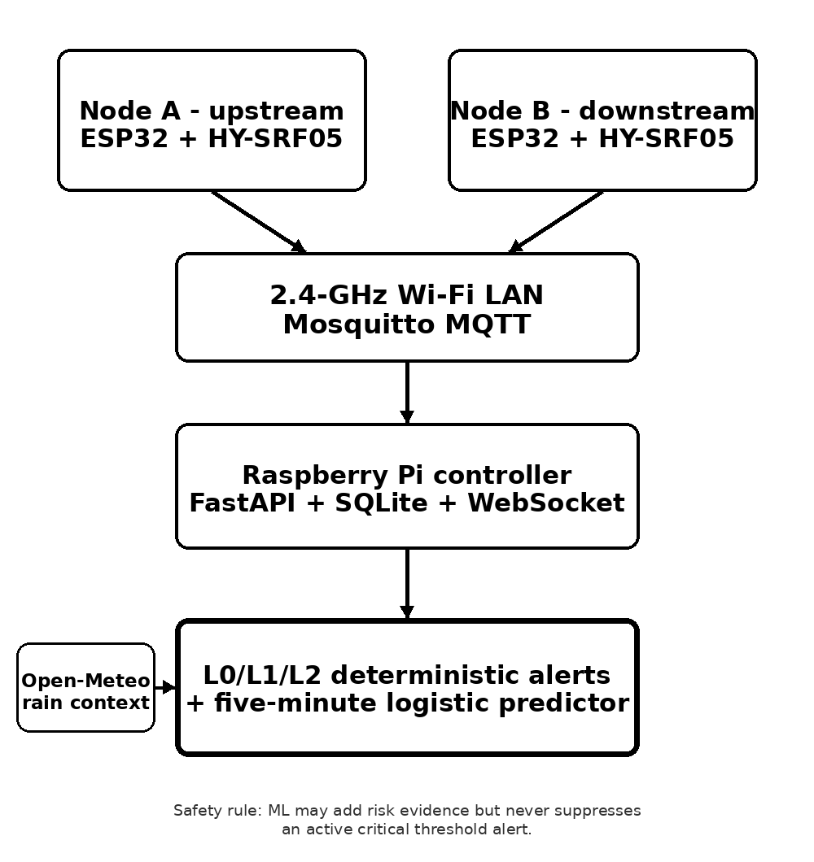
- Implemented two-node architecture and deterministic safety boundary.

Edge Services and Data Path
Both nodes join the same 2.4-GHz Wi-Fi network, discover edge-controller.local by multicast Domain Name System, register through Hypertext Transfer Protocol, and publish MQTT telemetry. The Raspberry Pi runs Mosquitto, FastAPI, SQLite, and WebSocket dashboard updates. Node status and Last Will messages are retained; distance telemetry is not retained. SQLite stores device configuration, directed links, the latest state, and timestamped telemetry_history rows used to estimate rise rate. Open-Meteo forecasts remain cached for display and rain gating. Field collection still requires a versioned export and event/ground-truth log.
- IMPLEMENTED SYSTEM ELEMENTS
Layer | Implemented element | Role
Sensing | 2 x ESP32/HY-SRF05 | Upstream and downstream depth
Interface | GPIO33/32 sensor; GPIO25-27 LEDs; GPIO14 buzzer | Protected sensing; local alarm
Transport | 2.4-GHz Wi-Fi; MQTT | Telemetry, status, commands
Edge | Raspberry Pi; Mosquitto; FastAPI | Ingestion and warning logic
Storage/UI | SQLite telemetry_history; WebSocket UI | History, rise rate, and state
Context | Open-Meteo API | Rainfall and data-quality flags

Measurement, Calibration, and Safety
For node i in {A,B}, the mounting datum z_i is the measured vertical distance from the selected zero-water reference to the sensor face. Raw distance d_i(t) is converted to bounded water depth h_i(t):
hᵢ(t) = clip[zᵢ − dᵢ(t), 0, zᵢ], i ∈ {A, B}. (1)
A dry-zero check and at least two known static depths are required for each node. The directed difference and finite-window rise rate are
Δh(t) = hₐ(t) − hᵦ(t), rᵢ(t) = [hᵢ(t) − hᵢ(t − Δt)]/Δt. (2)
Configurable fill and difference thresholds provide the primary warning path. A positive Delta h may indicate upstream accumulation only after the normal distribution for the installed geometry has been measured. If both levels rise together, the observation is more consistent with a segment-wide surcharge. The predictor may add risk evidence but can never clear a threshold-triggered critical warning.

Machine-Learning Method

Prediction Target and Feature Contract
At timestamp t, the binary target y(t) equals one when either monitored station reaches the configured critical distance during (t, t+5 min]; otherwise it equals zero. Rows at or after the current critical state are handled by deterministic rules, and rows without a complete five-minute future window are excluded from supervised scoring. The current paired artifact uses the feature contract in Table II. Missing, stale, or unassigned weather disables ML rather than being replaced by zero rainfall.
- TWO-SENSOR FEATURE CONTRACT
Group | Features | Purpose
Distance | d_A, d_B | Current water-surface range
Rates | rise_A, rise_B | Short-window rise
Delta | |d_A - d_B| | Spatial imbalance
Weather | rain now, 1 h, 6 h; P(rain) | Rain gate/context
Quality | online; valid; fresh weather | Safe disable
After standardization, logistic regression estimates the five-minute risk probability
p₅(t) = σ[β₀ + ∑ⱼ βⱼxⱼ(t)], σ(u) = 1/[1 + exp(−u)]. (3)

Training, Model Governance, and Fallback
Training and holdout data are separated by complete synthetic event, never by randomly shuffled adjacent rows. The generator uses seed 20260817 and produces 24 events with 20 one-minute samples each: normal dry operation, rain without flooding, segment-wide rise, local blockage, rapid critical rise, and sensor-fault scenarios. Sixteen events are assigned to training, four to validation, and four to test. Standardization is fitted only on training rows; a class-weighted logistic objective with L2 regularization is optimized offline, and the operating threshold is selected on validation F1 with recall as the tie-breaker.
The current model.json contains a portable logistic-regression artifact trained on 480 synthetic rows; 346 rows remain usable after incomplete future windows and explicit fault/quality exclusions. The validation-selected decision threshold is 0.62. Runtime inference is activated only when current precipitation is at least 0.1 mm, one-hour forecast precipitation is at least 0.5 mm, or six-hour precipitation is at least 1.0 mm with probability at least 50%. When dry, stale, offline, unlinked, or incomplete, the model reports an inactive/unavailable reason and deterministic warnings continue. Because field_validated=false, ML may add only L1 and cannot create or clear L2.

Experimental Methodology

Field Deployment and Ground Truth
Node A is installed upstream and Node B downstream on one drain segment. The final paper shall report the site coordinates or anonymized site identifier, inter-node spacing, mounting datums, drain cross-section, invert elevation, observation dates, sampling interval, and maintenance record. These values are currently TBD. Neither a 600-mm channel nor any fixed hydraulic geometry is assumed unless physically measured.
Ground truth is obtained from an independent staff gauge or calibrated depth reference, synchronized video, and timestamped operator logs. Each session begins with a dry or known-depth check, followed by a stable paired baseline and a controlled or naturally observed event. Labels distinguish normal operation, local restriction, segment-wide rise, critical depth, sensor failure, communication loss, and stale weather.
- REQUIRED FIELD-EVIDENCE RECORD
Item | Required record | Status
Geometry | Spacing, datums, cross-section | Author/field input required
Ground truth | Independent depth and time | Field collection required
Event label | Normal/restriction/rise/critical | Field annotation required
Sensor quality | Timeout, invalid, stale, history | Implemented; validate in field
Network | Loss, reconnect, delivery delay | Implemented; timing TBD
Weather | Value, provider time, age, stale | Integrated; archive check TBD

One-Sensor Versus Two-Sensor Comparison
Four warning configurations are evaluated on exactly the same held-out events. R denotes the deterministic L0/L1/L2 rule set. M_A uses Node A depth, fill, rise, rainfall, and quality features; M_B uses the corresponding Node B features. M_AB adds both nodes, Delta h, and paired interactions. M_A and M_B therefore represent the one-sensor baselines, while M_AB tests the incremental value of the second sensor. All ML configurations use the same algorithm, horizon, folds, calibration method, and threshold-selection rule.
The comparison is event-grouped and, where possible, split by date and site. A weather-only baseline may be reported as a secondary check, but it does not replace the required R, M_A, M_B, and M_AB comparison. The dual-sensor claim is supported only if M_AB improves held-out warning quality or lead time without an unacceptable increase in false alarms.

Synchronization, Pairing, and Data Quality
The controller stores the node identifier, source timestamp when available, reception timestamp, raw distance, calibrated depth, validity flag, and configuration revision. Controller time is synchronized by Network Time Protocol, while elapsed-time calculations use a monotonic clock. Node A and Node B readings are paired by nearest timestamp within a maximum tolerance of TBD s; the final tolerance must be reported with the achieved sampling interval and clock uncertainty. Samples older than the configured age limit are marked stale rather than silently reused.
Invalid or missing readings remain explicit in the analytical dataset. Forward filling is prohibited across event boundaries, communication outages, maintenance, and restarts. An event begins at the first independently verified hydraulic departure from baseline and ends after the depth remains below the recovery threshold for TBD min. Windows without a complete five-minute future label are censored from supervised scoring but retained for availability and fault analysis.

Metrics and Reliability Tests
For the positive critical-window class, the final report includes precision, recall, and F1; model reports also include receiver-operating-characteristic area under the curve and Brier score when both classes exist. False alarms are normalized by clean operating hours. Warning lead time and end-to-end delay are defined as
L = t_c - t_w, τ = t_w - t_s. (4)
Latency is summarized by median and 95th percentile from the sensor timestamp to the emitted warning. Reliability tests inject Wi-Fi loss, broker interruption, one-sensor timeout, stale weather, incompatible model schema, and recovery. Confidence intervals resample complete events rather than individual rows.

Statistical Analysis and Decision Criteria
Point estimates are accompanied by 95% event-level bootstrap confidence intervals. Paired bootstrap differences compare M_AB with M_A and M_B on the same resampled events; row-level resampling is not used because adjacent samples are temporally dependent. The final paper shall report the number of bootstrap replicates, random seed, operating-threshold selection rule, and all exclusions before inspecting the held-out test results.
The dual-sensor predictive claim is accepted only if the measured evidence shows an operationally meaningful improvement in recall or F1 and does not degrade false alarms per clean hour or median lead time beyond predeclared limits. Those limits are currently TBD and must be fixed before final testing. For every primary metric, the report shall include the absolute M_AB-minus-baseline difference and its 95% confidence interval; a confidence interval spanning no difference is reported as inconclusive.

Results
The tables in this section separate completed synthetic software validation from measurements that still require field or controlled-bench evidence. Synthetic scores are reported only for the implemented paired model M_AB. Rule-based R and one-sensor M_A/M_B baselines have not yet been evaluated on the same held-out events; field calibration, lead time, latency on Raspberry Pi, and false alarms per clean hour remain TBD.

Sensor Calibration and Data Quality
- SENSOR CALIBRATION AND DATA QUALITY
Node | Bias (cm) | MAE (cm) | RMSE (cm) | P95 error (cm) | Valid (%)
A | TBD | TBD | TBD | TBD | TBD
B | TBD | TBD | TBD | TBD | TBD
Evaluate against the independent depth reference over the stated calibration range; report the number of points and repetitions.

Dataset and Event Coverage
- FIELD DATASET SUMMARY
Item | Value | Evidence to retain
Sites / drain segments | 1 (SYN) | SYNTHETIC-DRAIN-01
Observation period | 24 events | 20 generated min/event
Valid paired samples | 470/480 | 10 invalid rows retained
Complete labeled events | 24 | 16 train / 4 val. / 4 test
Critical-window positives | 54 | Incomplete windows excluded
Clean operating hours | N/A | Field denominator required
Sensor/network faults | 2 events | 10 invalid rows

Comparative Warning Performance
- RULE, ONE-SENSOR, AND TWO-SENSOR RESULTS
Metric | R | M_A | M_B | M_AB
Precision | Not eval. | Not trained | Not trained | 0.8182
Recall | Not eval. | Not trained | Not trained | 1.0000
F1 | Not eval. | Not trained | Not trained | 0.9000
ROC-AUC | Not eval. | Not trained | Not trained | 1.0000
Brier score | Not eval. | Not trained | Not trained | 0.0265
False alarms/h | Not eval. | Not trained | Not trained | N/A synthetic
Median lead time | Not eval. | Not trained | Not trained | N/A; field TBD
R: deterministic rules; M_A/M_B: one-node baselines not yet trained; M_AB: paired rain-gated model. Reported M_AB values are from the synthetic test split only and have no event-level confidence intervals.

Edge Latency and Operational Reliability
- EDGE-SYSTEM PERFORMANCE
Metric | Statistic/unit | Measured value
Sensor acquisition | Median / p95, ms | TBD
MQTT delivery | Median / p95, ms | TBD
Model inference | Median / p95, ms | TBD
End-to-end warning | Median / p95, ms | TBD
Valid-reading rate | % | TBD
Packet loss | % | TBD
Service availability | % operating time | TBD
Fallback recovery | Median / p95, s | TBD
The synthetic paired model achieved the software-test values reported in Table VI, but these results cannot establish that a second sensor improves field prediction because M_A and M_B have not yet been trained and compared on identical measured events. The present evidence supports only pipeline operation, rain gating, portable inference, and deterministic fallback. The required field study must retain negative or neutral ablation outcomes.
- FAULT-INJECTION AND FALLBACK RESULTS
Injected condition | Expected safe behavior | Observed recovery
One-sensor timeout | Flag stale node; retain valid rules | ML off; rules retained; recovery TBD
Wi-Fi loss | Local fault state; reconnect | Reconnect implemented; recovery TBD
MQTT interruption | No silent data reuse; reconnect | Local alarm retained; recovery TBD
Stale weather | Mark missing; keep depth rules | Unit PASS: ML off; rules retained
Model-schema mismatch | Reject model; deterministic fallback | Artifact rejected; timing TBD
Service restart | Restore state without false clearance | Import smoke PASS; Pi timing TBD
For each condition, report detection time, warning continuity, recovery time, repetitions, and any lost samples.

Discussion

Interpretation and Deployment Value
The architecture separates deterministic safety logic from probabilistic prediction. This is important for an edge warning system because external weather, a model artifact, or one network service can fail while local water-depth thresholds remain observable. The paired feature Delta h is physically interpretable, but its sign and threshold depend on surveyed geometry and must not be generalized across sites without recalibration.
The current synthetic M_AB result is not a valid one-versus-two-sensor ablation. A field claim requires M_AB, M_A, and M_B to be trained with the same algorithm and evaluated on identical event-grouped holdouts. If M_AB does not improve warning quality, the defensible conclusion is that the second sensor contributes redundancy or diagnostics rather than predictive accuracy.

Limitations and Validity Threats
Two sensors cannot resolve branched drains, multiple simultaneous restrictions, conveyance capacity, or city-wide flood extent. HY-SRF05 is a hobby-grade ultrasonic sensor rather than a weatherproof field instrument; condensation, foam, debris, temperature, blind zone, beam angle, and mounting vibration may bias distance. A protected enclosure, stable power, and an independent depth reference are required for a defensible field study.
Open-Meteo precipitation is model-derived and spatially coarser than one drain inlet . The logistic model is deliberately inspectable but may underfit nonlinear hydraulic behavior. Site selection, class imbalance, event definition, operator labeling, and temporal leakage are major validity threats. These risks are addressed through complete-event splits, quality flags, retained fault events, transparent thresholds, and confidence intervals.

Conclusion
URBANDRAIN-EDGE implements two ESP32/HY-SRF05 edge nodes, a Raspberry Pi controller, deterministic local and controller-side warnings, Open-Meteo rainfall context, timestamped telemetry history, and a rain-gated five-minute logistic-regression artifact. A 480-row synthetic event dataset validates generation, training, serialization, API/dashboard inference, and safe fallback, but does not validate flood prediction in the field. Submission-ready performance claims require measured calibration, independently labeled events, one-versus-two-sensor ablation, Raspberry Pi latency, lead time, false-alarm rate, and reliability evidence.

Draft Completion Requirements
The following information cannot be inferred from synthetic data and must be supplied or measured before submission. Items left unresolved shall remain explicitly labeled as limitations rather than being estimated.
Authors - input required: Corresponding-author email; optional ORCID and contribution roles.
Site - survey required: Site ID/coordinates, node assignment, spacing, cross-section, and relative elevation.
Calibration - measurement required: Sensor datums, dry check, at least two known depths per node, and repetitions.
Thresholds - provisional: Confirm 12.9-cm normal, 11.0-cm L1, and 8.0-cm L2 against physical flood depths.
Collection - protocol input required: Dates, sampling and pairing tolerance, maintenance log, and event recovery duration.
Ground truth - field collection required: Independent staff gauge/video/operator timestamps and event IDs.
Ablation - not yet performed: Evaluate R, M_A, M_B, and M_AB on identical measured event splits.
Operations - measurement required: Pi latency, end-to-end delay, packet loss, availability, and fault recovery.
Statistics - author decision required: Bootstrap replicate count and predeclared operational improvement limits.
Acknowledgment
The author thanks FPT School of Business & Technology (FSB), FPT University, for supporting project development. Test-site partners and contributors should be added after their roles and consent are confirmed.
References
- N. M. Hieu, T. T. K. Trang, D. K. Bac, et al., 'An integrated approach to assessing the impacts of urbanization on urban flood hazards in Hanoi, Vietnam,' Sustainability, vol. 17, no. 23, art. 10763, 2025, doi: 10.3390/su172310763.
- H. N. Nguyen, H. Fukuda, and M. N. Nguyen, 'Assessment of the susceptibility of urban flooding using GIS with an analytical hierarchy process in Hanoi, Vietnam,' Sustainability, vol. 16, no. 10, art. 3934, 2024, doi: 10.3390/su16103934.
- C. Mydlarz, C. P. Silverman, C. S. Williams, et al., 'FloodNet: Low-cost ultrasonic sensors for real-time measurement of hyperlocal, street-level floods in New York City,' Water Resources Research, vol. 60, 2024, doi: 10.1029/2023WR036806.
- E. Skoubris and G. Hloupis, 'An AI-powered, low-cost IoT node oriented to flood early warning systems,' Engineering Proceedings, vol. 58, no. 1, art. 44, 2023, doi: 10.3390/ecsa-10-16023.

