NAME: PEACE NAMAHORO

ID:23868

COURSE: WEBTECH

Prototype: <https://www.figma.com/file/2eskIKhSNpgmUN74ET5jY9/Untitled?type=design&node-id=0-1&mode=design&t=NE8GPmuNNV5wC2IO-0>

FINAL PROJECT DOCUMENTATION

========================================

IGIHINGWAFARM PROJECT

IGIHINGWA PROJECT: IS a project which created to support agriculture management through this project where it will be having different users including Admin, different users, etc……

The admin has the capability to allow users and provide the authorization to the users and also view the user’s information while users will be creating the account for the new ones and register their seeds information and be viewed by the admin

Here there are some images for the overview of the system

Homepage

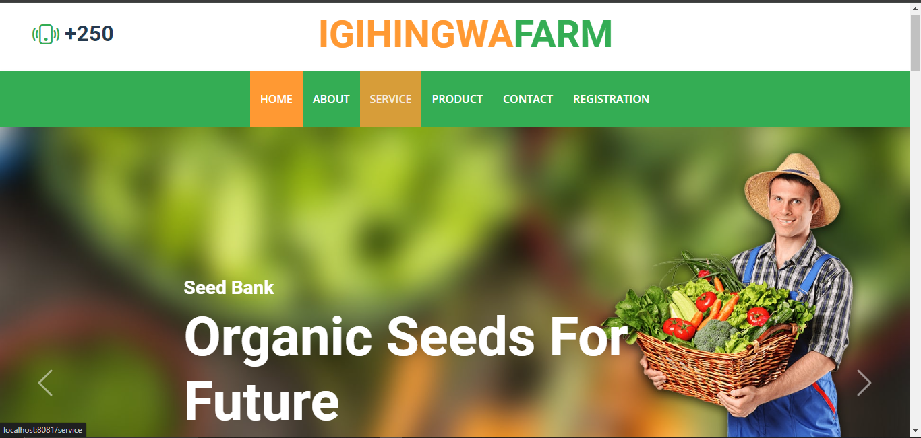

This is the IGIHINGWA FARM Homepage outlook where it displays the menu of the project web application consist of

Home, About, Service, Product, Contact, and Registration and the background Picture of the Organic Seeds for future

ABOUT

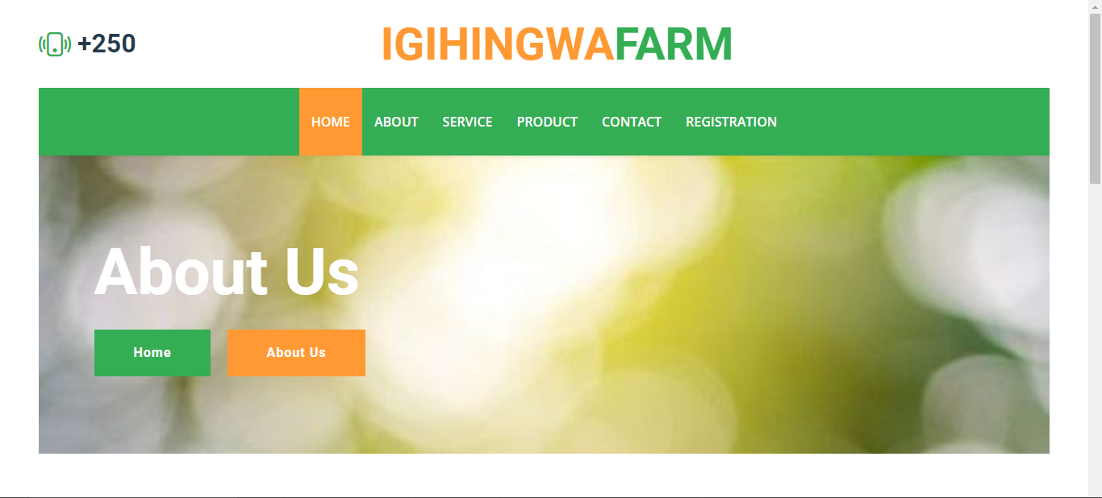

The About outlook with the description of the About us

SERVICE

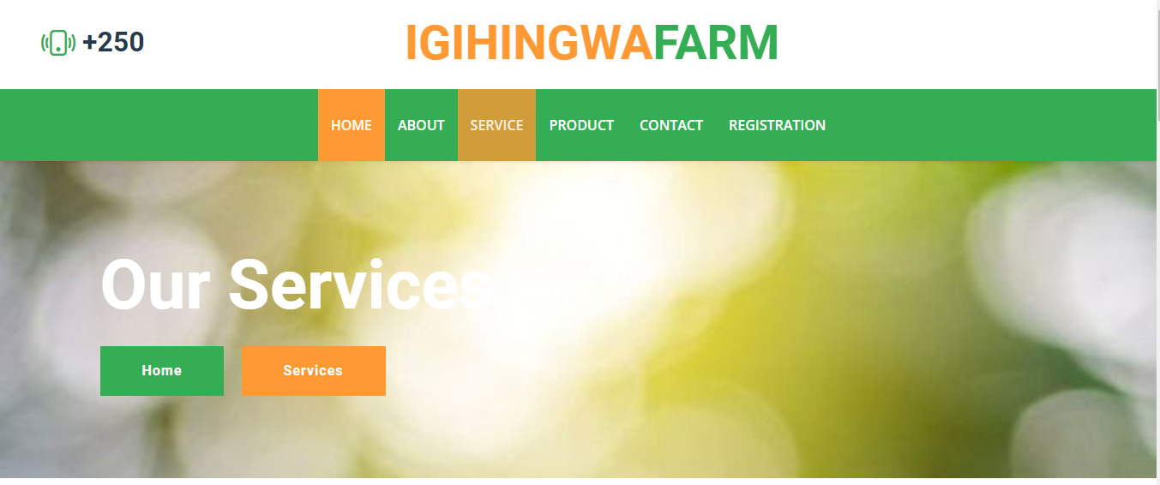

The Service page is crucial part of the IGIHINGWA Farm website, detailing the farm’s various services related to organic seeds. Users can learn about different services offered by the farm though this page

The Service page is structured with a header, service section, and a footer. each service section provides information about a specific aspect of the farm’s services.

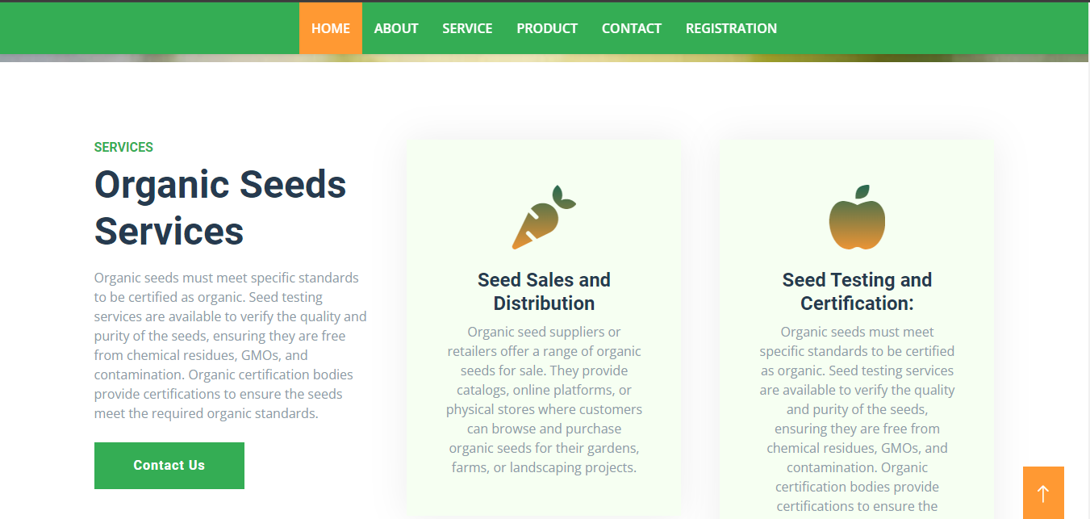

This section provide information about the standards organic seeds must meet, including testing service and organic certifications.

Understand the seed testing services available to verify the quantity and purity of seeds ensuring the meet organic standards

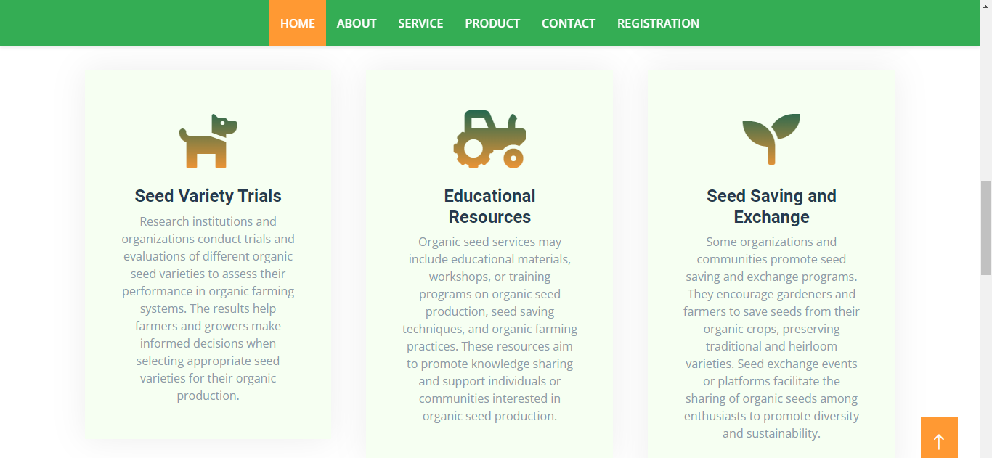

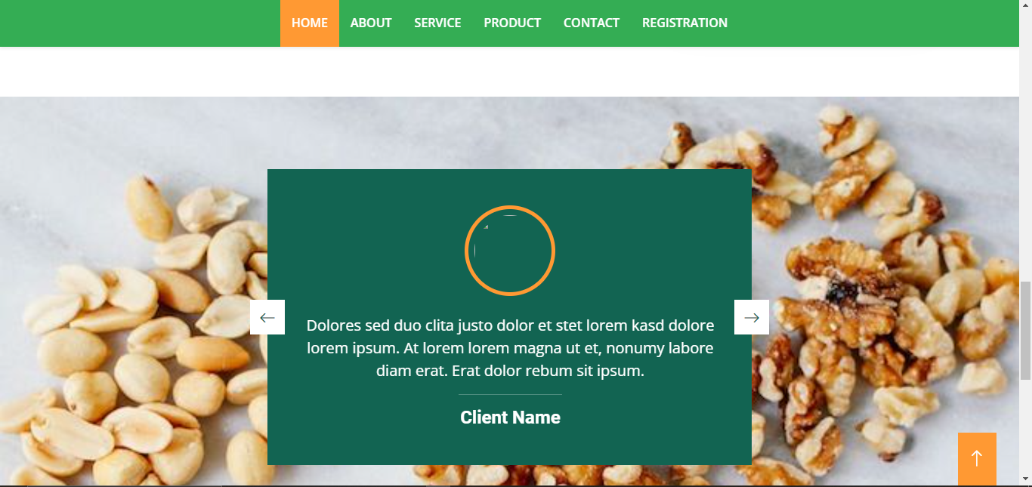

The service page serves an essential component of the IGIHINGWA Farm website, offering detailing information

About the farm’s services related to organic seeds. Regular updates content styles, and service to keep the page informative and engagement for visitors

PRODUCT

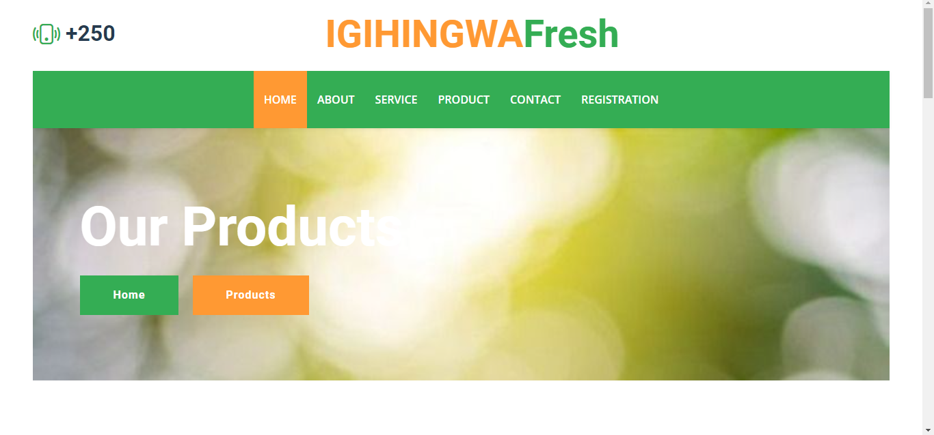

The Product Page of the IGIHINGEA Farm website showcases the various product offered by the farm. This documentation will guide you through understanding and customizing this Product page

This section visually represents different farm products.Each product is displayed with and image a brief description and a link for further details.

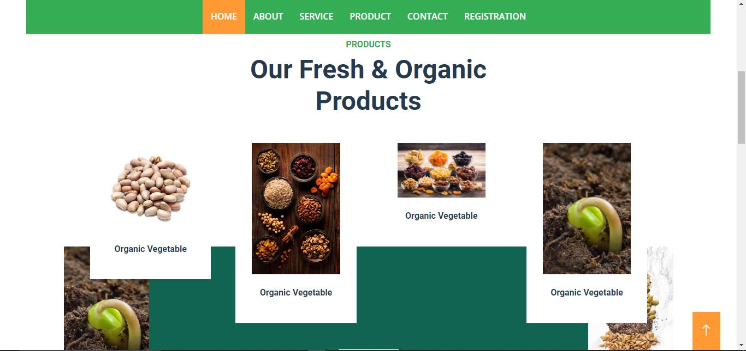

This section visually represents different farm product is displayed with an image of some product that offered by IGIHINGWA FARM system

CONTACT

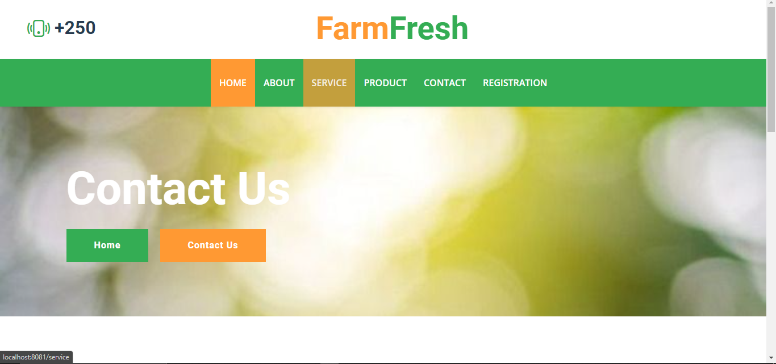

The Contact page of the IGIHINGWA Farm website facilitates communication between the users and the farm . This documentation will guide you through understanding and customize this Contact page

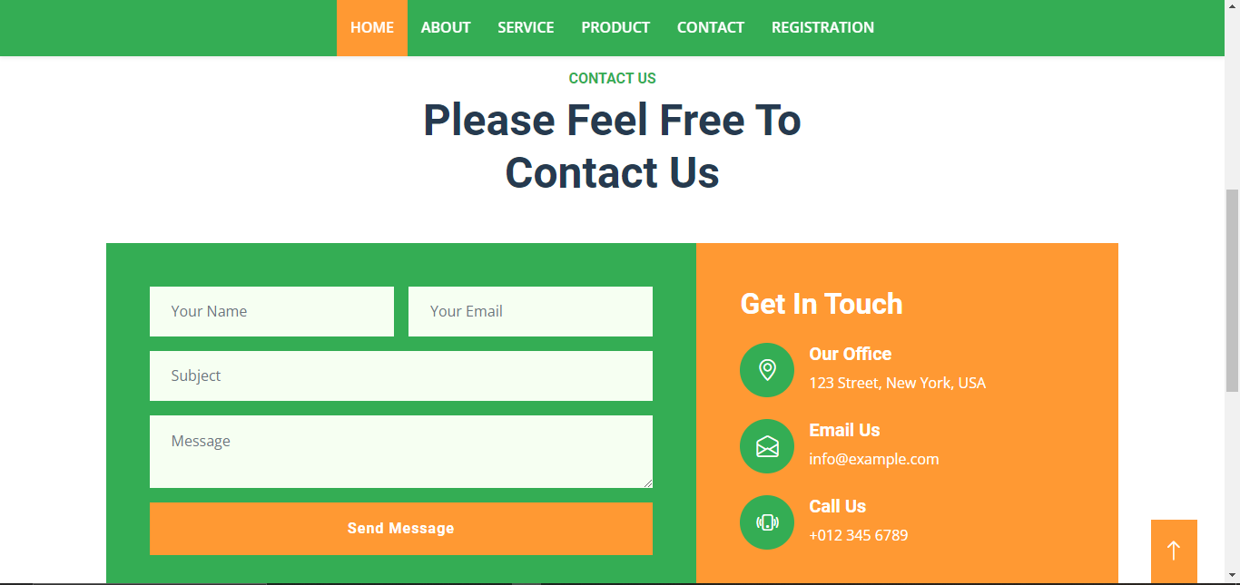

The contact Page which has the Registration form for the new users who want to create an account and some contact description and the website information consist with the our office, Email and where you can call us

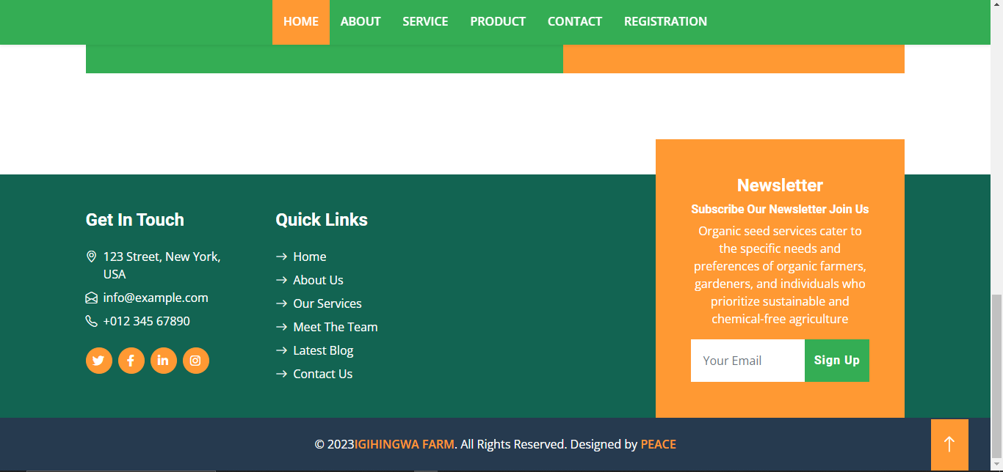

It’s a continuous Contact page which has the more information of where you can find us to Get in Touch and Quick Links for website information

REGISTRATION

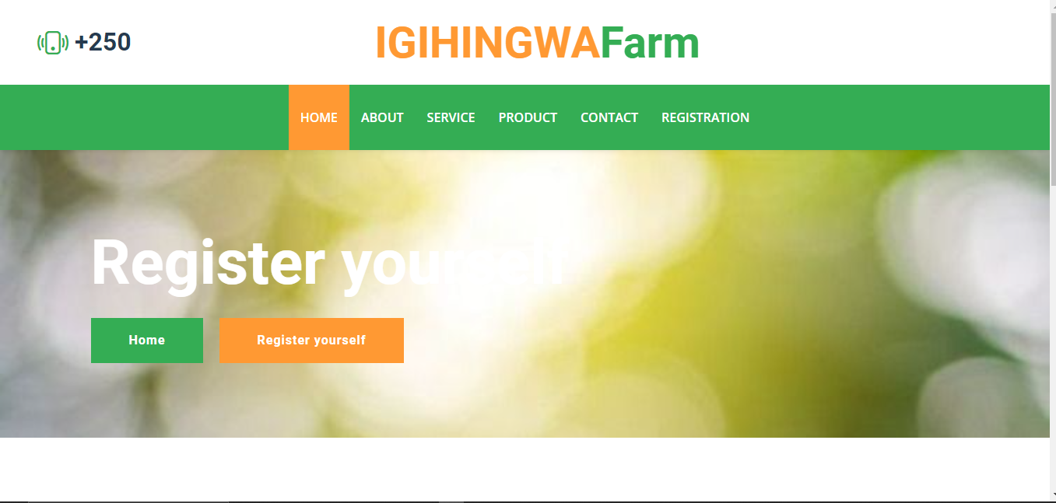

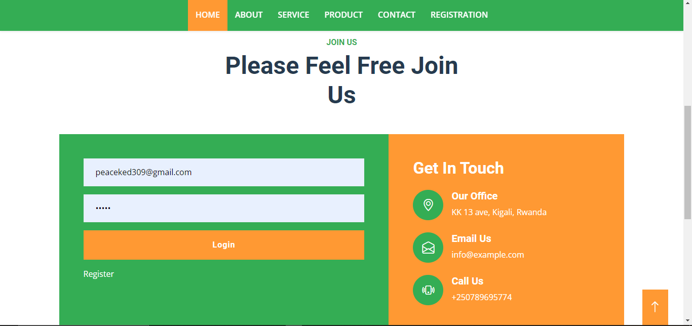

CREATE AN ACCOUNT

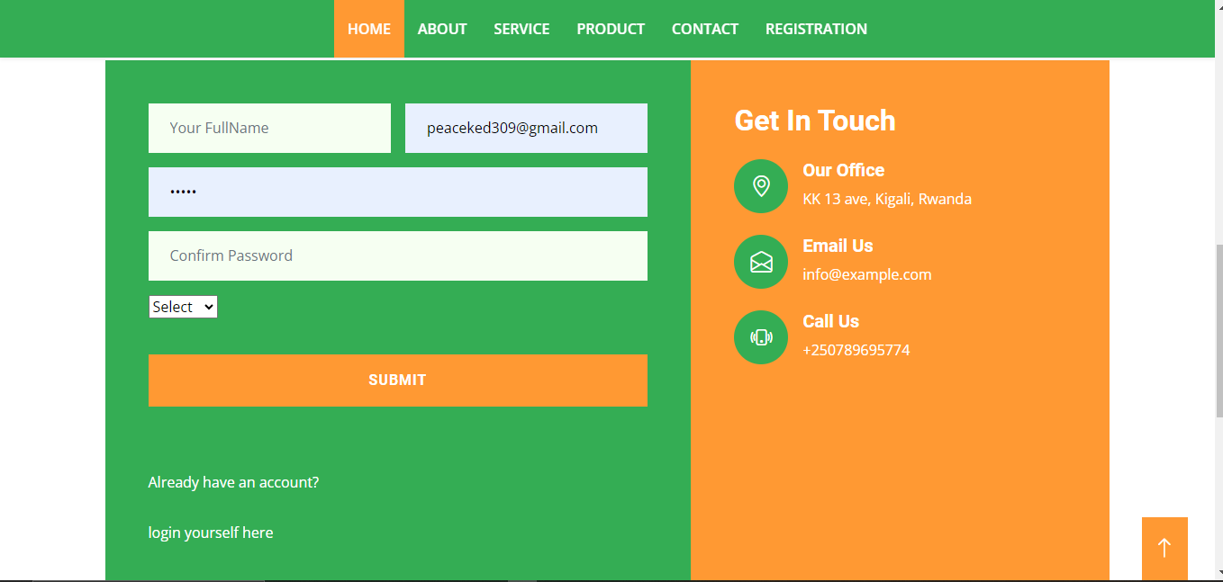

USER’S DASHBOARD

This the user Dashboard which shows the user who login in the system and their names and also their role

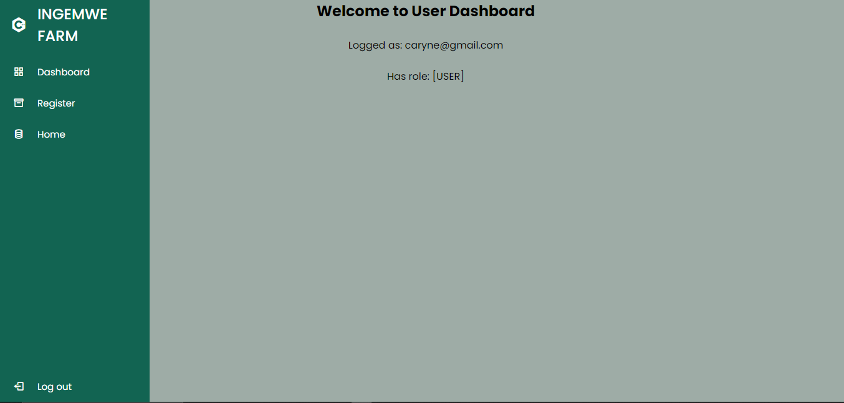

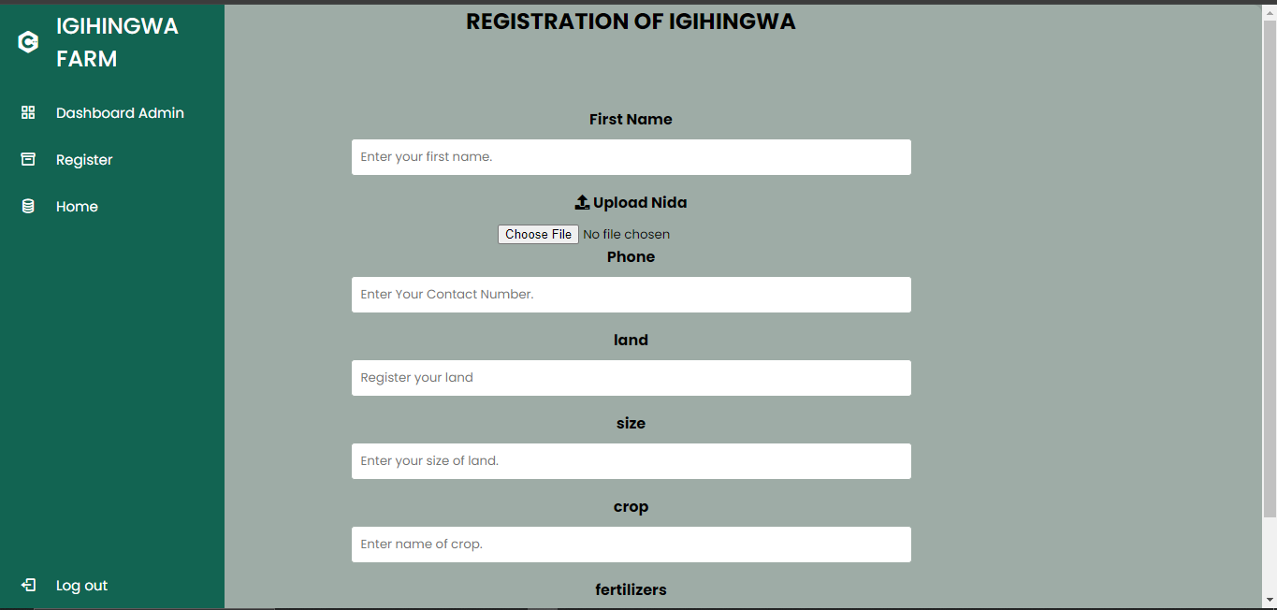



ADMIN DASHBOARD

this is the Admin dashboard where the admin views the list of users information on the registered their imbuto informations

