Abstract:

Build a general compiler that can understand and parse any Turing-complete language.

Process Model:

Incremental development Model

We will have two major increments (versions):

1. Build a special compiler:

In this stage of development, we attempt to build a compiler that understands exactly **one** Turing-complete language. The compiler will be designed with increment b in mind.

1. Generalize the compiler:

In this stage, the compiler will be generalized to accept any Turing complete language, given the rules of the language are defined.

Increment A:

Stages:

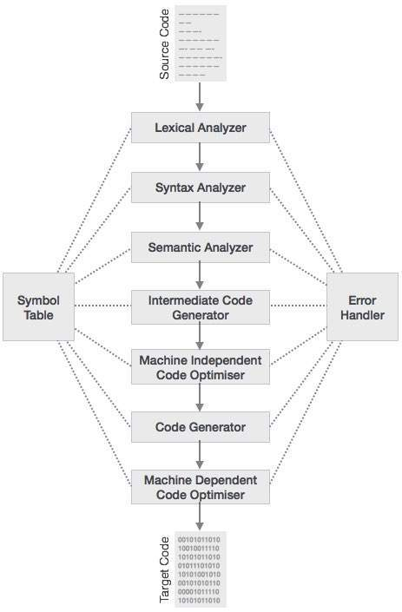

The details of each part are available at [1] and [2].

References:

1. Point, T. (2018, January 08). Compiler Design - Phases of Compiler. Retrieved March 13, 2018, from <https://www.tutorialspoint.com/compiler_design/compiler_design_phases_of_compiler.htm>
2. Mogensen, T. %. (2010). *Basics of compiler design*.