Abstract
The course of Instrumentation II is essentially related to design issues an electronics engineer faces in his/her career. The design we perform on classes and labs are not adequate as they don’t involve the rightful applications. Thus we have been asked to conduct a case study on a production industry related to our field and view how actual design principles are in practice.
This report presents an overview of the practical applications of electronics in Bottler’s Nepal Pvt. Ltd. There is nothing such as perfect in real world. Thus, we are proposing some modification in the plant to improve its production capacity efficiently.
We are not boasting that our proposed design is more faultless than the current one. As every coin has two sides the proposed design can also have its own flaws along with the new efficiency. However, being an Electronics Engineer we believe that our proposed design can improve the efficiency of the existing plant.

Introduction
Coca-cola, imported from India, was, first introduced into Nepal in 1973, with local production of coca-cola beginning in 1979.
Bottlers Nepal Limited (BNL) is the only bottler of Coca-cola products in Nepal, and has two bottling plants; namely Kathmandu (Bottlers Nepal Limited- BNL) and Bharatpur (Bottlers Nepal (Terai) Limited which is 160km from Kathmandu, its capital.
Coca-cola sabco operates in seven southern and East African countries and five Asian countries, and employs more than 9500 people. It operates 25 bottling plants and aims to fulfill the refreshment needs of more than 240 million consumers that live in its markets. It is a proud developing markets Anchor bottler.

Objectives of case study
The main objective of doing case study is to get acquainted about use instrumentation in real field. So we research about the application of different designs of electronics. We were guided to find any problems in the existing plant and propose a design to solve the problem. So in our case we propose a design to solve problems related to operation and manufacturing of coca cola.
Hence the main objective of our visit can be summarized as following:
- To visit the chosen organization and learn its operation under supervision of senior engineers and technicians.
- To study the existing management system and technology of company.
- To be familiar with various engineering aspects demanded by that particular company.
- To learn the vital role of engineer in a particular company.
- To learn about electronics design using microcontroller and microprocessor in commercial field. To observe the current system carefully and detect any fault in existing system if any.
- To propose solutions to boost the efficiency of the system.
The processing plant of coca-cola company has been installed in Balaju industrial state several years ago. All the processing plants are being closely monitored by Nepal ease technicians and engineers. The plant has been working smoothly.
Process of manufacturing:
- Preparation of bottles and cans.
- Chemicals
- Machinery Equipments
- Computers

- Preparation of bottles and cans: The pre-form for preparing Bottles are imported from India where as the pre-form for the PET bottles are manufactured in Bhutan and blown in Nepal using Blow Mold machine which outputs bottle and cans. The associated label is imported from India.
- Chemicals: The flavor used for the production of beverage is imported from South Africa and sugar from Dubai (U.A.E). The sugar required is of the quality prescribed by the company.
As coca-cola company is primarily a private owned company, has an obligation to fulfill various criteria for most of its work. The effect is seen in the procurement of materials and machines. The department, either mechanical, electrical or AC section identifies need for necessary equipments and prepares a report bases in it and forward it to material and management Department. The material management then seeks for the bidders and buys the needed materials and equipments in accordance with company rule and policy. Generally, the bidder with equipments meeting all the required specification as produced the coca-cola company and low in price obtains the tender to sell the equipments to company. Then material management department forwards the equipments to the departments that for material.
There are various operations implemented during the production and distribution of the products. They are
- Collection of bottles from every part of the country.
- Cleaning of the bottles with water jet.
- Testing of bottles for unwanted materials (EBI).
- Mixing of the ingredients in a proportion prescribed by coca-cola company (Atlanta).
- Automatic time controlled filling.
- Automatic capping.
- Automatic Date coding.
- COLLECTION OF BOTTLES:
Initially the empty bottles are collected from the retailers by the dealers. Now the bottles are brought to the company’s depot from the dealers. Further these bottles are fed to the plant for the next process.
- EBI(ELECTRONIC BOTTLE INDICATOR)TEST
The bottles are now cleaned by keeping the bottle in various positions and striking with the water jet. Then so called cleaned bottle is send to the EBI unit where the sensor senses any alien materials present in the bottle. The test if passed sends the bottle for further processing and if failed rejects the bottle and again the bottle is recycled. This unit also checks if there is any cracks in bottle.
- MIXING OF INGREDIENTS
In this unit, first of all the given proportion of the flavor is diluted with specified ratio of water with added sugar. Additional amount of flavors are also mixed up with the solution to give it the proper flavor. The mixture thus obtained is called syrup.
- AUTOMATIC TIME CONTROLLED FILLING UNIT
In this unit, the bottles passed from the EBI unit are filled the solution of the mixture on the time basis. The bottles are clamped by a robotics arm for a certain period of time during which the mixture is filled into it. The time duration is kept different for different sizes of bottles. Followed by the filling, the carbon dioxide gas is also introduced in the bottle with immediate capping. The carbon dioxide gas is used to make the solution harder and give it additional flavor. It is also used as preservative.
The capping is also done automatically. As soon as the mixture is carbonated, the caps loaded into the machine are locked onto the bottle ensuring the proper sealing.
- TEMPERATURE TEST UNIT
Here, the filled bottles are tested for the appropriate temperatures. The testing is performed by the bottles into water kept at 120 degree Celsius. If there is any impurity present in the mixture, certain symptoms like clotting etc may seem to occur. If such symptoms are encountered, the whole lot of the solution is discarded.
Block Diagram & Description of the Plant
PET (Polyethylenterepthalate)

Chiller
Blow Mold (sipa)
HP Compressor
Para mix Blender

Air
Rinser+Filter+cappe
Data Code
(Video jet)
Warmer
(Khs)
Lableller
(Krones)
Cartoon Taking

Chain
Conveyor

RGB (Returnable Glass)
Decrater (Ketlner)
Bottle Washer
(Crown/Bade)
EBI
(Empty Bottle)
Filling+ Crowner
Data Code
Carter

PRODUCTION:
The production of drinking soft drink in coca-cola company broadly involves four steps:
1. Importing spring water from various part of Kathmandu.
2. Purification of soft drink.
3. Washing and filling of bottles.
4. Storage
1. Importing spring water from various part of Kathmandu.
As there is no boring in coca-cola company, the company has to import spring water. It imports spring water from various part of Kathmandu such as Balaju water supply etc.
2. Purification of water
Purification of water is a very important process. The brand name depends on the production pure water. The basic block diagram for purification of water is shown below:
Chlorine
Spring water
Ozone
Generator

Pure water for packing (should be left for at least 4 hours before drinking)
Ozone contact Tank
Reverse
Osmosis
Sedimentation Tank (sediment for 6-8 hours)
+
Chlorination
Sand filter (Removes suspended particles)
AM filter (Anthracite & manganese filter)
Carbon filter (Removes organic Residue)
Softener (Removes hardness of water)
Bag filter (Removes microscopic particles up to 5 microns)
Candle filter

Fig 1.Water Purification Plant
Water is obtained as spring water. The water is then collected in sedimentation Tank. The simple process of sedimentation allows heavy suspended particles to settle down. The process of chlorination is also performed in this tank. Chlorination is the process of adding the element to water as a method of water purification to make it fit for human consumption as drinking water. Water which has been treated with chlorine is effective in preventing the spread of disease.
Next, pressurized water is passed through a variety of filters as shown in the figure. First, the water is passed through sand filter. A sand filter is a basic tool of water purification passing flocculated water through a sand filter strains out the flock and the particles trapped within it. The medium of filter is sand of varying grades. As water flows through the sand, impurities such as solids, precipitates, turbidity and in some case even bacterial particles are filtered out. After being filtered through the sand filter water is then filtered for any anthracite and manganese through AM filter.

Next, water is passed through carbon filter. Carbon filters are most effective at removing chlorine and volatile organic compounds from water. They are not generally effective at removing minerals, salt, and dissolved inorganic compounds. Spring water generally is exposed to variety of minerals underground. This causes the formation of hard water. Hard water is the one with high mineral content. Hard water deposits can serve as a medium for bacterial growth and irritation. During purification the mineral ions are exchanged with the ions that don’t cause hardness.
Then, water is passed through bag filter to remove suspended particles smaller than 5 microns and finally through candle filter.
After completion of the purification reverse osmosis is performed. The term reverse osmosis comes from the process of osmosis, the natural movement of solvent from an area of low solute concentration, through a membrane to an area of high solute concentration if no external pressure is applied. Reverse osmosis is the process of pushing a solution through a filter that traps the solute on one side and allows the pure solvent to be obtained from the other side. More formally, it is the process of forcing a solvent from a region of high solute concentration through a membrane to a region of low solute concentration by applying a pressure in excess of the osmotic pressure. This process removes minerals in the water and is best known for it’s used in desalination.
The final stage of purification involves sterilizing water with ozone. Ozone is bubbled in ozone contact tank to sterilize water from any remaining contamination. Ozone is an excellent sterilizing agent without any effects. As ozone is unstable it breaks down into oxygen molecules after some time.
3. Washing and filling of bottles
The PC (polycarbonate) bottles are the reusable bottles. They have a capacity of holding 19 liters of water. The company distributes filled bottles and collects the empty bottles from the customers.
The equipments used are fine at performing the corresponding job assigned to them. The equipments are from snap co. The equipments is separated into two section for washing and filling water respectively. The overall block diagram is shown below.
Clean bottles
Manual input of unclean bottles
Automatic jet washer
(Cap snap co)
Filter and capper
Delivery trolley

Fig 2. Washing and filling of PC jars
The reusable bottles encounter a variety of environments and thus are susceptible to contamination. The first process is thus cleaning of the bottles as soon as they arrive at the company. Although the machine cleaning is sufficient enough, the bottles are first manually cleaned by sprinkling detergent water. Then the bottles are transported to automatic jet washer. An employee observes for any cracks and unwanted residues that cannot be removed. S/He then mounts them in the Automatic jet Washer one by one. The bottles are rotated in a convey halting at certain points. When halted a jet of detergent water with chlorine jets into the bottle. Next it is washed by recalculating water. Then the bottle is washed by hyper assonated water to remove any remaining infections.

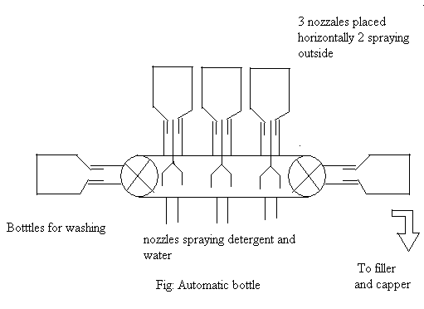

The Automatic bottle Washer performs the first three tasks. The water is filled and the bottle sealed at filler and capper. The filler and capper section first detects the arrival of bottle and lifts them off the convey belt. It is then filled with soft drink. The bottle is not released until the next one arrives. After being released the caps are placed on the mouth of the bottle and sealed. The filled bottles are then loaded in a trolley and taken to storage facility.

4. Storage
The assonated soft drink is not suitable for drinking. Since, ozone is unstable it breaks down into oxygen molecules, the soft drink has to be left aside for at least four hours. Coca-cola Company, however stores the recently packed bottles for one whole day. They are dispatched only on the other day.
The purification of the water is quite perfect and employs a number of filters to remove impurities and infections. However, the washing and filling stations employ electro mechanics. The current system is only based on the timing sequences. The processes repeat itself in a fixed duration of time. The disorder in any timing sequences can disrupt the whole system. Also, if any sequence is to be rearranged the entire system may have to be dismantled for a small purpose.
Here, we purpose a microprocessor based automatic washing and filling station, which has a much easier control structure.
The different instruments and devices we propose to add are:
- Bottle sensor: These can be anything from simple limit switch to IR sensors to detect the presence of the bottle at that position. The detected signal is used as an input to microcontroller or the counter.
- Solenoid valve: Solenoid valve are valves controlled via electrical signals. The proposed design uses four of them. Three solenoid valves are used in the Automatic Jet Washer while the final one is fill the bottle with pure soft drink.
- Temperature sensors: Although sensors are already present in the previous design we will use the temperature sensor to maintain the temperature using heaters and coolers.
- Load cell: Previously no weighing machine was used. The time a bottle took to fill was estimated to be around 10-12 seconds. Now we proposed to add a weighing machine and weigh the amount of soft drink filled. The weight information will be used to control the amount of soft drink.
- User keypad: This is a new feature allows user to make different modifications according to his need.
- Electromagnetic lift: This is a magnetic lift the bottles during filling of soft drink.
- Press: This may be a hydraulic press or any other one seal the bottle.
- LCD Display: The display shows the temperature in the automatic bottle washer and the total number of production in the factory.
The block diagram of the proposed bottle washer is as shown in fig below. The new jet washer incorporates the use of bottle sensors to jet the soft drink in the corresponding slot. If the bottle is into present in a slot then the corresponding jet will not eject soft drink. This design allows the plant to save water, detergent and hyper assonated water.
First the jets are in the off state. As soon as the motors stall the sensors checks the corresponding location. If the slot is full then the solenoid valve corresponding to the slot is activated. After 10 seconds the jet are turned off and the motor rotates for about 2 seconds to move the bottle to next cleaning location. Again the slots are checked and results verified to open the equivalent solenoid valve. After the washing is complete the bottles are passed on to the conveyer belt to pass bottle to filling and capping station.
After the bottle is washed it is transported to the filling section by a convey line. But it should be remembered that convey should transported the bottles smoothly without any
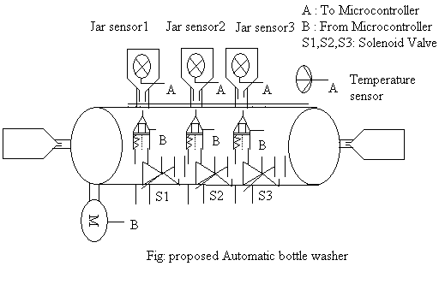

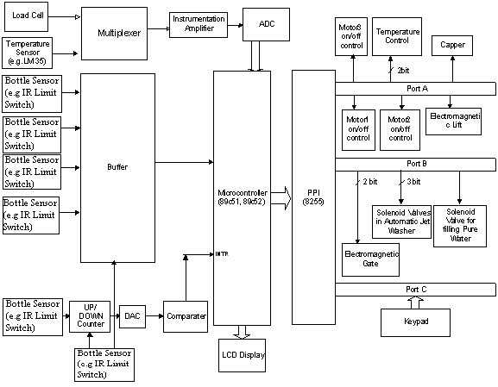
Fig . Block Diagram of Proposed Design

