

Python Project Report
Minesweeper with SAT Solver

01286121 Computer Programming
Software Engineering Program

By

68011354 Jiramet Harnjan

Python Project
Minesweeper with SAT Solver

Project Description

This is a program that recreates the game Minesweeper. “Minesweeper is a logic puzzle video game genre. The game features a grid of clickable tiles, with hidden "mines" dispersed throughout the board. The objective is to clear the board without detonating any mines, with help from clues about the number of neighboring mines in each field.

Cells have three states: unopened, opened and flagged. An unopened cell is blank and clickable, while an opened cell is exposed. Flagged cells are those marked by the player to indicate a potential mine location.

A player selects a cell to open it. If a player opens a mined cell, the game ends. Otherwise, the opened cell displays either a number, indicating the number of mines vertically, horizontally or diagonally adjacent to it, or a blank tile (or "0"), and all adjacent non-mined cells will automatically be opened. Players can also flag a cell, visualised by a flag being put on the location, to denote that they believe a mine to be in that place. Flagged cells are still considered unopened, and a player can click on them to open them”

This program also features a SAT solver that automatically open cells and flag mines.

The full code can be found here.

Screen Capture of your Program

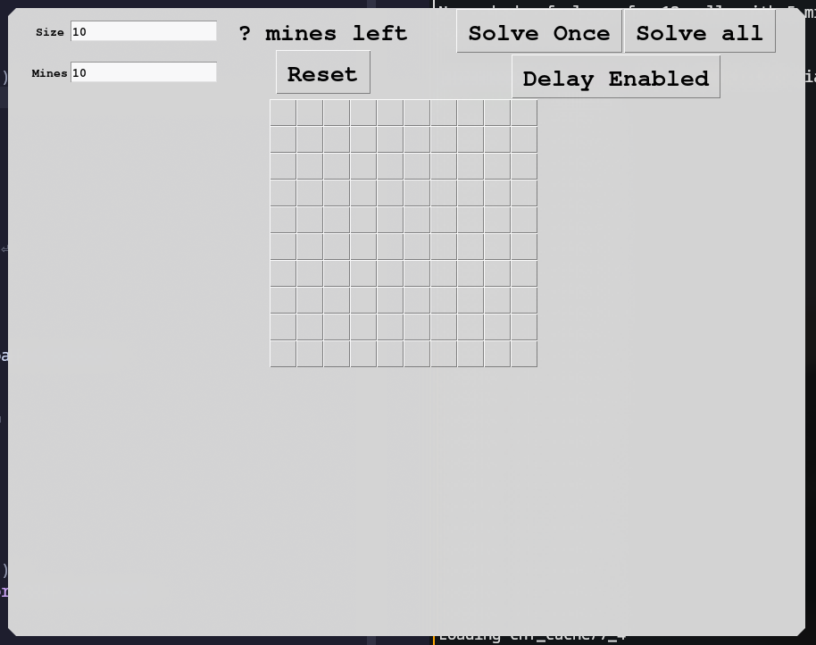
Screen1

Screen2
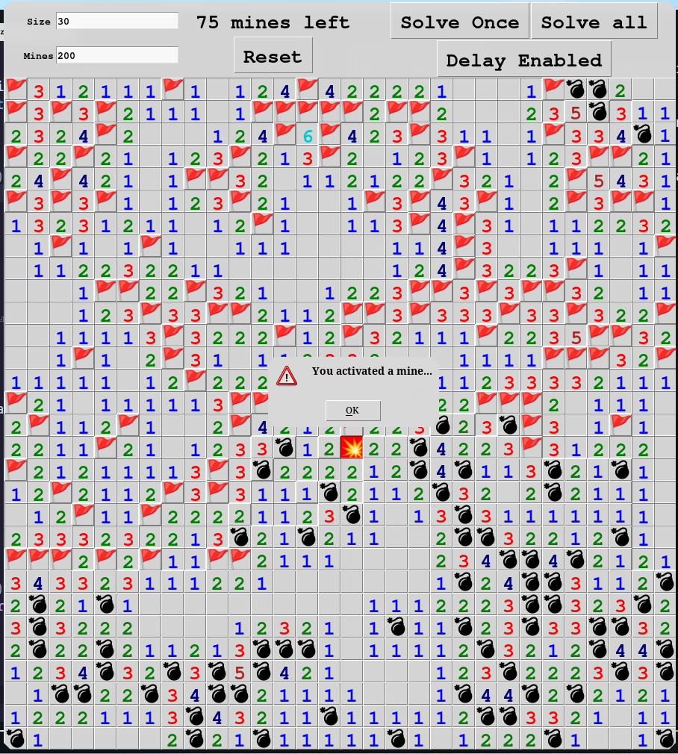

Screen 3
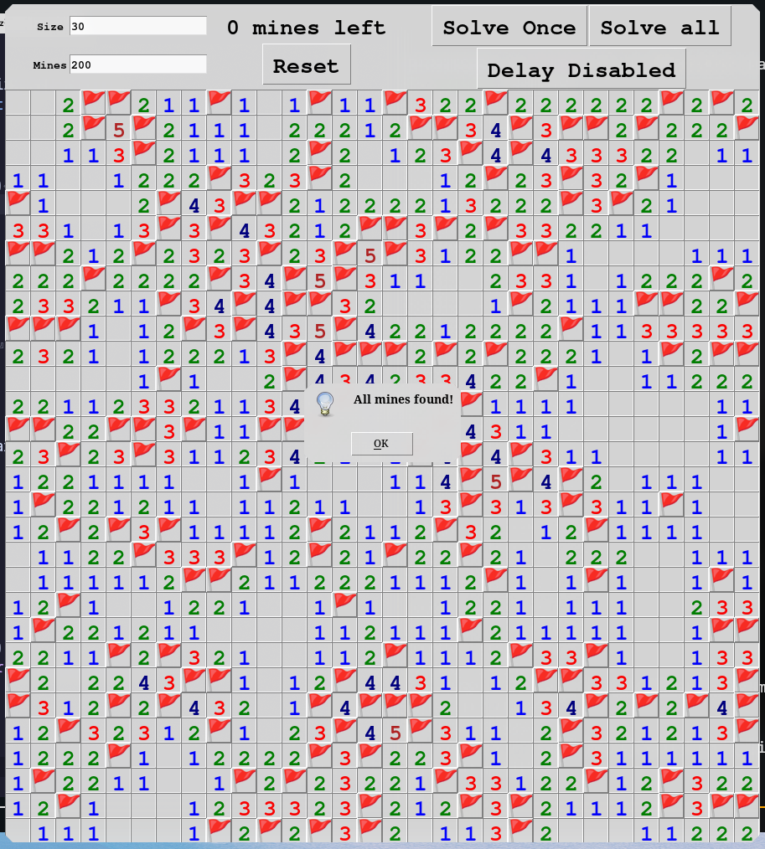

Project Source Codes
game.py:

import tkinter as tk
from tkinter import messagebox
import random
import solver
import time

font = ("Courier", 20, "bold")
small_font = ("Courier", 10, "bold")

dpos = [(1, 0), (-1, 0), (0, 1), (0, -1), (1, 1), (-1, -1), (1, -1), (-1, 1)]
cell_number_colors = [
"blue",
"green",
"red",
"navy",
"firebrick",
"darkturquoise",
"black",
"darkgray",
]

cell_content_bomb = "💣"
cell_content_bomb_exploded = "💥"
cell_content_flag = "🚩"
cell_content_flag_wrong = "❌"

class Board(tk.Frame):
def __init__(self, master, board_size, mines, cell_size):
super().__init__(master)
self.board_size = board_size
self.mines = mines
self.cell_size = cell_size
self.board_generated = False
self.initialize_cell_buttons()
self.interaction_enabled = True

def reset(self):
for column in self.cell_buttons:
for button in column:
button.destroy()
self.board_generated = False
self.initialize_cell_buttons()

def initialize_board_data(self):
self.exploded = False
self.cells_revealed = set()
self.cells_flagged_locations = set()
self.cells_grid_flagged = [[False for i in range(self.board_size)] for i in range(self.board_size)]
self.cells_grid_info = [[0 for i in range(self.board_size)] for i in range(self.board_size)]
self.cells_unrevealed = { (x, y) for x in range(self.board_size) for y in range(self.board_size)}
self.mine_locations = set()

def setup_grid_info(self):
for x, y in self.mine_locations:
for dx, dy in dpos:
test_x = x + dx
test_y = y + dy
if not 0 <= test_x < self.board_size or not 0 <= test_y < self.board_size:
continue
if not type(self.cells_grid_info[test_x][test_y]) is int:
continue

self.cells_grid_info[test_x][test_y] += 1

def generate_random_board(self):
self.initialize_board_data()
for _ in range(self.mines):
mine_x = random.randint(0, self.board_size - 1)
mine_y = random.randint(0, self.board_size - 1)
self.cells_grid_info[mine_x][mine_y] = '*'
self.mine_locations.add((mine_x, mine_y))
self.setup_grid_info()

def setup_custom_board(self, mine_locations=None, cells_to_reveal=None, cells_to_flag=None):
self.initialize_board_data()
if mine_locations:
self.mine_locations = set(mine_locations)
for x, y in self.mine_locations:
self.cells_grid_info[x][y] = '*'
self.setup_grid_info()
if cells_to_reveal:
for pos in cells_to_reveal:
board.reveal_cell(*pos)
if cells_to_flag:
for pos in cells_to_flag:
board.cell_flag(*pos)

def initialize_cell_buttons(self):
self.cell_buttons = []
for x in range(self.board_size):
column = []
for y in range(self.board_size):
# Make button square
cell_button_frame = tk.Frame(
self,
width=self.cell_size,
height=self.cell_size,
)
cell_button_frame.grid_propagate(False) # Prevent the frame from resizing
cell_button_frame.grid_columnconfigure(0, weight=1) # Allows the button to fill the frame
cell_button_frame.grid_rowconfigure(0, weight=1)
cell_button_frame.grid(column=x, row=y, sticky=tk.NSEW)

cell_button = tk.Button(
cell_button_frame,
font=font,
highlightthickness=0,
)
cell_button.configure(command=self.on_cell_left_clicked(x, y))
cell_button.bind("<Button-3>", self.on_cell_right_clicked(x, y))
cell_button.grid(column=0, row=0, sticky=tk.NSEW)
column.append(cell_button_frame)
self.cell_buttons.append(column)

def button_at(self, x, y):
if not (0 <= x < self.board_size \
and 0 <= y < self.board_size):
return None

return self.cell_buttons[x][y].winfo_children()[0]

def pos_inside_board(self, x, y):
return 0 <= x < self.board_size and 0 <= y < self.board_size

def cell_is_revealed(self, x, y):
return (x, y) in self.cells_revealed

def cell_is_empty(self, x, y):
return self.cells_grid_info[x][y] == 0

def cell_is_number(self, x, y):
val = self.cells_grid_info[x][y]
if not isinstance(val, int):
return False
return 1 >= val >= 8

def cell_is_bomb(self, x, y):
return self.cells_grid_info[x][y] == "*"

def cell_is_flagged(self, x, y):
return self.cells_grid_flagged[x][y]

def show_cell_button(self, x, y):
if self.cell_is_empty(x, y):
if self.cell_is_flagged(x, y):
self.button_at(x, y).config(
text=cell_content_flag,
)
elif self.cell_is_bomb(x, y):
if self.cell_is_flagged(x, y):
self.button_at(x, y).config(
text=cell_content_flag,
)
else:
color = "black"
self.button_at(x, y).config(
text=cell_content_bomb,
disabledforeground=color,
foreground=color
)
else:
if self.cell_is_flagged(x, y):
self.button_at(x, y).config(
text=cell_content_flag_wrong,
foreground="red",
disabledforeground="red",
)
else:
color = cell_number_colors[self.cells_grid_info[x][y] - 1]
content = str(self.cells_grid_info[x][y])
self.button_at(x, y).config(
text=content,
disabledforeground=color,
foreground=color
)

def reveal_cell(self, x, y):
if (x, y) in self.cells_revealed:
return

self.cells_unrevealed.remove((x, y))
self.cells_revealed.add((x, y))
if self.cell_is_empty(x, y) and not self.cell_is_flagged(x, y):
for dx, dy in dpos:
testx = x + dx
testy = y + dy
if 0 <= testx < self.board_size \
and 0 <= testy < self.board_size \
and type(self.cells_grid_info[testx][testy]) is int:
self.reveal_cell(testx, testy)

self.button_at(x, y).config(
relief=tk.SUNKEN,
state=tk.DISABLED,
)

if self.cell_is_empty(x, y):
pass
elif self.cell_is_bomb(x, y):
self.button_at(x, y).config(
text=cell_content_bomb_exploded,
disabledforeground="black",
background="red"
)
else:
self.button_at(x, y).config(
text=str(self.cells_grid_info[x][y]),
disabledforeground=cell_number_colors[self.cells_grid_info[x][y] - 1]
)
self.cells_revealed.add((x, y))

def reveal_all(self):
for x in range(self.board_size):
for y in range(self.board_size):
if (x, y) in self.cells_revealed:
continue

self.show_cell_button(x, y)
self.button_at(x, y).config(
state=tk.DISABLED
)

def find_number_cells_adjacent_to_unrevealed_cell(self):
cells = set()
for mine_x, mine_y in self.mine_locations:
for dx, dy in dpos:
testx = mine_x + dx
testy = mine_y + dy
if not self.pos_inside_board(testx, testy) \
or not self.cell_is_revealed(testx, testy) \
or (testx, testy) in self.mine_locations:
continue

number_cell_x, number_cell_y = testx, testy
for dx, dy in dpos:
testx = number_cell_x + dx
testy = number_cell_y + dy
if not self.cell_is_revealed(testx, testy):
continue
cells.add((number_cell_x, number_cell_y))
break
return cells

def cell_flag_without_event(self, x, y):
if (x, y) in self.cells_revealed or self.exploded:
return
self.button_at(x, y).config(text=cell_content_flag, state=tk.DISABLED)
self.cells_grid_flagged[x][y] = True
self.cells_flagged_locations.add((x, y))

def cell_flag(self, x, y):
self.cell_flag_without_event(x, y)
self.event_generate("<<CellFlagged>>")

def cell_unflag(self, x, y):
if (x, y) in self.cells_revealed or self.exploded:
return
self.button_at(x, y).config(text="", state=tk.NORMAL)
self.cells_grid_flagged[x][y] = False
self.cells_flagged_locations.remove((x, y))
self.event_generate("<<CellUnflagged>>")

def on_cell_left_clicked(self, x, y):
def on_cell_left_clicked_inner():
if not self.interaction_enabled:
return

# Attempts til giving up generating good start
attempts = 1000
while not self.board_generated:
self.generate_random_board()
attempts -= 1
if not self.cell_is_empty(x, y) and attempts > 0:
continue
self.board_generated = True
self.event_generate("<<BoardGenerated>>")
break

if self.cells_grid_info[x][y] == "*":
self.reveal_cell(x, y)
self.reveal_all()
self.event_generate("<<CellExploded>>")
self.exploded = True
else:
self.reveal_cell(x, y)
self.event_generate("<<CellRevealed>>")

return on_cell_left_clicked_inner

def on_cell_right_clicked(self, x, y):
def on_cell_right_clicked_inner(event):
if not self.interaction_enabled:
return
if not self.board_generated \
or (x, y) in self.cells_revealed \
or self.exploded:
return
if self.cells_grid_flagged[x][y]:
self.cell_unflag(x, y)
else:
self.cell_flag(x, y)
return on_cell_right_clicked_inner

def update_mines_left_label(args):
mines_left = len(board.mine_locations) - len(board.cells_flagged_locations)
mines_left_str.set(f"{mines_left} mines left")

def check_board_completed(args):
if len(board.mine_locations) == len(board.cells_flagged_locations) \
and len(board.cells_revealed) == board.board_size * board.board_size - len(board.mine_locations):
messagebox.showinfo("Game completed", "All mines found!")
board.interaction_enabled = False

def exploded(args):
messagebox.showwarning("Game over", "You activated a mine...")

def reset():
try:
board.board_size = int(board_size_var.get())
board.mines = int(mines_var.get())
except:
pass
board.reset()
mines_left_str.set(f"? mines left")
board.interaction_enabled = True

def tksleep(t):
'emulating time.sleep(seconds)'
ms = int(t*1000)
root = tk._get_default_root()
var = tk.IntVar(root)
root.after(ms, lambda: var.set(1))
root.wait_variable(var)

def solve_once():
if not board.board_generated or board.exploded:
return

result = solver.solve_once(board)
if result == None:
print("Cannot solve")
return

# Nice animation
delay = 0.005
for cell, is_mine in result.items():
if not board.board_generated or board.exploded:
break

if enable_delay.get():
tksleep(delay)
x, y = cell
if is_mine:
board.cell_flag_without_event(x, y)
else:
if not board.exploded:
board.reveal_cell(x, y)
if board.cells_grid_info[x][y] == "*":
board.reveal_all()
board.exploded = True
break

if board.exploded:
board.event_generate("<<CellExploded>>")
board.event_generate("<<CellFlagged>>")

def solve_all():
while True:
result = solver.solve_once(board)
if result == None:
print("Solve all finished")
return
if not board.board_generated or board.exploded:
return

delay = 0.005
for cell, is_mine in result.items():
if enable_delay.get():
tksleep(delay)
x, y = cell
if is_mine:
board.cell_flag_without_event(x, y)
else:
if not board.exploded:
board.reveal_cell(x, y)
if board.cells_grid_info[x][y] == "*":
board.reveal_all()
board.exploded = True

if board.exploded:
board.event_generate("<<CellExploded>>")
board.event_generate("<<CellFlagged>>")

def toggle_solver_delay():
if enable_delay.get():
enable_delay.set(False)
toggle_delay_text.set("Delay Disabled")
else:
enable_delay.set(True)
toggle_delay_text.set("Delay Enabled")

# Preemptively load caches for common cases
for neighbors_count in range(1, 8):
for mines_count in range(1, neighbors_count + 1):
solver.load_cache(neighbors_count, mines_count)

root = tk.Tk()

top_bar = tk.Frame()
top_bar.grid(column=0, row=0, ipadx=50)
top_bar.grid_columnconfigure(0, weight=1)
top_bar.grid_columnconfigure(1, weight=1)

gameplay_ui = tk.Frame(top_bar)
gameplay_ui.grid(column=0, row=0)
gameplay_ui.grid_rowconfigure(0, weight=1)
gameplay_ui.grid_rowconfigure(1, weight=1)

mines_left_str = tk.StringVar()
mines_left_str.set("? mines left")
mines_left_label = tk.Label(gameplay_ui, textvariable=mines_left_str, font=font)
mines_left_label.grid(column=2, row=0)

reset_button = tk.Button(gameplay_ui, text="Reset", font=font, command=reset)
reset_button.grid(column=2, row=1)

def board_size_entry_on_invalid():
board_size_entry.delete(0, "end")
board_size_entry.insert(0, board.board_size)

board_size_var = tk.StringVar()
board_size_var.set(10)
board_size_entry = tk.Entry(
gameplay_ui,
textvariable=board_size_var,
font=small_font,
validate="focusout",
validatecommand=(
root.register(lambda v: v.isdigit()),
"%P"
),
invalidcommand=board_size_entry_on_invalid
)
board_size_entry.grid(column=1, row=0, padx=(0, 20))
size_label = tk.Label(gameplay_ui, text="Size", font=small_font)
size_label.grid(column=0, row=0)

def mines_entry_on_invalid():
mines_entry.delete(0, "end")
mines_entry.insert(0, str(board.mines))

mines_var = tk.StringVar()
mines_entry = tk.Entry(
gameplay_ui,
textvariable=mines_var,
font=small_font,
validate="focusout",
validatecommand=(
root.register(lambda v: v.isdigit() and int(v) < int(board_size_var.get()) * int(board_size_var.get())),
"%P"
),
invalidcommand=mines_entry_on_invalid,
)
mines_entry.insert(0, "10")
mines_entry.grid(column=1, row=1, padx=(0, 20))
mines_label = tk.Label(gameplay_ui, text="Mines", font=small_font)
mines_label.grid(column=0, row=1)

solver_ui = tk.Frame(top_bar)
solver_ui.grid(column=1, row=0)
solver_ui.grid_rowconfigure(0, weight=1)
solver_ui.grid_rowconfigure(1, weight=1)

solve_once_button = tk.Button(solver_ui, text="Solve Once", font=font, command=solve_once)
solve_once_button.grid(column=0, row=0)

solve_all_button = tk.Button(solver_ui, text="Solve all", font=font, command=solve_all)
solve_all_button.grid(column=1, row=0)

toggle_delay_text = tk.StringVar()
toggle_delay_text.set("Delay Enabled")
enable_delay = tk.BooleanVar()
enable_delay.set(True)
delay_button = tk.Button(solver_ui, textvariable=toggle_delay_text, font=font, command=toggle_solver_delay)
delay_button.grid(column=0, row=1, columnspan=2)

board = Board(root, 10, 10, 30)
board.grid(column=0, row=1)

# test_board(board)

board.bind("<<BoardGenerated>>", update_mines_left_label)
board.bind("<<CellFlagged>>", update_mines_left_label)
board.bind("<<CellUnflagged>>", update_mines_left_label)

board.bind("<<BoardGenerated>>", check_board_completed, True)
board.bind("<<CellFlagged>>", check_board_completed, True)
board.bind("<<CellUnflagged>>", check_board_completed, True)
board.bind("<<CellRevealed>>", check_board_completed, True)

board.bind("<<CellExploded>>", exploded)

root.mainloop()

solver.py:

from pysat.formula import CNF
from pysat.solvers import Solver

dpos = [(1, 0), (-1, 0), (0, 1), (0, -1), (1, 1), (-1, -1), (1, -1), (-1, 1)]

cache_directory = "cnf_cache"

cache = {}

# Return True if cache exists, False otherwise.
def load_cache(cells_count, mines_count):
cnf = []
path = f"{cache_directory}/{cells_count}_{mines_count}"
try:
f = open(path)
except OSError as e:
return False

print(f"Loading {path}")
for line in f:
if line.startswith("="):
break
clause = filter(lambda x: x != '', line.strip().split(" "))
clause = map(int, clause)
cnf.append(list(clause))
cache[(cells_count, mines_count)] = cnf
return True

def get_cached_cnf(cells_count, mines_count):
if not (cells_count, mines_count) in cache:
has_cache = load_cache(cells_count, mines_count)
if not has_cache:
return None

return cache[(cells_count, mines_count)]

# The translate the atoms within local CNF from the cache
# to atoms that uniquely represent the cells
def translate_cached_cnf(cnf, cell_ids, mines_count):
new_cnf = []
for clause in cnf:
new_clause = []
for atom in clause:
if atom < 0:
new_atom = -cell_ids[(-atom) - 1]
else:
new_atom = cell_ids[atom - 1]
new_clause.append(new_atom)
new_cnf.append(new_clause)
return new_cnf

def get_cnf(cell_names, mines_count):
cnf = get_cached_cnf(len(cell_names), mines_count)
if cnf == None:
return None
return translate_cached_cnf(cnf, cell_names, mines_count)

def solve_once(board):
# Converts (x, y) positions to the integer format accepted by pysat
def pos_to_atom(x, y, board_width):
index = y * board_width + x
return index + 1

def atom_to_pos(index, board_width):
index = index - 1
return (index % board_width, index // board_width)

adjacent_cnf = CNF()

number_cells_to_check = board.find_number_cells_adjacent_to_unrevealed_cell()
for x, y in number_cells_to_check:
flagged_neighbor = set()
unrevealed_neighbor = set()
for dx, dy in dpos:
testx = x + dx
testy = y + dy
if not board.pos_inside_board(testx, testy):
continue
if board.cell_is_flagged(testx, testy):
flagged_neighbor.add((testx, testy))
if not board.cell_is_revealed(testx, testy):
unrevealed_neighbor.add((testx, testy))

# Or also called the number for the number cell
mine_nearby_count = board.cells_grid_info[x][y]

unrevealed_neighbor = [pos_to_atom(x, y, board.board_size) for x, y in unrevealed_neighbor]
adjacent_cnf_clauses = get_cnf(unrevealed_neighbor, mine_nearby_count)
if adjacent_cnf_clauses == None:
print("A CNF Clause is unavailable")
return None
adjacent_cnf.extend(adjacent_cnf_clauses)

solver = Solver(bootstrap_with=adjacent_cnf)

# All the cells that both the agent and user has flagged is assumed
# to be mines.
cells_flagged_assumed_mine = { pos_to_atom(x, y, board.board_size) for x, y in board.cells_flagged_locations }

solver.solve(assumptions=list(cells_flagged_assumed_mine))
if not solver.solve():
return None

# Exhaustive checks
# If an assignment of a cell is negated and the solution is unsatisfiable,
# then that cell must not be changed, e.g.
# 1. The first model for a specific cell is false
# 2. Try solve again but assumed to be true
# 3. If the result is unsatisfiable -> The cell must be false, e.g. the cell must be empty
# 3. If the result is satisfiable -> The cell could either be empty or a mine
# or
# 1. The first model for a specific cell is true
# 2. Try solve again but assumed to be false
# 3. If the result is unsatisfiable -> The cell must be true, e.g. the cell must be a mine
# 3. If the result is satisfiable -> The cell could either be empty or a mine

safe_model = set()

initial_model = solver.get_model()
for initial_atom in initial_model:
if initial_atom in cells_flagged_assumed_mine:
continue
satisfiable = solver.solve(assumptions=set([-initial_atom]) | cells_flagged_assumed_mine)
if not satisfiable:
safe_model.add(initial_atom)

# Attempting to solve from known leftover mines.
if len(safe_model) == 0:
print("Solving leftover")
all_unknown_cells = board.cells_unrevealed - board.cells_flagged_locations
all_unknown_cells = { pos_to_atom(x, y, board.board_size) for x, y in all_unknown_cells }
mines_left = len(board.mine_locations) - len(board.cells_flagged_locations)

mines_left_cnf = get_cnf(list(all_unknown_cells), mines_left)
if mines_left_cnf == None:
print(f"No cached cnf clause for {len(all_unknown_cells)} cells with {mines_left} mines exists")
return None

mines_left_cnf = CNF(from_clauses=mines_left_cnf)
# Combines with previous adjacent CNF
mines_left_cnf.extend(adjacent_cnf)

solver = Solver(bootstrap_with=mines_left_cnf)
cells_flagged_assumed_mine = { pos_to_atom(x, y, board.board_size) for x, y in board.cells_flagged_locations }
solver.solve(assumptions=list(cells_flagged_assumed_mine))
if not solver.solve():
# No valid solution possible without guessing
return None

# Exhaustive checks, same as previously
initial_model = solver.get_model()
for initial_atom in initial_model:
if initial_atom in cells_flagged_assumed_mine:
continue
satisfiable = solver.solve(assumptions=set([-initial_atom]) | cells_flagged_assumed_mine)
if not satisfiable:
safe_model.add(initial_atom)

# Rarely a board can be solved from leftover so an annoucement is exciting
if len(safe_model) > 0:
print("Solution found from leftover")

if len(safe_model) == 0:
# No valid solution possible without guessing
return None

# Safe solution found
result = {}
for atom in safe_model:
if atom > 0:
is_mine = True
pos = atom_to_pos(atom, board.board_size)
else:
is_mine = False
pos = atom_to_pos(-atom, board.board_size)
result[pos] = is_mine
return result

compute_cnf.py:
# Converts DNF to CNF
#
# Some preemptive elimination is necessary to be able to compute
# the CNF clauses within reasonble amount of memory and time.
#
# It's the bottleneck.
def convert_normal_form(form):
def inner(first_clause, tail_clauses):
# Use set to eliminate a or a within a clause.
if len(tail_clauses) == 0:
return set(frozenset(set([x])) for x in first_clause)

form = set()
for tail_atoms in inner(tail_clauses[0], tail_clauses[1:]):
for first_atom in first_clause:
# Eliminate clause that contains ~a or a
if -first_atom in tail_atoms:
continue
form.add(frozenset(set([first_atom]) | tail_atoms))
return form

return inner(form[0], form[1:])

# Remove duplicate clause to reduce memory usage.
def dedup(clauses):
new_clauses = set()
for clause in clauses:
clause = set(clause)
eliminate_clause = False
for atom in clause:
# Eliminate clauses that contains ~a or a again just in case.
if atom < 0 and -atom in clause:
eliminate_clause = True
break
if eliminate_clause:
continue
new_clauses.add(frozenset(clause))
return [list(clause) for clause in new_clauses]

# Sort a bit so it's easier to inspect some patterns in case we were able
# to generate CNF clause directly without going through the DNF->CNF conversion
# in the future.
def sort(clauses):
for clause in clauses:
clause.sort(key=lambda a: -a if a < 0 else a)

def key(clause):
l = len(clause) * 10000
# if len(clause[0]) == 1:
# l += ord('1') - ord(clause[0]) + 1
for i, atom in enumerate(clause):
if atom < 0:
l -= 2**i
return l

clauses.sort(reverse=True, key=key)

# Attempts to generate combinations of possible mine locations in DNF clause.
def generate_mine_dnf_clauses(cells, mines_count):
def inner(current_clause, cells, mines_count):
if len(cells) == 0:
clauses = set([frozenset(current_clause)])
return clauses

if mines_count > 0:
# There are more mine positions we can combine.
clauses = set()
for x in cells:
tail_clauses = inner(
current_clause | set([x]),
cells - set([x]),
mines_count - 1,
)
clauses = clauses | tail_clauses
return clauses
else:
# Mines positions has been taken over by other cells
# Return the rest negated, e.g. not a mine.
clause = current_clause | set([-x for x in cells])
return set([frozenset(clause)])

clauses = inner(set(), cells, mines_count)
return [list(clause) for clause in clauses]

def generate(cell_count, mines_count):
cells = [i for i in range(1, 1 + cell_count)]

dnf = generate_mine_dnf_clauses(set(cells), mines_count)

cnf = convert_normal_form(dnf)
cnf = dedup(cnf)
sort(cnf)

with open(f"cache/{cell_count}_{mines_count}", "w", encoding="utf-8") as f:
for clause in cnf:
for atom in clause:
f.write(f"{atom:>2} ")
f.write(f"\n")
# Specifiy an ending marker in case the programs stops midway for whatever reasons
# to prevent from incomplete CNF being in used
f.write(f"=")

print(f"{cell_count} {mines_count} finished")

from concurrent.futures import ProcessPoolExecutor

# with ProcessPoolExecutor(max_workers=16) as e:
# for cell_count in range(1, 13):
# for mines_count in range(0, cell_count + 1):
# e.submit(generate, cell_count, mines_count)

for cell_count in range(1, 13):
for mines_count in range(0, cell_count + 1):
generate(cell_count, mines_count)

https://en.wikipedia.org/wiki/Minesweeper_(video_game)
https://github.com/peach-on-the-way/tkinter-minesweeper

