Objectives:
- Pseudo code – Motivation and Examples
- Mental Model of Memory
- Designing Data Structures
To Do:
- Reading assignment before next lecture (see Lecture page).
- Sign up for Turing’s Craft: (See CS125 FAQ website)
- Laptop setup isues? Go to this evening's section or Mon Office Hours
- Sunday Debug-Your-Brain starts in 11 days time.

1. Computer Science Terminology – did your neighbor do the readings? YES/NO
Discuss with your neighbor what a Computer Scientist means by the following terms and give an example of each:
• algorithms • primitives
• composition • abstraction
• memory locations • address

Q1: How many bits are in a byte?
Q2: What number is represented by the bit pattern 010110?

Representing algorithms?
(http://userpages.wittenberg.edu/bshelburne/Comp150/Algorithms.htm)
- Use natural languages
- Use formal programming languages
- Pseudo-Code - natural language constructs modeled to look like
statements available in many programming languages
Pseudo-Code is a numbered list of instructions to perform some task.
- ordered sequence of operations
- each instruction is computable
- complete

Three Categories of Algorithmic Operations:
- sequential operations – instructions executed in order
- conditional “question asking” operations – select from alternatives
- iterative operations (loops) – repeating a block of instructions

Computing a Quiz Average: Pseudo-code to calculate a quiz average
- get number of quizzes
- sum := 0
- count := 0
- while count < number of quizzes
    - get quiz grade
    - sum = sum + quiz grade
    - count = count + 1
5. average = sum / number of quizzes
6. display average

2. Mapping computing a Quiz Average to Memory
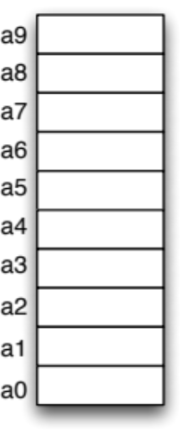
3. Write Pseudo-code to print the highest quiz score

4. Design a Data Structure for Sudoku

5. Design a Data Structure for Tetris

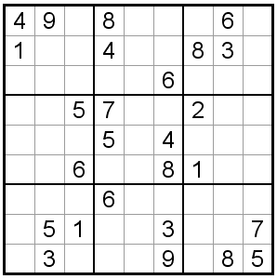
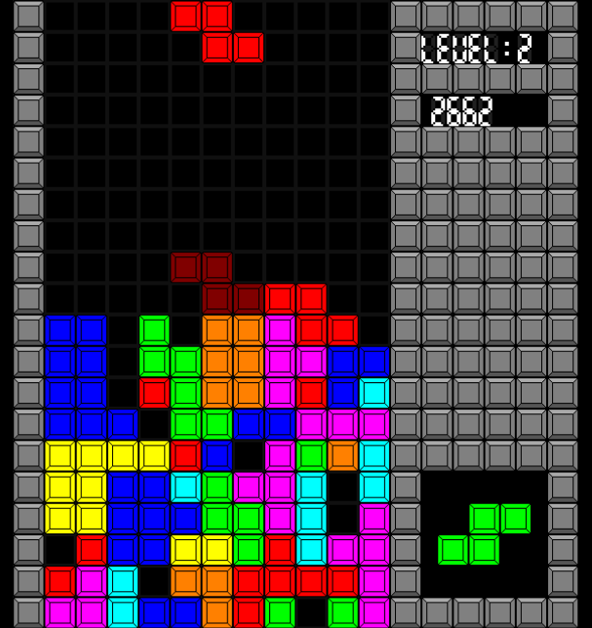

Abstraction

"On Off Off On Off"
Hi Lo Lo Hi Lo
Love Hate Hate Love Hate
T F F T F
1 0 0 1 0
1 0 0 1 0₂ = 1+2+4+8+16

1 0 0 1 0₂ _{" 18 plus 6 is 24"}
+0 0 1 1 0₂
1 1 0 0 0₂

4 7 11 10 8 4 1 9

Memory Address | Value
11
10
9
8
7
6
5
4
3
2
1
0

NOTES:
Have students complete activity 1 (Terminology).
Ask: Did your neighbor do the readings better than you?
Review Abstraction: I don’t like how Jason writes about it. Abstraction = separation of interface from implementation. (Driving a car, same interface different implementations.)
Ask Q1. Mention Nybble = 4b for fun
Ask Q2. 2 answers: 1) unsigned/2’s Complement = 22, 2) any number we want; we can define the encoding scheme. Bits are just bits and must be interpreted.
Discuss algorithms/pseudo-code: right level of formalism
Show examples of “variables”, “conditional”, and “iteration” in example algorithm.
Execute Quiz average algorithm on example input (e.g., 7, 8, 3)
Talk about mapping the variables to memory locations (#2)
Ask them to write a new algorithm in Pseudocode (#3). Need to show them an “if” statement. Display student solution. Discuss.
Ask them to design data structure for Sudoku.

