2. Design a Data Structure for your brain connectivity
1) identify what data you need to represent
2) decide how to represent it
3) decide how to order the state in memory (as 1-dimensional vector)

Objective:
- There is no magic in how a computer works: Von Neumann Architecture
- Learn to be a computer: Machine Language – A simple execution model
- The reading schedule is up; keep up with reading/Turing’s Craft Exercises;
  - Jason2- Program Development (part 2)
  - Java book: ch1.3 & ch1.4
  - Sign up for Turing's Craft. Sign onto the Piazza, Get Eclipse and svn installed (see MP0). Help for all these can be found in Website’s FAQ.
  - Bring your laptop to Mon Debug-Your-MP (6pm-8pm) if you need help to get your laptop setup

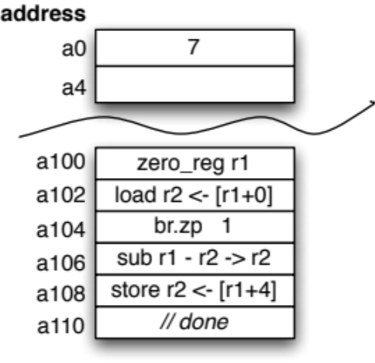
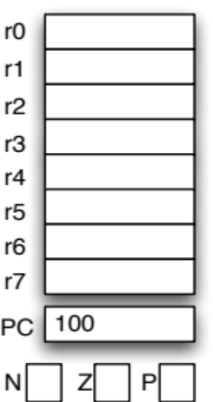
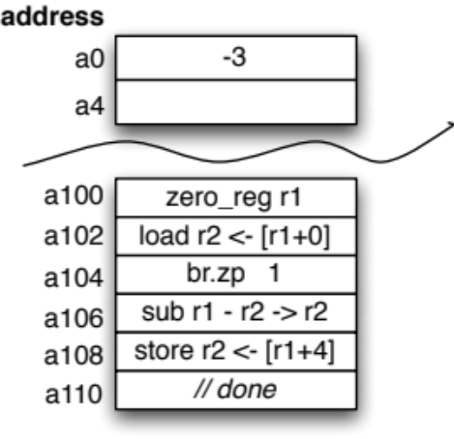
3. Execute a Machine code program

1. Computer Science Terminology – did your neighbor do the readings?
Discuss with your neighbor what a Computer Scientists means by the following terms and give an example of each:
• fetch-execute cycle • CPU
• opcode • operand
• register • condition code

A simple machine language:
zero_reg destR – puts a zero in the specified register.
add srcR1 + srcR2 -> destR – add the values in two registers together and write the result in the destination register.
add srcR1 + constant -> destR – add the value in a register to a constant and write the result in the destination register.
sub srcR1 - srcR2 -> destR – subtract the value in one register from another and write the result in the destination register.
sub srcR1 - constant -> destR – subtract a constant from the value in a register and write the result in the destination register.
load destR <- [baseR + constant] – add the value in a register to a constant to compute a memory address and copy 4 bytes starting at that address to the destination register.
store srcR1 -> [baseR + constant] – add the value in a register to a constant to compute a memory address and copy the value in the source register to 4 bytes of memory starting at that address.
br.___ PCoffset – the branch instruction specifies a combination of condition codes (n, z, p); if any of the specified condition codes holds a 1, the PC is set to PC + 2 + 2(PCoffset). Otherwise PC is set to PC + 2.

For all instructions other than the branch, PC is set to PC + 2. Any instruction that writes a general-purpose register also set the condition code bits: if new value is negative then n=1, else n=0; if new value is zero then z=1, else z=0; if new value is positive then p=1, else p=0.

4. What does this code do?

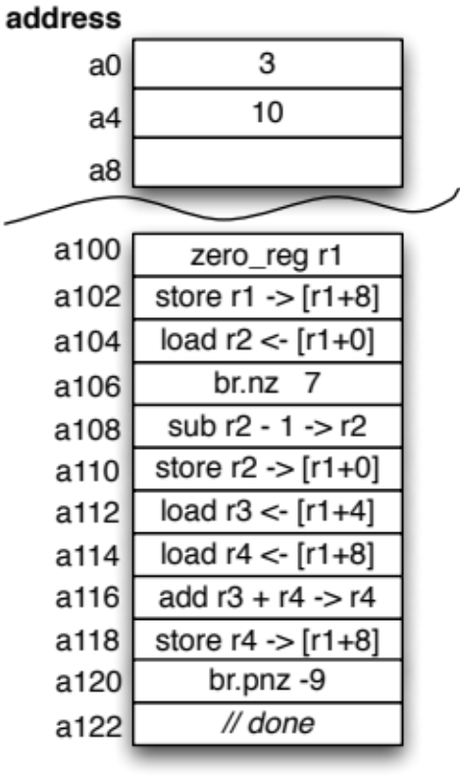
5. Execute another machine code program

6. What does this code do?

Notes
Lenny's Wooden Box And/Or Gates
Marble Adding Machine Youtube

