Objectives:
- Problem decomposition and refinement
- Identify variables, conditions, looping.
To do for Next Lecture: Types, Variables, Expressions

1. You hold 12 playing cards of the same suite in your hand. Write down the steps required to sort them in numerical order. Check your neighbor's algorithm for clarity and correctness. Together, can you think of an alternative sort algorithm?

2. Your startup, 'YouTube Inc' has N online videos. Describe a two-pass algorithm to print the # views of the most popular video and also the number of videos that achieved at least 5% of that viewing popularity. Why do you need two passes through the data?
Use 'viewed[0]' to mean the # views of the first online video, 'viewed[i]' for the number of views of the i^{th} online video.

3. "Describe an algorithm using a flowchart that calculates N! i.e. 1x2x3x...N". A proposed solution is included below.
i) What is the purpose of the three variables, N,M,F?
N:______ M:_____ F: _____
Which variable is unchanged by the loop?
(A "Loop Invariant")

ii) Will the algorithm terminate for all values of N?
If no, provide a counter-example: N = _____

iii) Create a new algorithm that only uses two variables -
Draw your flowchart & check your neighbor's answer.
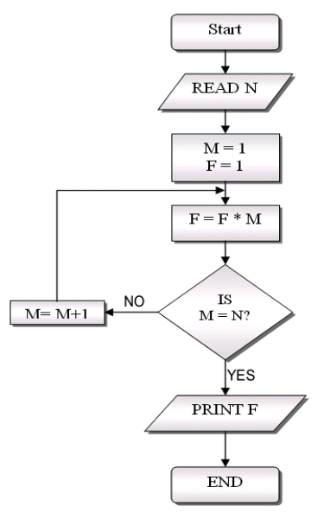
x 0 1 2 3..
y
3
2
1
0

N
5. Surgical Robot Problem (Not enough lecture time - finish this with your dorm friends)
You're in a team that's writing the program for a new micro-surgical robot. The patient lies in a MRI magnetic field and the robot is inserted into a major vein and the robot will crawl up the vein to a target destination. Some of the program (written by others) already seems to be working correctly: The code that has already been written includes the following subroutines:

move(); // moves forward one inch in current direction
turnRight(); // orientates robot by turning 90 degrees to the right
turnLeft(); // orientates robot by turning 90 degrees to the left

The robot also keeps track of its current position and orientation using three integer variables: x, y, dir. The 'dir' variable will only have four possible values: 0 (facing North), 90(East), 180(South) or 270(West). You can read the value of each of these variables but you don't change them yourself. Some example code
Pseudo code: while x < 10 move
Java: while(x<10) move();

1.Write code that moves the robot from (1, 0) initially facing "North" (positive y) to (2, 3)
facing East.

2. Write code that visits all four positions (1,1),(1,2),(2,1),(2,2) starting from position (1, 1) facing North.

3. If the robot starts at (1, anything) but facing East what additional pseudo-code do you need to solve problem #2 (i.e. visit all nine positions)?

4. [Advanced] Design a new subroutine called MoveTo(targetX, targetY, targetDir), that moves the robot to the desired position and orientation. (hint: you will need conditionals, loops, and the given subroutines)
What kind of algorithm could solve this?
How would you represent this maze?
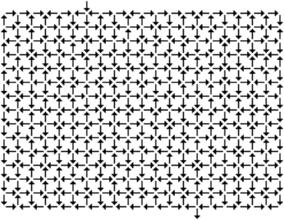
4. Boolean state .... "She loves me, or, She loves me not?"
i) What kind of variable(s) do you need to implement this game?
ii) Write an algorithm in pseudo-code to print your fate by removing flower petals.

iii) Lawrence will write a Java version ...

