CS241 #24 Simple TCP Client Example + HTTP

What is the OSI (**Open Systems Interconnection)** Model?

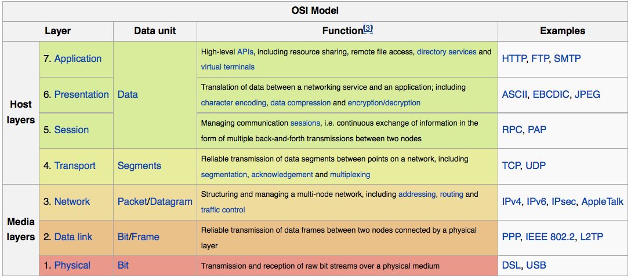

Image Attribution: http://en.wikipedia.org/wiki/OSI_model

What is "U.D.P." and what are its main characteristics?

What is T.C.P. and what are its main characteristics?

Which one uses handshaking?

Which one requires more system resources?

Which one can be used with read and write system calls?

Which one encrypts the data payload?

If your application preferred to handle missing packets over late packets, which one would you use?

What is HTTP? Does it run over TCP or UDP?

Is HTTP version 1.0 and version 1.1 a text or binary protocol?

How do you make a TCP connection to a server

What is the purpose of getaddrinfo ?

struct addrinfo {

int ai_flags;

int ai_family; int ai_socktype; int ai_protocol; socklen_t ai_addrlen; struct sockaddr *ai_addr;

char *ai_canonname; struct addrinfo *ai_next;

};

struct addrinfo?

Why memset?

AF_INET; ?

SOCK_STREAM; ?

connect?

struct addrinfo hints, *result;

memset(&hints, 0, sizeof(struct addrinfo) );

hints.ai_family = AF_INET;

hints.ai_socktype = SOCK_STREAM;

s = getaddrinfo("illinois.edu", "80", &hints, &result);

if (s != 0) {

fprintf(stderr, "getaddrinfo: %s\n", gai_strerror(s));

exit(1);

}

int sock_fd = socket(hints.ai_family, hints.ai_socktype, 0);

connect(sock_fd, result->ai_addr, result->ai_addrlen);

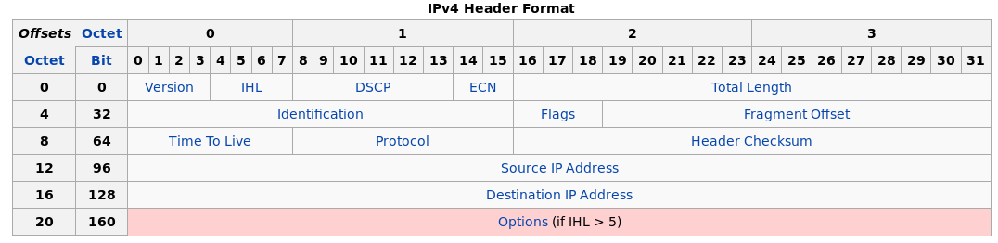

TCP header:

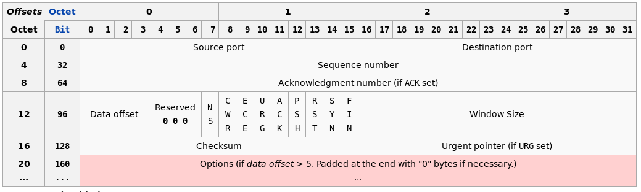

Image attribution – wikipedia.com

https://xkcd.com/195/

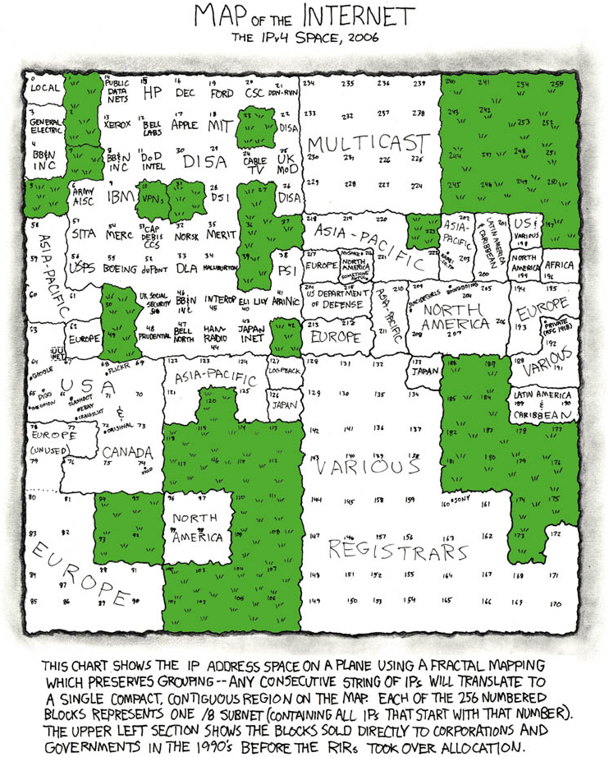

socket

listen

accept

Exhaustion of IPv4 for each of the 5 regional authorities.

ARIN exhausted 24 September 2015

commons.wikimedia.org/wiki/File:Regional_Internet_Registries_world_map.svg

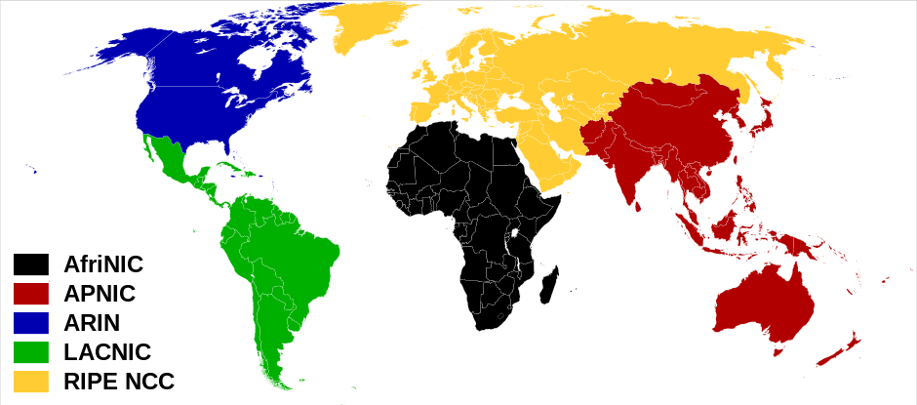

https://www.arin.net/resources/request/ipv4_countdown.html